Supplement: Diagnostics

Martijn Schuemie, Zhong Yuan, Elliot Barnathan, Jamie Weaver

2024-05-15

Table of Contents

1 Propensity score distribution and equipoise 2

1.0.1 CCAE 2

1.0.2 OptumDod 3

1.0.3 OptumEhr 4

1.0.4 PharMetrics 5

1.0.5 MDCR 6

2 Covariate balance 7

2.0.1 CCAE 8

2.0.2 OptumDod 9

2.0.3 OptumEhr 10

2.0.4 PharMetrics 11

2.0.5 MDCR 12

3 Minimum detectable relative risk and follow-up time 13

3.1 Minimum detectable relative risk 13

3.2 Follow-up time in the target cohort 14

3.3 Follow-up time in the comparator cohort 16

4 Mediator risk score distribution 17

4.0.1 CCAE 17

4.0.2 OptumDod 21

4.0.3 OptumEhr 25

4.0.4 PharMetrics 29

4.0.5 MDCR 33

5 Negative controls 37

5.0.1 CCAE 39

5.0.2 OptumDod 51

5.0.3 OptumEhr 63

5.0.4 PharMetrics 75

5.0.5 MDCR 87

# 1 Propensity score distribution and equipoise

Table 1.1: Overview of empirical equipoise per database and comparison

| Database | Target | Comparator | Equipoise |
| --- | --- | --- | --- |
| CCAE | DOACs | Warfarin | 36.1% |
| CCAE | Rivaroxaban | Warfarin | 34.2% |
| OptumDod | DOACs | Warfarin | 36.0% |
| OptumDod | Rivaroxaban | Warfarin | 45.3% |
| OptumEhr | DOACs | Warfarin | 36.2% |
| OptumEhr | Rivaroxaban | Warfarin | 39.8% |
| PharMetrics | DOACs | Warfarin | 39.4% |
| PharMetrics | Rivaroxaban | Warfarin | 37.7% |
| MDCR | DOACs | Warfarin | 42.8% |
| MDCR | Rivaroxaban | Warfarin | 45.8% |

### 1.0.1 CCAE

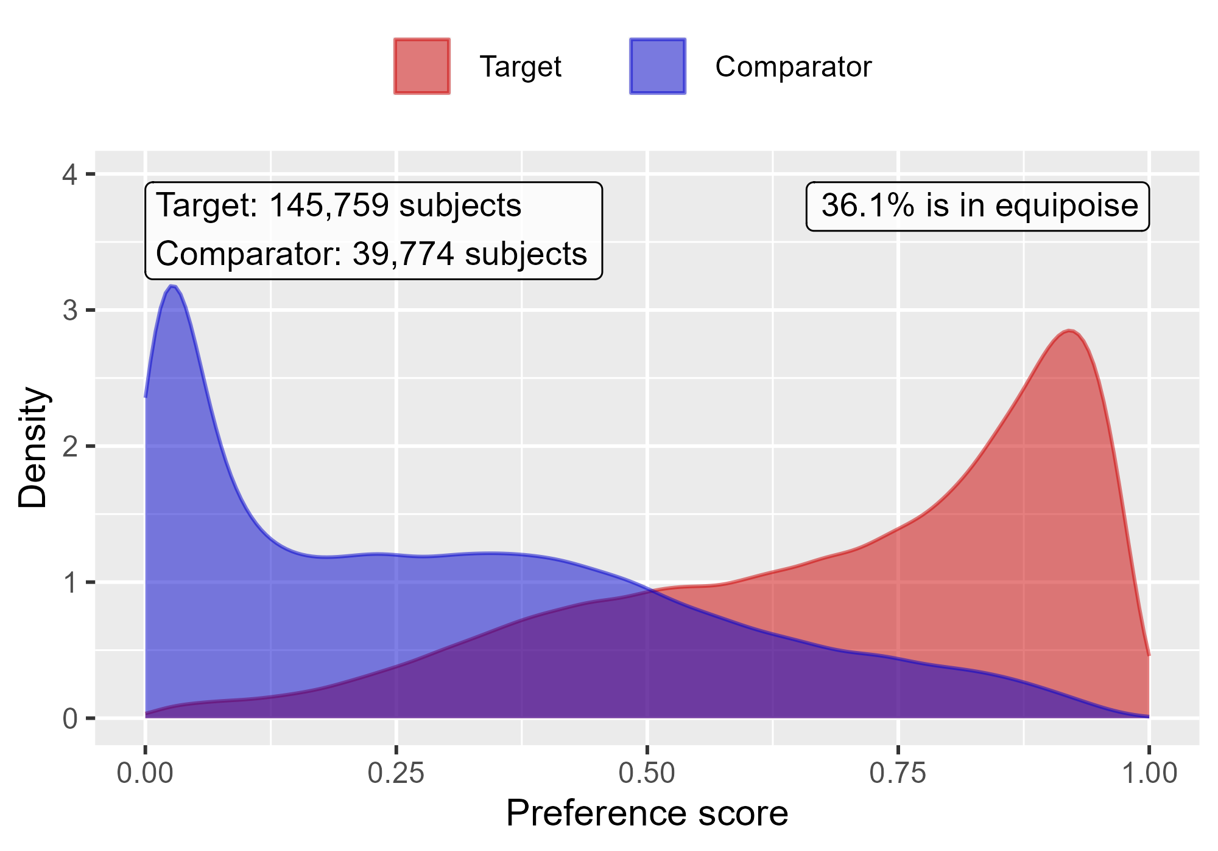

Propensity score distribution comparing DOACs to Warfarin in CCAE.

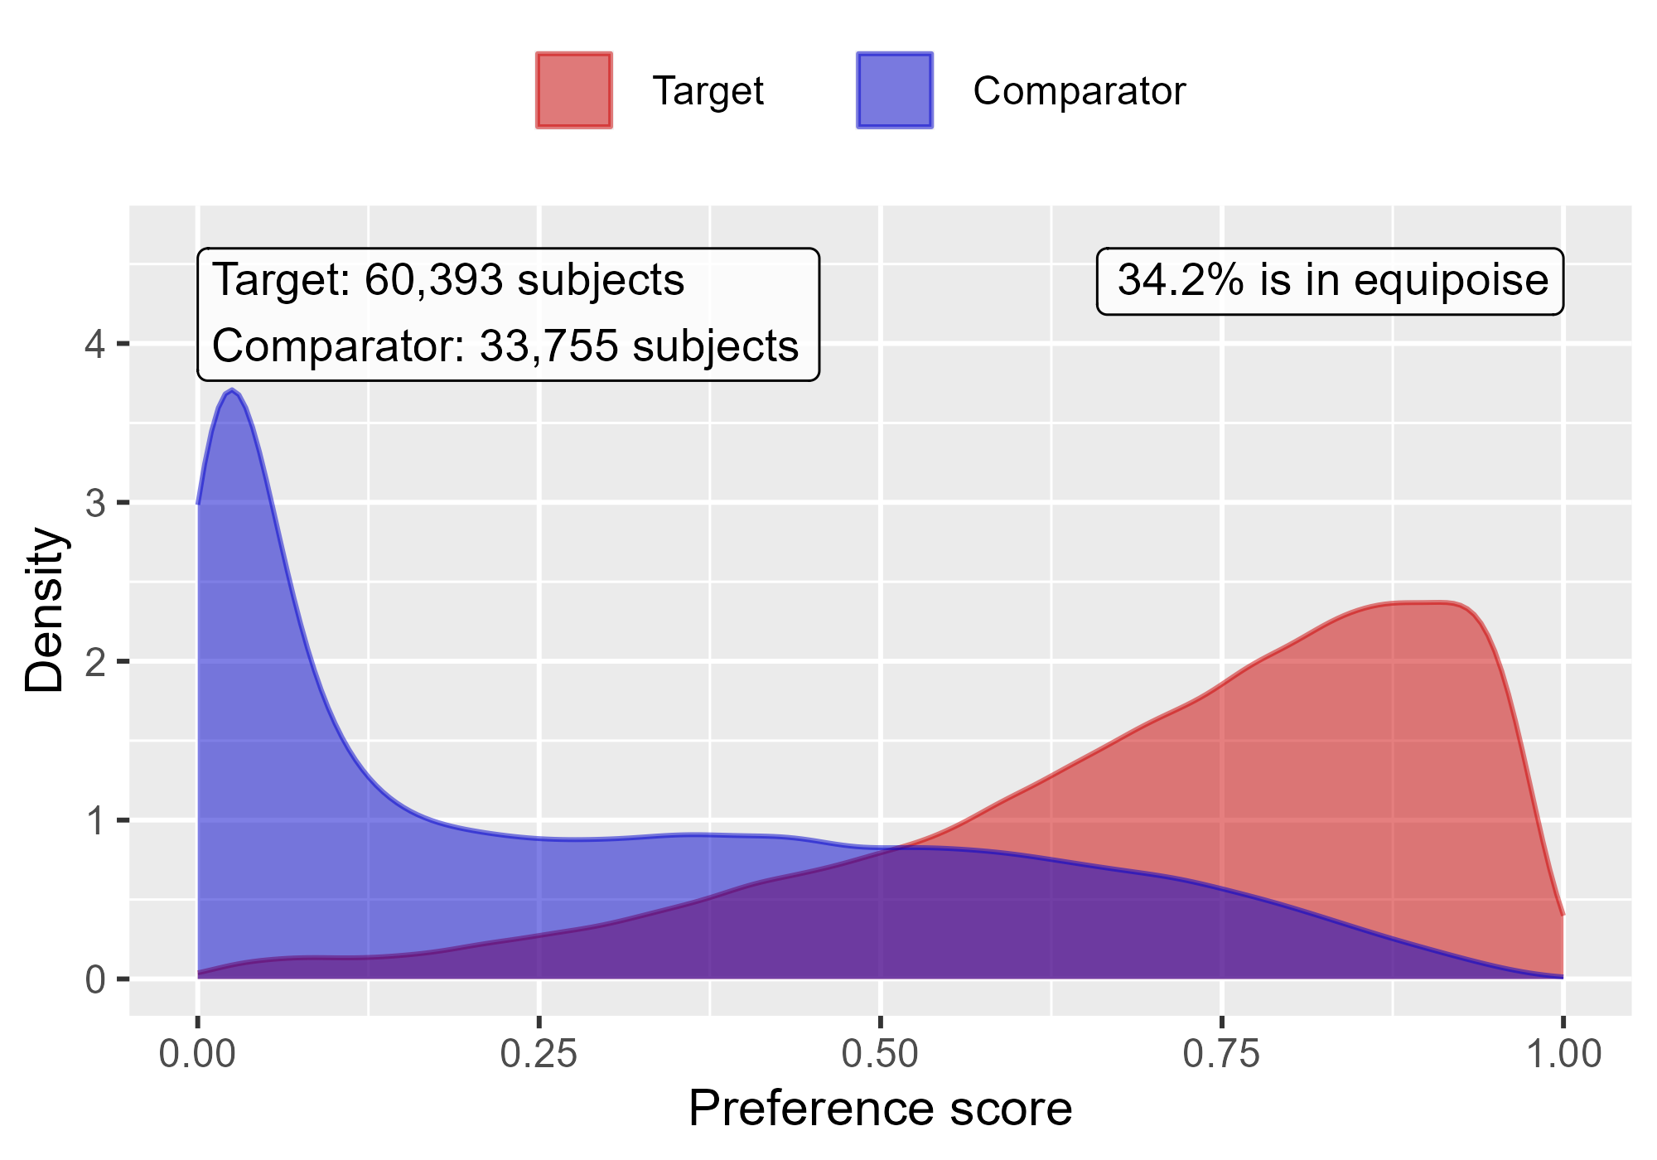

Propensity score distribution comparing Rivaroxaban to Warfarin in CCAE.

### 1.0.2 OptumDod

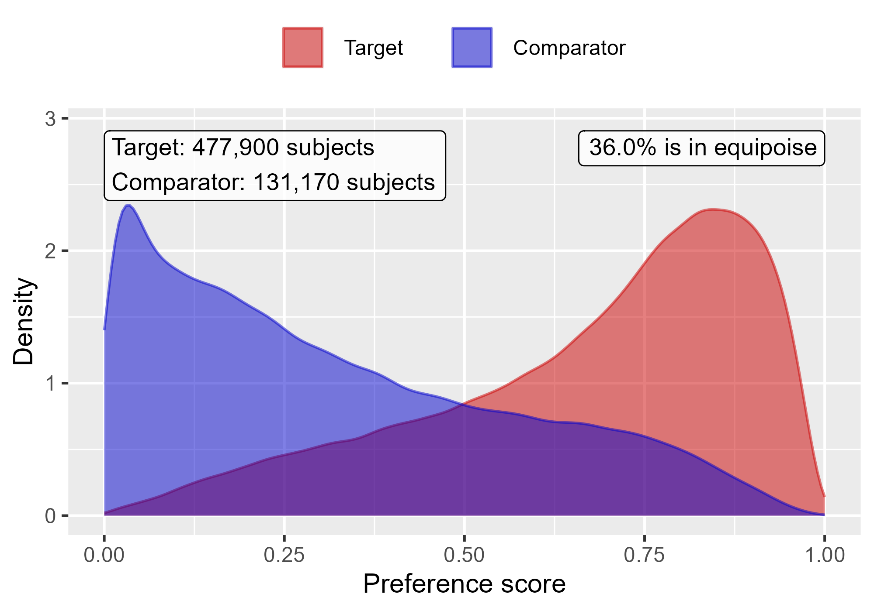

Propensity score distribution comparing DOACs to Warfarin in OptumDod.

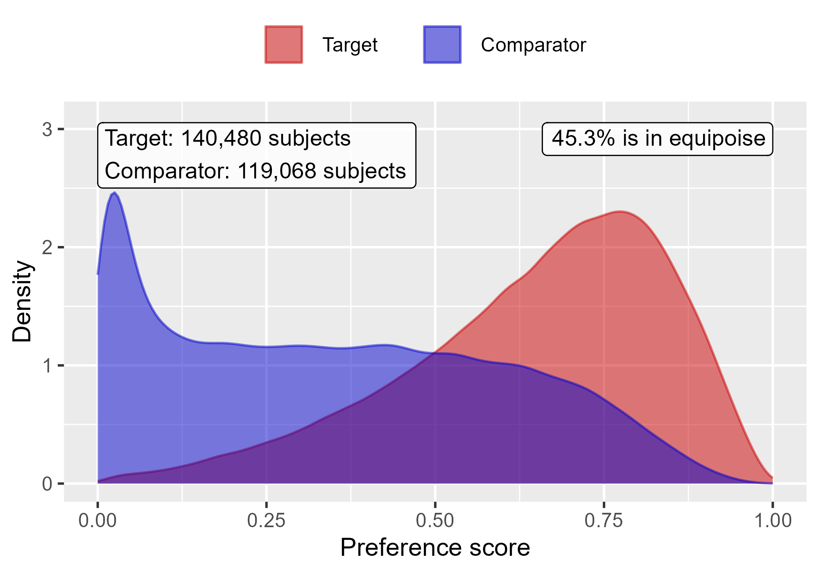

Propensity score distribution comparing Rivaroxaban to Warfarin in OptumDod.

### 1.0.3 OptumEhr

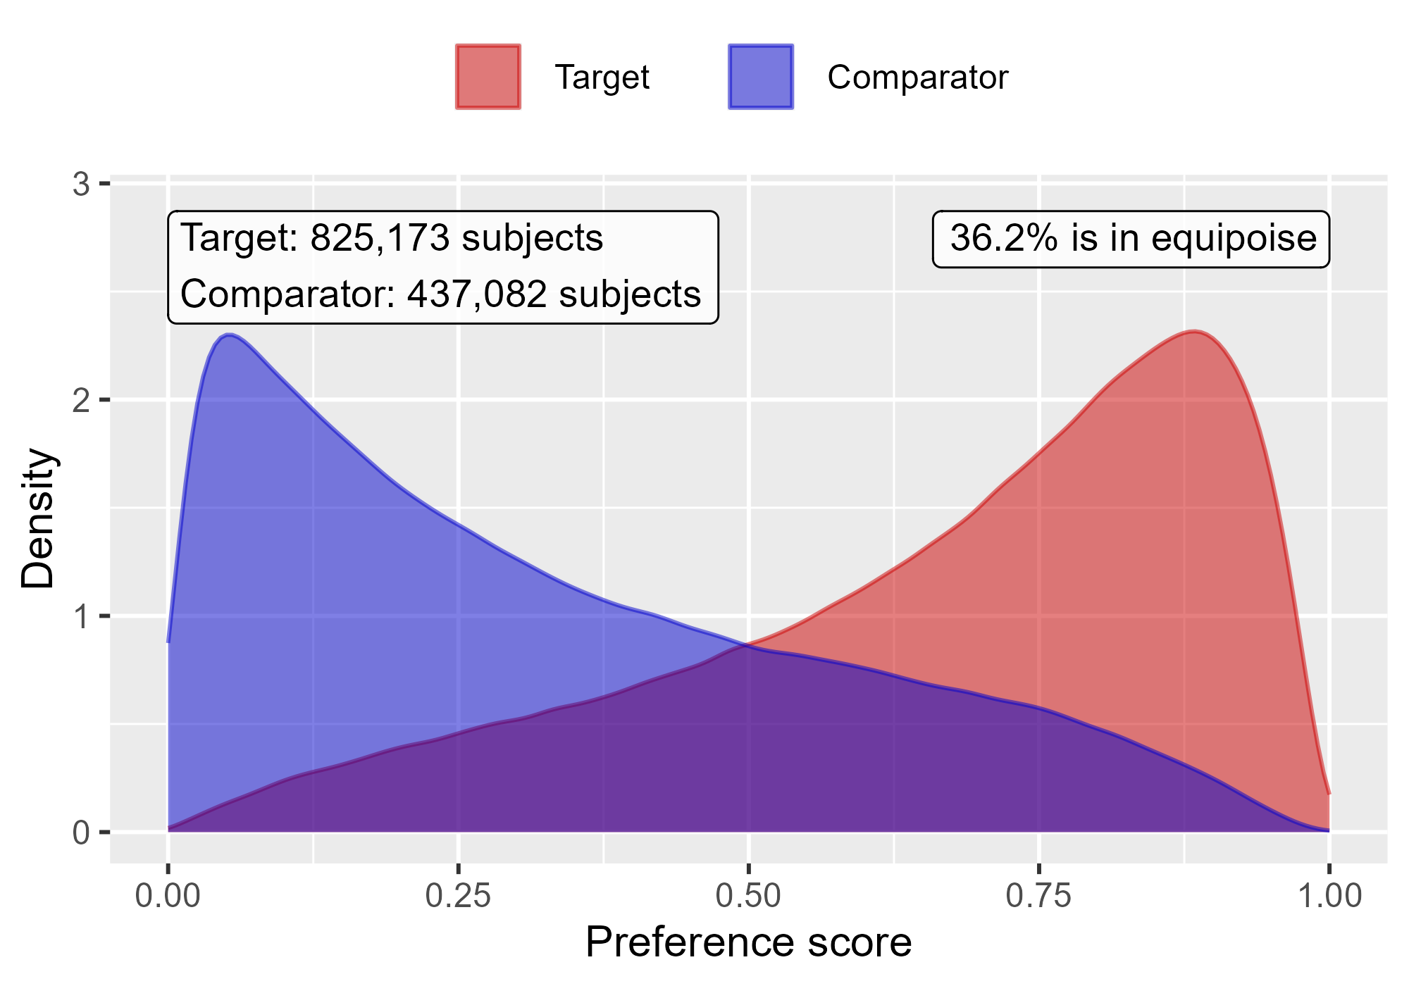

Propensity score distribution comparing DOACs to Warfarin in OptumEhr.

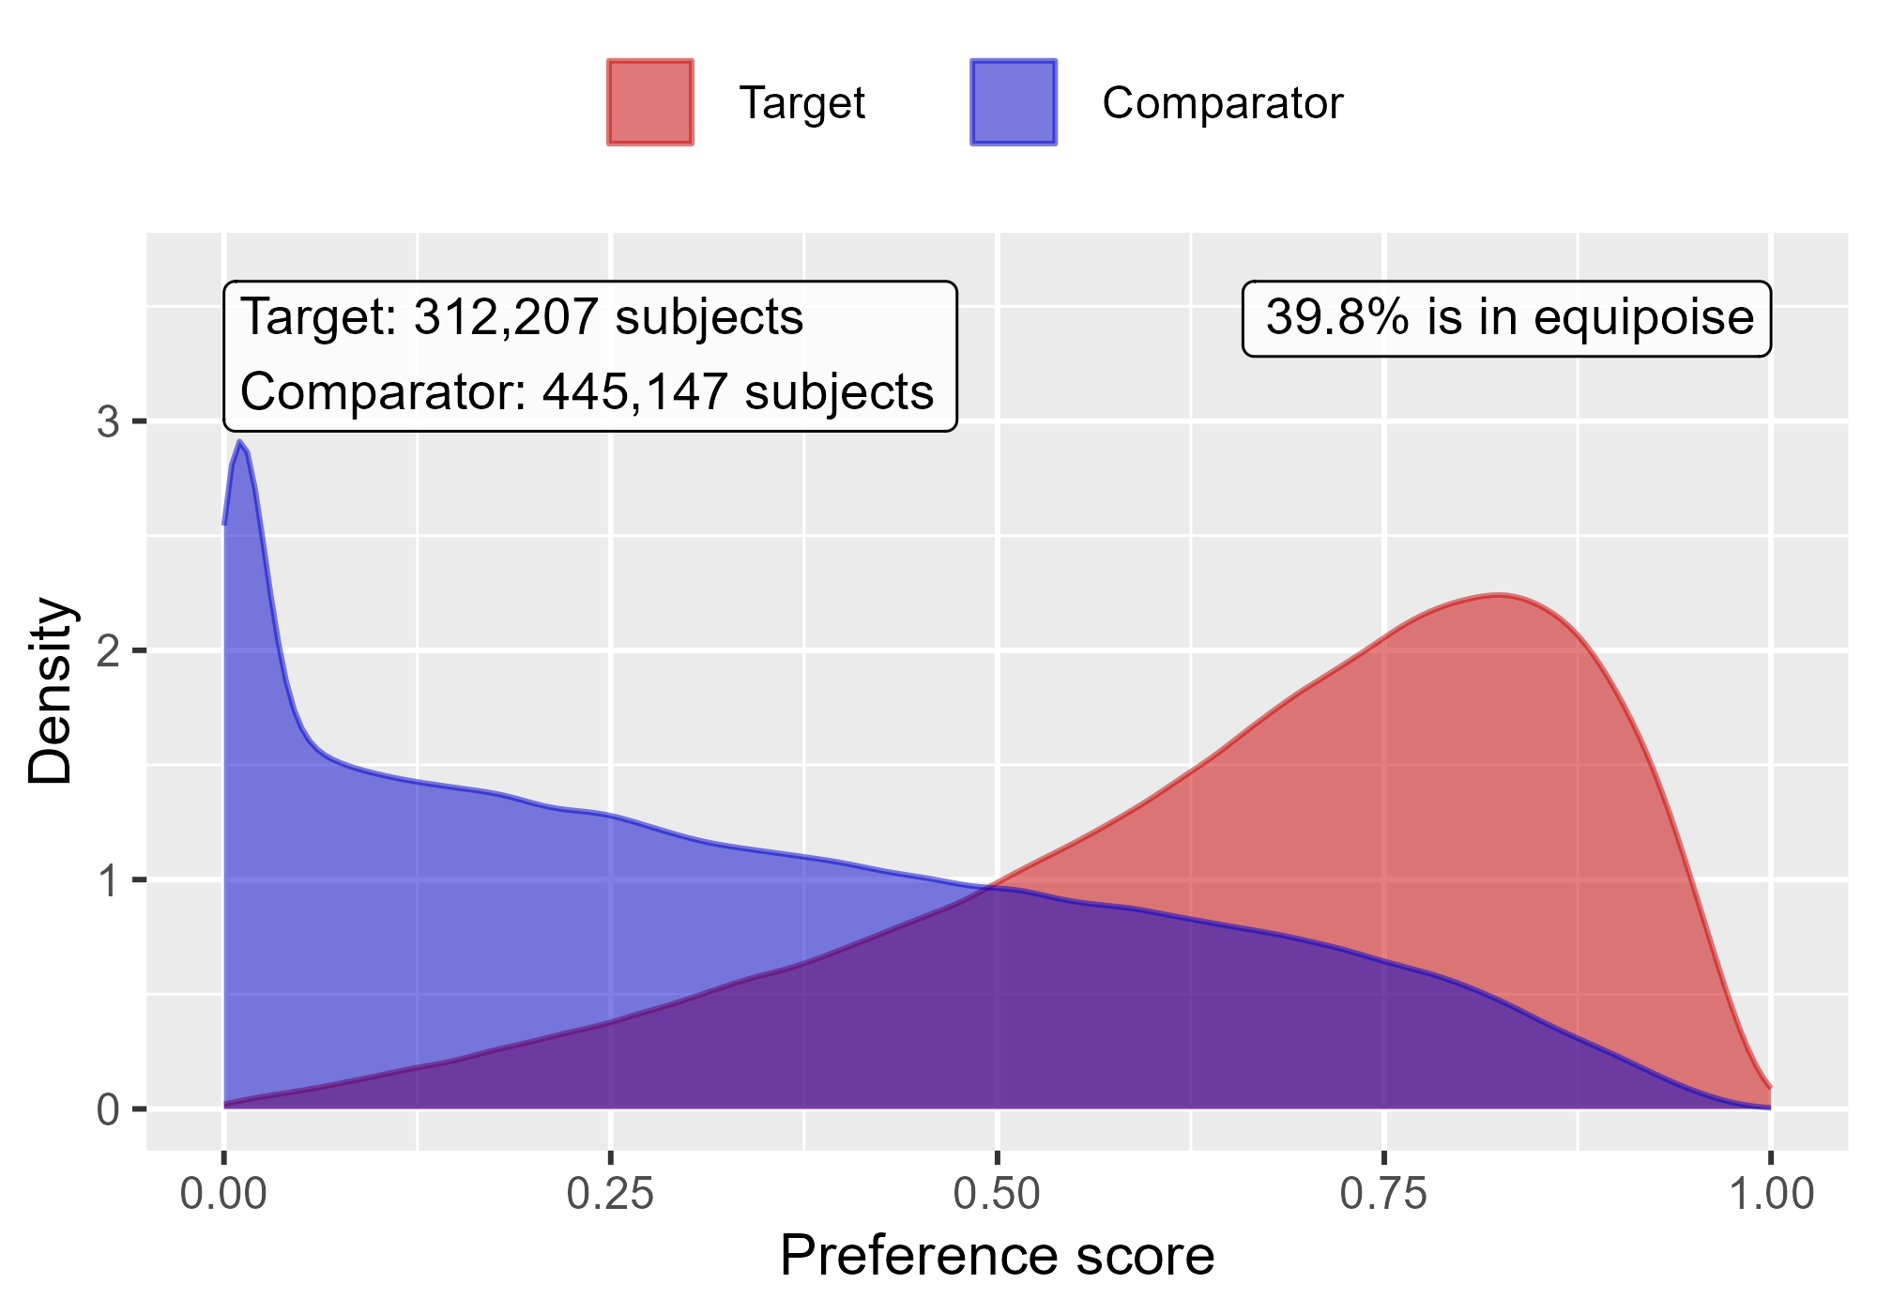

Propensity score distribution comparing Rivaroxaban to Warfarin in OptumEhr.

### 1.0.4 PharMetrics

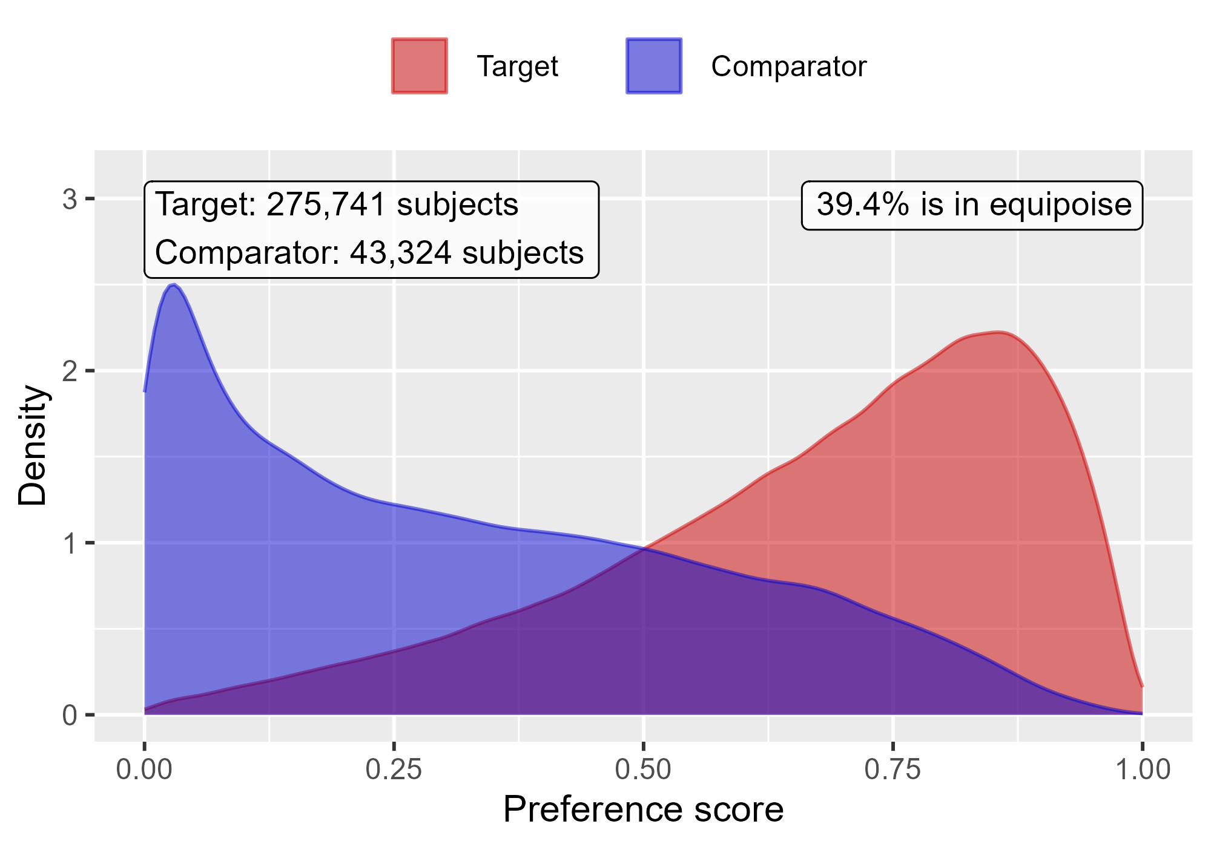

Propensity score distribution comparing DOACs to Warfarin in PharMetrics.

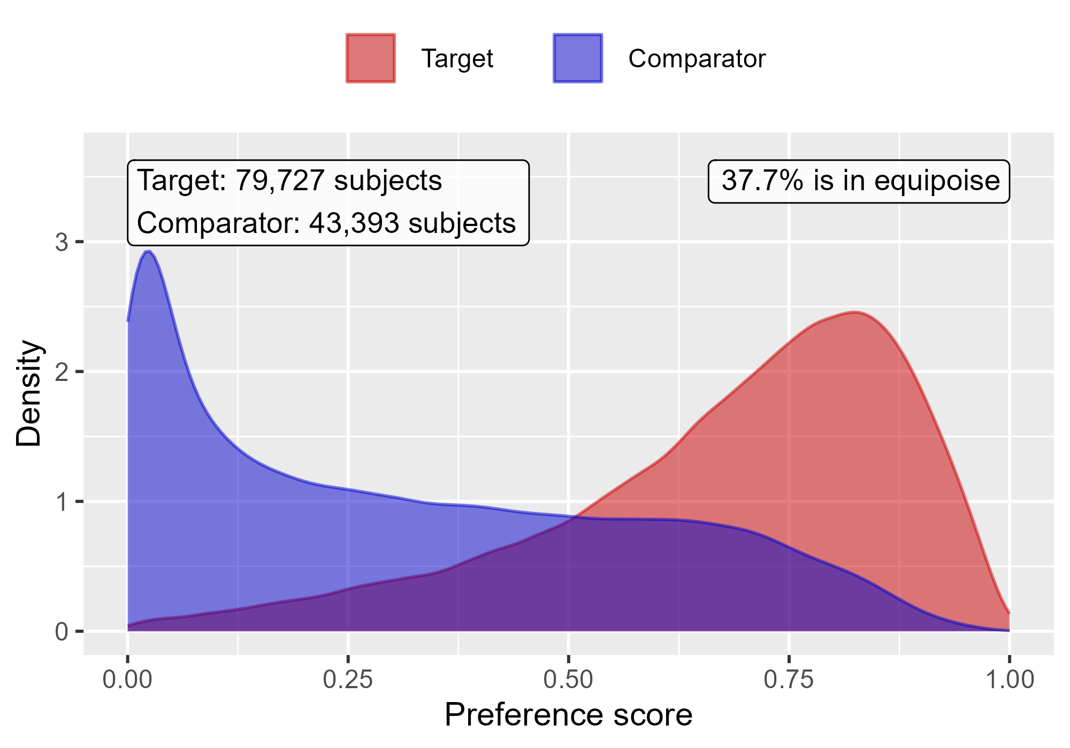

Propensity score distribution comparing Rivaroxaban to Warfarin in PharMetrics.

### 1.0.5 MDCR

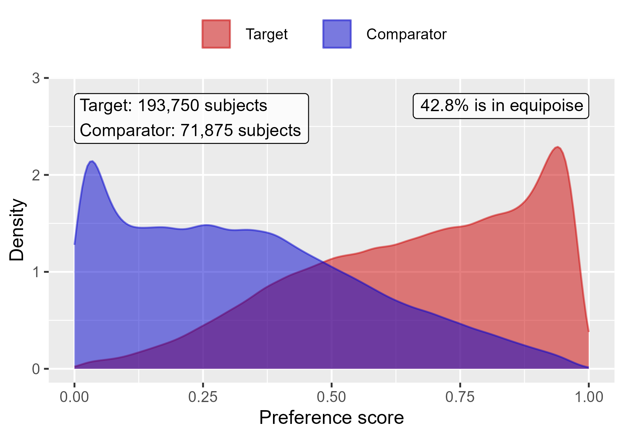

Propensity score distribution comparing DOACs to Warfarin in MDCR.

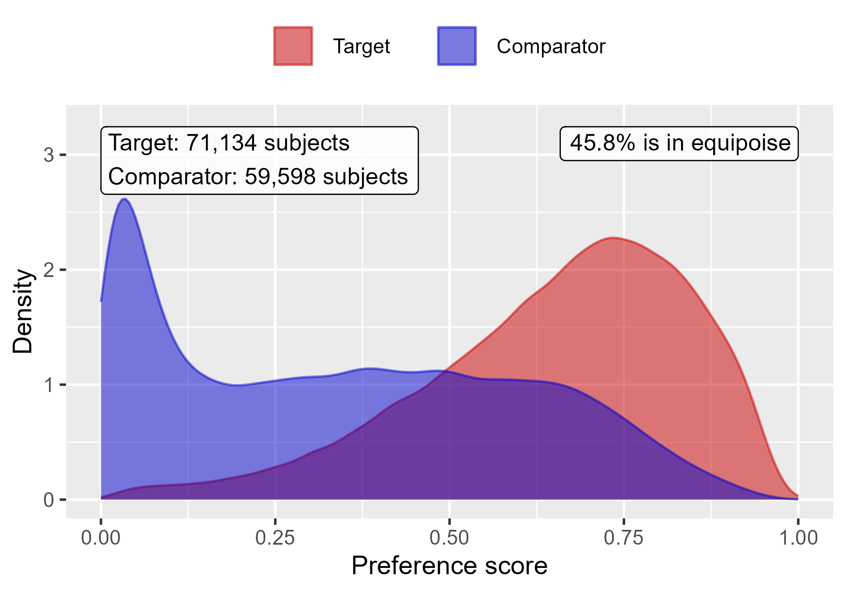

Propensity score distribution comparing Rivaroxaban to Warfarin in MDCR.

# 2 Covariate balance

Table 2.1: Overview of balance per database and comparison

| Database | Target | Comparator | Number of covariates | Max ASDM |
| --- | --- | --- | --- | --- |
| CCAE | DOACs | Warfarin | 89,601 | 0.05 |
| CCAE | Rivaroxaban | Warfarin | 77,072 | 0.05 |
| OptumDod | DOACs | Warfarin | 127,326 | 0.05 |
| OptumDod | Rivaroxaban | Warfarin | 113,953 | 0.07 |
| OptumEhr | DOACs | Warfarin | 122,913 | 0.06 |
| OptumEhr | Rivaroxaban | Warfarin | 118,035 | 0.08 |
| PharMetrics | DOACs | Warfarin | 78,981 | 0.07 |
| PharMetrics | Rivaroxaban | Warfarin | 67,123 | 0.06 |
| MDCR | DOACs | Warfarin | 87,462 | 0.04 |
| MDCR | Rivaroxaban | Warfarin | 74,352 | 0.05 |

### 2.0.1 CCAE

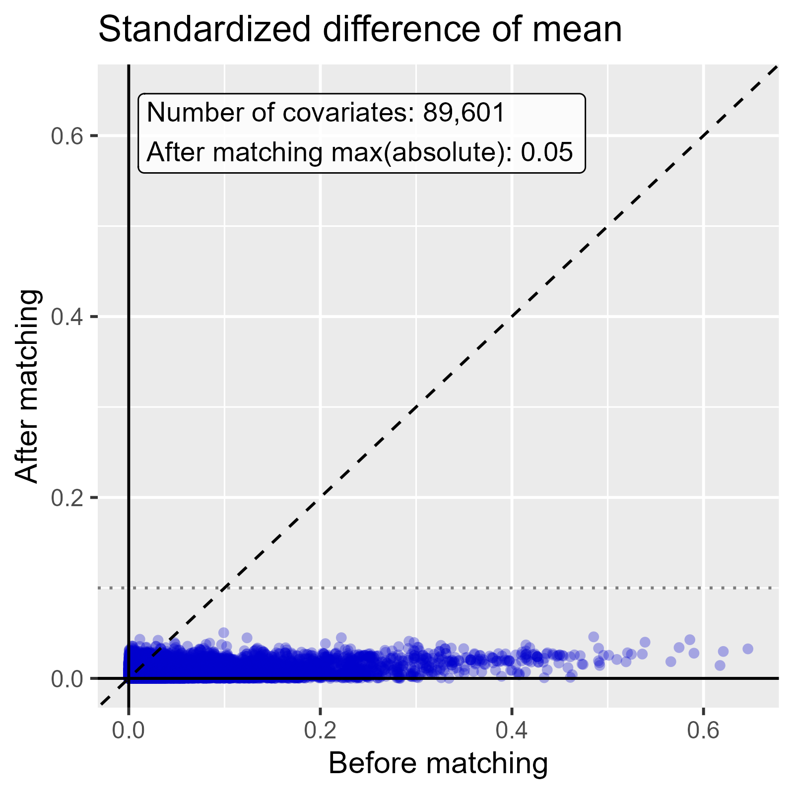

Standardized difference of mean comparing DOACs to Warfarin in CCAE.

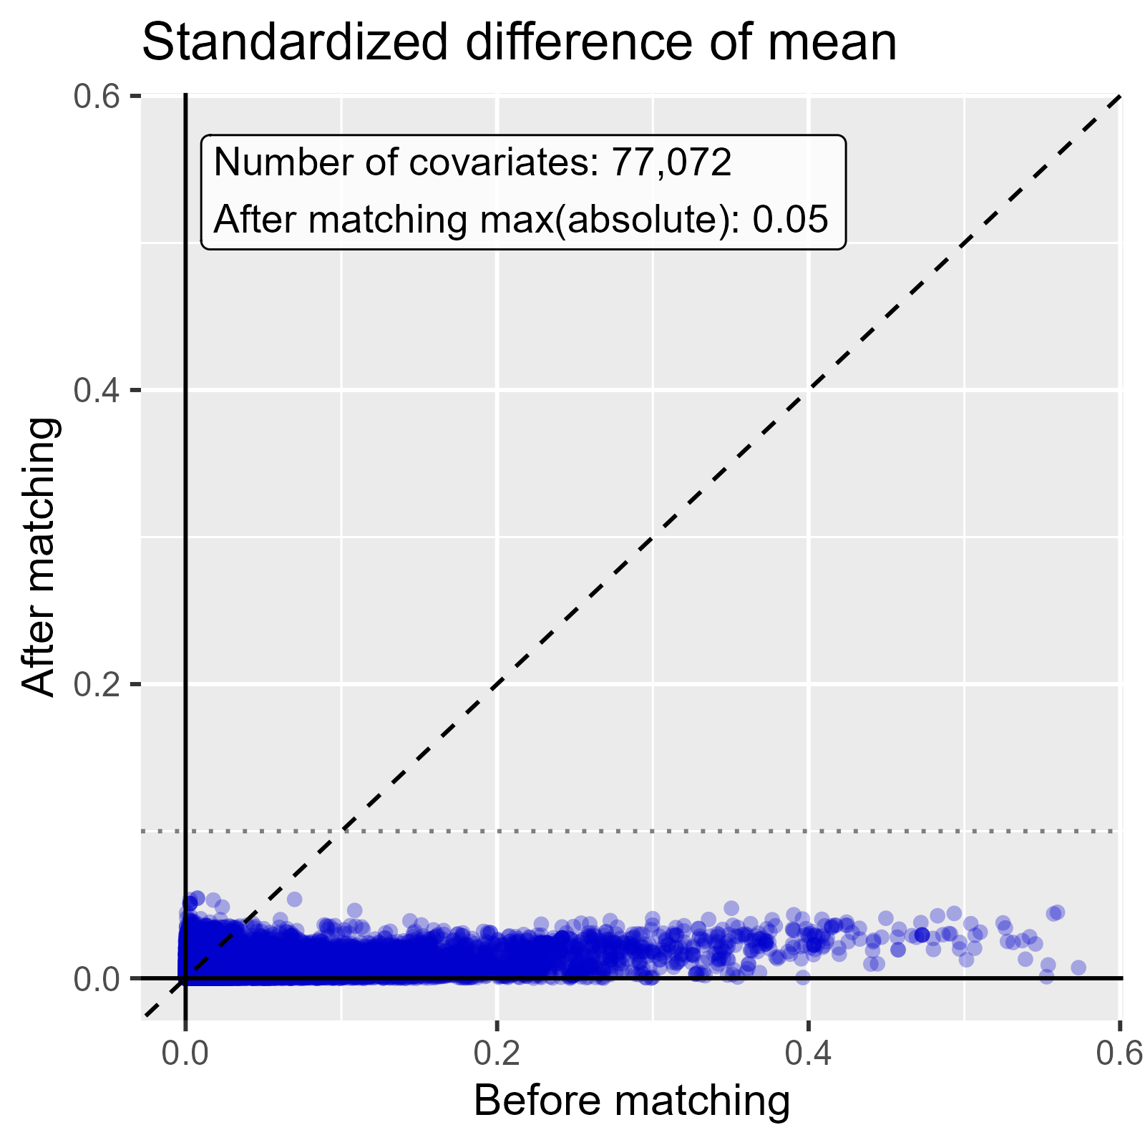

Standardized difference of mean comparing Rivaroxaban to Warfarin in CCAE.

### 2.0.2 OptumDod

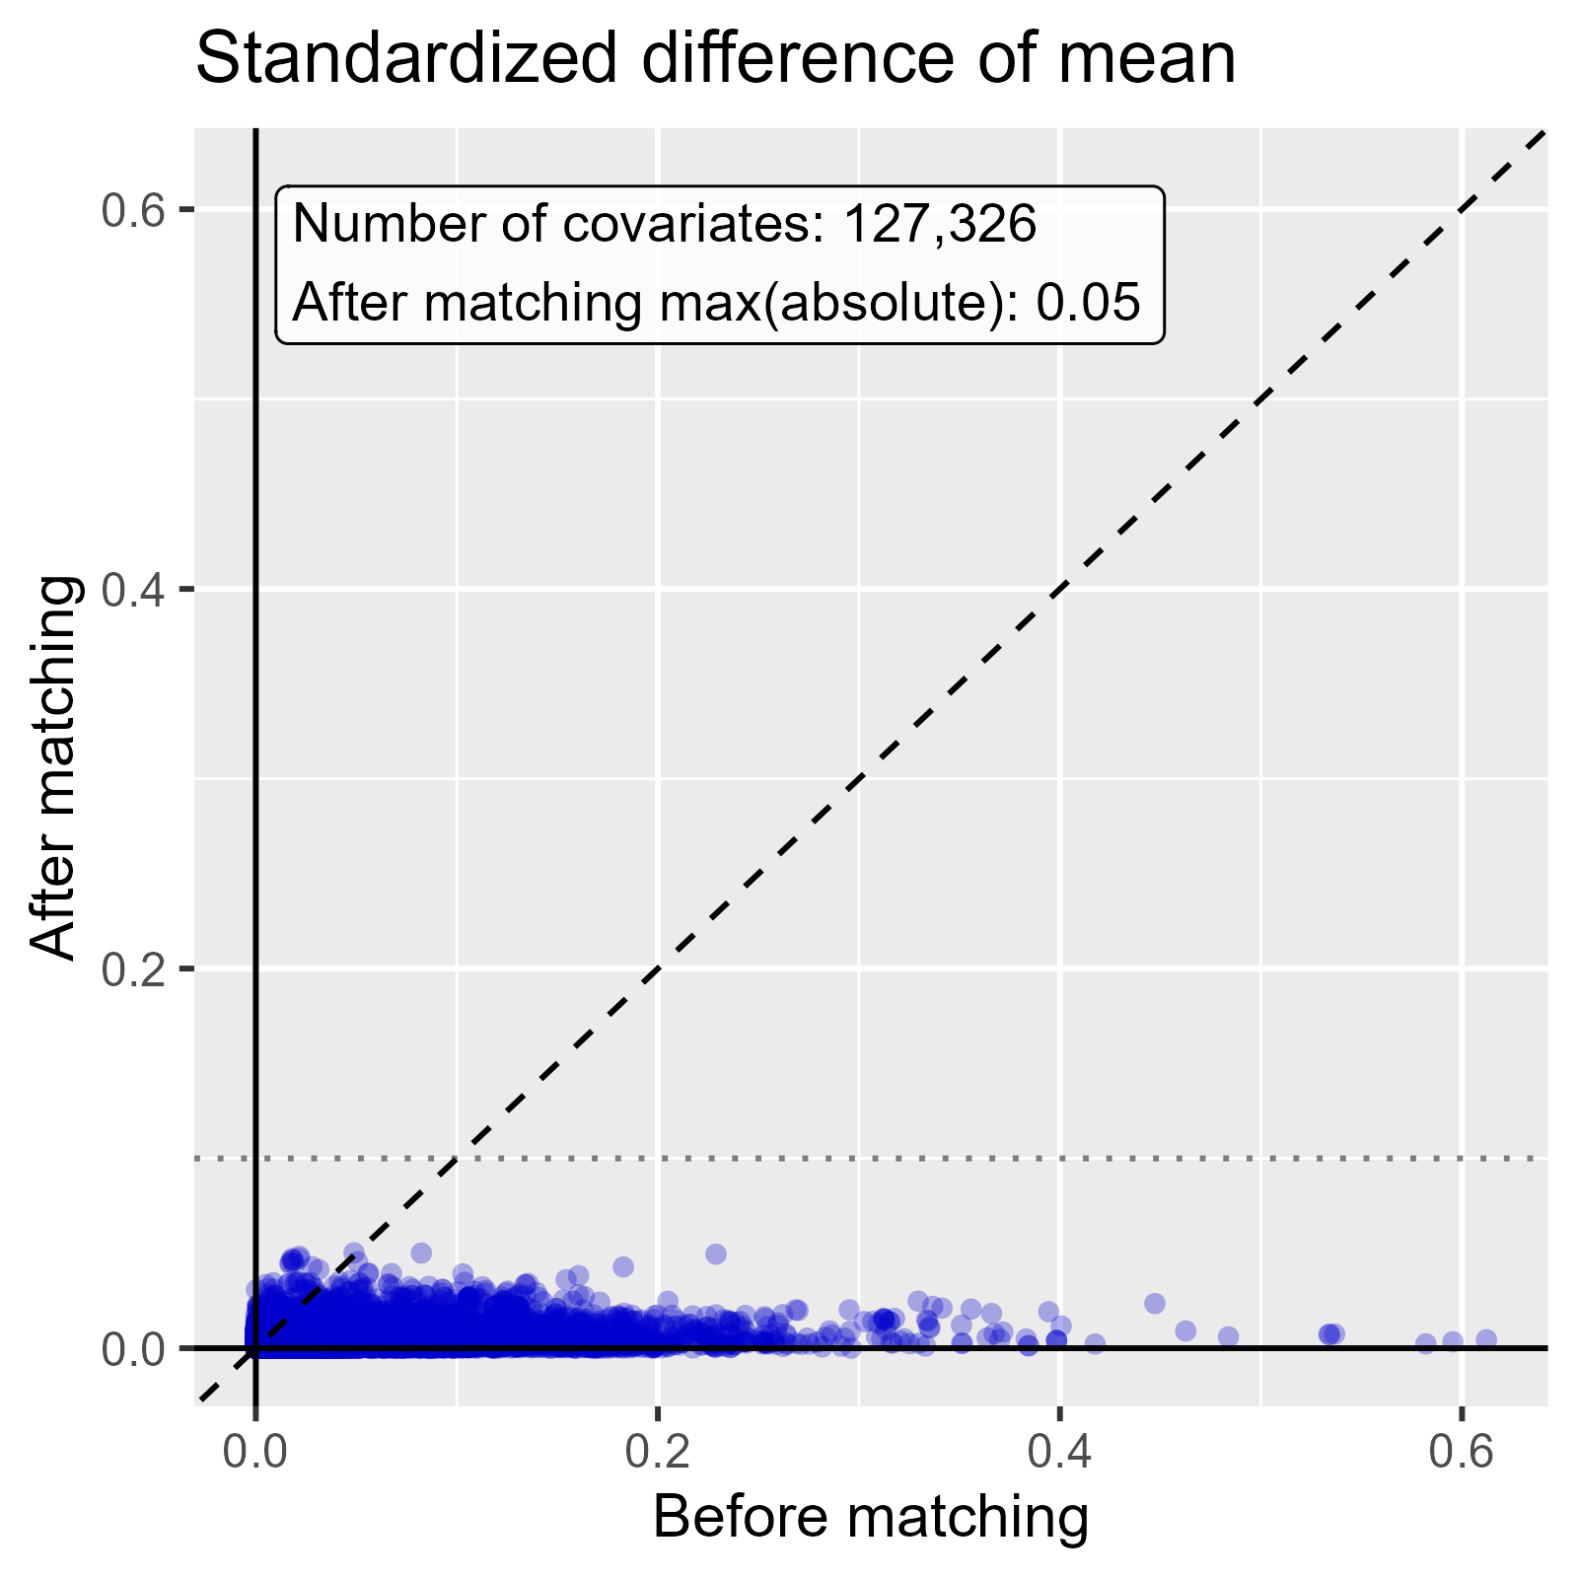

Standardized difference of mean comparing DOACs to Warfarin in OptumDod.

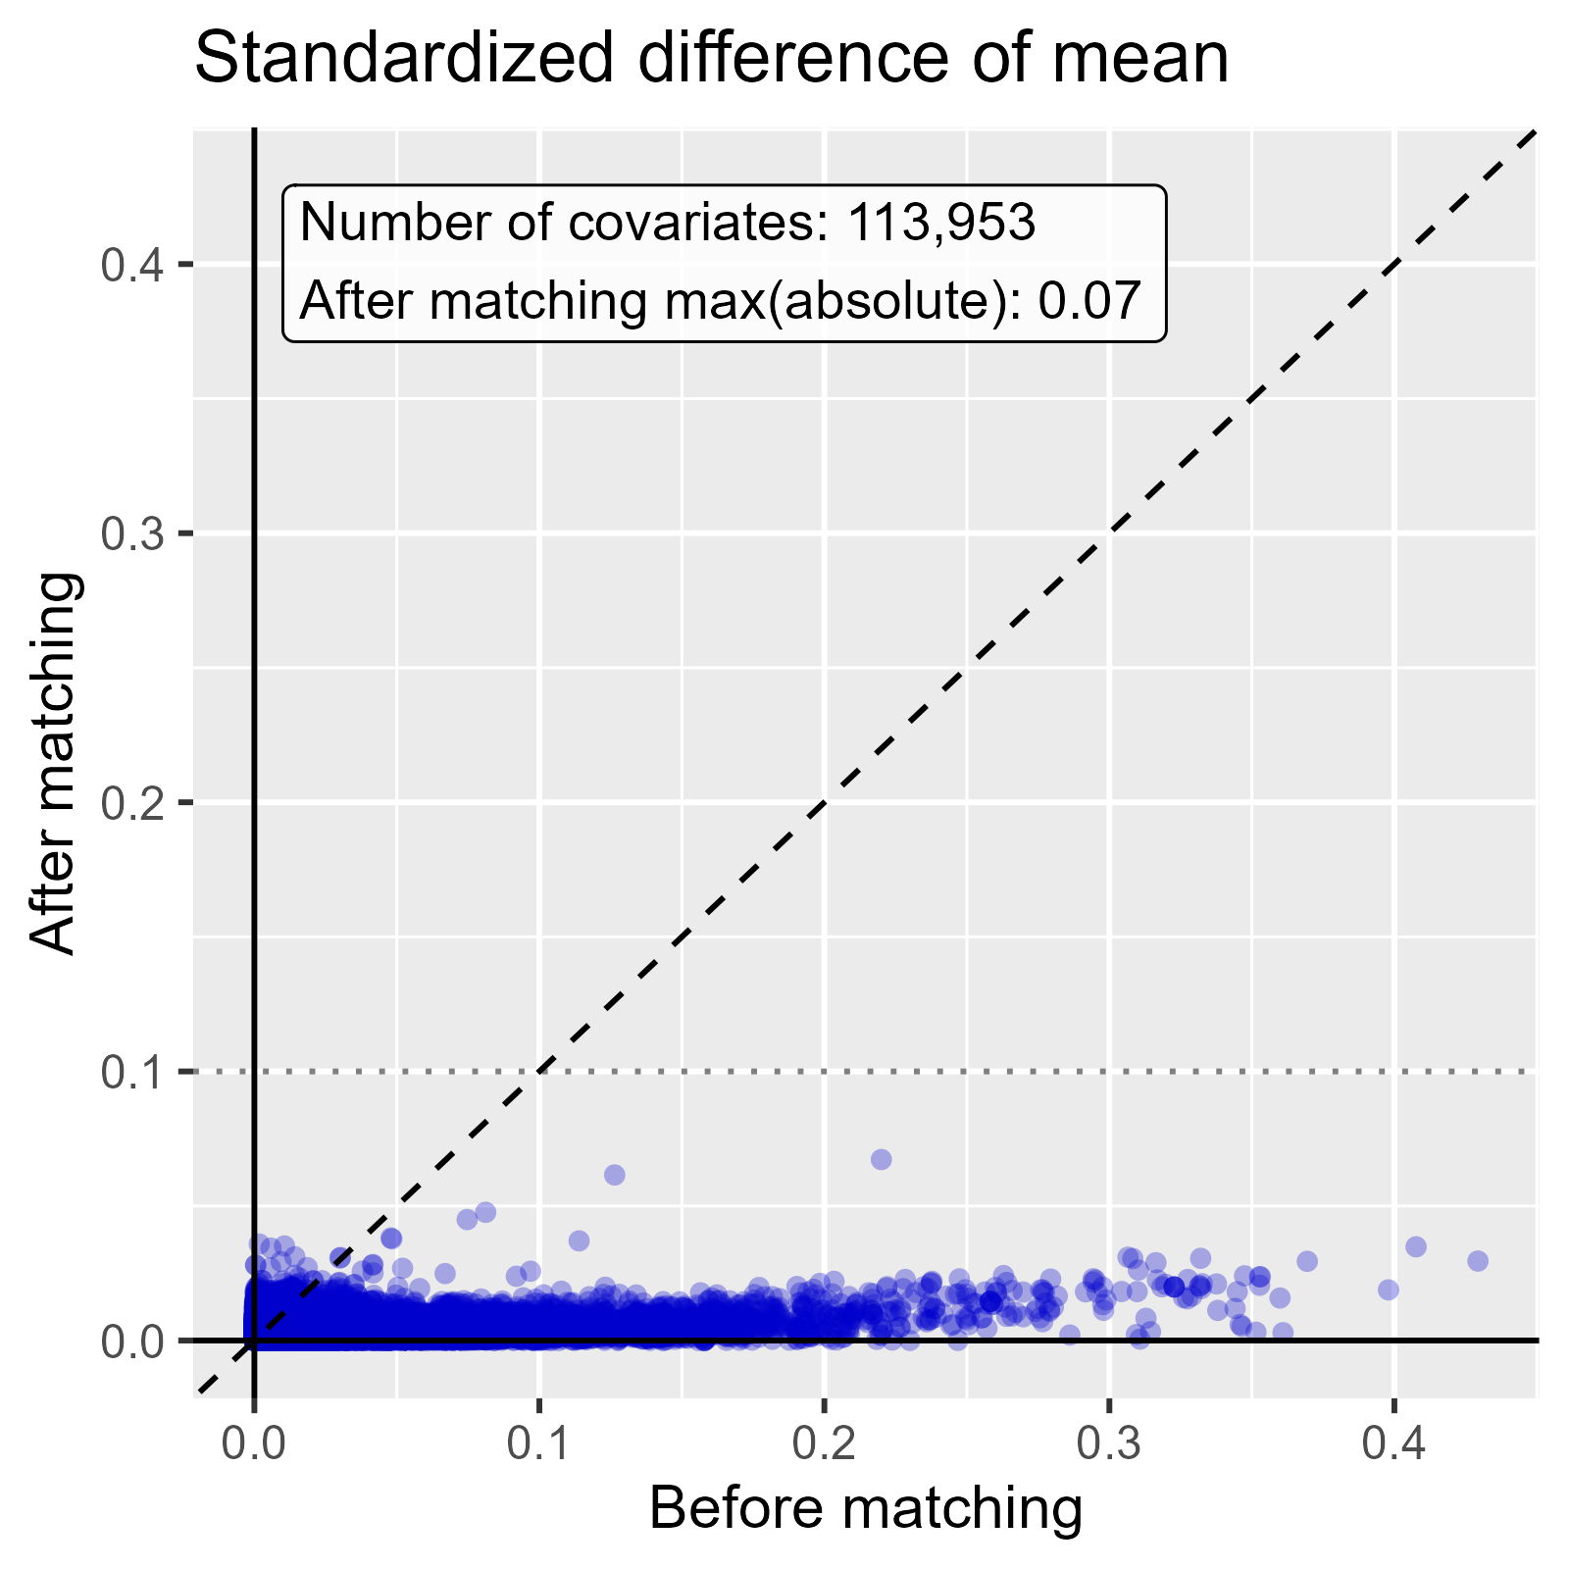

Standardized difference of mean comparing Rivaroxaban to Warfarin in OptumDod.

### 2.0.3 OptumEhr

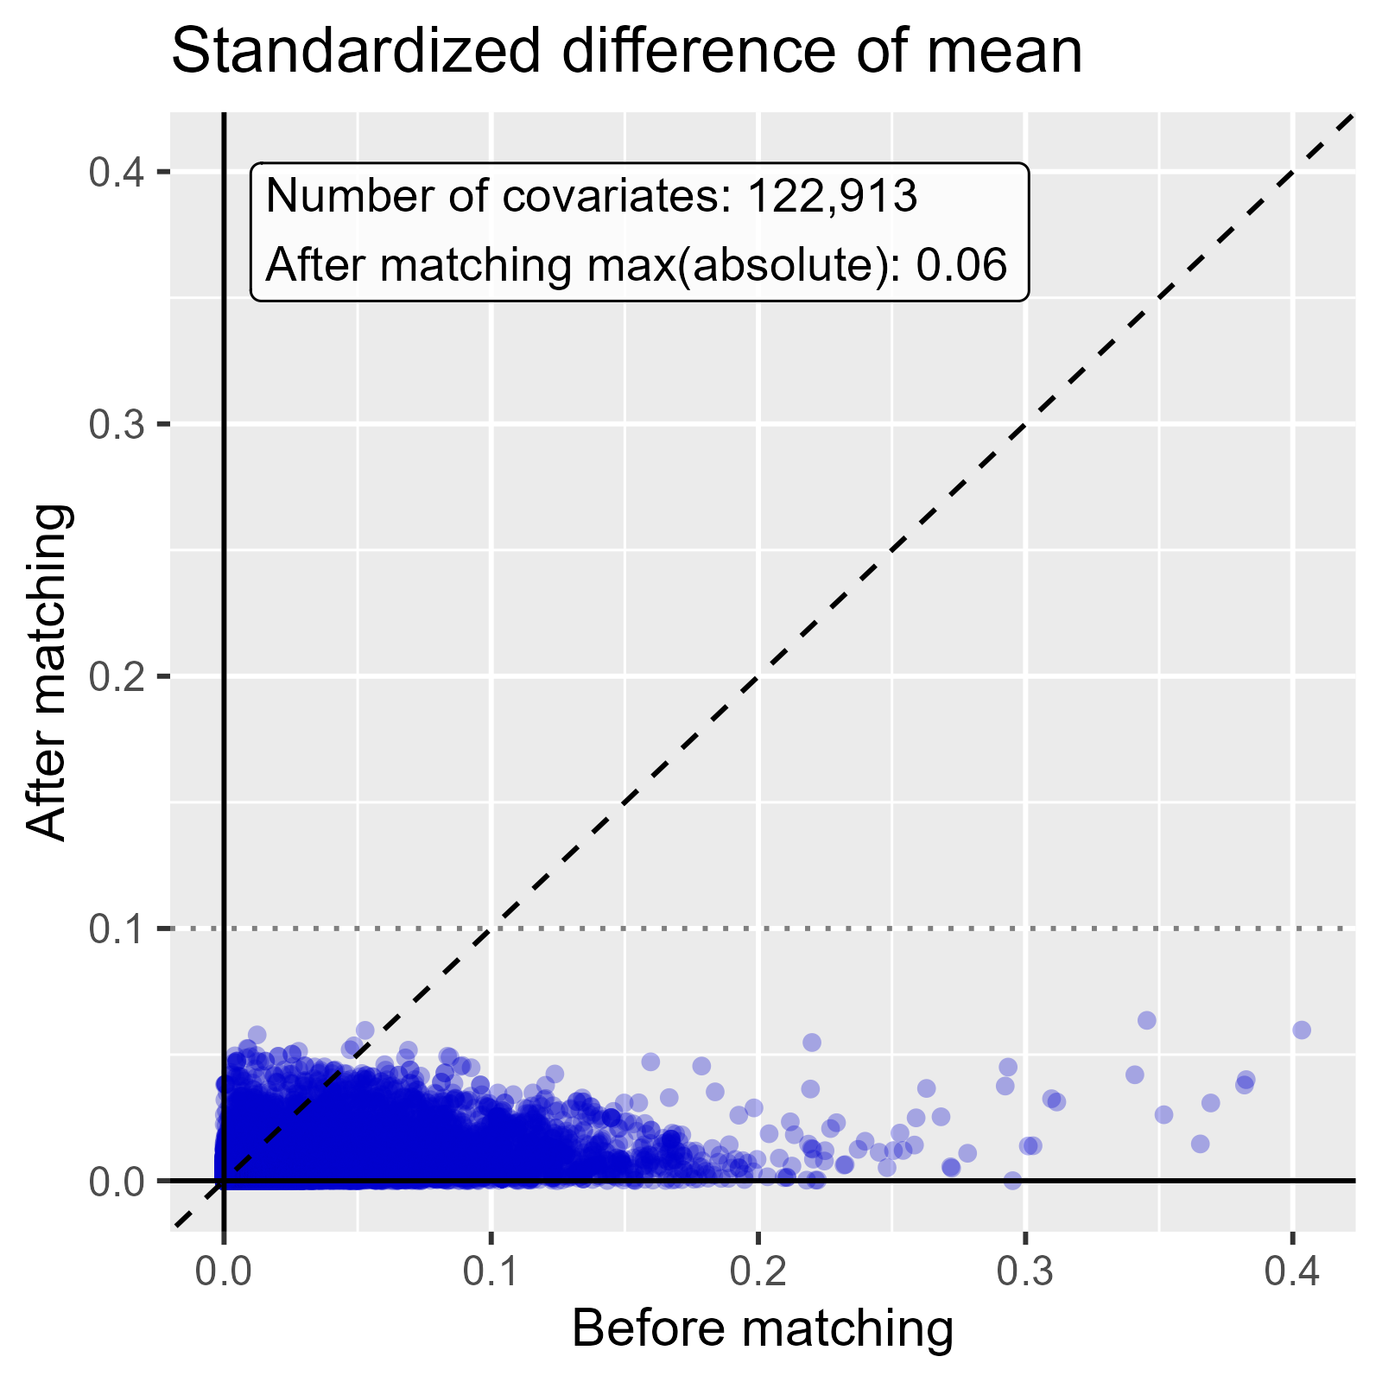

Standardized difference of mean comparing DOACs to Warfarin in OptumEhr.

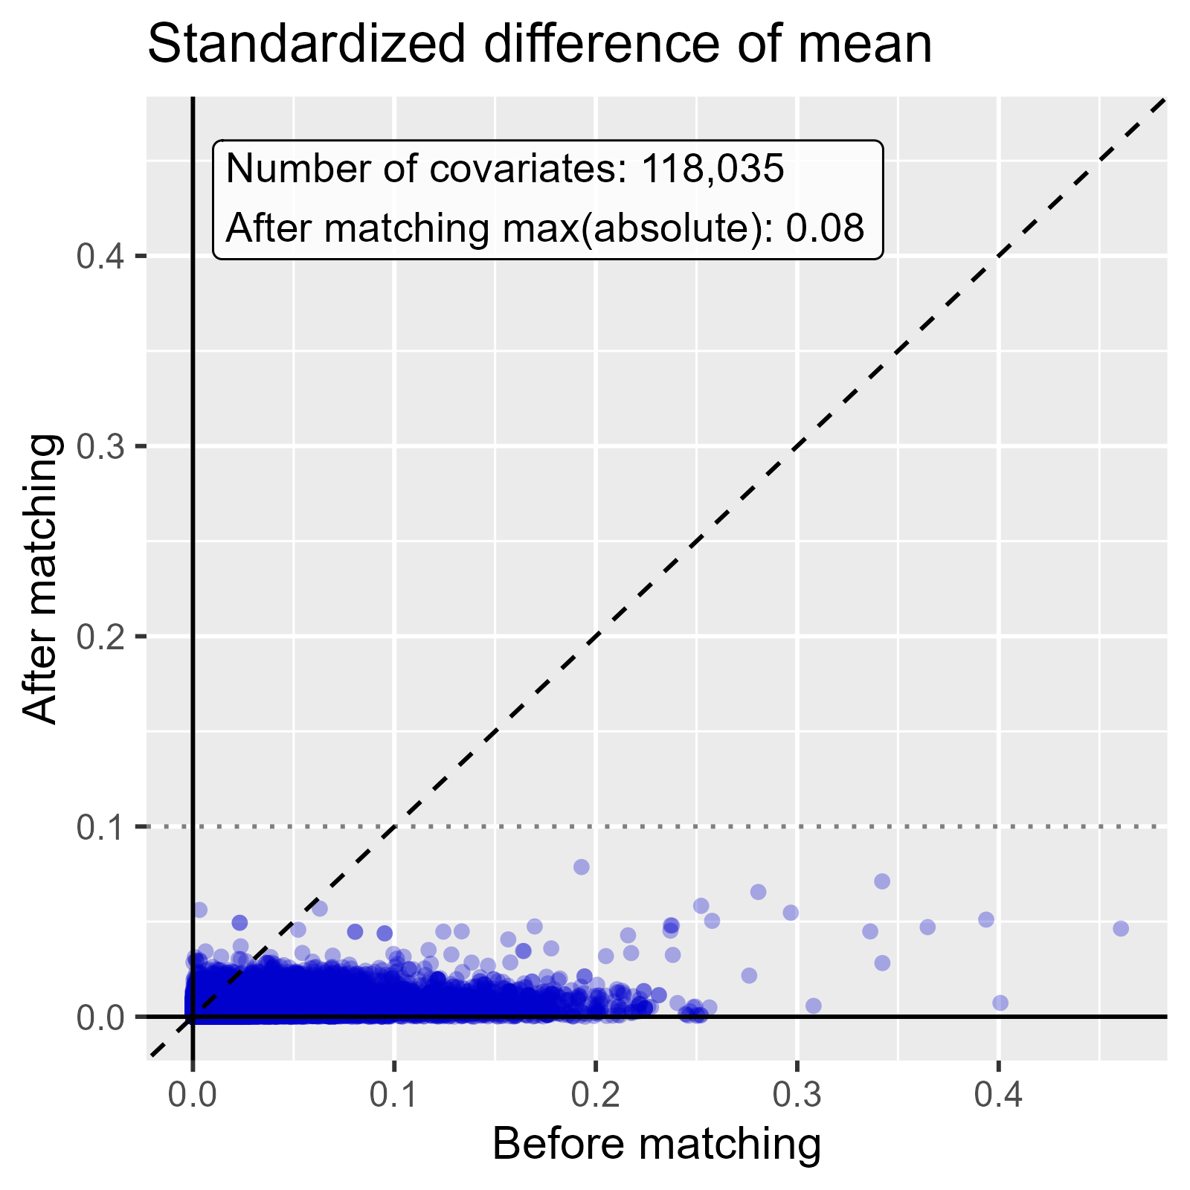

Standardized difference of mean comparing Rivaroxaban to Warfarin in OptumEhr.

### 2.0.4 PharMetrics

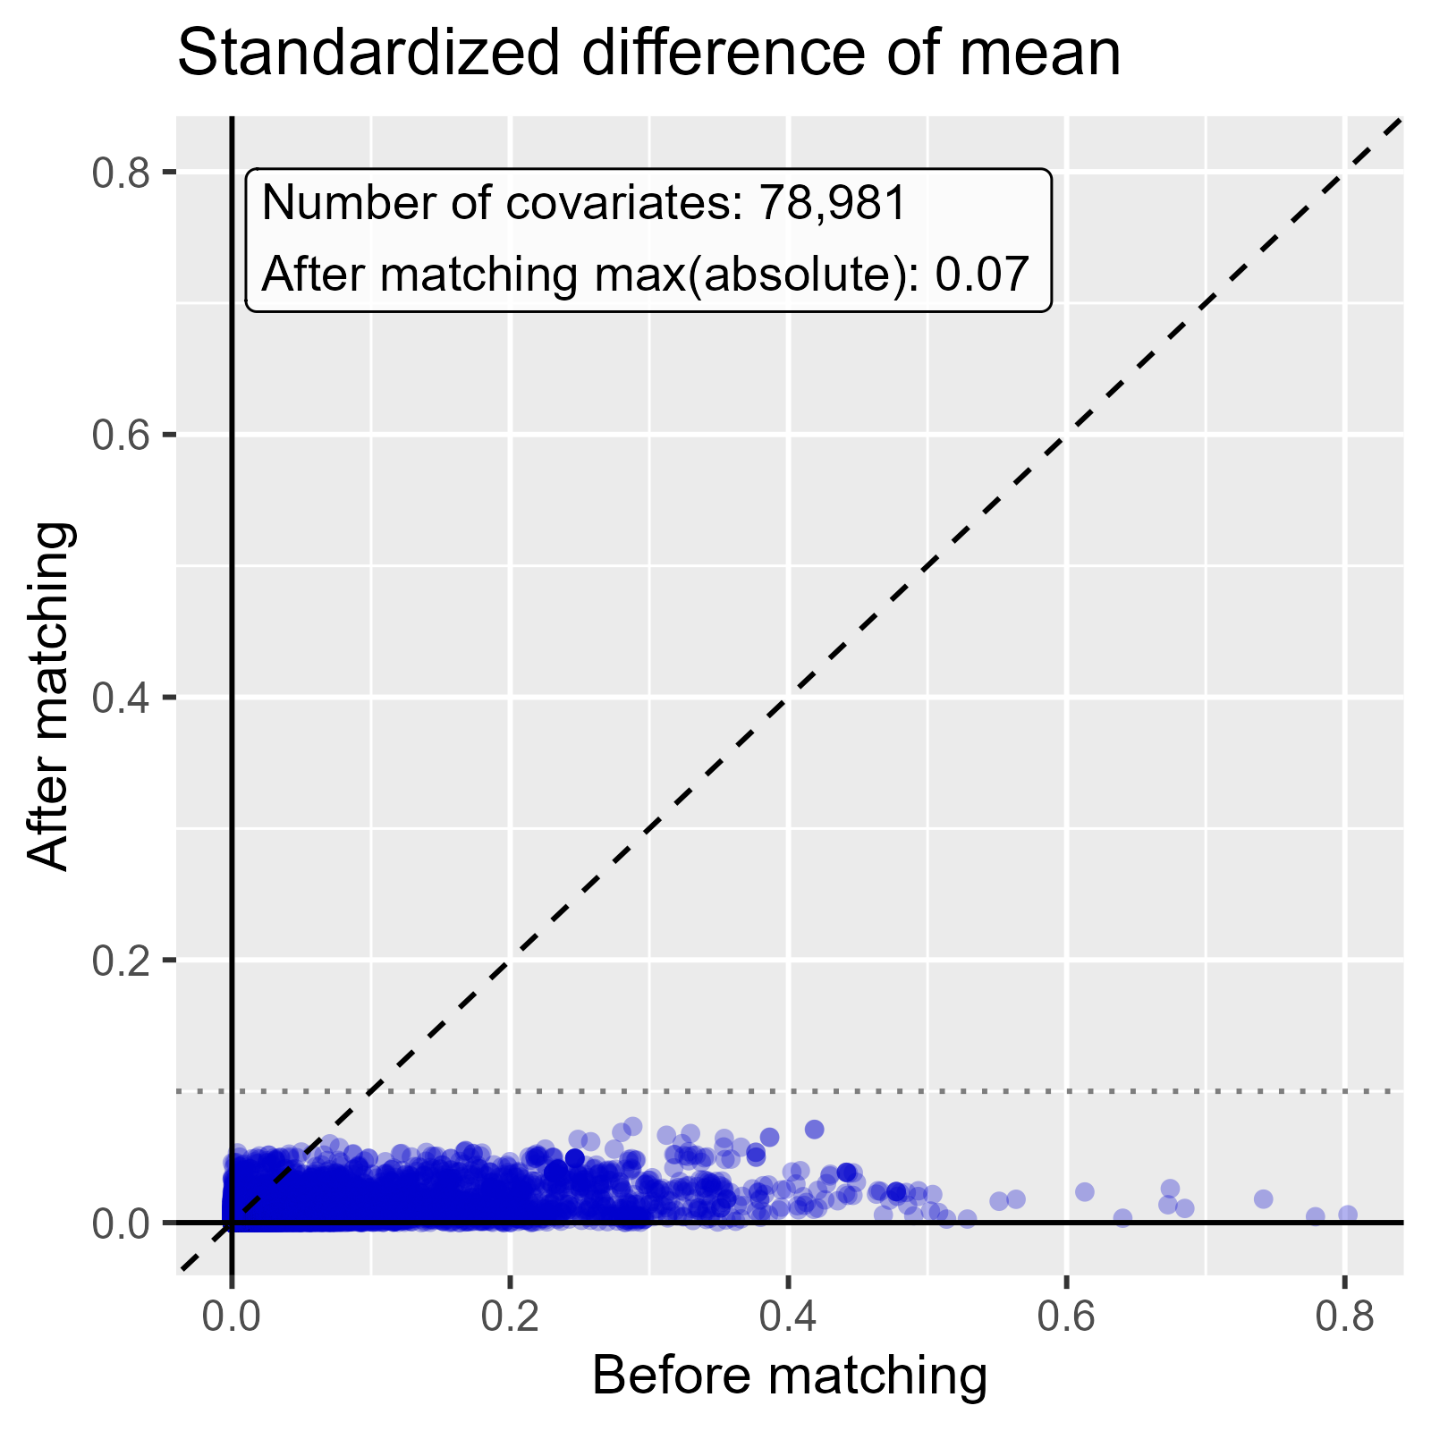

Standardized difference of mean comparing DOACs to Warfarin in PharMetrics.

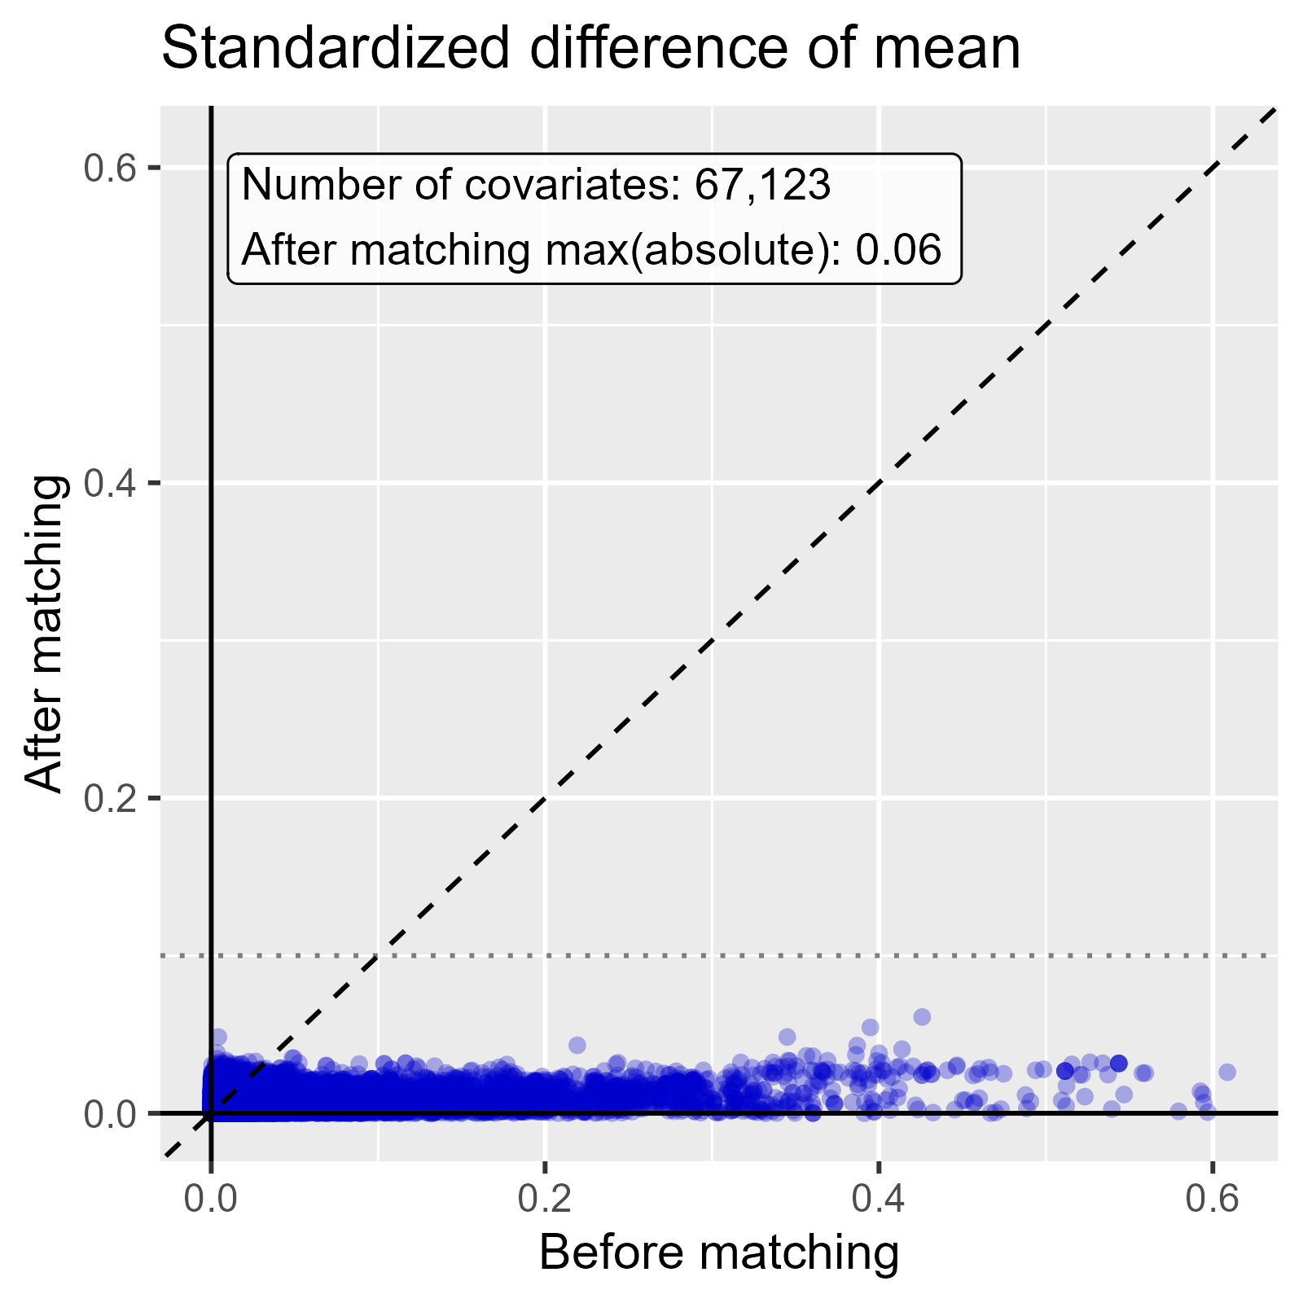

Standardized difference of mean comparing Rivaroxaban to Warfarin in PharMetrics.

### 2.0.5 MDCR

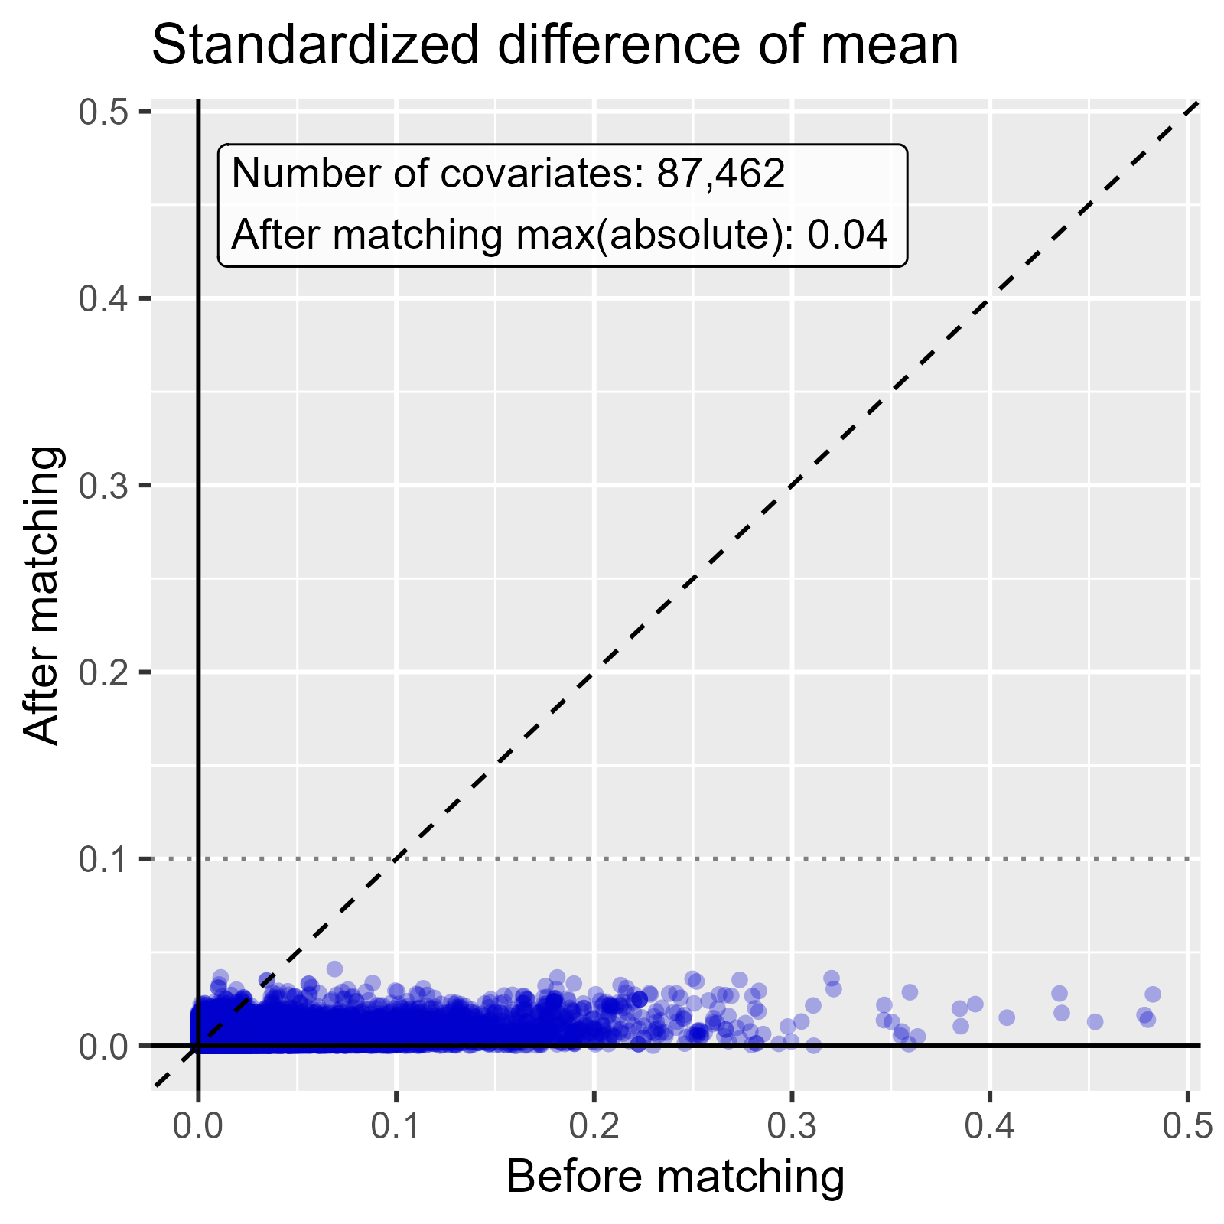

Standardized difference of mean comparing DOACs to Warfarin in MDCR.

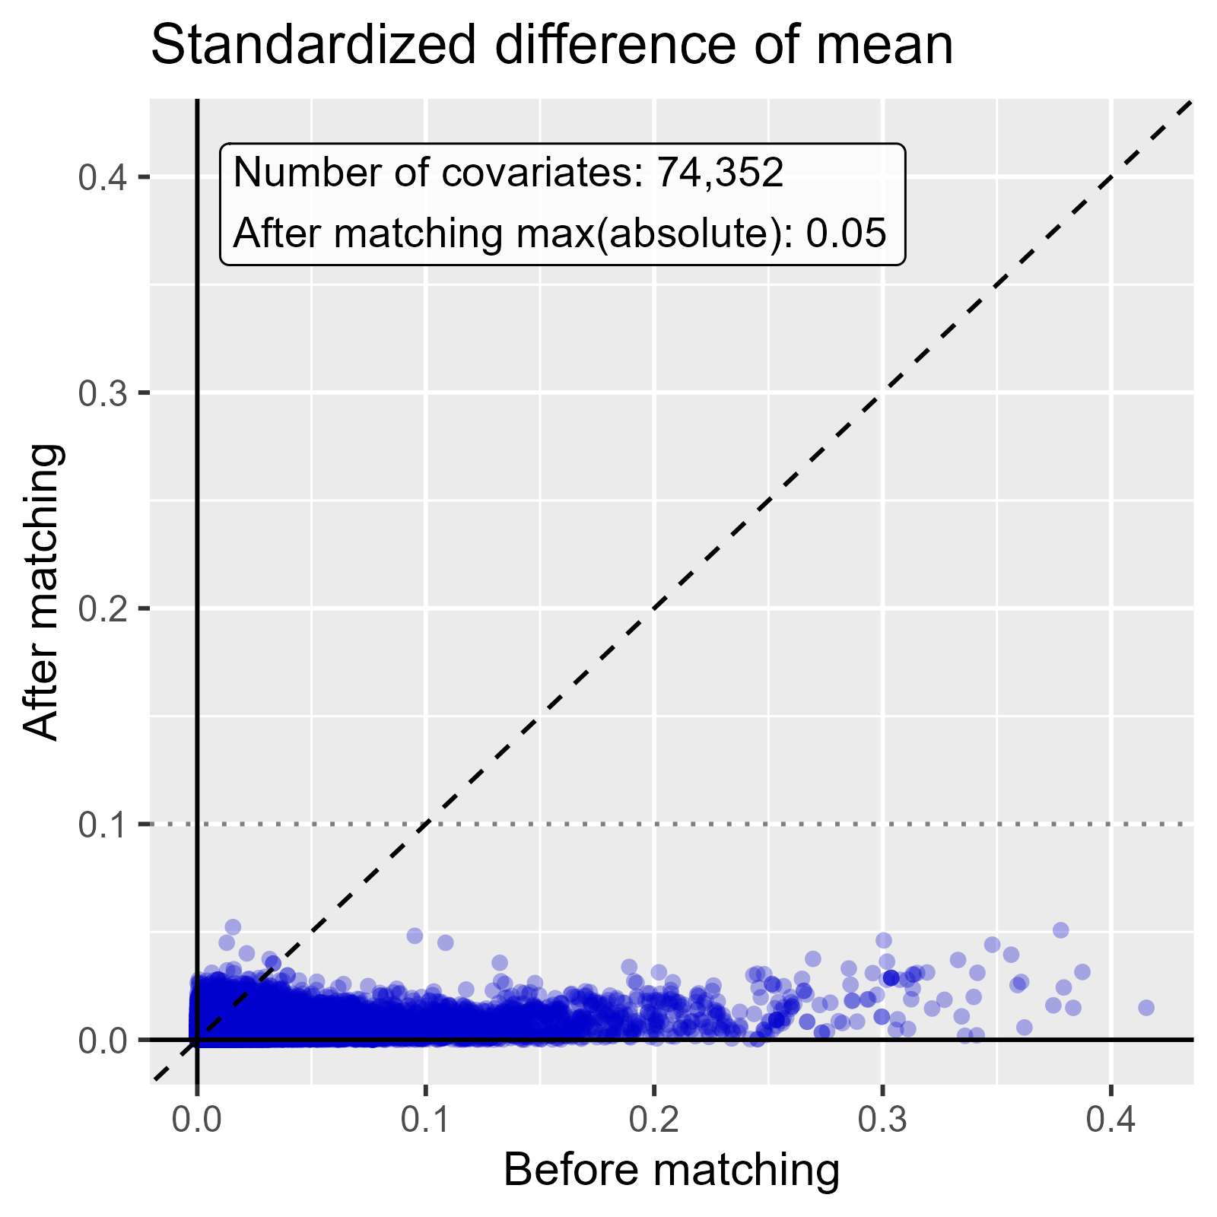

Standardized difference of mean comparing Rivaroxaban to Warfarin in MDCR.

# 3 Minimum detectable relative risk and follow-up time

## 3.1 Minimum detectable relative risk

Table 3.1: Overview of minimum detectable relative risk (MDRR) per database, comparison, and outcome.

| Database | Target | Comparator | Outcome | Target subjects | Comparator subjects | Total outcomes | MDRR |
| --- | --- | --- | --- | --- | --- | --- | --- |
| CCAE | DOACs | Warfarin | AMI | 22,025 | 32,335 | 634 | 1.25 |
| CCAE | DOACs | Warfarin | Ischemic stroke | 22,182 | 32,986 | 532 | 1.28 |
| CCAE | DOACs | Warfarin | Composite | 20,744 | 30,081 | 989 | 1.20 |
| CCAE | Rivaroxaban | Warfarin | AMI | 15,053 | 28,126 | 526 | 1.29 |
| CCAE | Rivaroxaban | Warfarin | Ischemic stroke | 15,120 | 28,725 | 446 | 1.32 |
| CCAE | Rivaroxaban | Warfarin | Composite | 14,220 | 26,116 | 808 | 1.23 |
| OptumDod | DOACs | Warfarin | AMI | 76,373 | 105,169 | 4,775 | 1.09 |
| OptumDod | DOACs | Warfarin | Ischemic stroke | 76,134 | 105,579 | 4,656 | 1.09 |
| OptumDod | DOACs | Warfarin | Composite | 70,206 | 95,531 | 7,968 | 1.07 |
| OptumDod | Rivaroxaban | Warfarin | AMI | 56,171 | 100,549 | 4,148 | 1.09 |
| OptumDod | Rivaroxaban | Warfarin | Ischemic stroke | 55,715 | 100,755 | 3,984 | 1.10 |
| OptumDod | Rivaroxaban | Warfarin | Composite | 52,085 | 91,126 | 6,877 | 1.07 |
| OptumEhr | DOACs | Warfarin | AMI | 210,874 | 370,657 | 18,036 | 1.04 |
| OptumEhr | DOACs | Warfarin | Ischemic stroke | 211,897 | 374,503 | 16,426 | 1.05 |
| OptumEhr | DOACs | Warfarin | Composite | 203,464 | 358,980 | 31,485 | 1.03 |
| OptumEhr | Rivaroxaban | Warfarin | AMI | 155,890 | 372,100 | 16,683 | 1.05 |
| OptumEhr | Rivaroxaban | Warfarin | Ischemic stroke | 156,577 | 376,897 | 15,156 | 1.05 |
| OptumEhr | Rivaroxaban | Warfarin | Composite | 150,696 | 359,545 | 28,982 | 1.04 |
| PharMetrics | DOACs | Warfarin | AMI | 26,930 | 33,632 | 1,217 | 1.18 |
| PharMetrics | DOACs | Warfarin | Ischemic stroke | 27,550 | 34,805 | 933 | 1.20 |
| PharMetrics | DOACs | Warfarin | Composite | 25,051 | 31,323 | 1,832 | 1.14 |
| PharMetrics | Rivaroxaban | Warfarin | AMI | 21,298 | 36,857 | 1,076 | 1.19 |
| PharMetrics | Rivaroxaban | Warfarin | Ischemic stroke | 21,437 | 38,072 | 835 | 1.22 |
| PharMetrics | Rivaroxaban | Warfarin | Composite | 19,988 | 34,340 | 1,637 | 1.15 |
| MDCR | DOACs | Warfarin | AMI | 42,182 | 59,381 | 2,355 | 1.12 |
| MDCR | DOACs | Warfarin | Ischemic stroke | 41,367 | 58,971 | 2,413 | 1.12 |
| MDCR | DOACs | Warfarin | Composite | 38,398 | 53,530 | 4,060 | 1.09 |
| MDCR | Rivaroxaban | Warfarin | AMI | 28,377 | 50,112 | 1,878 | 1.14 |
| MDCR | Rivaroxaban | Warfarin | Ischemic stroke | 27,735 | 49,718 | 1,886 | 1.14 |
| MDCR | Rivaroxaban | Warfarin | Composite | 25,969 | 45,091 | 3,183 | 1.11 |

## 3.2 Follow-up time in the target cohort

Table 3.2: Overview of follow-up time in days in the target cohort per database, comparison, and outcome.

| Database | Target | Comparator | Outcome | p10 | p25 | Median | p75 | p90 |
| --- | --- | --- | --- | --- | --- | --- | --- | --- |
| CCAE | DOACs | Warfarin | AMI | 60.0 | 60 | 153 | 356 | 706.0 |
| CCAE | DOACs | Warfarin | Ischemic stroke | 60.0 | 60 | 151 | 353 | 699.0 |
| CCAE | DOACs | Warfarin | Composite | 58.0 | 60 | 150 | 351 | 696.0 |
| CCAE | Rivaroxaban | Warfarin | AMI | 54.0 | 60 | 151 | 339 | 688.0 |
| CCAE | Rivaroxaban | Warfarin | Ischemic stroke | 55.0 | 60 | 150 | 337 | 683.0 |
| CCAE | Rivaroxaban | Warfarin | Composite | 53.0 | 60 | 149 | 336 | 681.0 |
| OptumDod | DOACs | Warfarin | AMI | 60.0 | 81 | 191 | 439 | 847.0 |
| OptumDod | DOACs | Warfarin | Ischemic stroke | 60.0 | 78 | 187 | 430 | 833.0 |
| OptumDod | DOACs | Warfarin | Composite | 59.0 | 77 | 188 | 432 | 836.0 |
| OptumDod | Rivaroxaban | Warfarin | AMI | 60.0 | 67 | 177 | 416 | 850.0 |
| OptumDod | Rivaroxaban | Warfarin | Ischemic stroke | 60.0 | 65 | 173 | 410 | 843.0 |
| OptumDod | Rivaroxaban | Warfarin | Composite | 58.0 | 65 | 174 | 411 | 842.0 |
| OptumEhr | DOACs | Warfarin | AMI | 43.0 | 60 | 73 | 120 | 213.0 |
| OptumEhr | DOACs | Warfarin | Ischemic stroke | 45.0 | 60 | 74 | 120 | 215.0 |
| OptumEhr | DOACs | Warfarin | Composite | 34.0 | 60 | 72 | 118 | 210.0 |
| OptumEhr | Rivaroxaban | Warfarin | AMI | 57.0 | 60 | 63 | 107 | 179.0 |
| OptumEhr | Rivaroxaban | Warfarin | Ischemic stroke | 60.0 | 60 | 64 | 107 | 179.0 |
| OptumEhr | Rivaroxaban | Warfarin | Composite | 47.0 | 60 | 63 | 105 | 177.0 |
| PharMetrics | DOACs | Warfarin | AMI | 56.0 | 71 | 174 | 405 | 811.0 |
| PharMetrics | DOACs | Warfarin | Ischemic stroke | 57.0 | 70 | 172 | 400 | 801.0 |
| PharMetrics | DOACs | Warfarin | Composite | 55.0 | 68 | 171 | 399 | 800.0 |
| PharMetrics | Rivaroxaban | Warfarin | AMI | 56.0 | 60 | 153 | 372 | 793.0 |
| PharMetrics | Rivaroxaban | Warfarin | Ischemic stroke | 56.0 | 60 | 152 | 370 | 788.0 |
| PharMetrics | Rivaroxaban | Warfarin | Composite | 54.0 | 60 | 152 | 368 | 785.9 |
| MDCR | DOACs | Warfarin | AMI | 44.0 | 70 | 187 | 454 | 865.0 |
| MDCR | DOACs | Warfarin | Ischemic stroke | 43.0 | 67 | 183 | 446 | 853.0 |
| MDCR | DOACs | Warfarin | Composite | 42.0 | 67 | 184 | 449 | 857.0 |
| MDCR | Rivaroxaban | Warfarin | AMI | 43.0 | 60 | 177 | 431 | 847.0 |
| MDCR | Rivaroxaban | Warfarin | Ischemic stroke | 42.7 | 60 | 173 | 424 | 841.0 |
| MDCR | Rivaroxaban | Warfarin | Composite | 42.0 | 60 | 173 | 425 | 839.0 |

## 3.3 Follow-up time in the comparator cohort

Table 3.3: Overview of follow-up time in days in the comparator cohort per database, comparison, and outcome.

| Database | Target | Comparator | Outcome | p10 | p25 | Median | p75 | p90 |
| --- | --- | --- | --- | --- | --- | --- | --- | --- |
| CCAE | DOACs | Warfarin | AMI | 40 | 60 | 120 | 250 | 493.0 |
| CCAE | DOACs | Warfarin | Ischemic stroke | 41 | 60 | 120 | 246 | 483.0 |
| CCAE | DOACs | Warfarin | Composite | 40 | 60 | 120 | 243 | 481.0 |
| CCAE | Rivaroxaban | Warfarin | AMI | 47 | 60 | 122 | 251 | 492.0 |
| CCAE | Rivaroxaban | Warfarin | Ischemic stroke | 48 | 60 | 121 | 247 | 482.0 |
| CCAE | Rivaroxaban | Warfarin | Composite | 45 | 60 | 120 | 244 | 479.0 |
| OptumDod | DOACs | Warfarin | AMI | 47 | 70 | 152 | 356 | 713.0 |
| OptumDod | DOACs | Warfarin | Ischemic stroke | 46 | 68 | 149 | 347 | 701.0 |
| OptumDod | DOACs | Warfarin | Composite | 45 | 67 | 149 | 350 | 705.0 |
| OptumDod | Rivaroxaban | Warfarin | AMI | 57 | 75 | 154 | 357 | 711.0 |
| OptumDod | Rivaroxaban | Warfarin | Ischemic stroke | 57 | 74 | 151 | 349 | 697.0 |
| OptumDod | Rivaroxaban | Warfarin | Composite | 54 | 73 | 151 | 351 | 702.0 |
| OptumEhr | DOACs | Warfarin | AMI | 41 | 89 | 122 | 201 | 397.0 |
| OptumEhr | DOACs | Warfarin | Ischemic stroke | 42 | 91 | 122 | 202 | 399.0 |
| OptumEhr | DOACs | Warfarin | Composite | 27 | 75 | 121 | 196 | 389.0 |
| OptumEhr | Rivaroxaban | Warfarin | AMI | 60 | 105 | 123 | 205 | 408.0 |
| OptumEhr | Rivaroxaban | Warfarin | Ischemic stroke | 60 | 108 | 123 | 207 | 411.0 |
| OptumEhr | Rivaroxaban | Warfarin | Composite | 40 | 87 | 122 | 201 | 400.0 |
| PharMetrics | DOACs | Warfarin | AMI | 40 | 63 | 135 | 306 | 622.4 |
| PharMetrics | DOACs | Warfarin | Ischemic stroke | 40 | 62 | 134 | 302 | 614.0 |
| PharMetrics | DOACs | Warfarin | Composite | 38 | 61 | 133 | 302 | 618.0 |
| PharMetrics | Rivaroxaban | Warfarin | AMI | 50 | 70 | 138 | 306 | 622.0 |
| PharMetrics | Rivaroxaban | Warfarin | Ischemic stroke | 50 | 69 | 137 | 302 | 613.0 |
| PharMetrics | Rivaroxaban | Warfarin | Composite | 48 | 68 | 136 | 303 | 617.0 |
| MDCR | DOACs | Warfarin | AMI | 42 | 60 | 137 | 299 | 577.8 |
| MDCR | DOACs | Warfarin | Ischemic stroke | 43 | 60 | 134 | 291 | 569.0 |
| MDCR | DOACs | Warfarin | Composite | 40 | 60 | 133 | 291 | 568.0 |
| MDCR | Rivaroxaban | Warfarin | AMI | 45 | 60 | 136 | 297 | 574.2 |
| MDCR | Rivaroxaban | Warfarin | Ischemic stroke | 45 | 60 | 133 | 290 | 566.0 |
| MDCR | Rivaroxaban | Warfarin | Composite | 44 | 60 | 132 | 289 | 565.0 |

# 4 Mediator risk score distribution

### 4.0.1 CCAE

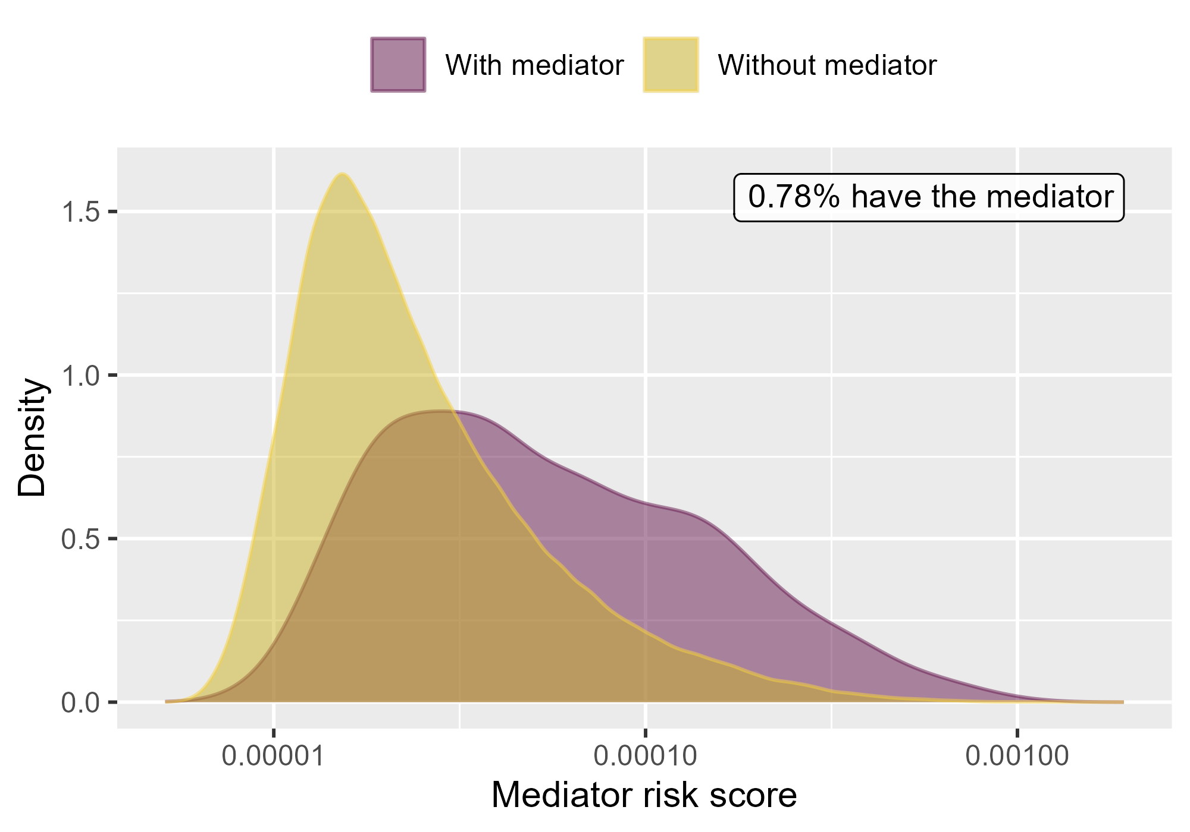

Mediator risk score by mediator status when comparing DOACs to Warfarin using mediator Extracranial Major bleeding IP-ER in CCAE.

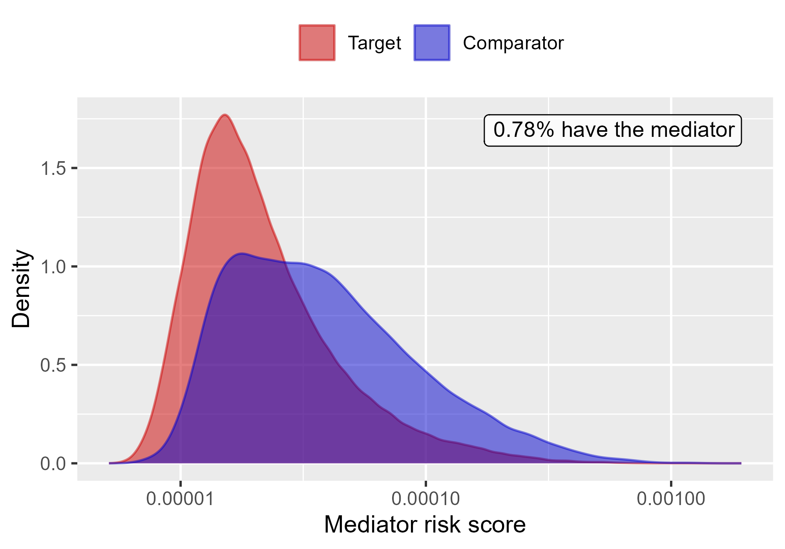

Mediator risk score by exposure status when comparing DOACs to Warfarin using mediator Extracranial Major bleeding IP-ER in CCAE.

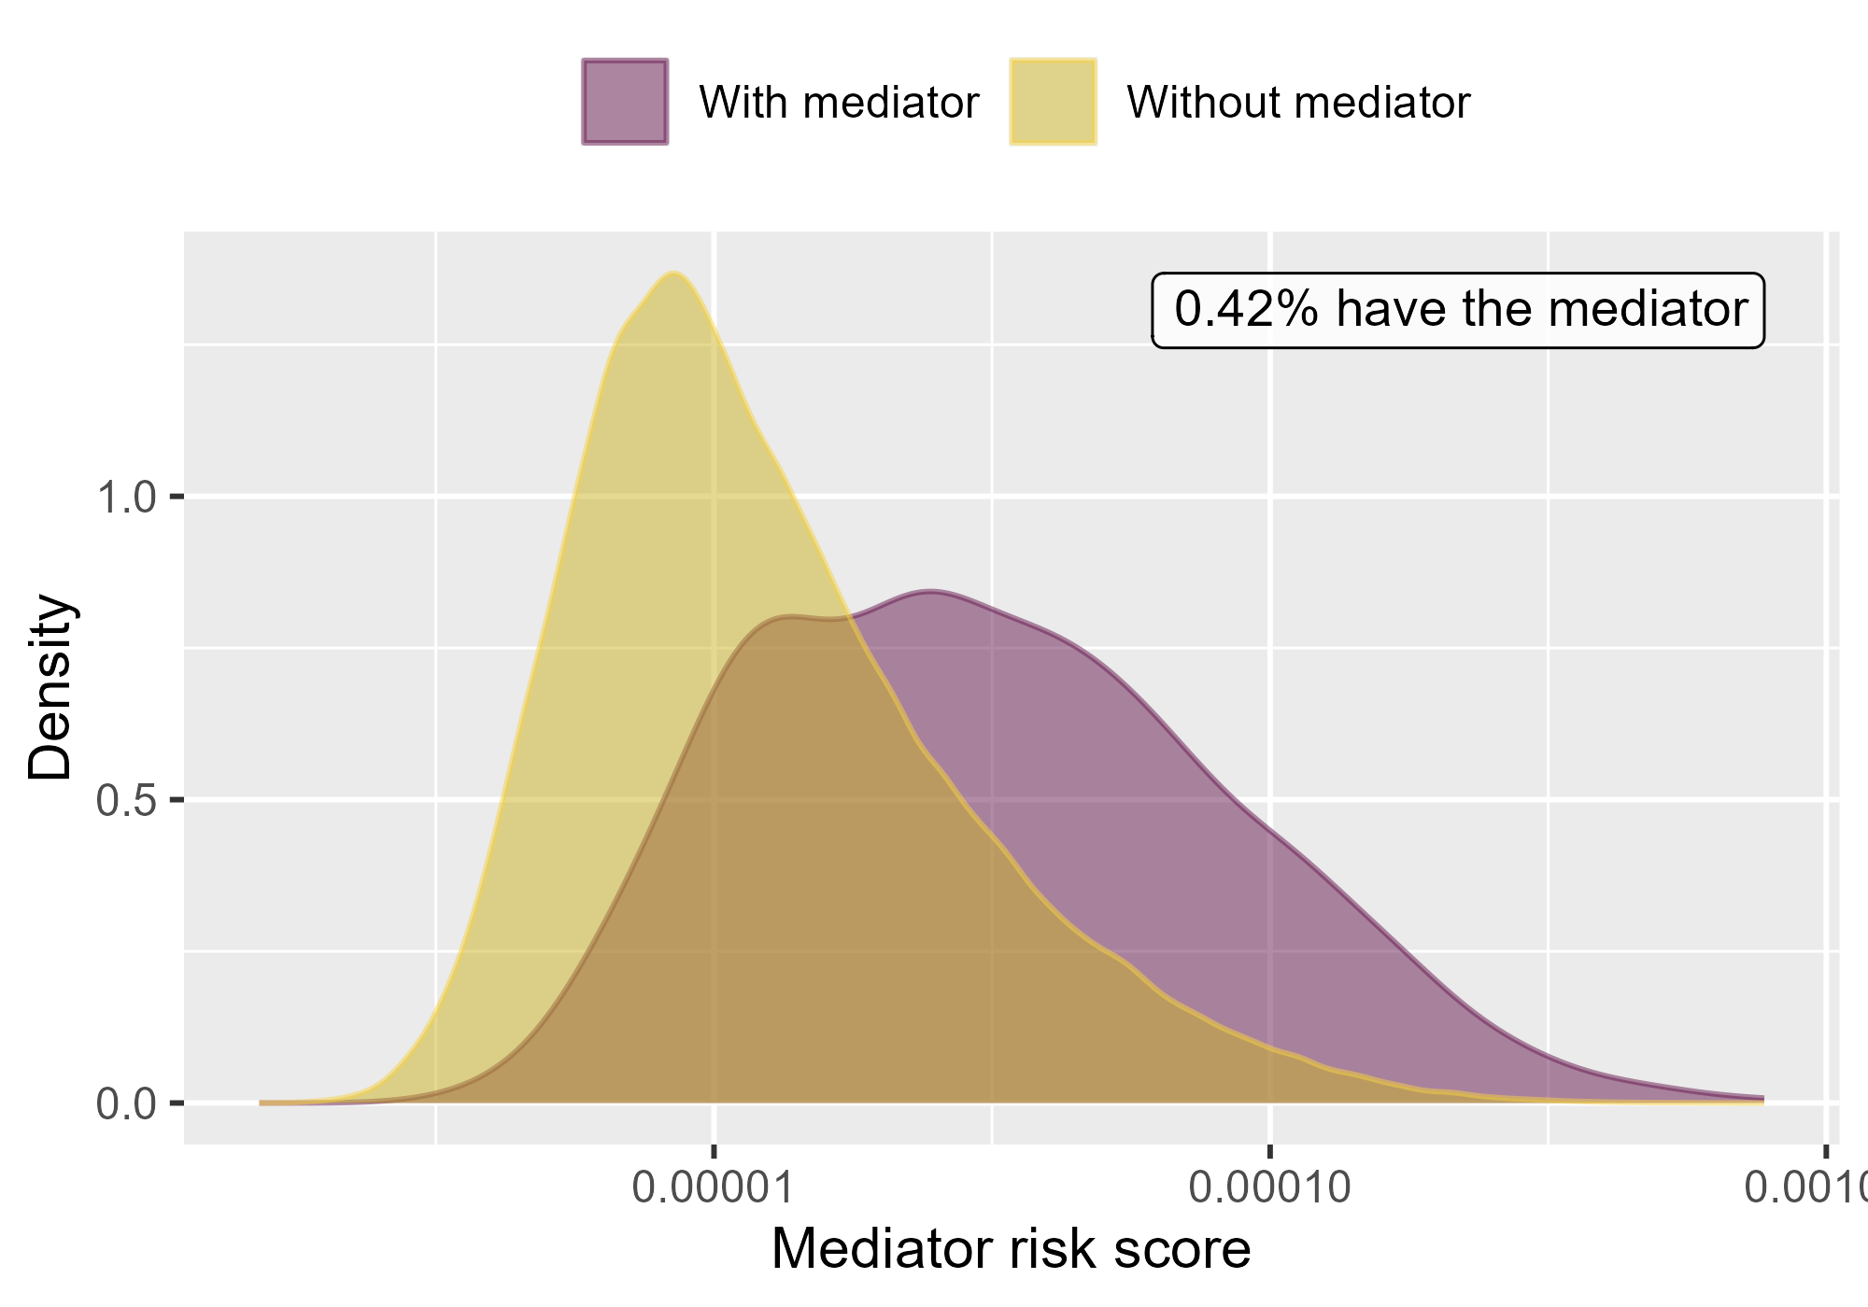

Mediator risk score by mediator status when comparing DOACs to Warfarin using mediator Extracranial Major bleeding IP in CCAE.

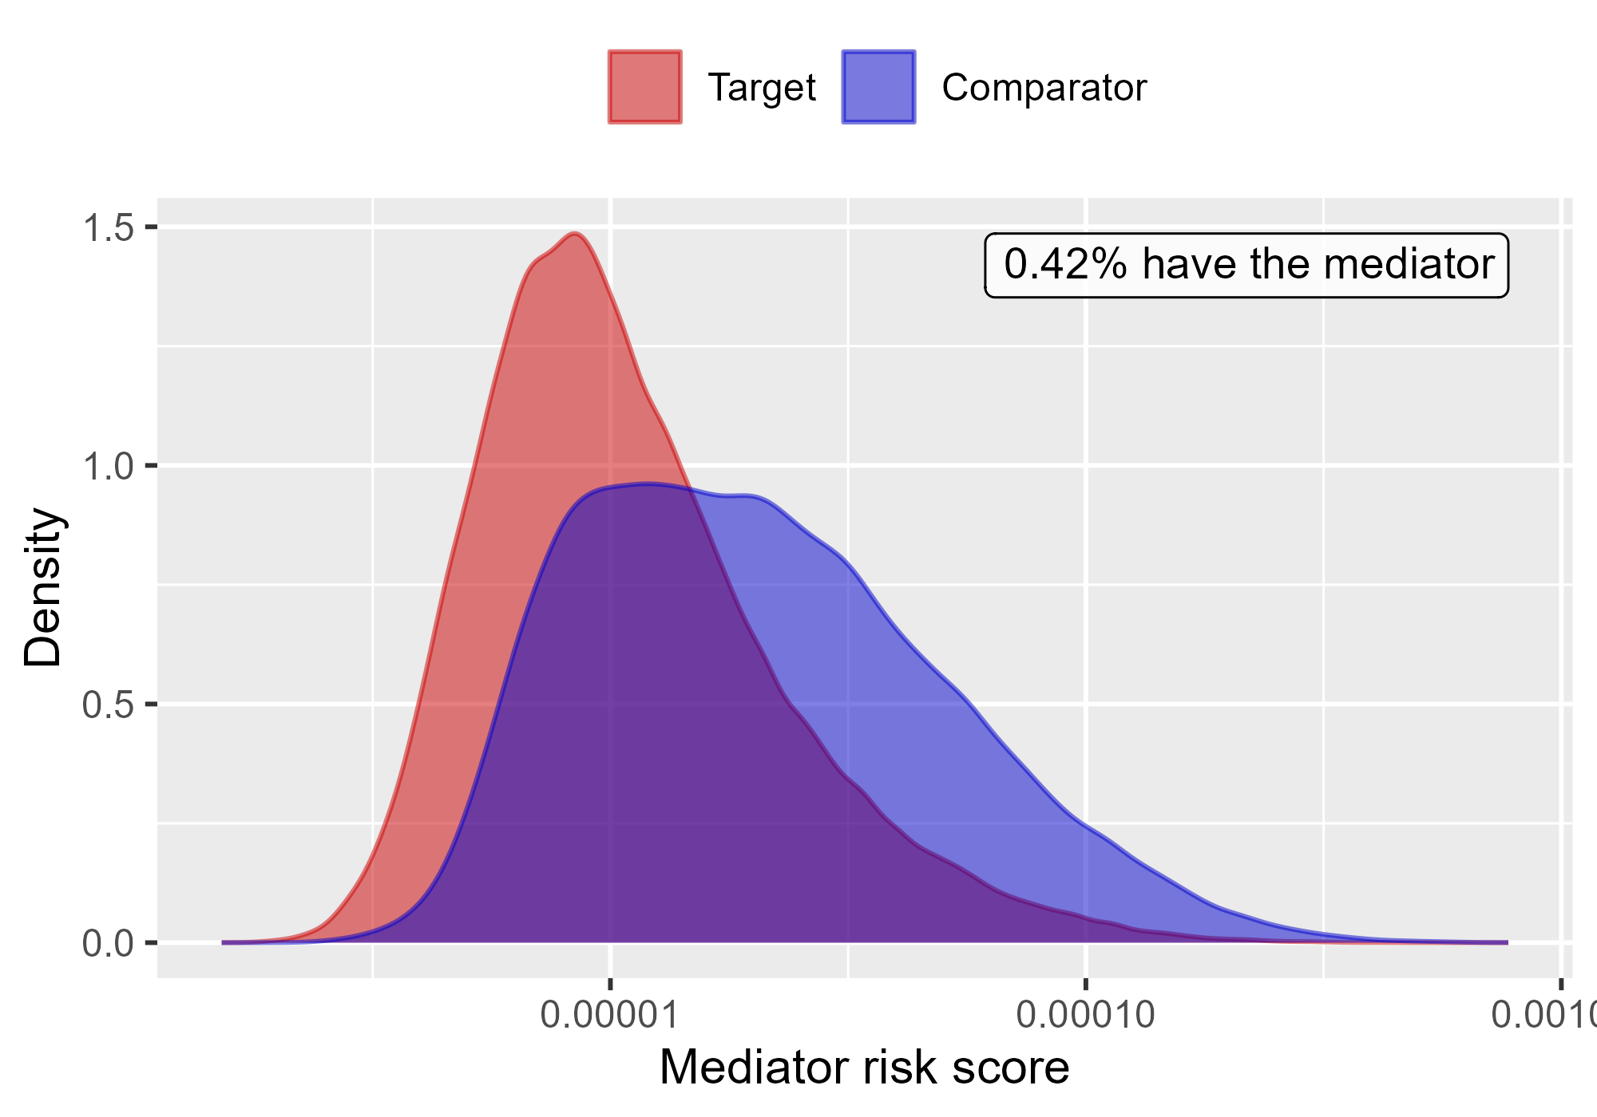

Mediator risk score by exposure status when comparing DOACs to Warfarin using mediator Extracranial Major bleeding IP in CCAE.

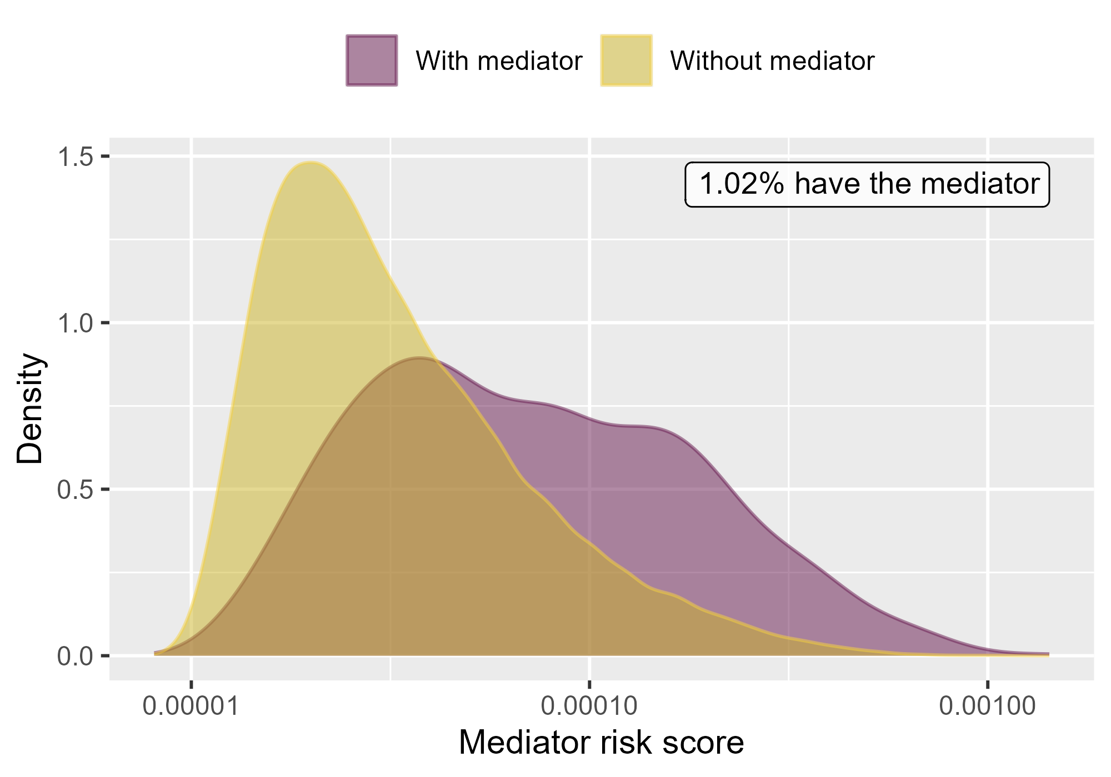

Mediator risk score by mediator status when comparing Rivaroxaban to Warfarin using mediator Extracranial Major bleeding IP-ER in CCAE.

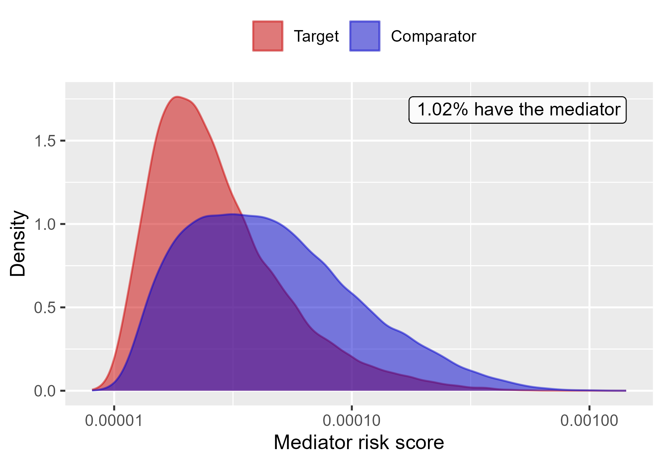

Mediator risk score by exposure status when comparing Rivaroxaban to Warfarin using mediator Extracranial Major bleeding IP-ER in CCAE.

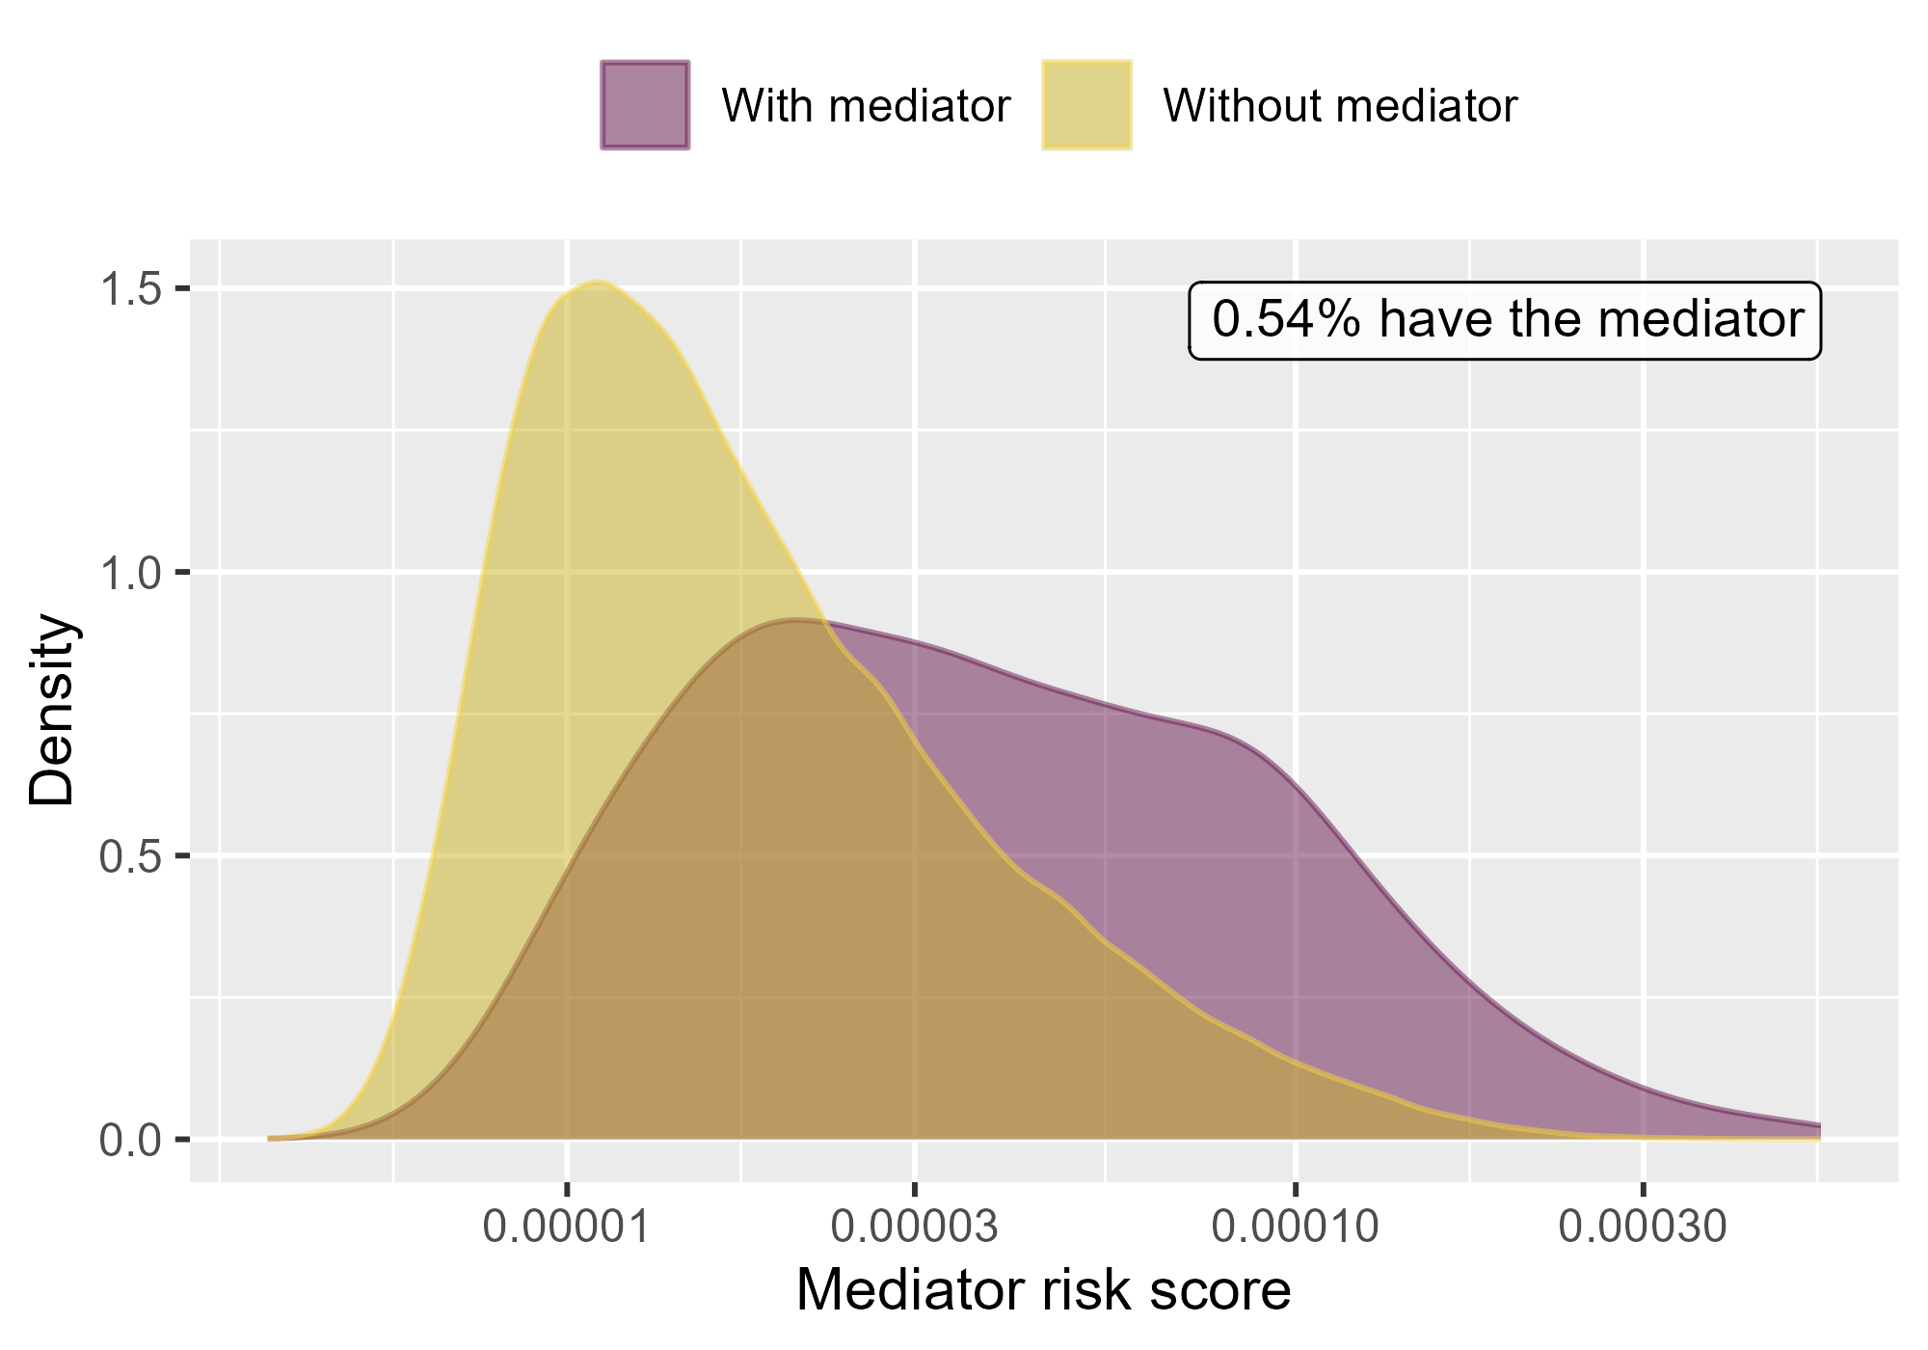

Mediator risk score by mediator status when comparing Rivaroxaban to Warfarin using mediator Extracranial Major bleeding IP in CCAE.

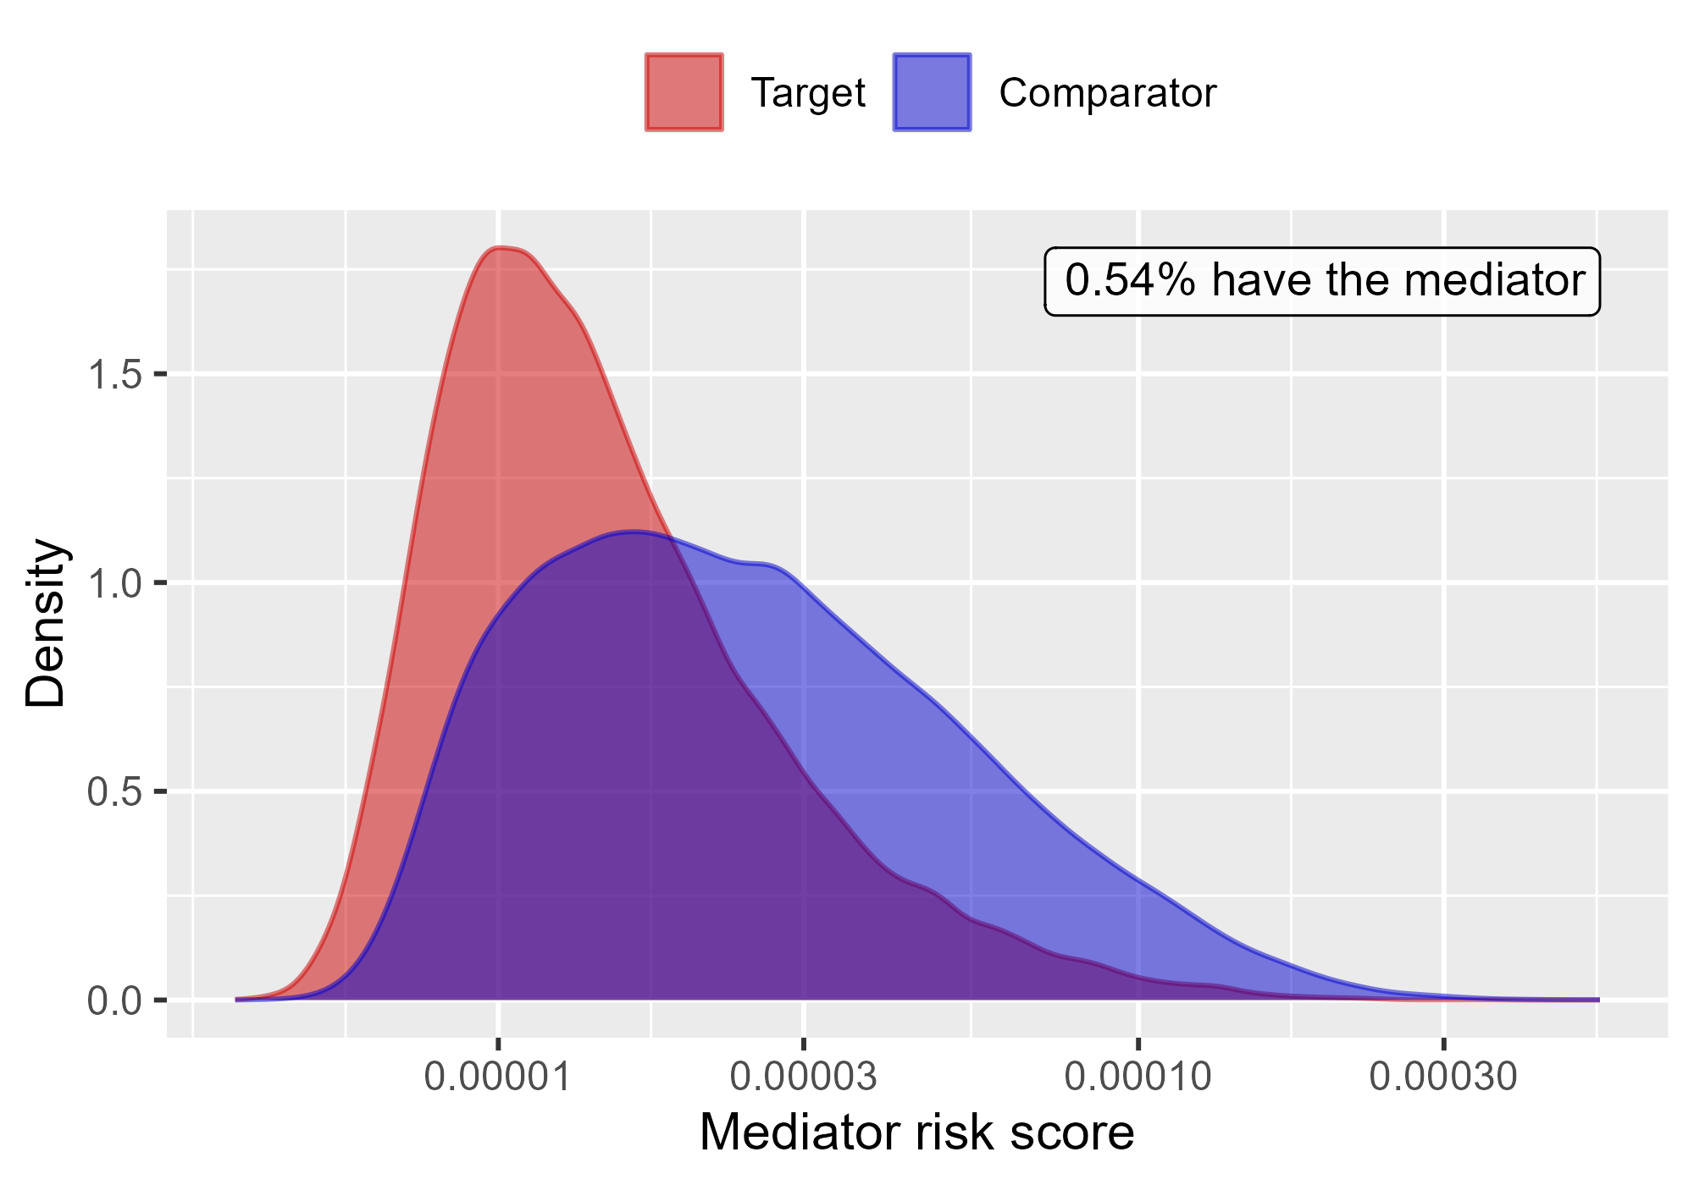

Mediator risk score by exposure status when comparing Rivaroxaban to Warfarin using mediator Extracranial Major bleeding IP in CCAE.

### 4.0.2 OptumDod

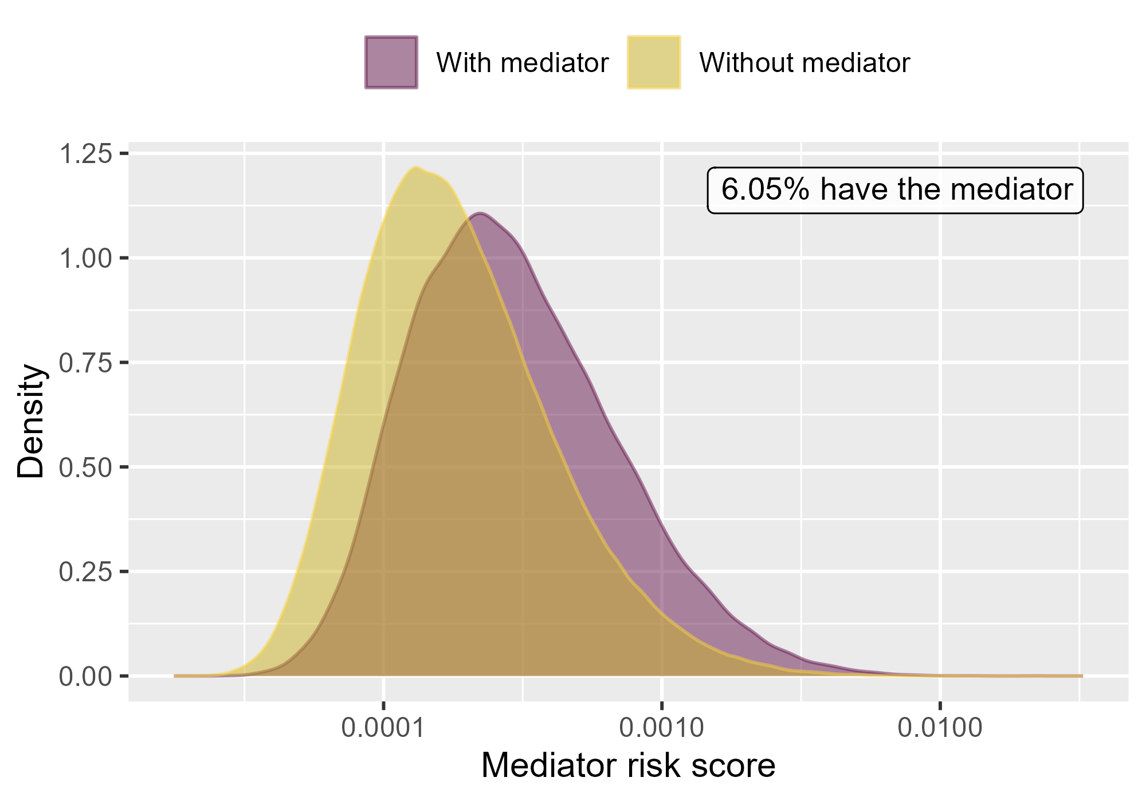

Mediator risk score by mediator status when comparing DOACs to Warfarin using mediator Extracranial Major bleeding IP-ER in OptumDod.

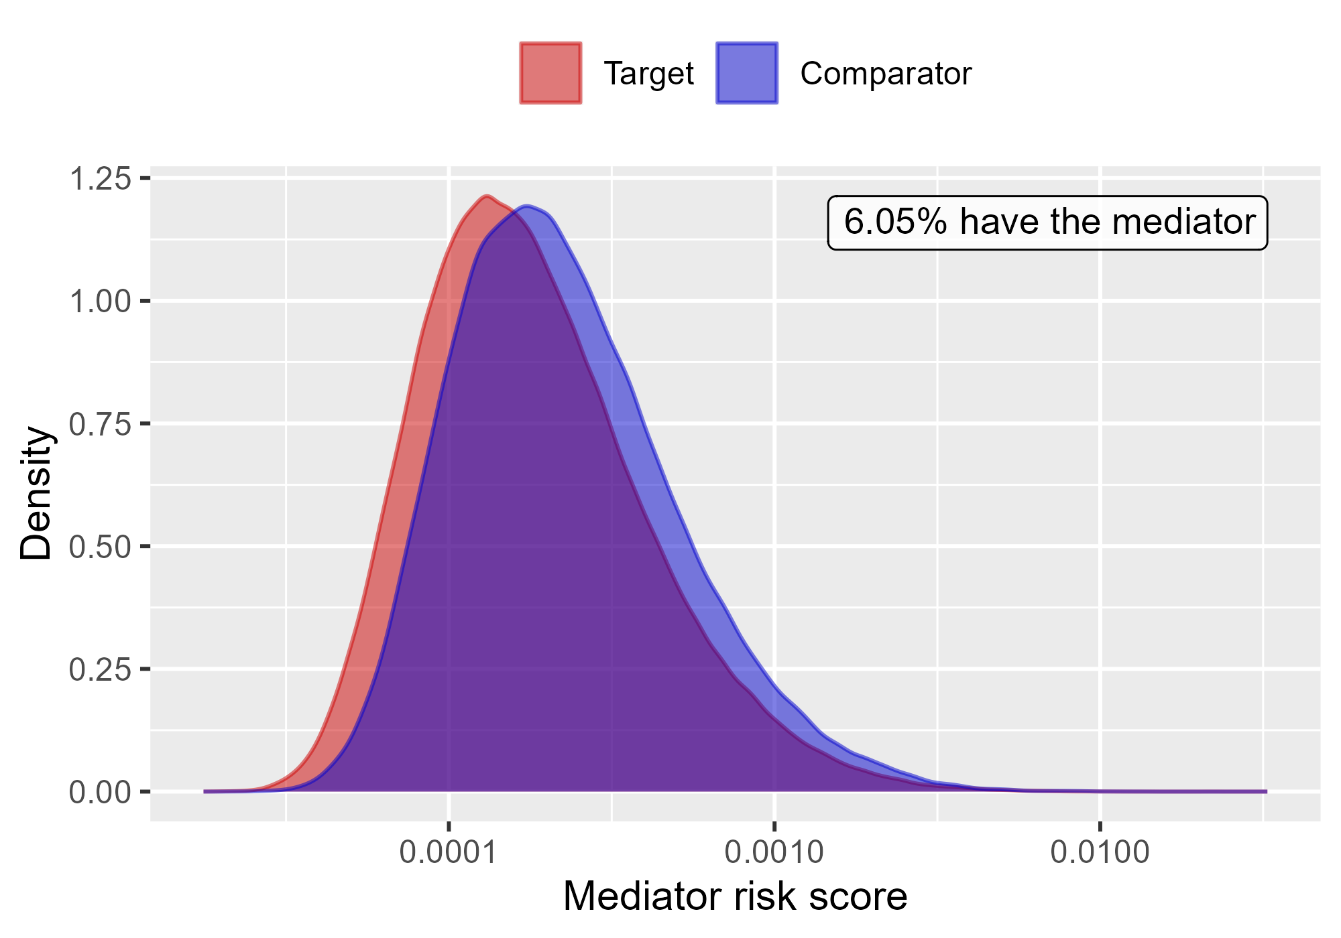

Mediator risk score by exposure status when comparing DOACs to Warfarin using mediator Extracranial Major bleeding IP-ER in OptumDod.

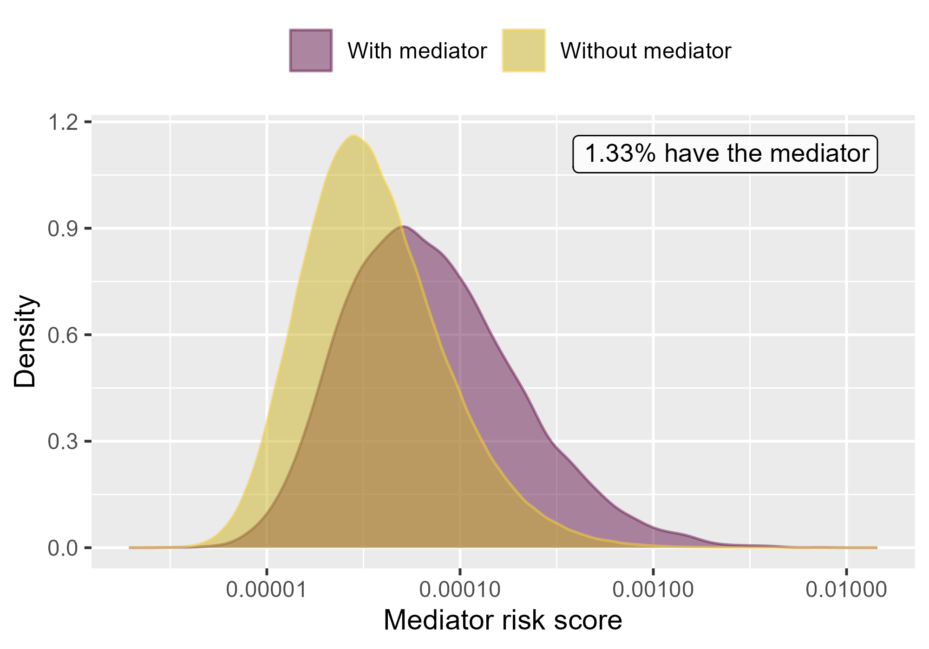

Mediator risk score by mediator status when comparing DOACs to Warfarin using mediator Extracranial Major bleeding IP in OptumDod.

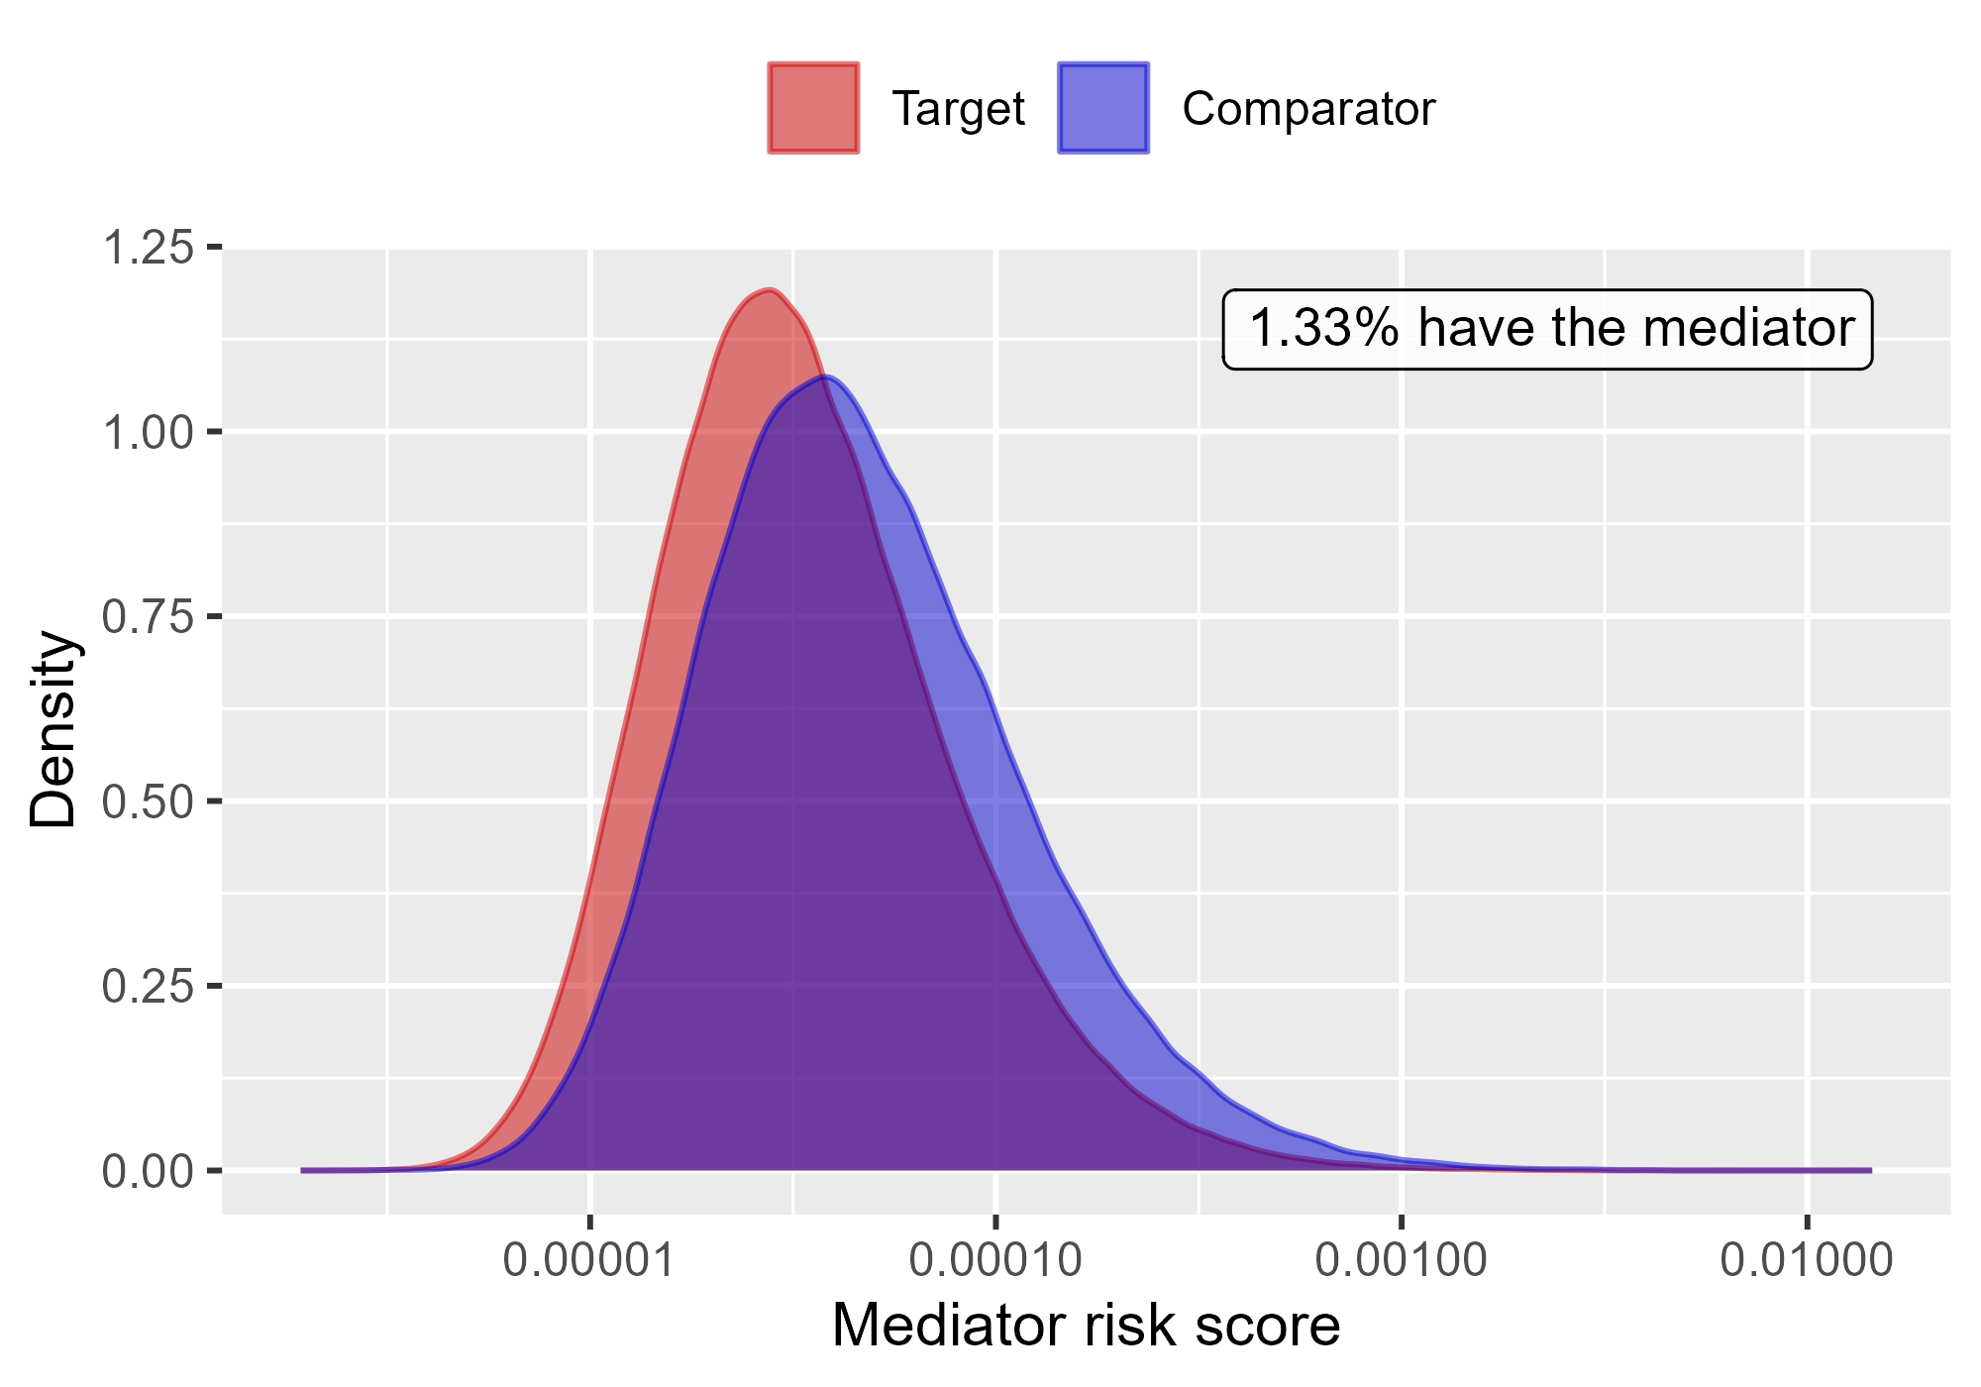

Mediator risk score by exposure status when comparing DOACs to Warfarin using mediator Extracranial Major bleeding IP in OptumDod.

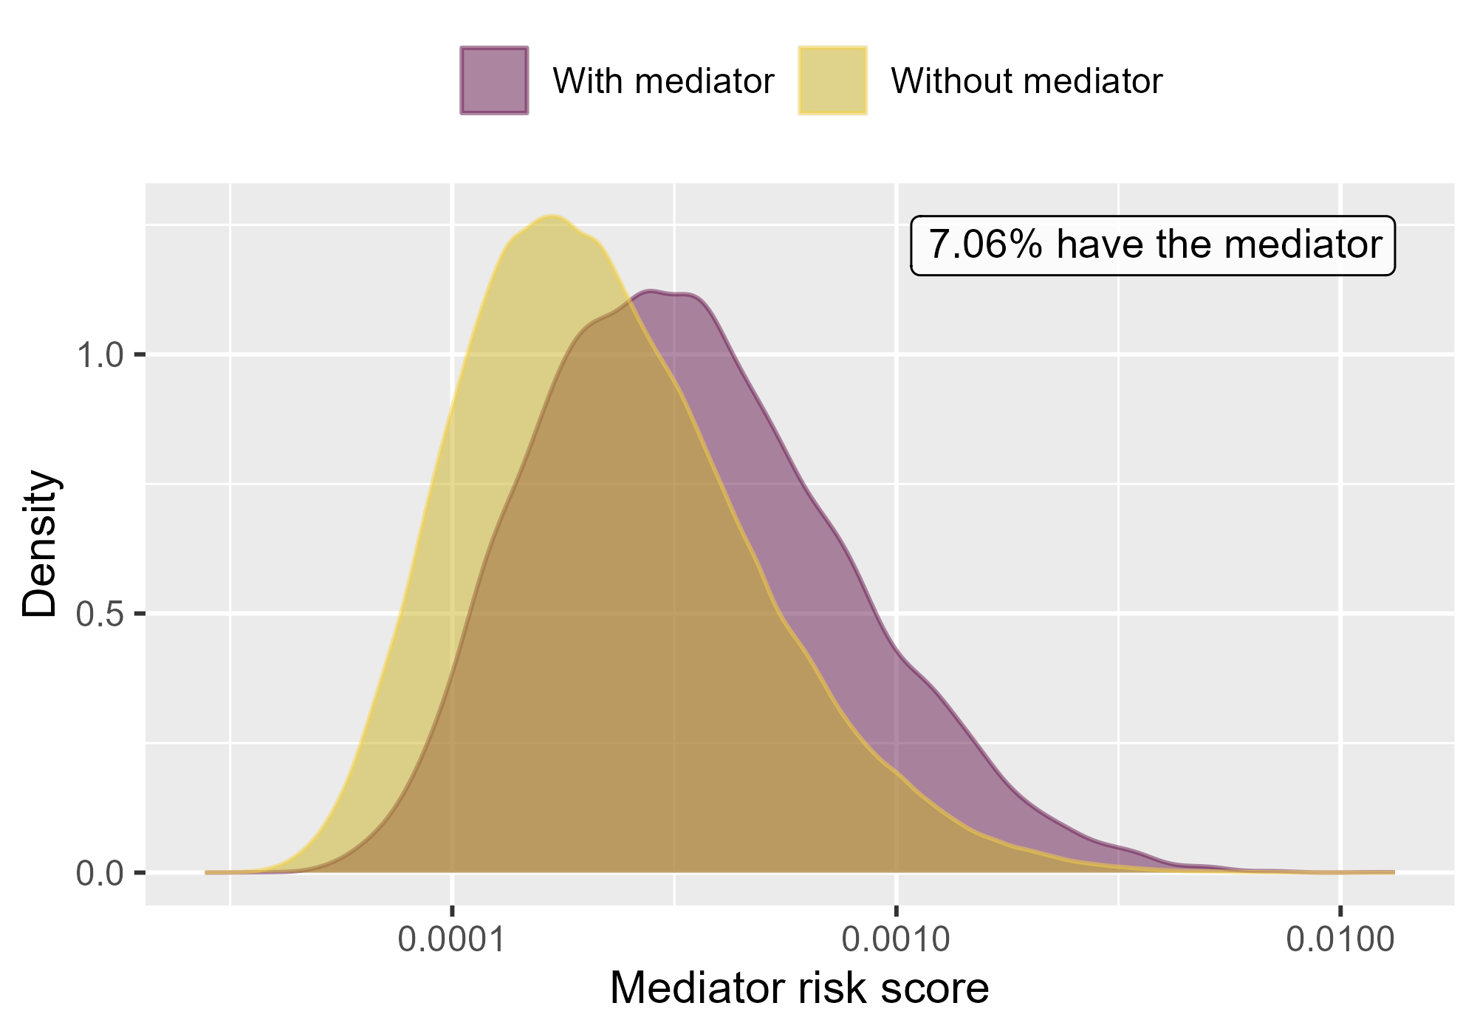

Mediator risk score by mediator status when comparing Rivaroxaban to Warfarin using mediator Extracranial Major bleeding IP-ER in OptumDod.

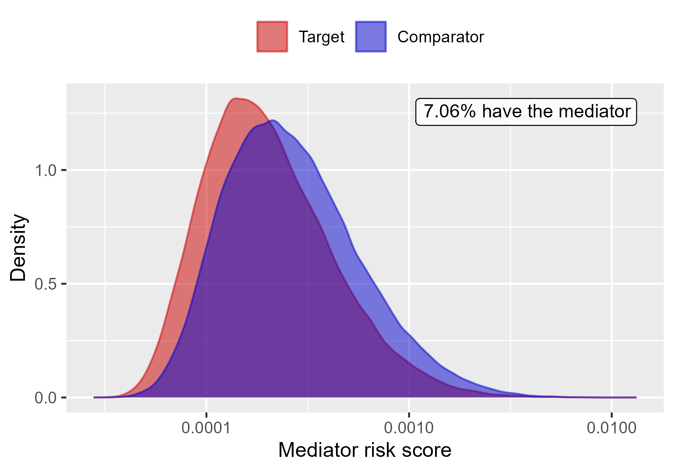

Mediator risk score by exposure status when comparing Rivaroxaban to Warfarin using mediator Extracranial Major bleeding IP-ER in OptumDod.

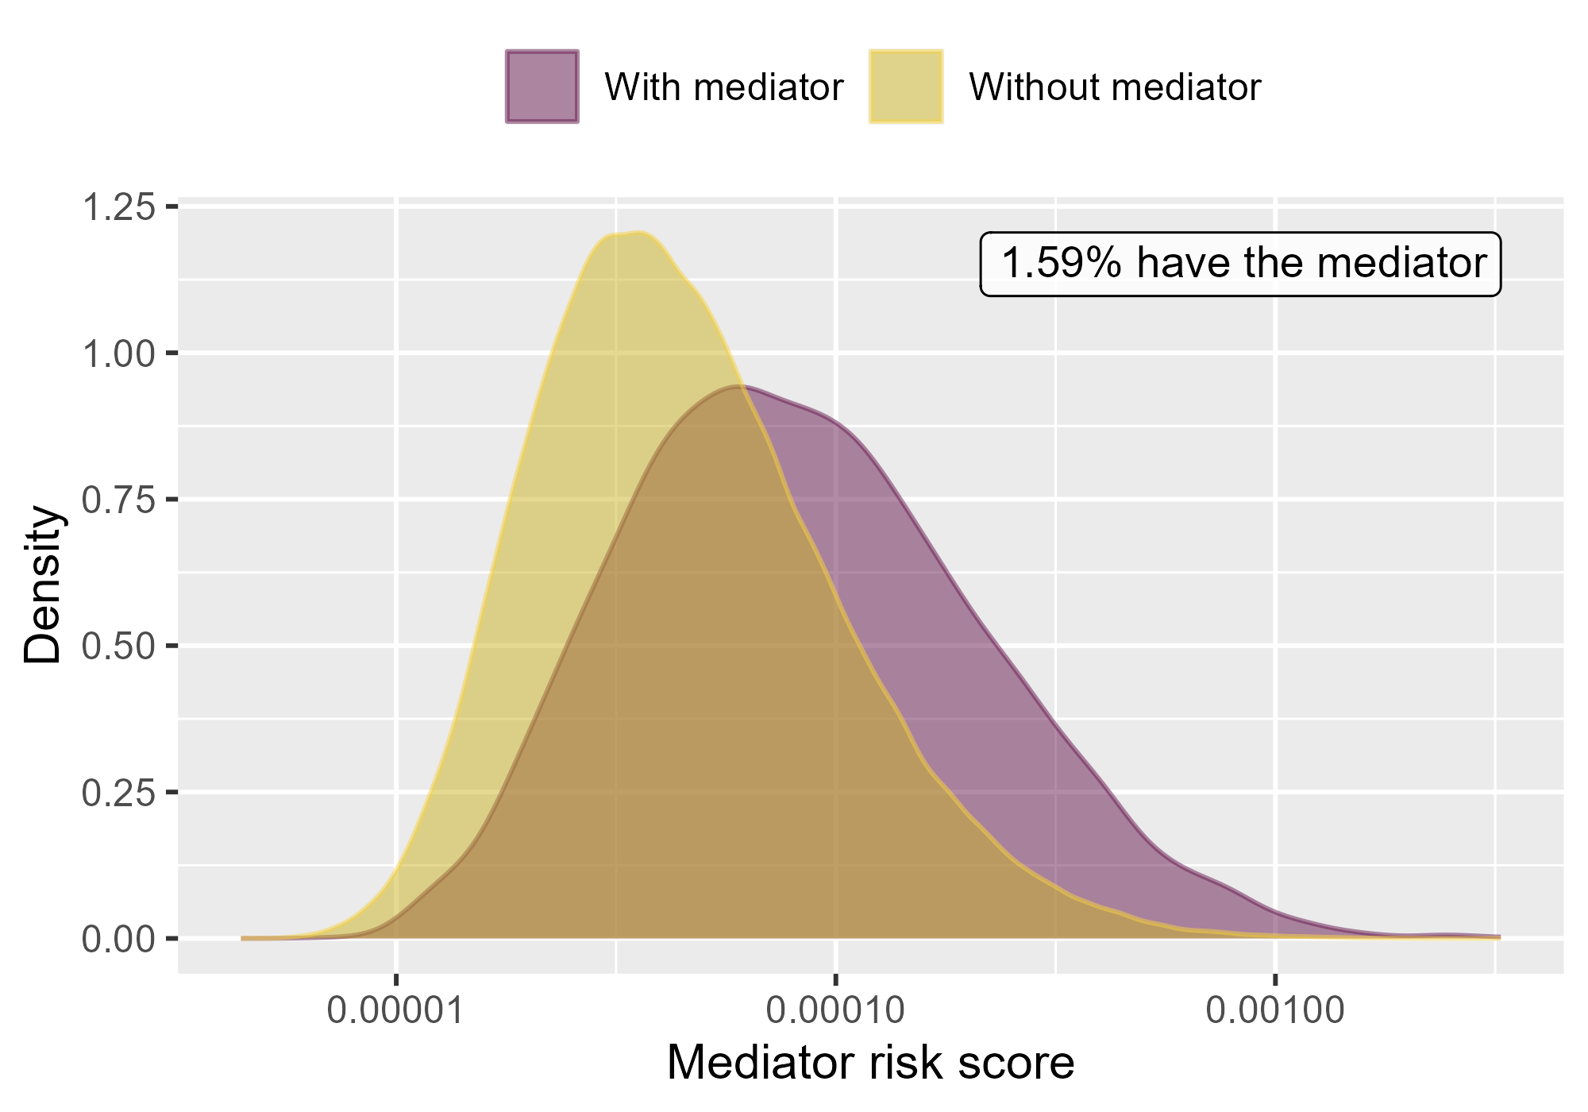

Mediator risk score by mediator status when comparing Rivaroxaban to Warfarin using mediator Extracranial Major bleeding IP in OptumDod.

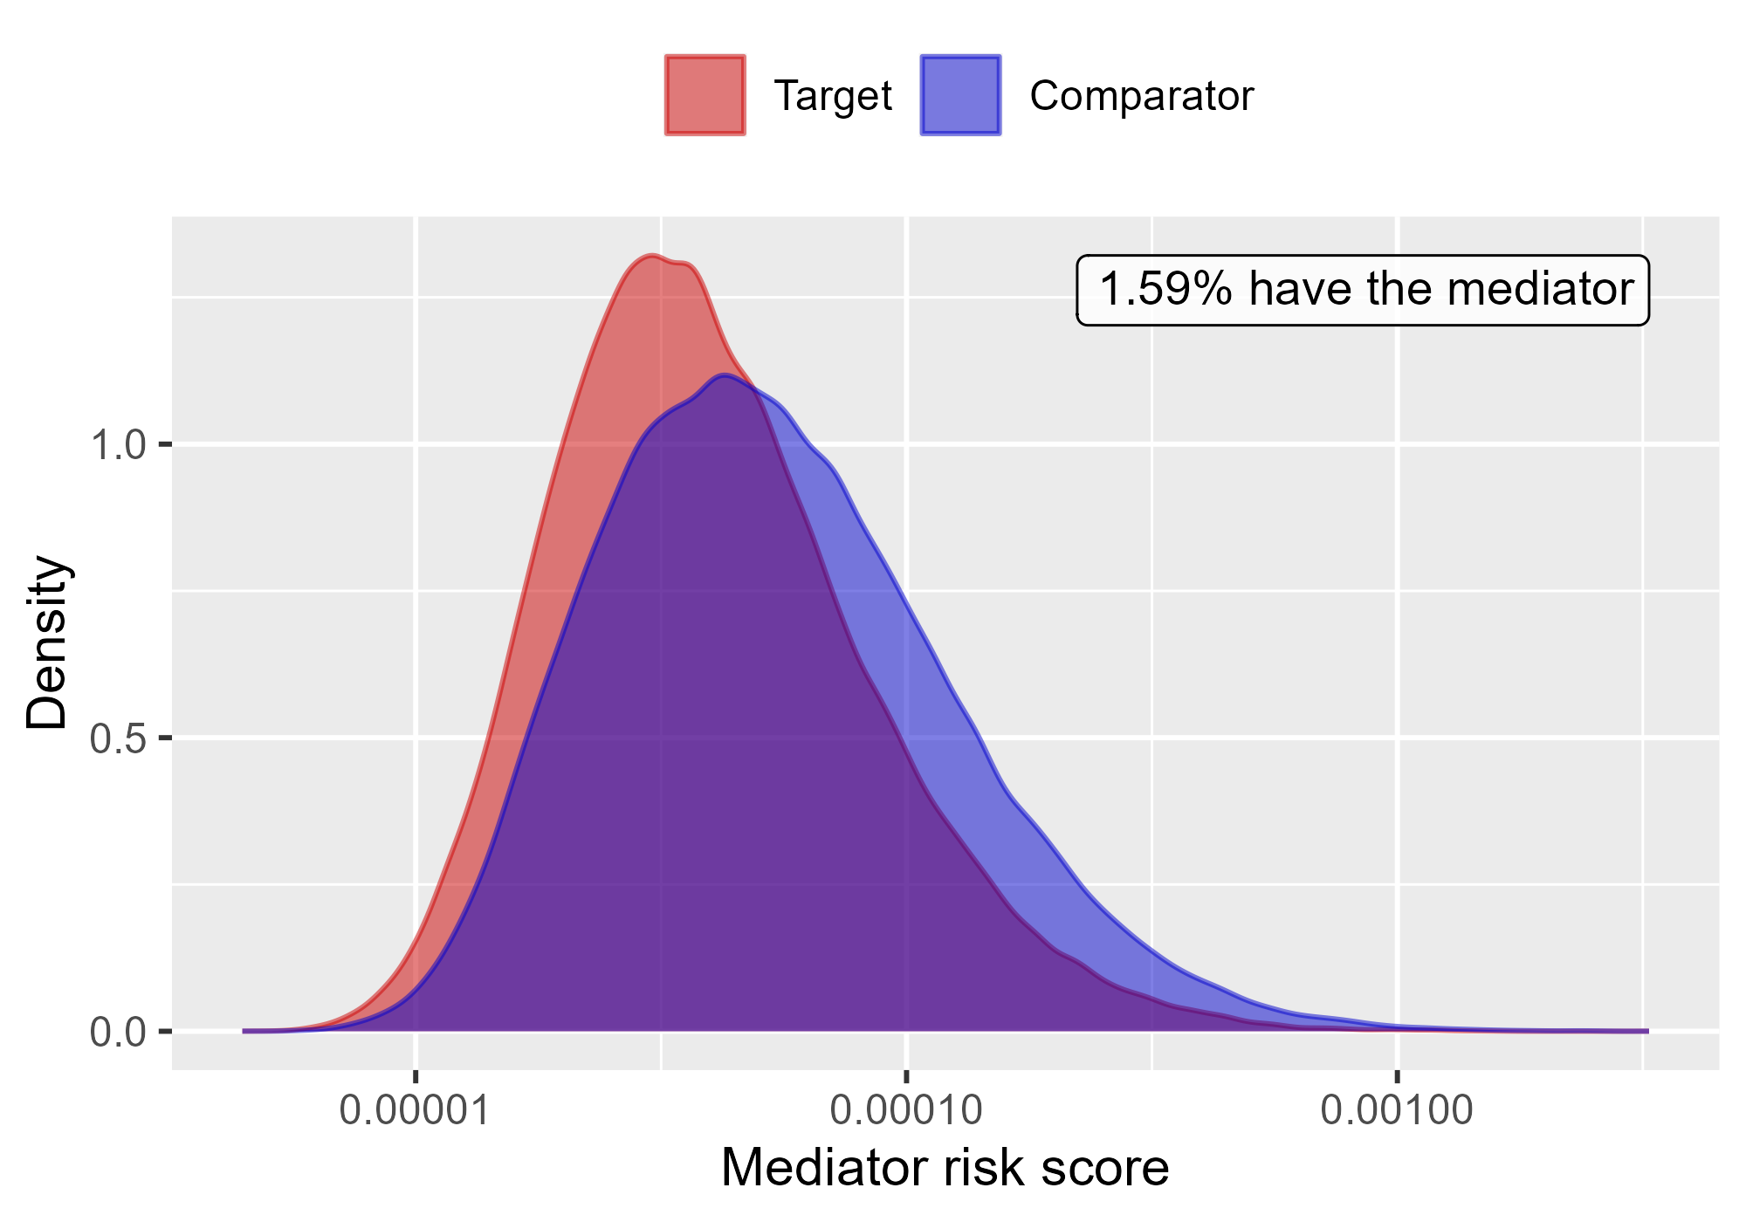

Mediator risk score by exposure status when comparing Rivaroxaban to Warfarin using mediator Extracranial Major bleeding IP in OptumDod.

### 4.0.3 OptumEhr

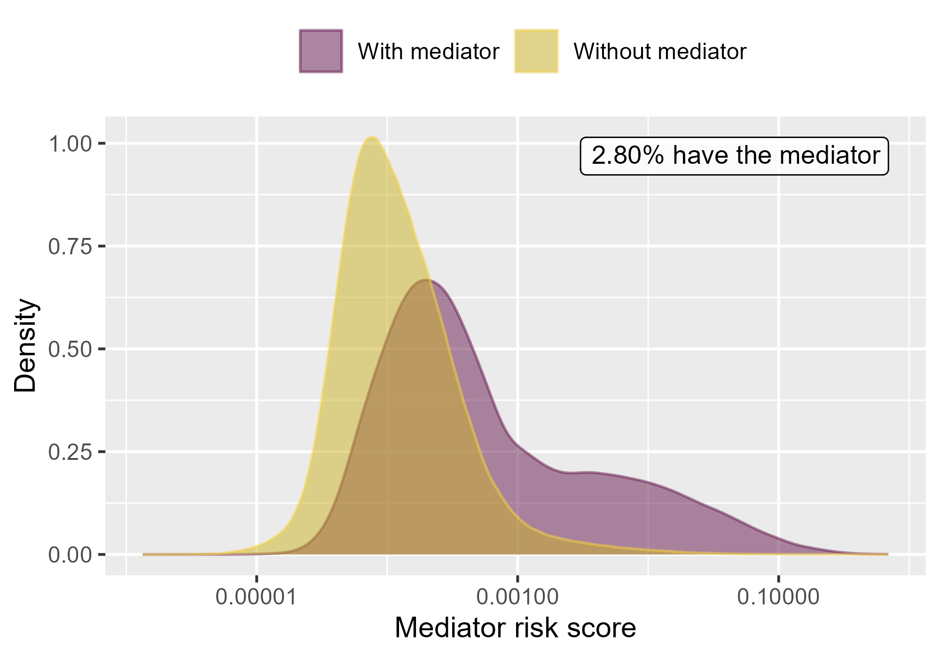

Mediator risk score by mediator status when comparing DOACs to Warfarin using mediator Extracranial Major bleeding IP-ER in OptumEhr.

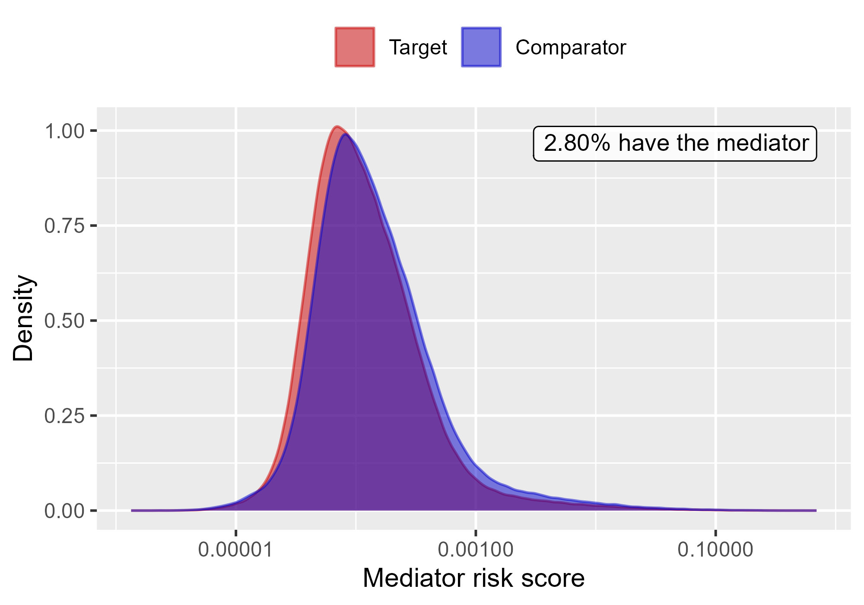

Mediator risk score by exposure status when comparing DOACs to Warfarin using mediator Extracranial Major bleeding IP-ER in OptumEhr.

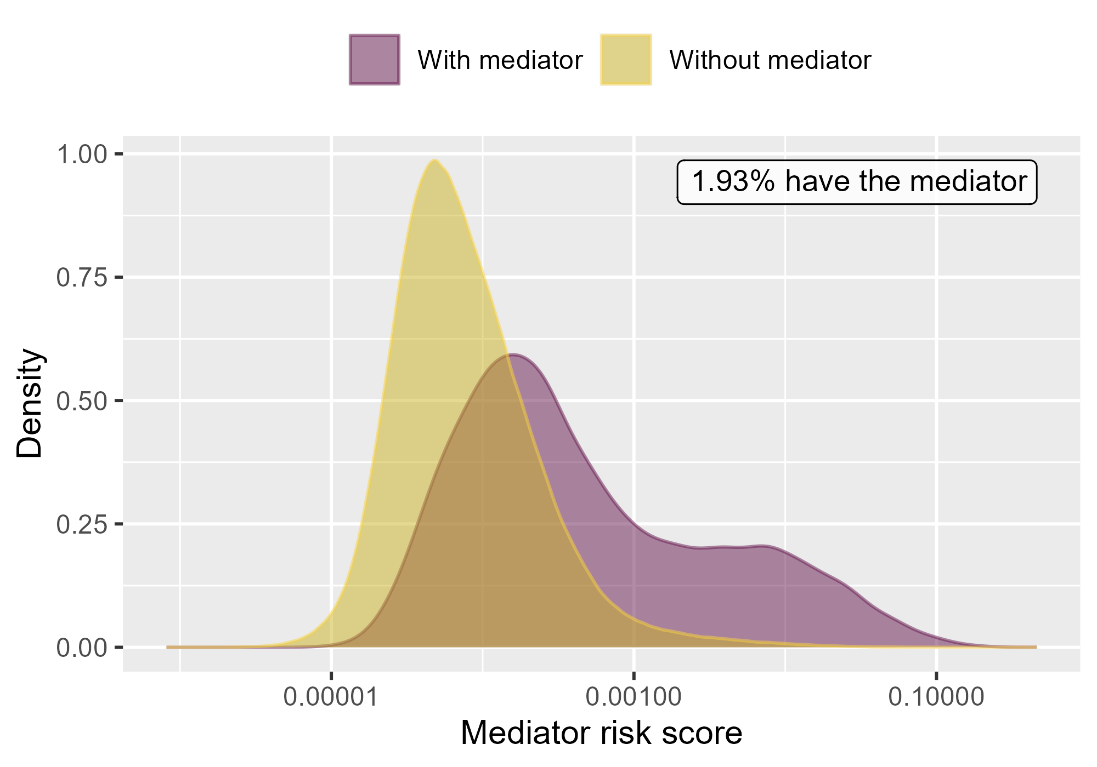

Mediator risk score by mediator status when comparing DOACs to Warfarin using mediator Extracranial Major bleeding IP in OptumEhr.

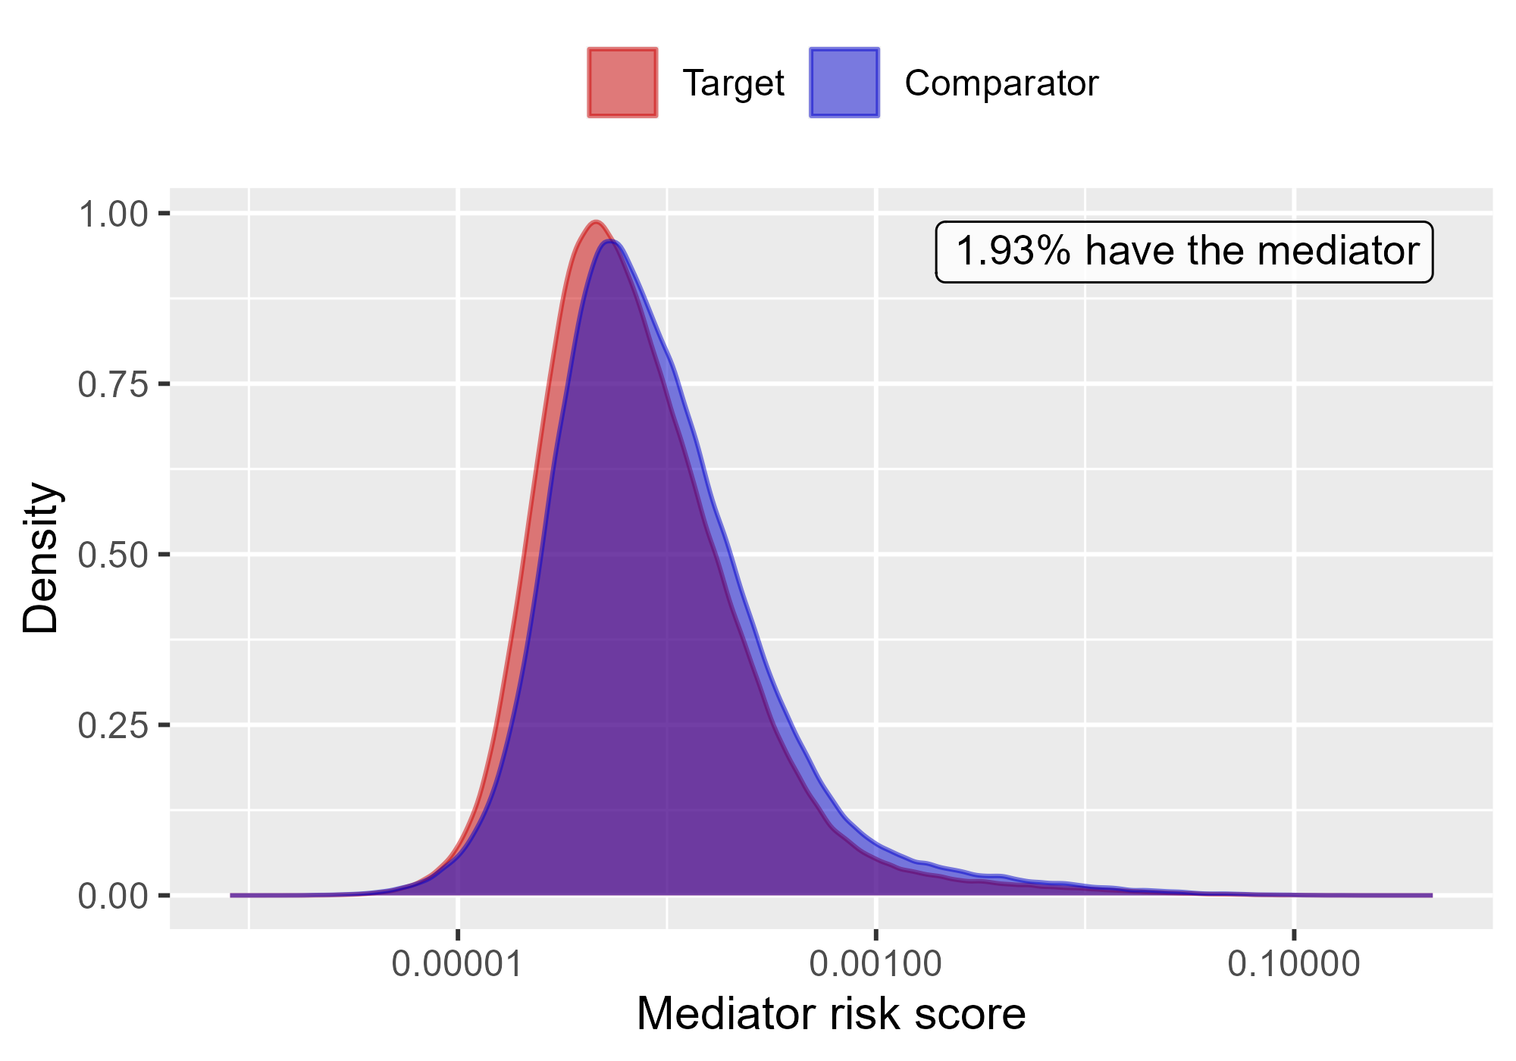

Mediator risk score by exposure status when comparing DOACs to Warfarin using mediator Extracranial Major bleeding IP in OptumEhr.

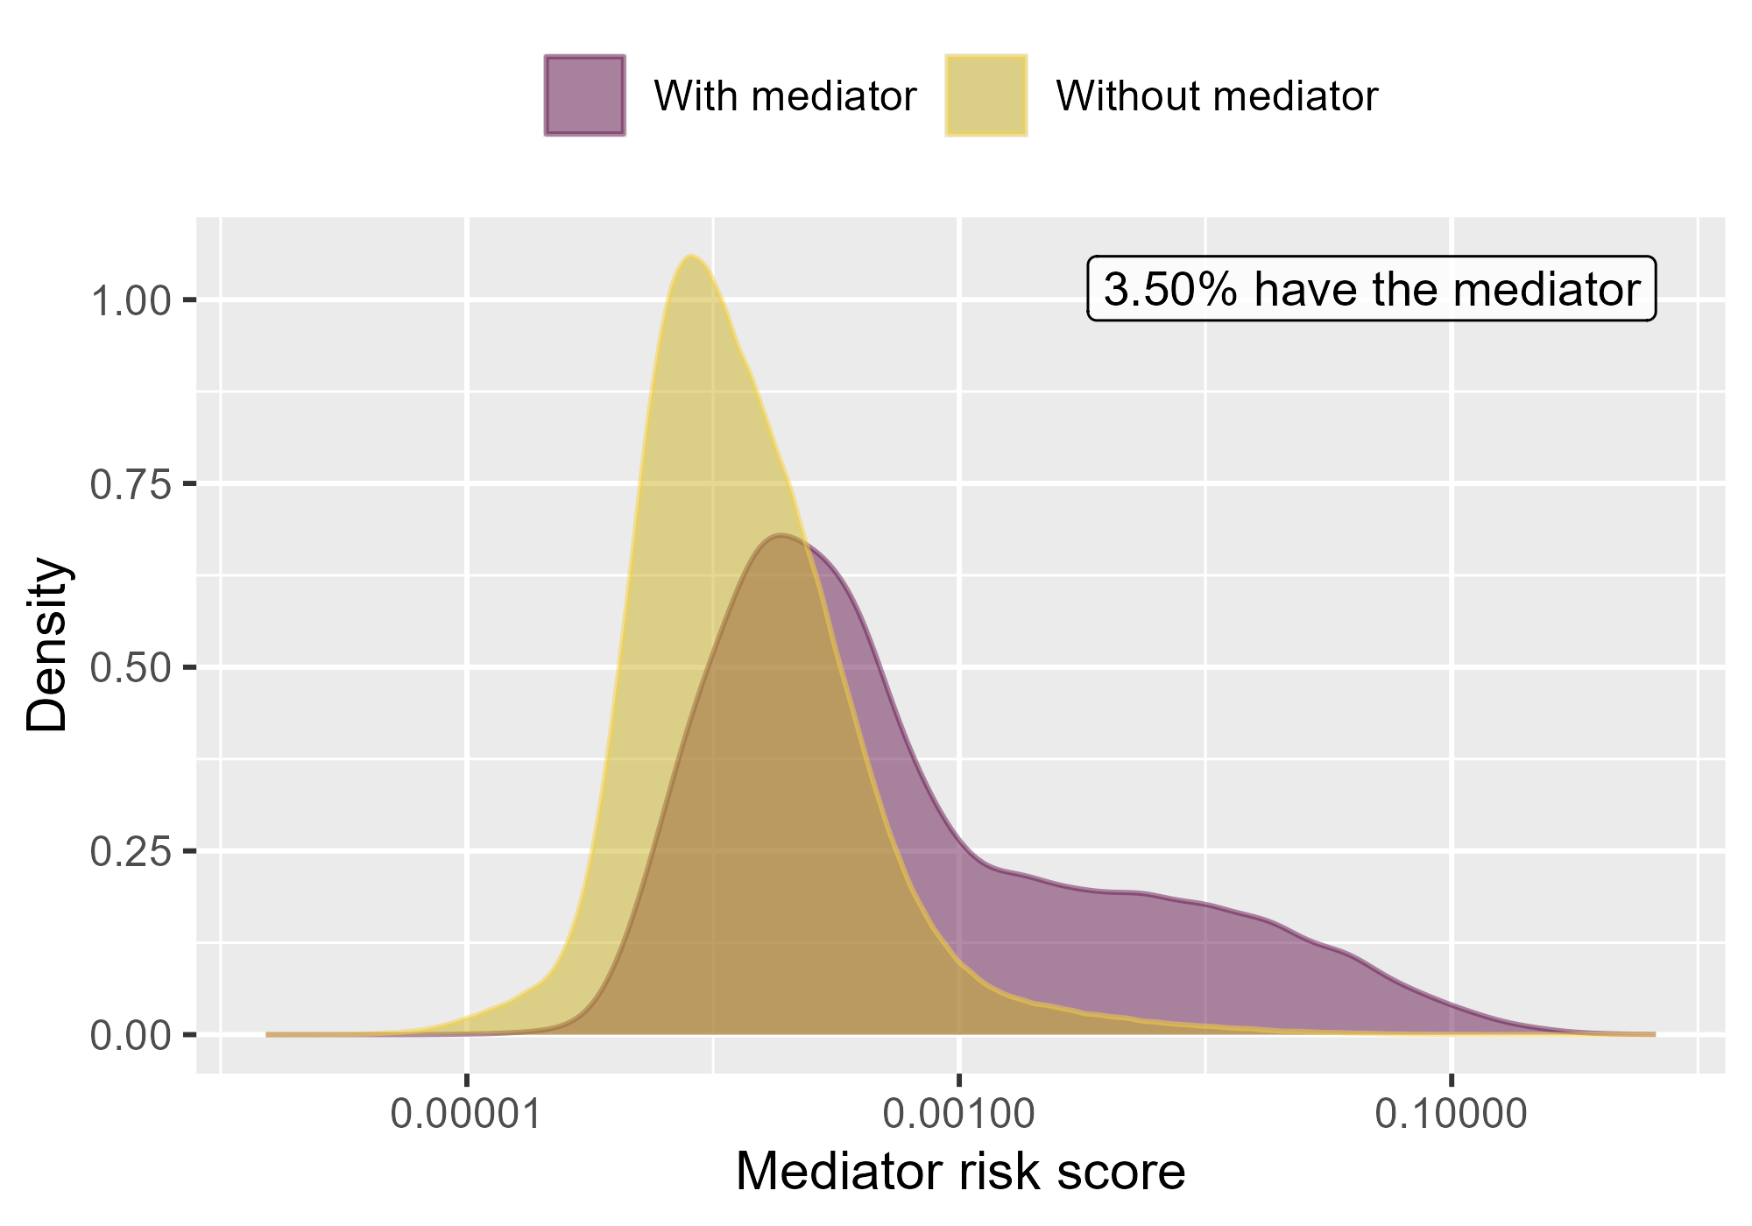

Mediator risk score by mediator status when comparing Rivaroxaban to Warfarin using mediator Extracranial Major bleeding IP-ER in OptumEhr.

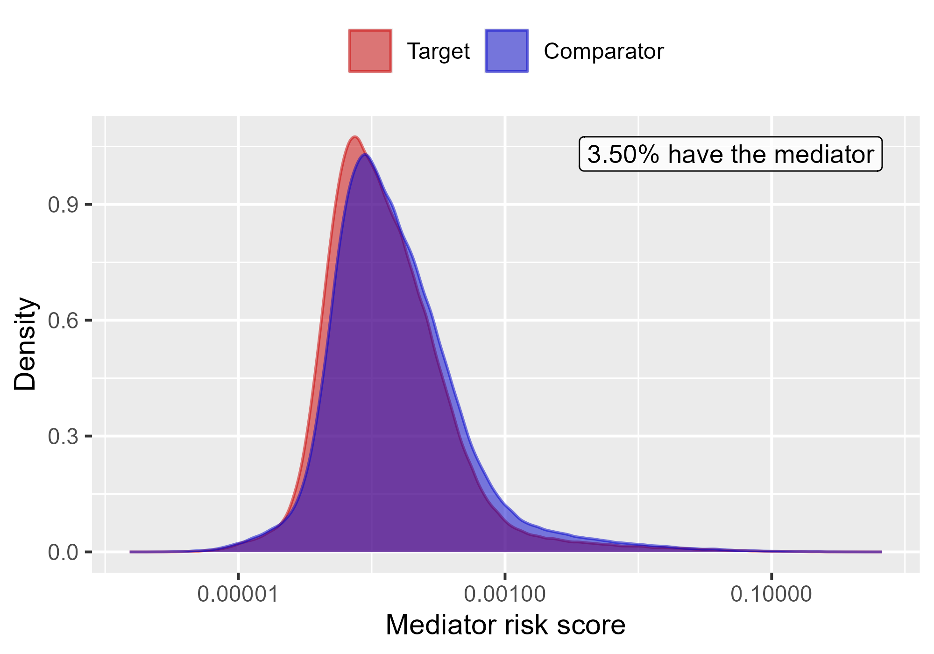

Mediator risk score by exposure status when comparing Rivaroxaban to Warfarin using mediator Extracranial Major bleeding IP-ER in OptumEhr.

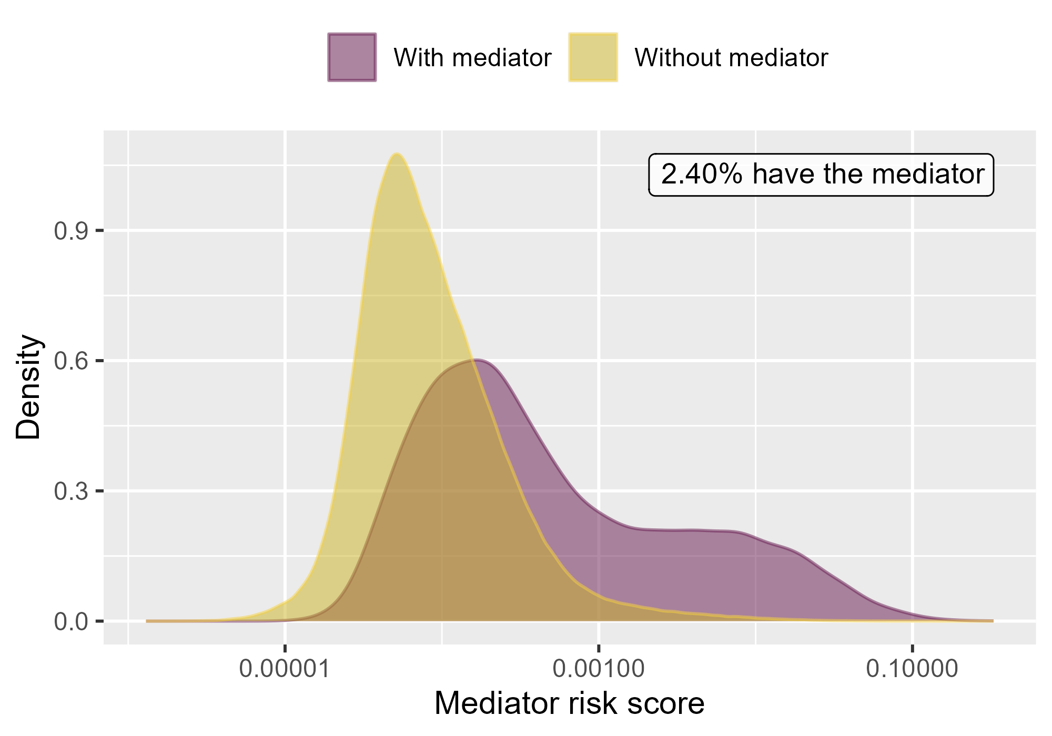

Mediator risk score by mediator status when comparing Rivaroxaban to Warfarin using mediator Extracranial Major bleeding IP in OptumEhr.

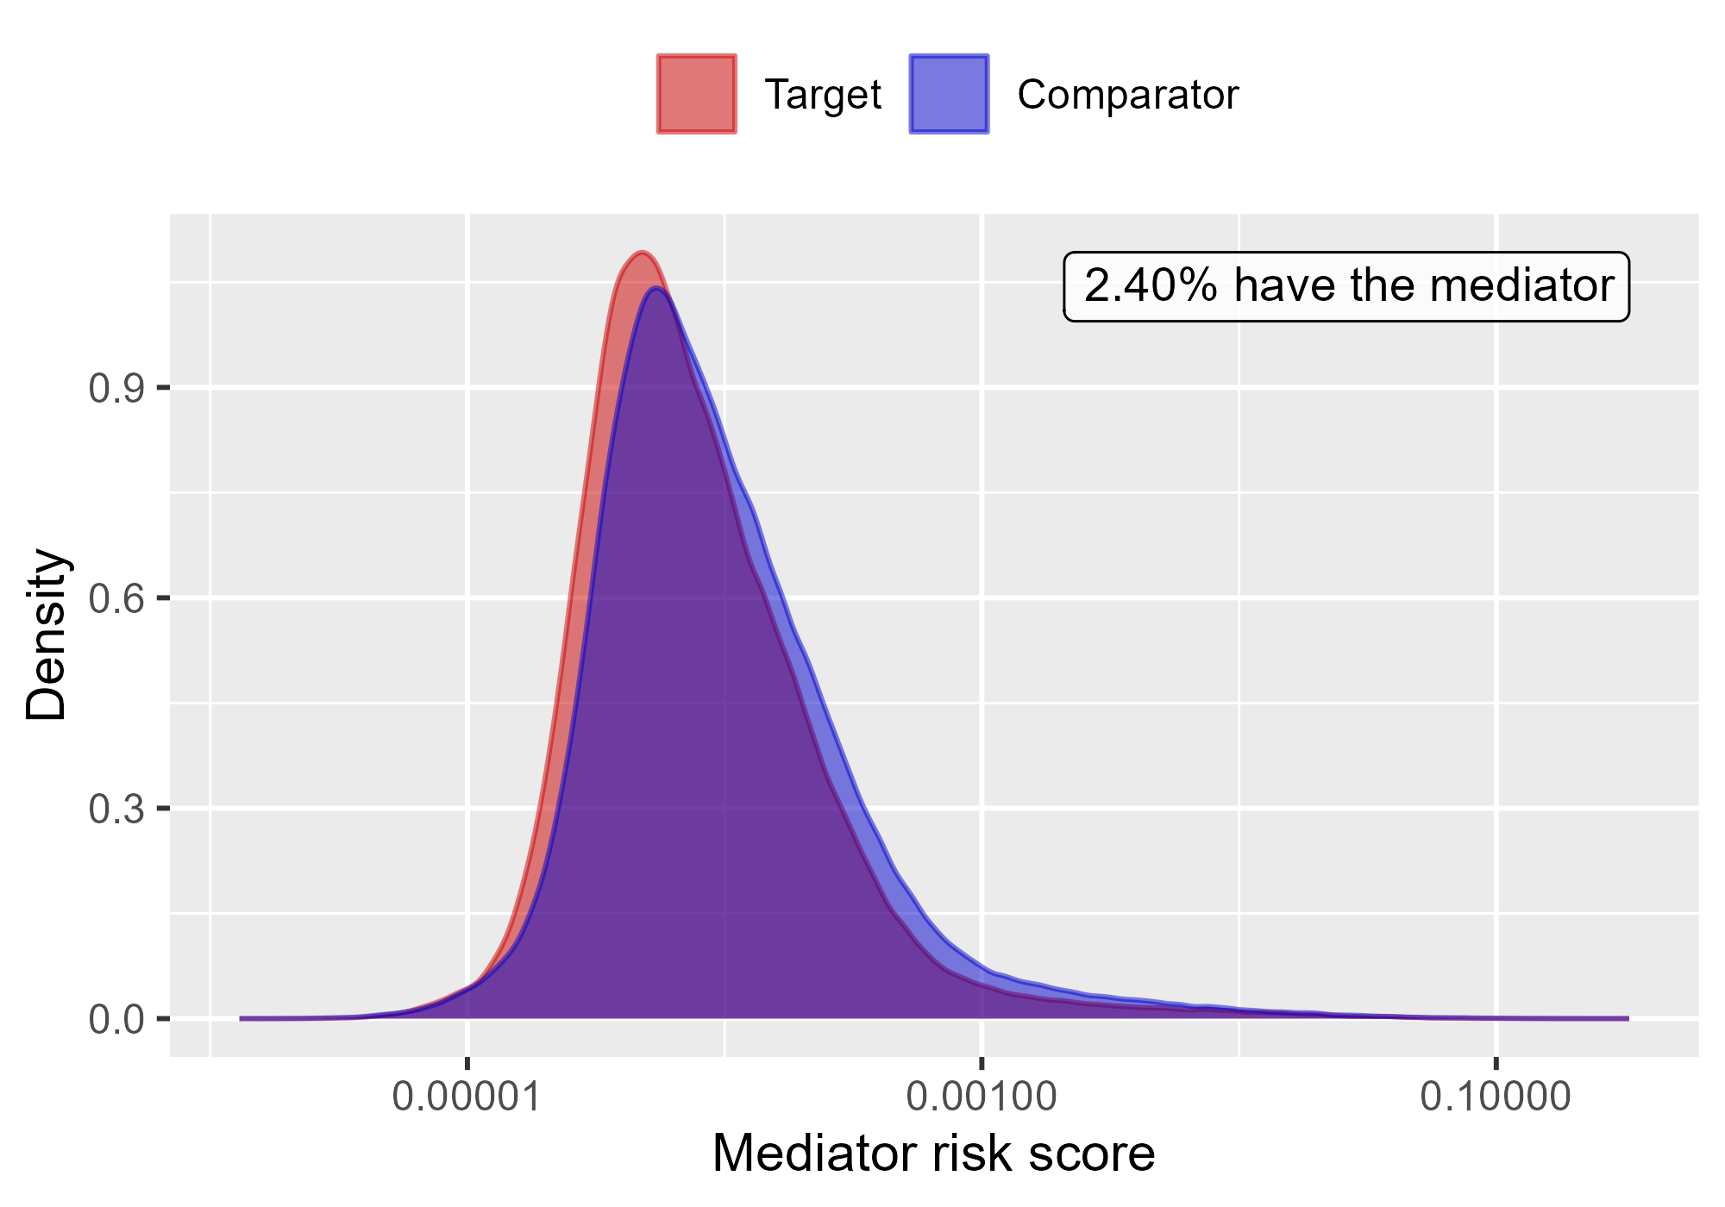

Mediator risk score by exposure status when comparing Rivaroxaban to Warfarin using mediator Extracranial Major bleeding IP in OptumEhr.

### 4.0.4 PharMetrics

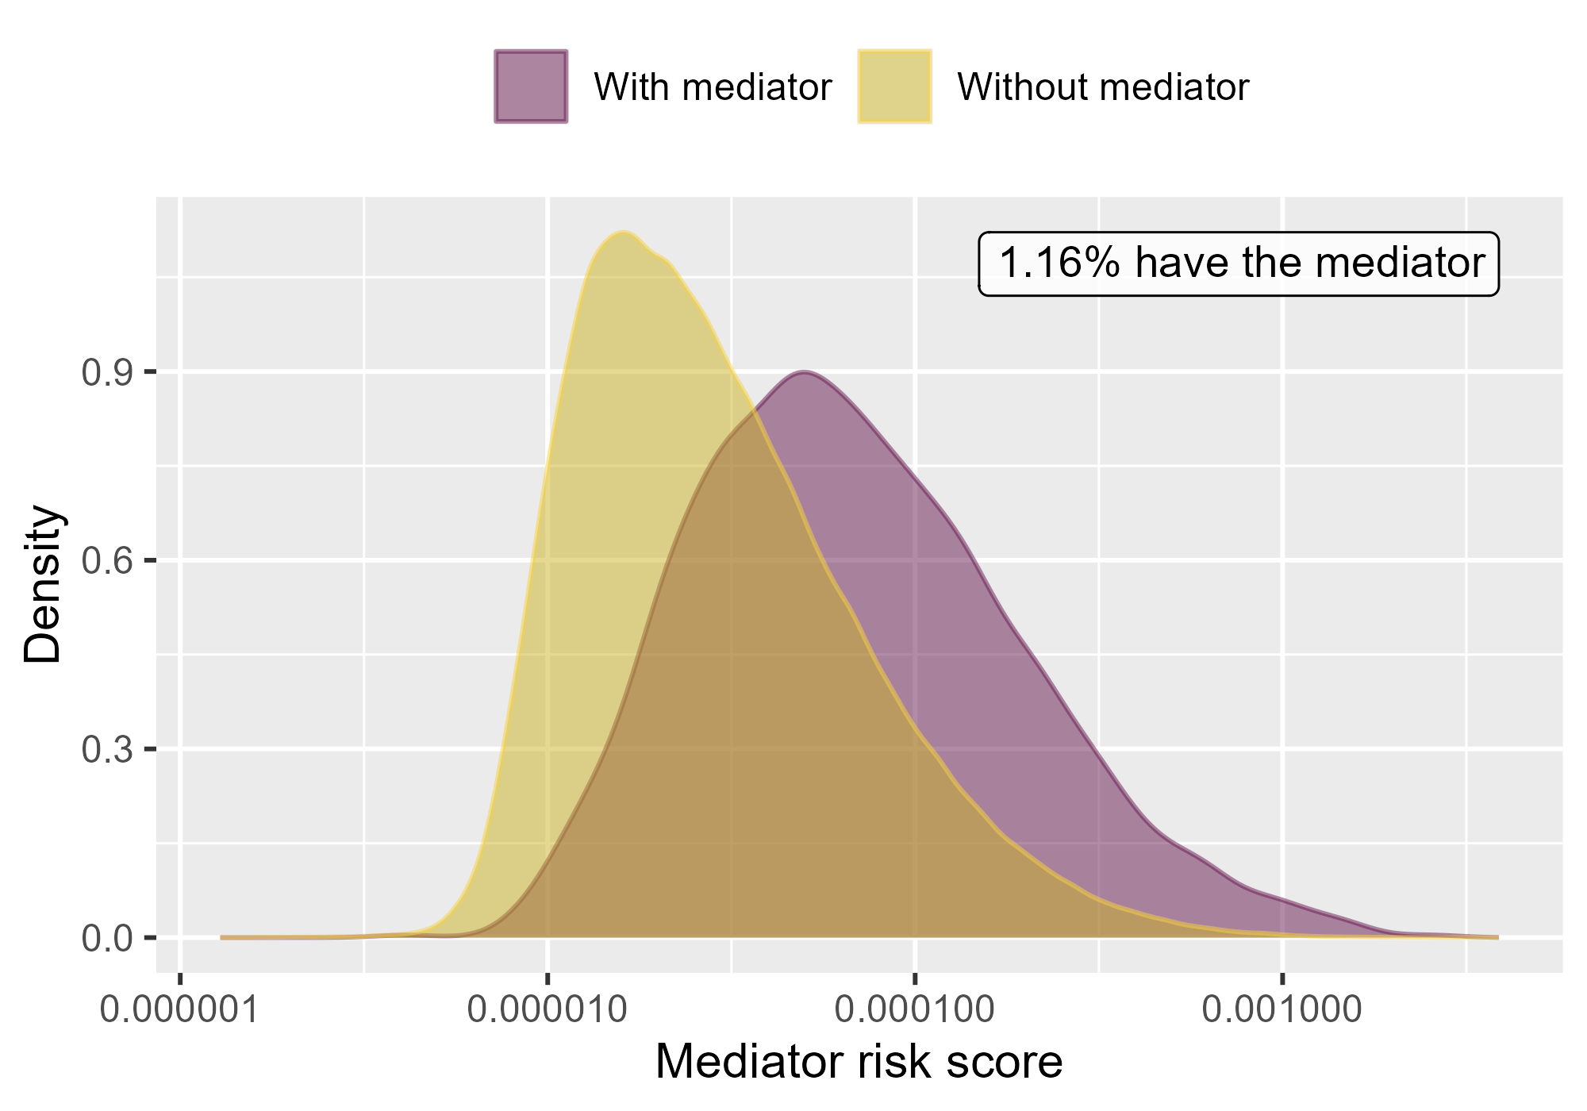

Mediator risk score by mediator status when comparing DOACs to Warfarin using mediator Extracranial Major bleeding IP-ER in PharMetrics.

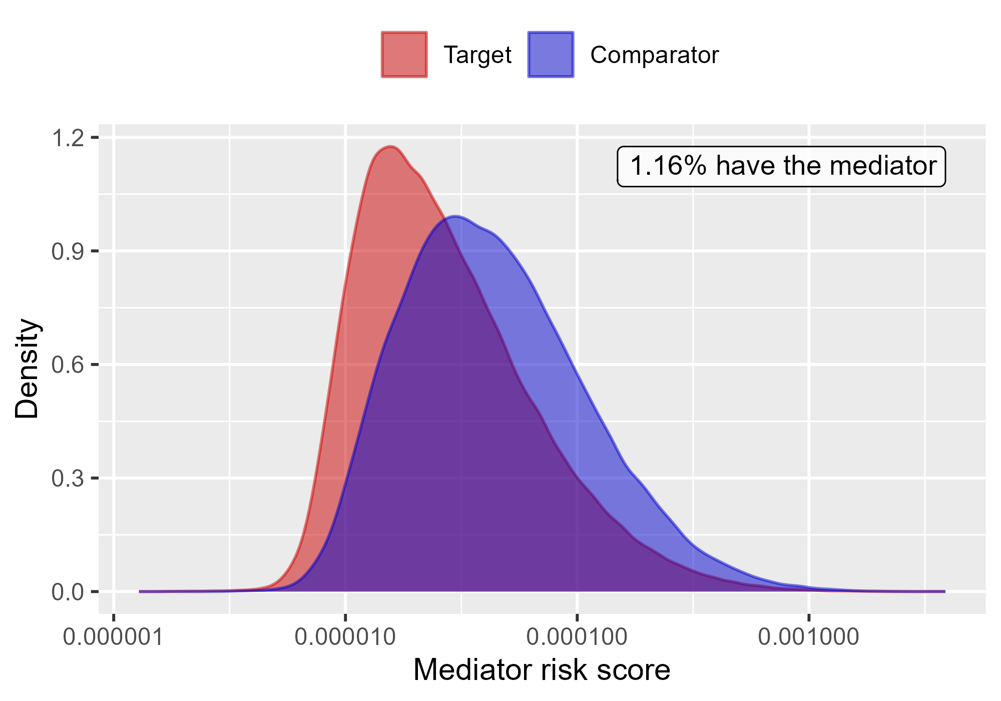

Mediator risk score by exposure status when comparing DOACs to Warfarin using mediator Extracranial Major bleeding IP-ER in PharMetrics.

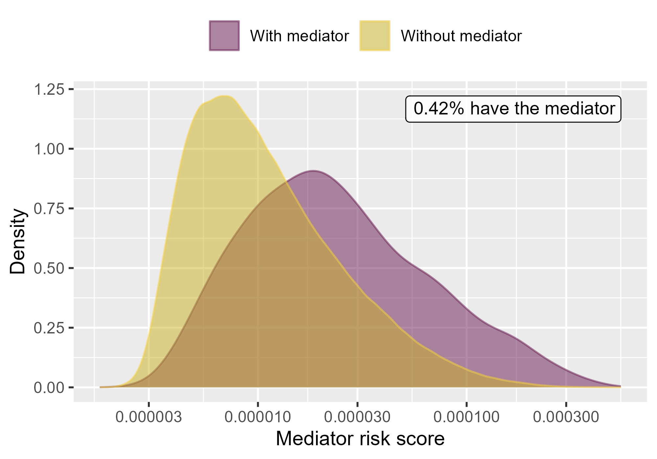

Mediator risk score by mediator status when comparing DOACs to Warfarin using mediator Extracranial Major bleeding IP in PharMetrics.

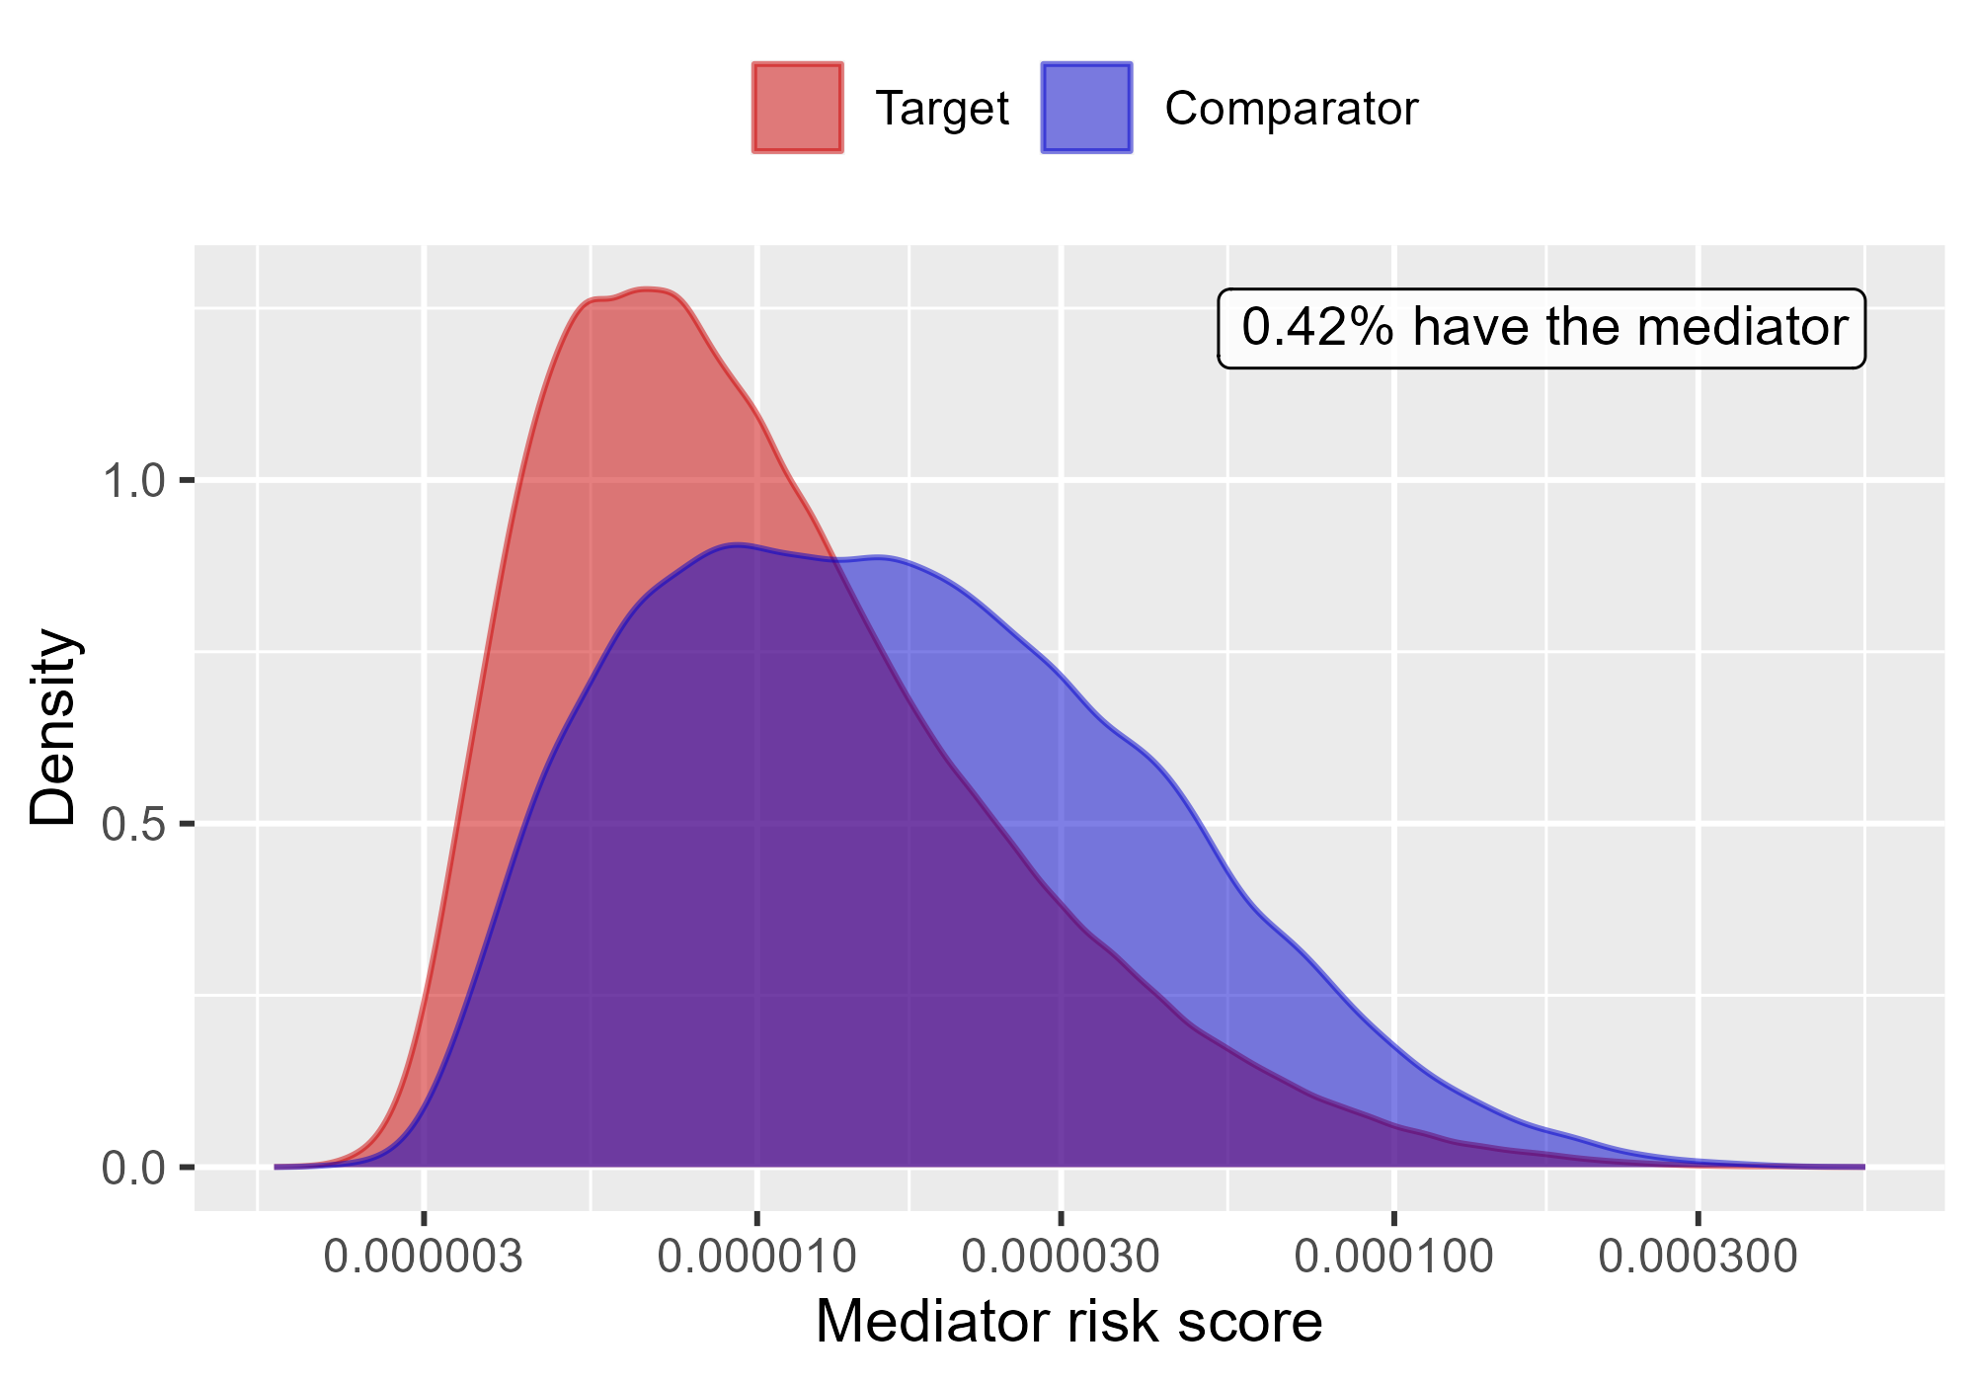

Mediator risk score by exposure status when comparing DOACs to Warfarin using mediator Extracranial Major bleeding IP in PharMetrics.

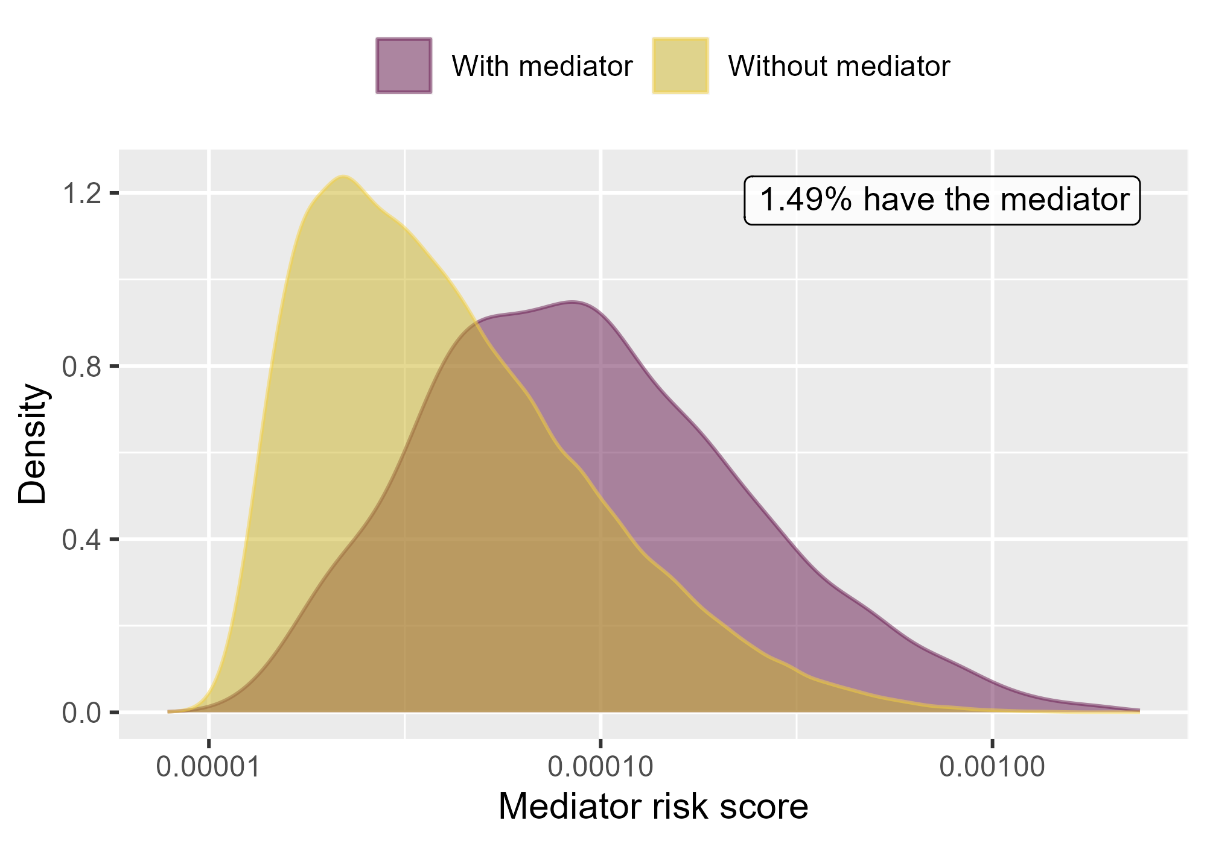

Mediator risk score by mediator status when comparing Rivaroxaban to Warfarin using mediator Extracranial Major bleeding IP-ER in PharMetrics.

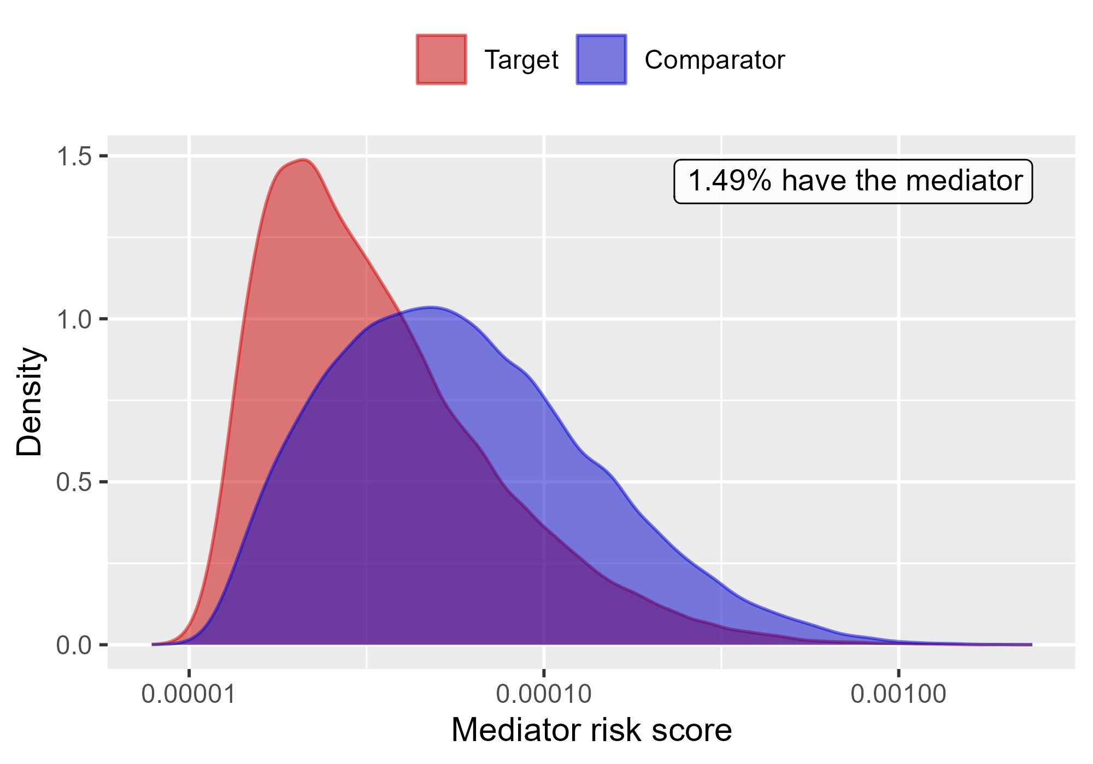

Mediator risk score by exposure status when comparing Rivaroxaban to Warfarin using mediator Extracranial Major bleeding IP-ER in PharMetrics.

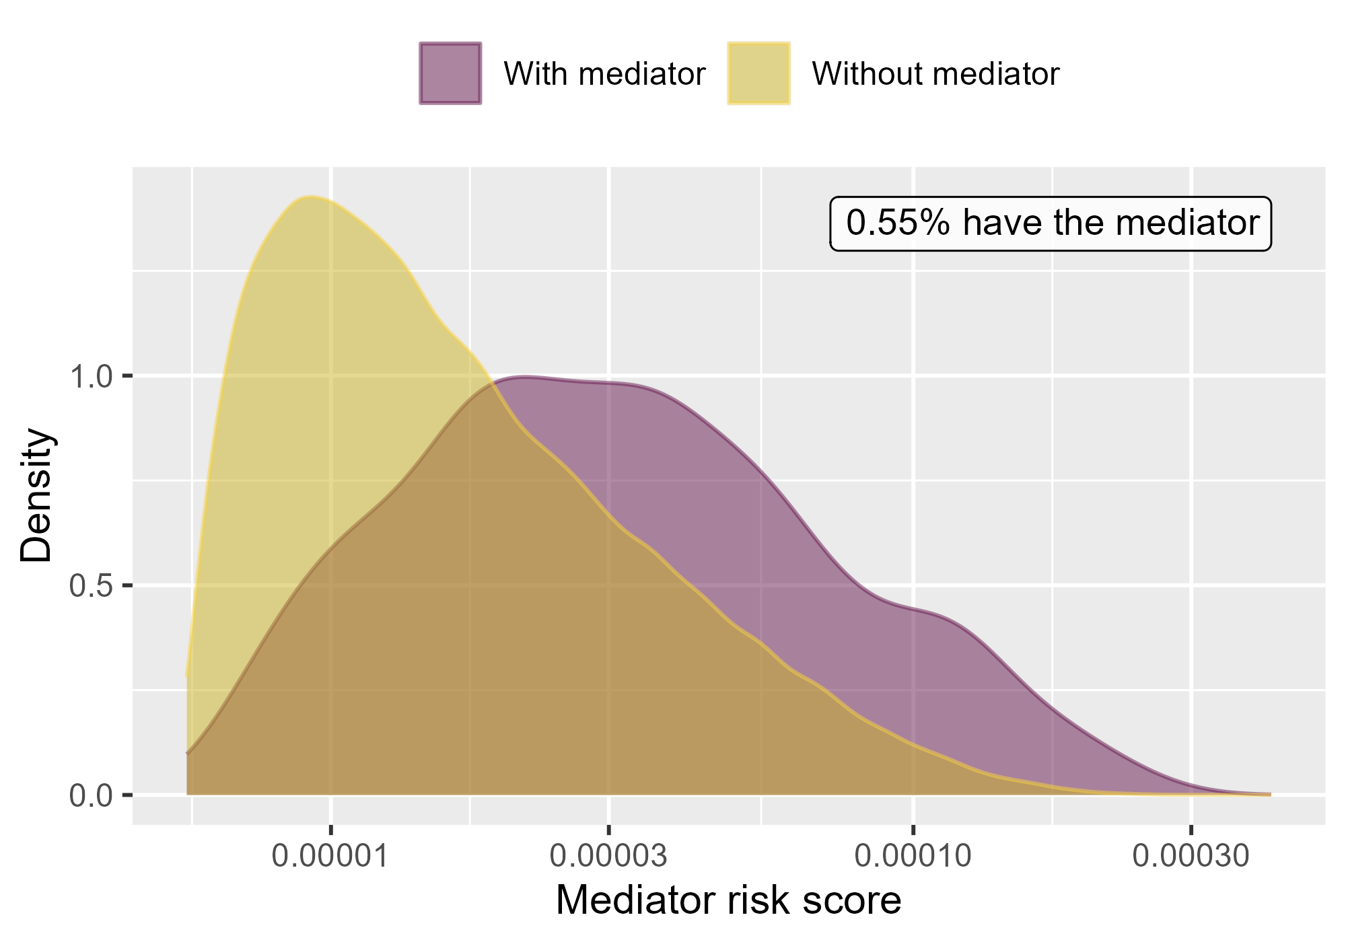

Mediator risk score by mediator status when comparing Rivaroxaban to Warfarin using mediator Extracranial Major bleeding IP in PharMetrics.

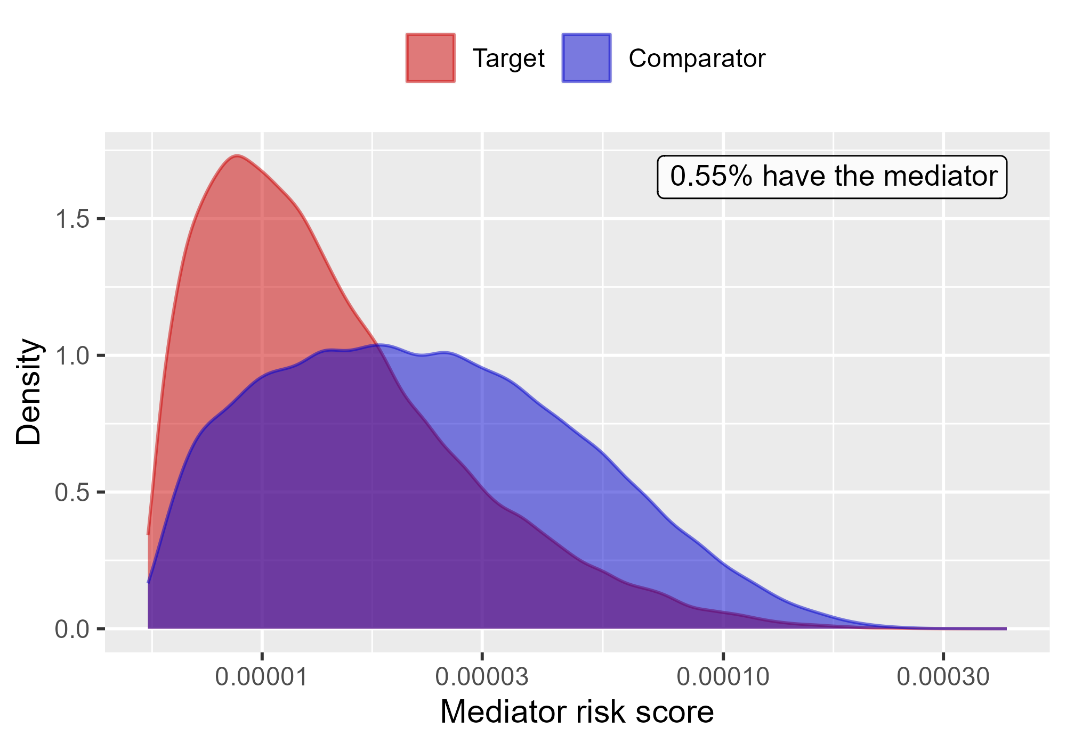

Mediator risk score by exposure status when comparing Rivaroxaban to Warfarin using mediator Extracranial Major bleeding IP in PharMetrics.

### 4.0.5 MDCR

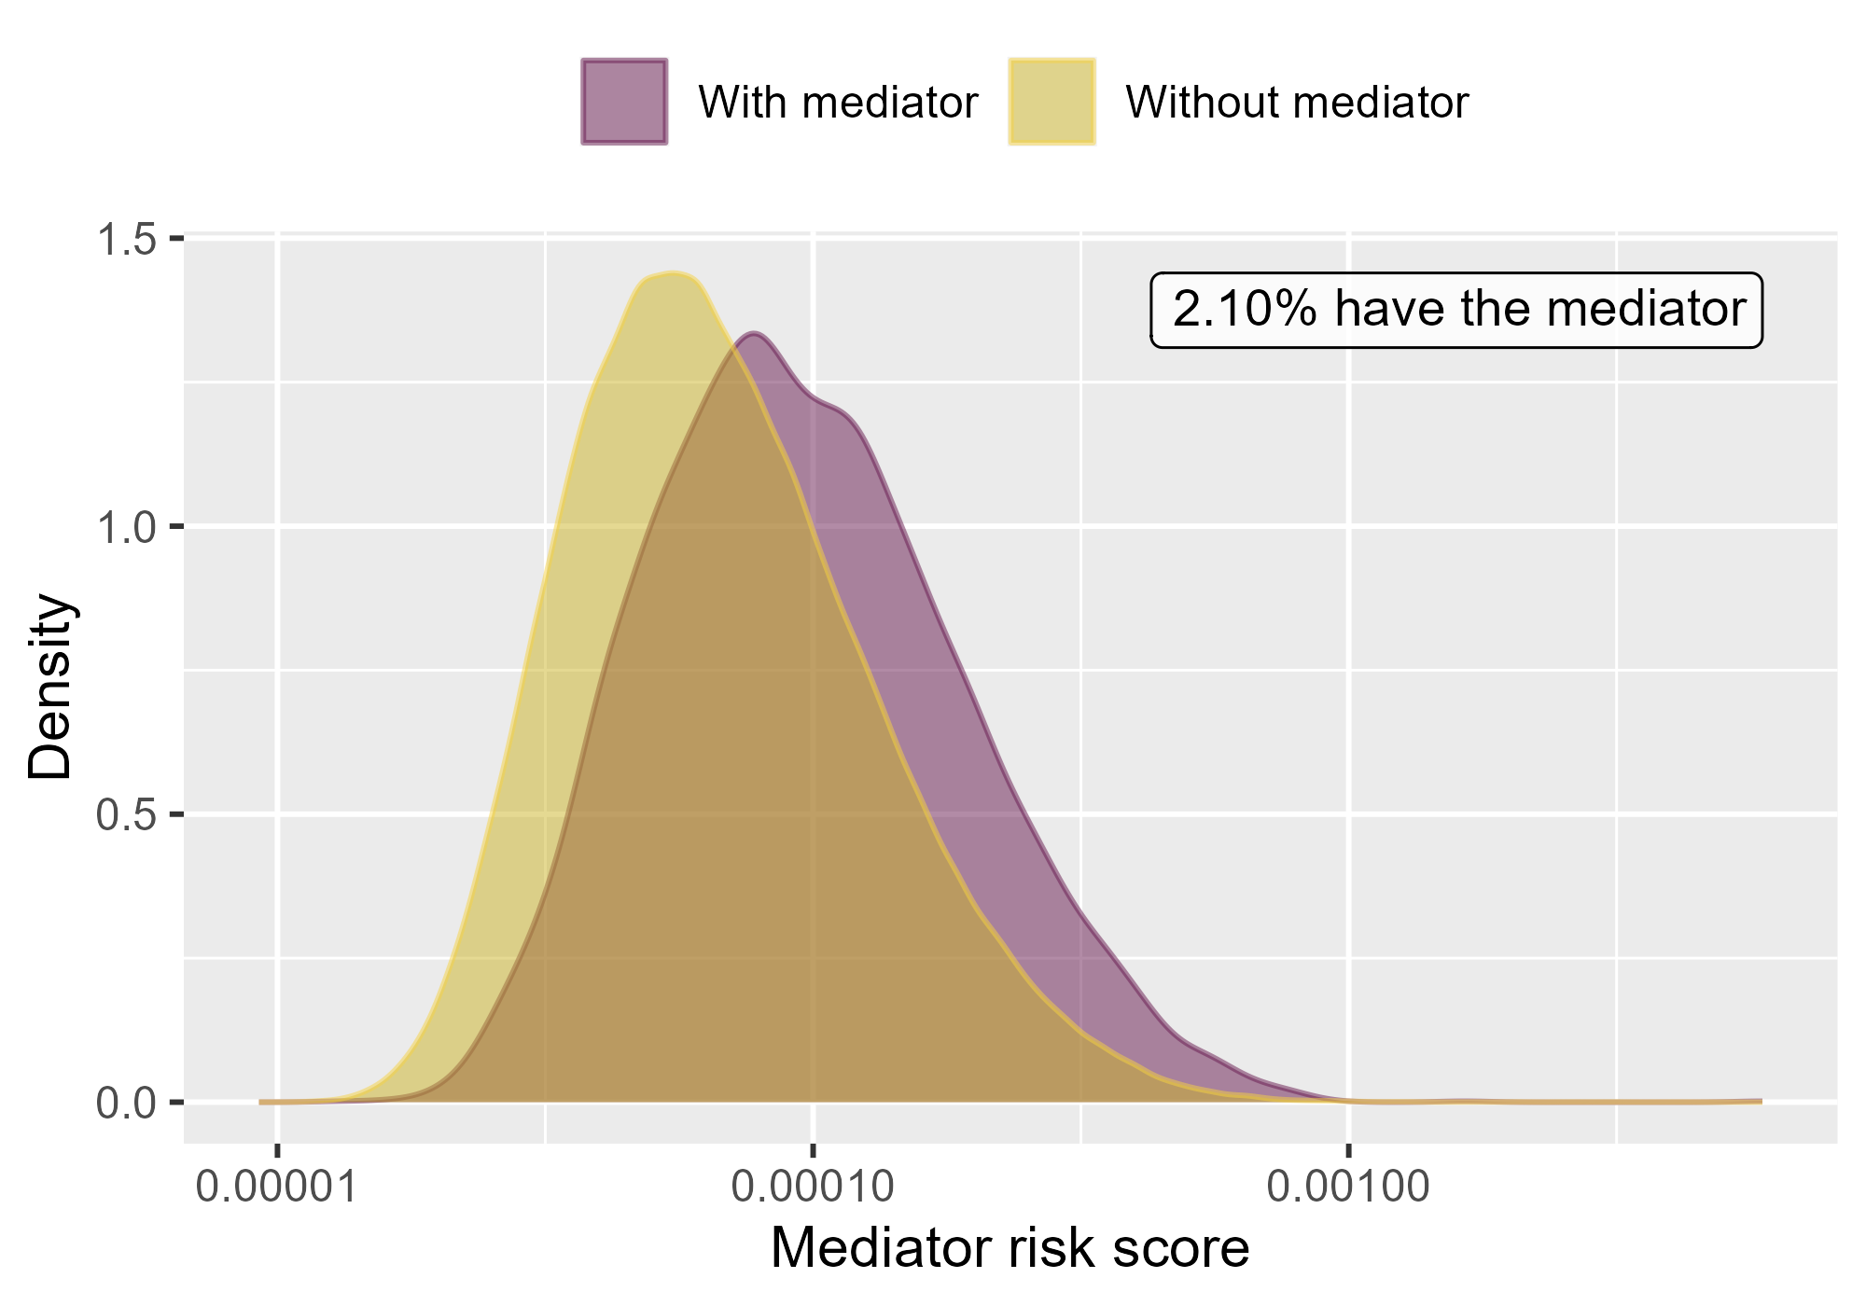

Mediator risk score by mediator status when comparing DOACs to Warfarin using mediator Extracranial Major bleeding IP-ER in MDCR.

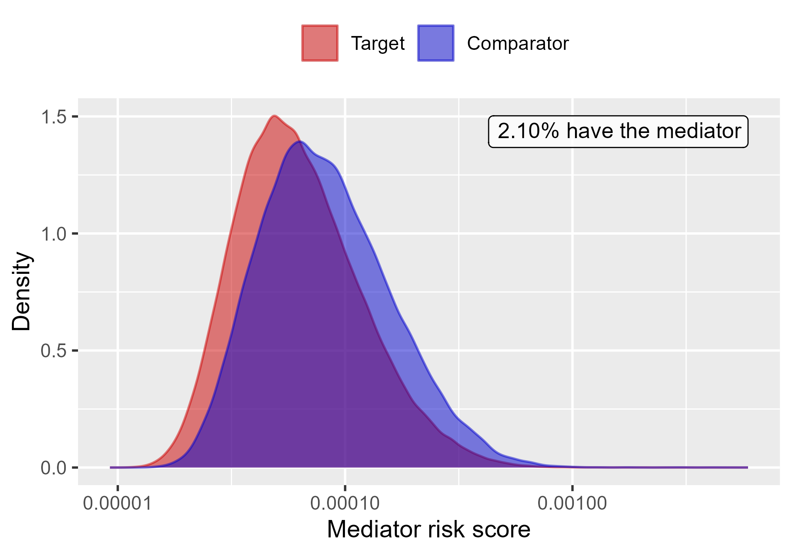

Mediator risk score by exposure status when comparing DOACs to Warfarin using mediator Extracranial Major bleeding IP-ER in MDCR.

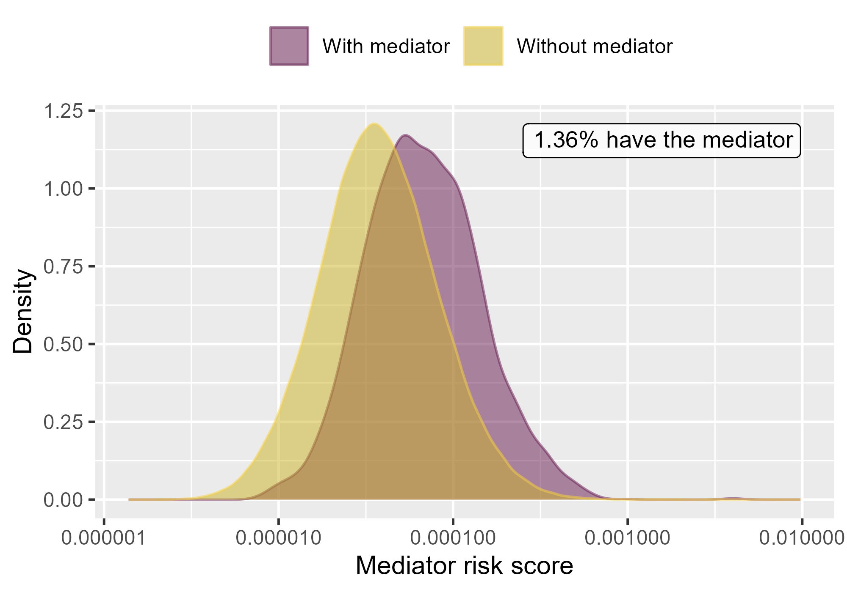

Mediator risk score by mediator status when comparing DOACs to Warfarin using mediator Extracranial Major bleeding IP in MDCR.

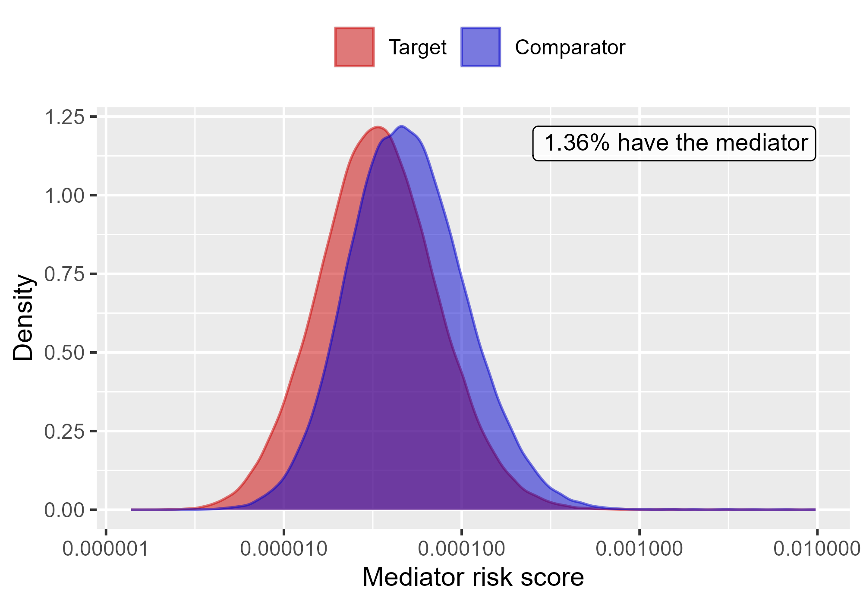

Mediator risk score by exposure status when comparing DOACs to Warfarin using mediator Extracranial Major bleeding IP in MDCR.

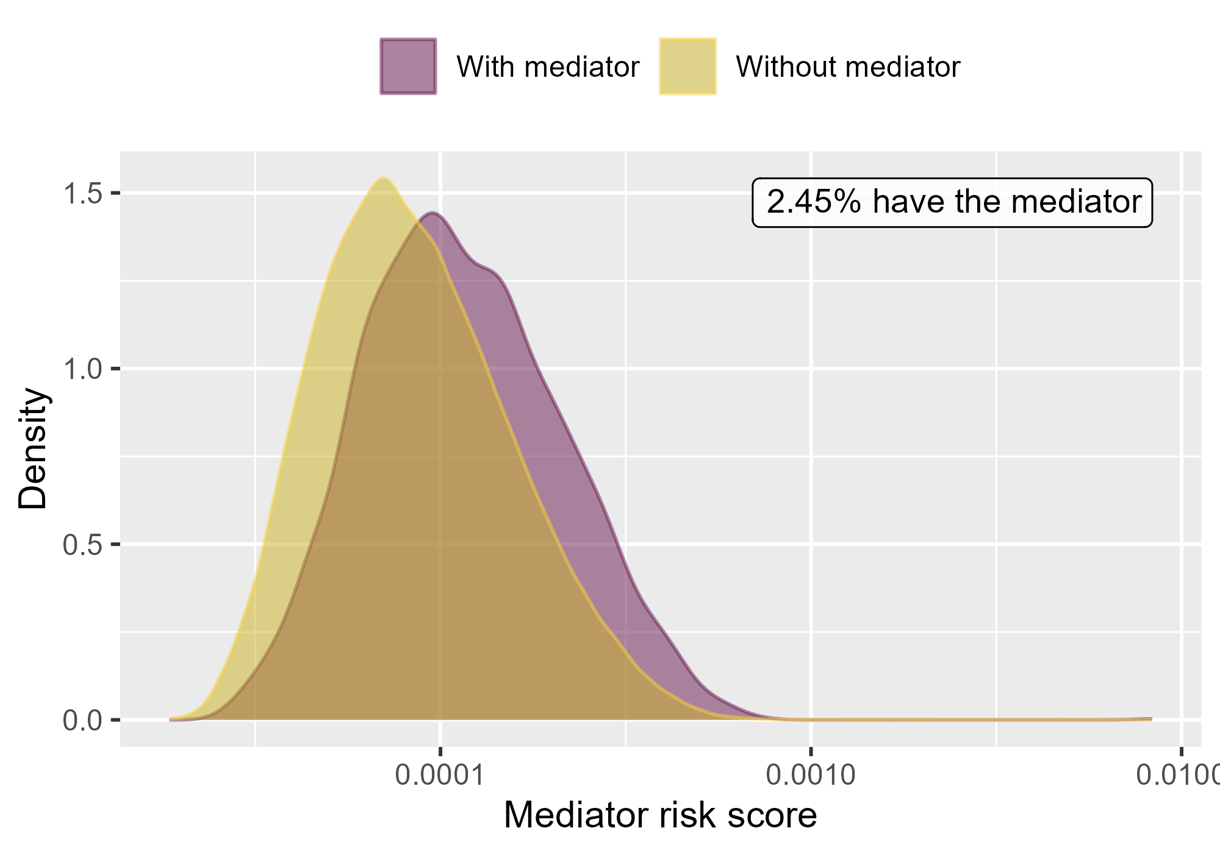

Mediator risk score by mediator status when comparing Rivaroxaban to Warfarin using mediator Extracranial Major bleeding IP-ER in MDCR.

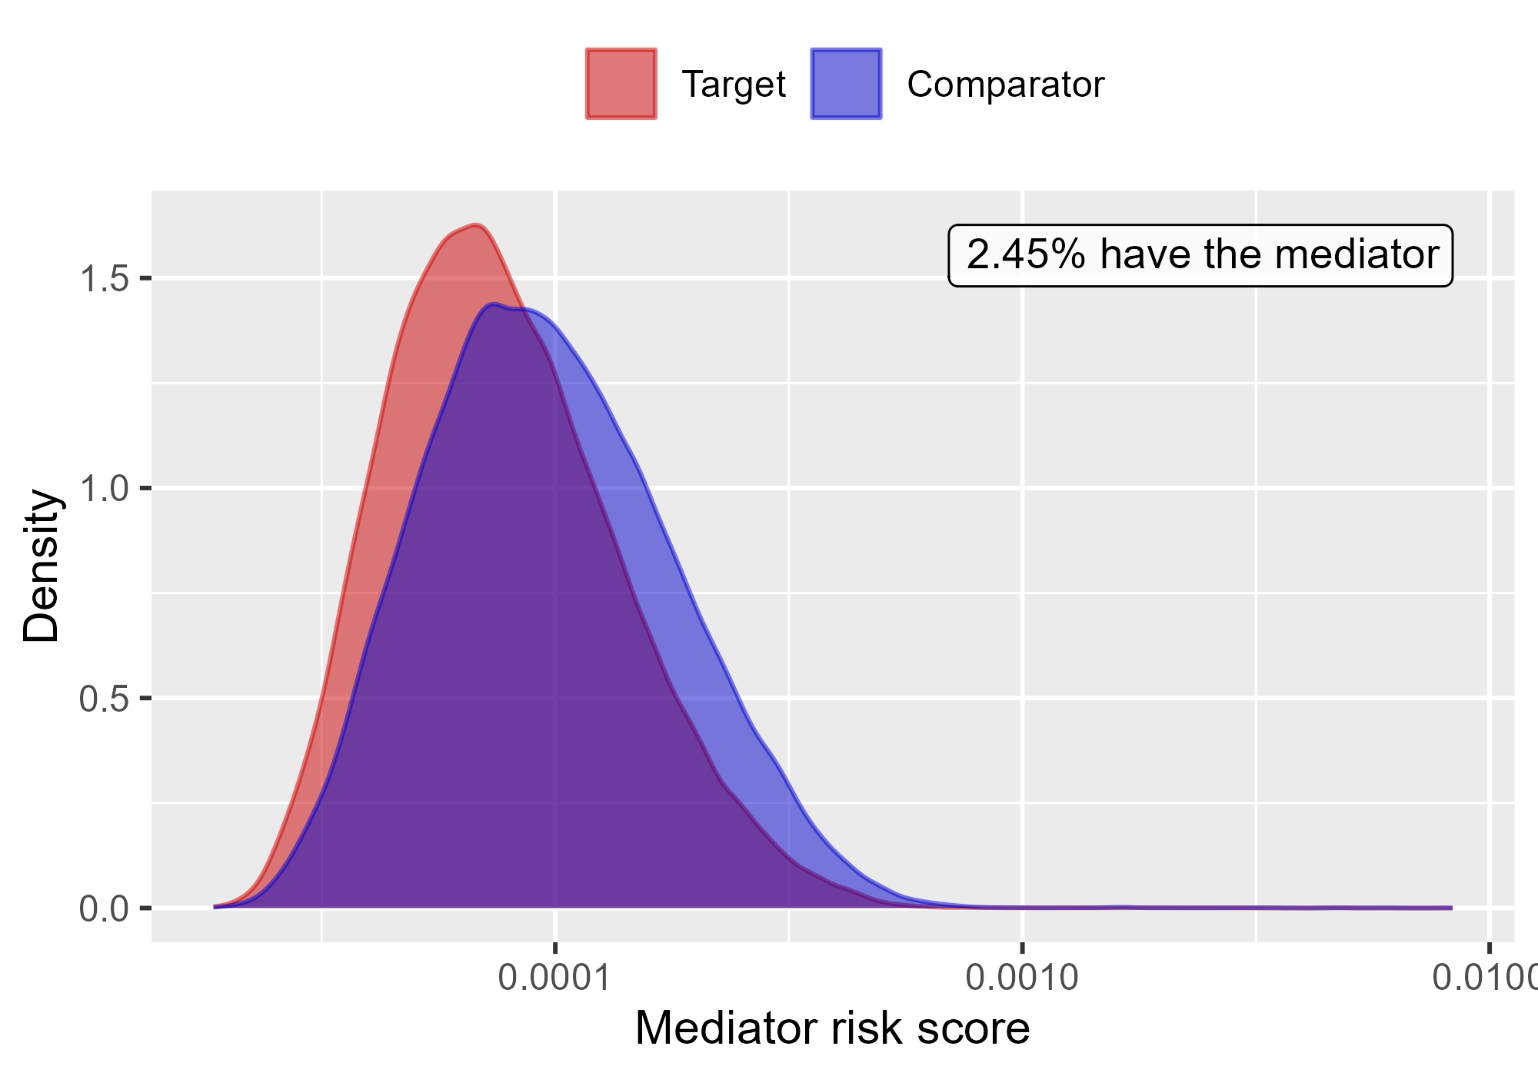

Mediator risk score by exposure status when comparing Rivaroxaban to Warfarin using mediator Extracranial Major bleeding IP-ER in MDCR.

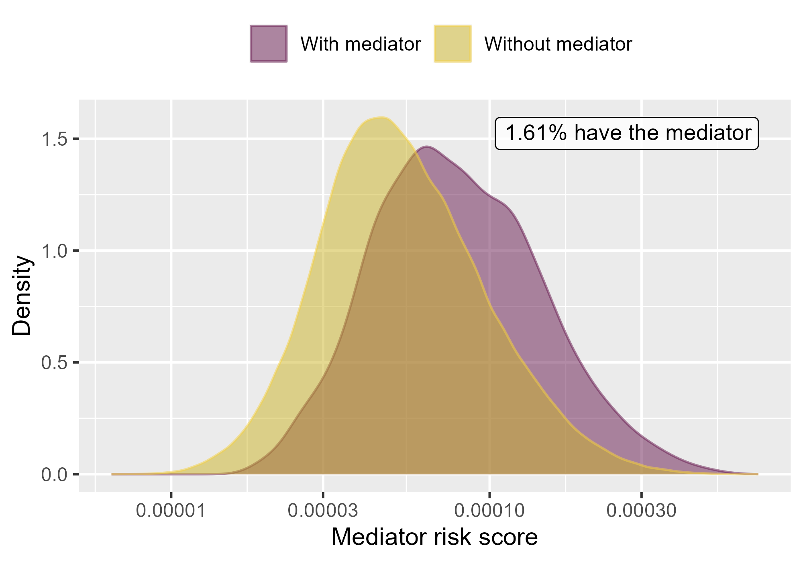

Mediator risk score by mediator status when comparing Rivaroxaban to Warfarin using mediator Extracranial Major bleeding IP in MDCR.

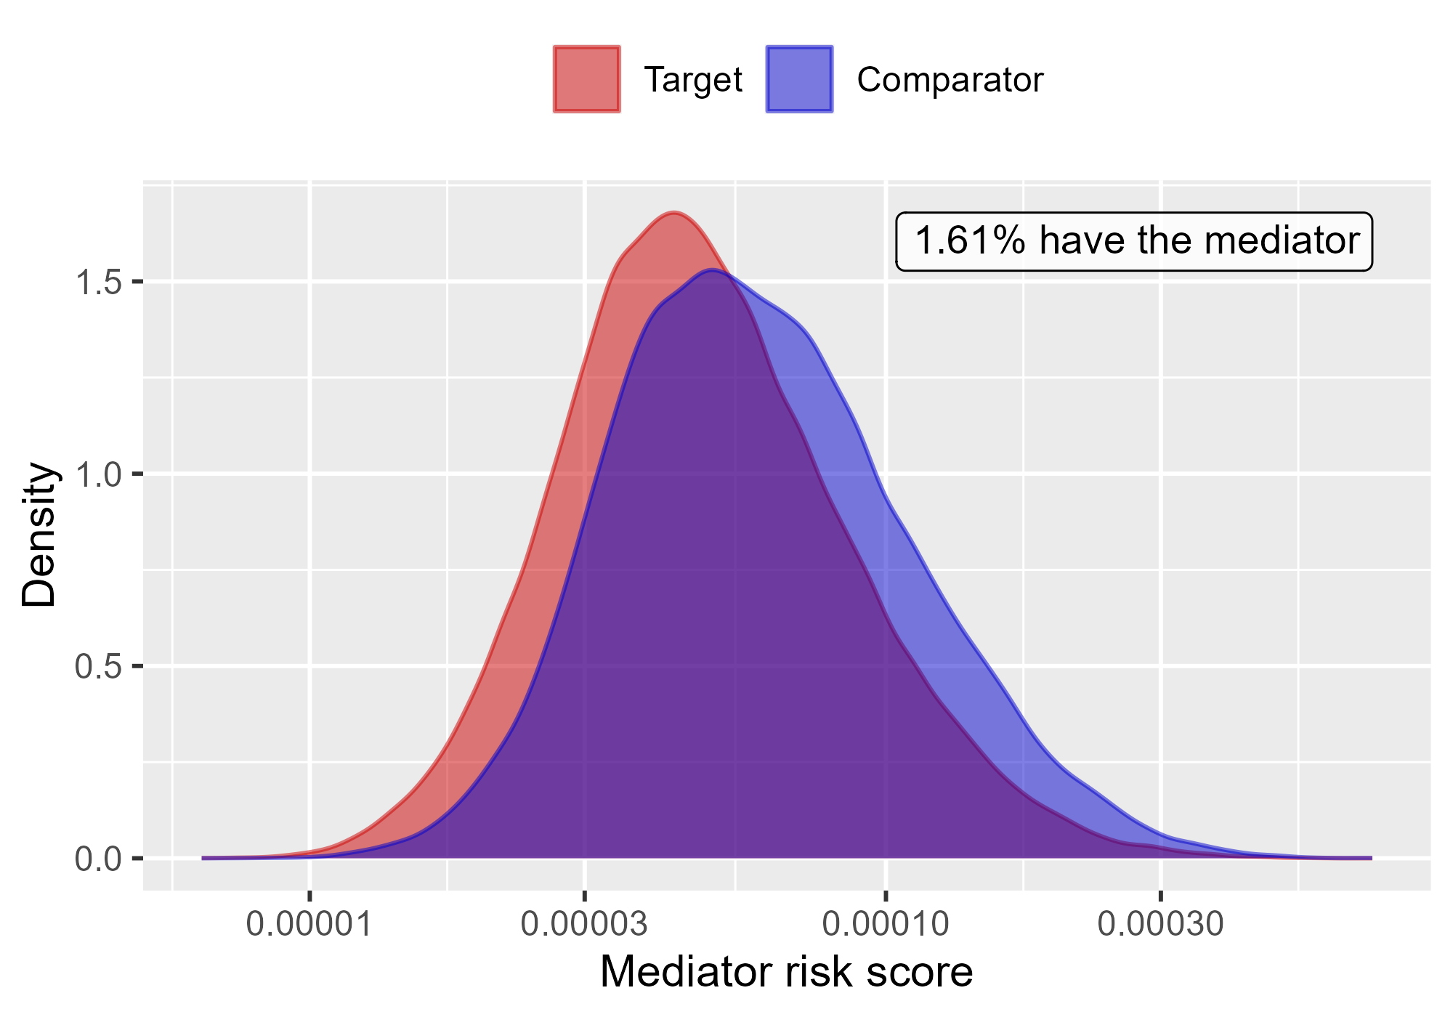

Mediator risk score by exposure status when comparing Rivaroxaban to Warfarin using mediator Extracranial Major bleeding IP in MDCR.

# 5 Negative controls

Table 5.1: Expected Absolute Systematic Error (EASE) per database, comparison, and mediator.

| Database | Target | Comparator | Mediator | EASE main | EASE direct | EASE indirect |
| --- | --- | --- | --- | --- | --- | --- |
| CCAE | DOACs | Warfarin | Extracranial Major bleeding IP-ER | 0.07 | 0.07 | 0.00 |
| CCAE | DOACs | Warfarin | Extracranial Major bleeding IP | 0.07 | 0.07 | 0.00 |
| CCAE | Rivaroxaban | Warfarin | Extracranial Major bleeding IP-ER | 0.08 | 0.08 | 0.01 |
| CCAE | Rivaroxaban | Warfarin | Extracranial Major bleeding IP | 0.08 | 0.08 | 0.00 |
| OptumDod | DOACs | Warfarin | Extracranial Major bleeding IP-ER | 0.09 | 0.09 | 0.00 |
| OptumDod | DOACs | Warfarin | Extracranial Major bleeding IP | 0.09 | 0.09 | 0.00 |
| OptumDod | Rivaroxaban | Warfarin | Extracranial Major bleeding IP-ER | 0.06 | 0.06 | 0.00 |
| OptumDod | Rivaroxaban | Warfarin | Extracranial Major bleeding IP | 0.07 | 0.07 | 0.00 |
| OptumEhr | DOACs | Warfarin | Extracranial Major bleeding IP-ER | 0.04 | 0.04 | 0.00 |
| OptumEhr | DOACs | Warfarin | Extracranial Major bleeding IP | 0.04 | 0.04 | 0.00 |
| OptumEhr | Rivaroxaban | Warfarin | Extracranial Major bleeding IP-ER | 0.05 | 0.05 | 0.00 |
| OptumEhr | Rivaroxaban | Warfarin | Extracranial Major bleeding IP | 0.05 | 0.05 | 0.00 |
| PharMetrics | DOACs | Warfarin | Extracranial Major bleeding IP-ER | 0.02 | 0.02 | 0.00 |
| PharMetrics | DOACs | Warfarin | Extracranial Major bleeding IP | 0.02 | 0.02 | 0.00 |
| PharMetrics | Rivaroxaban | Warfarin | Extracranial Major bleeding IP-ER | 0.03 | 0.03 | 0.00 |
| PharMetrics | Rivaroxaban | Warfarin | Extracranial Major bleeding IP | 0.03 | 0.03 | 0.00 |
| MDCR | DOACs | Warfarin | Extracranial Major bleeding IP-ER | 0.03 | 0.03 | 0.00 |
| MDCR | DOACs | Warfarin | Extracranial Major bleeding IP | 0.03 | 0.03 | 0.00 |
| MDCR | Rivaroxaban | Warfarin | Extracranial Major bleeding IP-ER | 0.04 | 0.05 | 0.00 |
| MDCR | Rivaroxaban | Warfarin | Extracranial Major bleeding IP | 0.05 | 0.04 | 0.00 |

### 5.0.1 CCAE

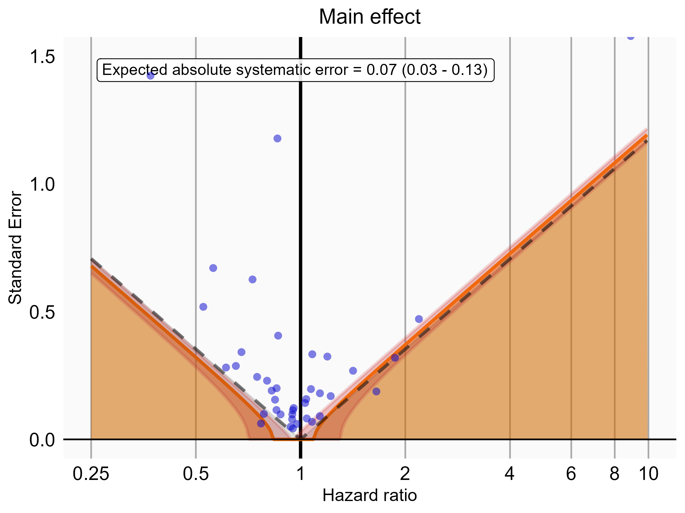

Negative control estimates of the main effect comparing DOACs to Warfarin using mediator Extracranial Major bleeding IP-ER in CCAE.

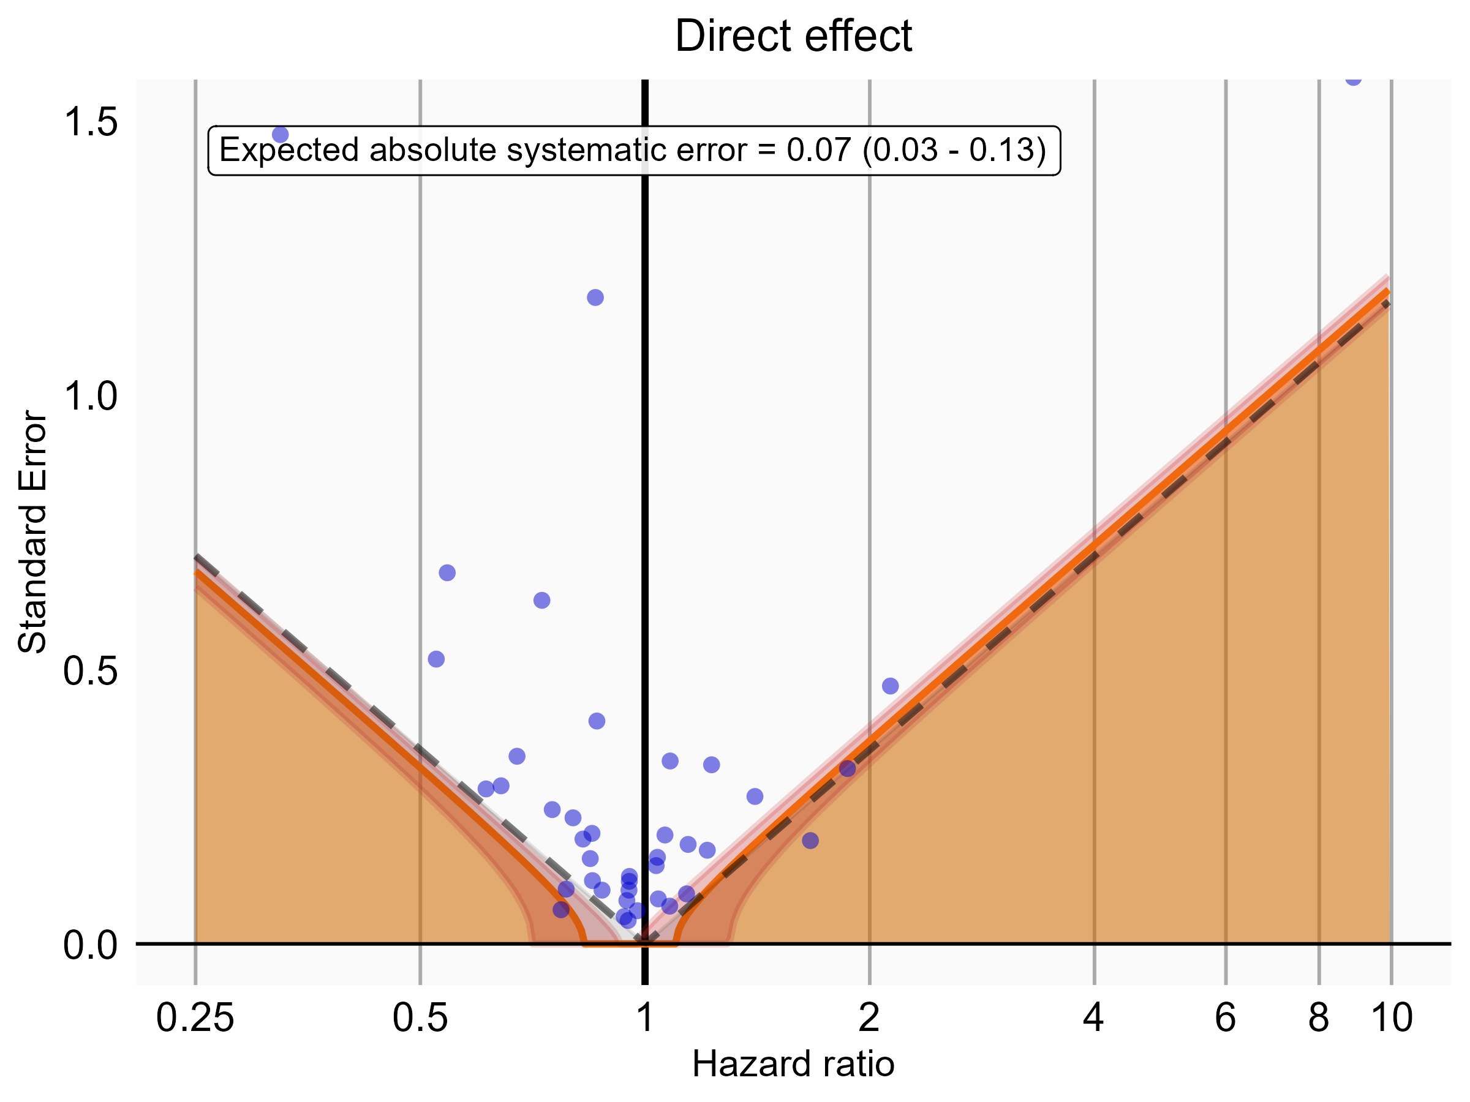

Negative control estimates of the direct effect comparing DOACs to Warfarin using mediator Extracranial Major bleeding IP-ER in CCAE.

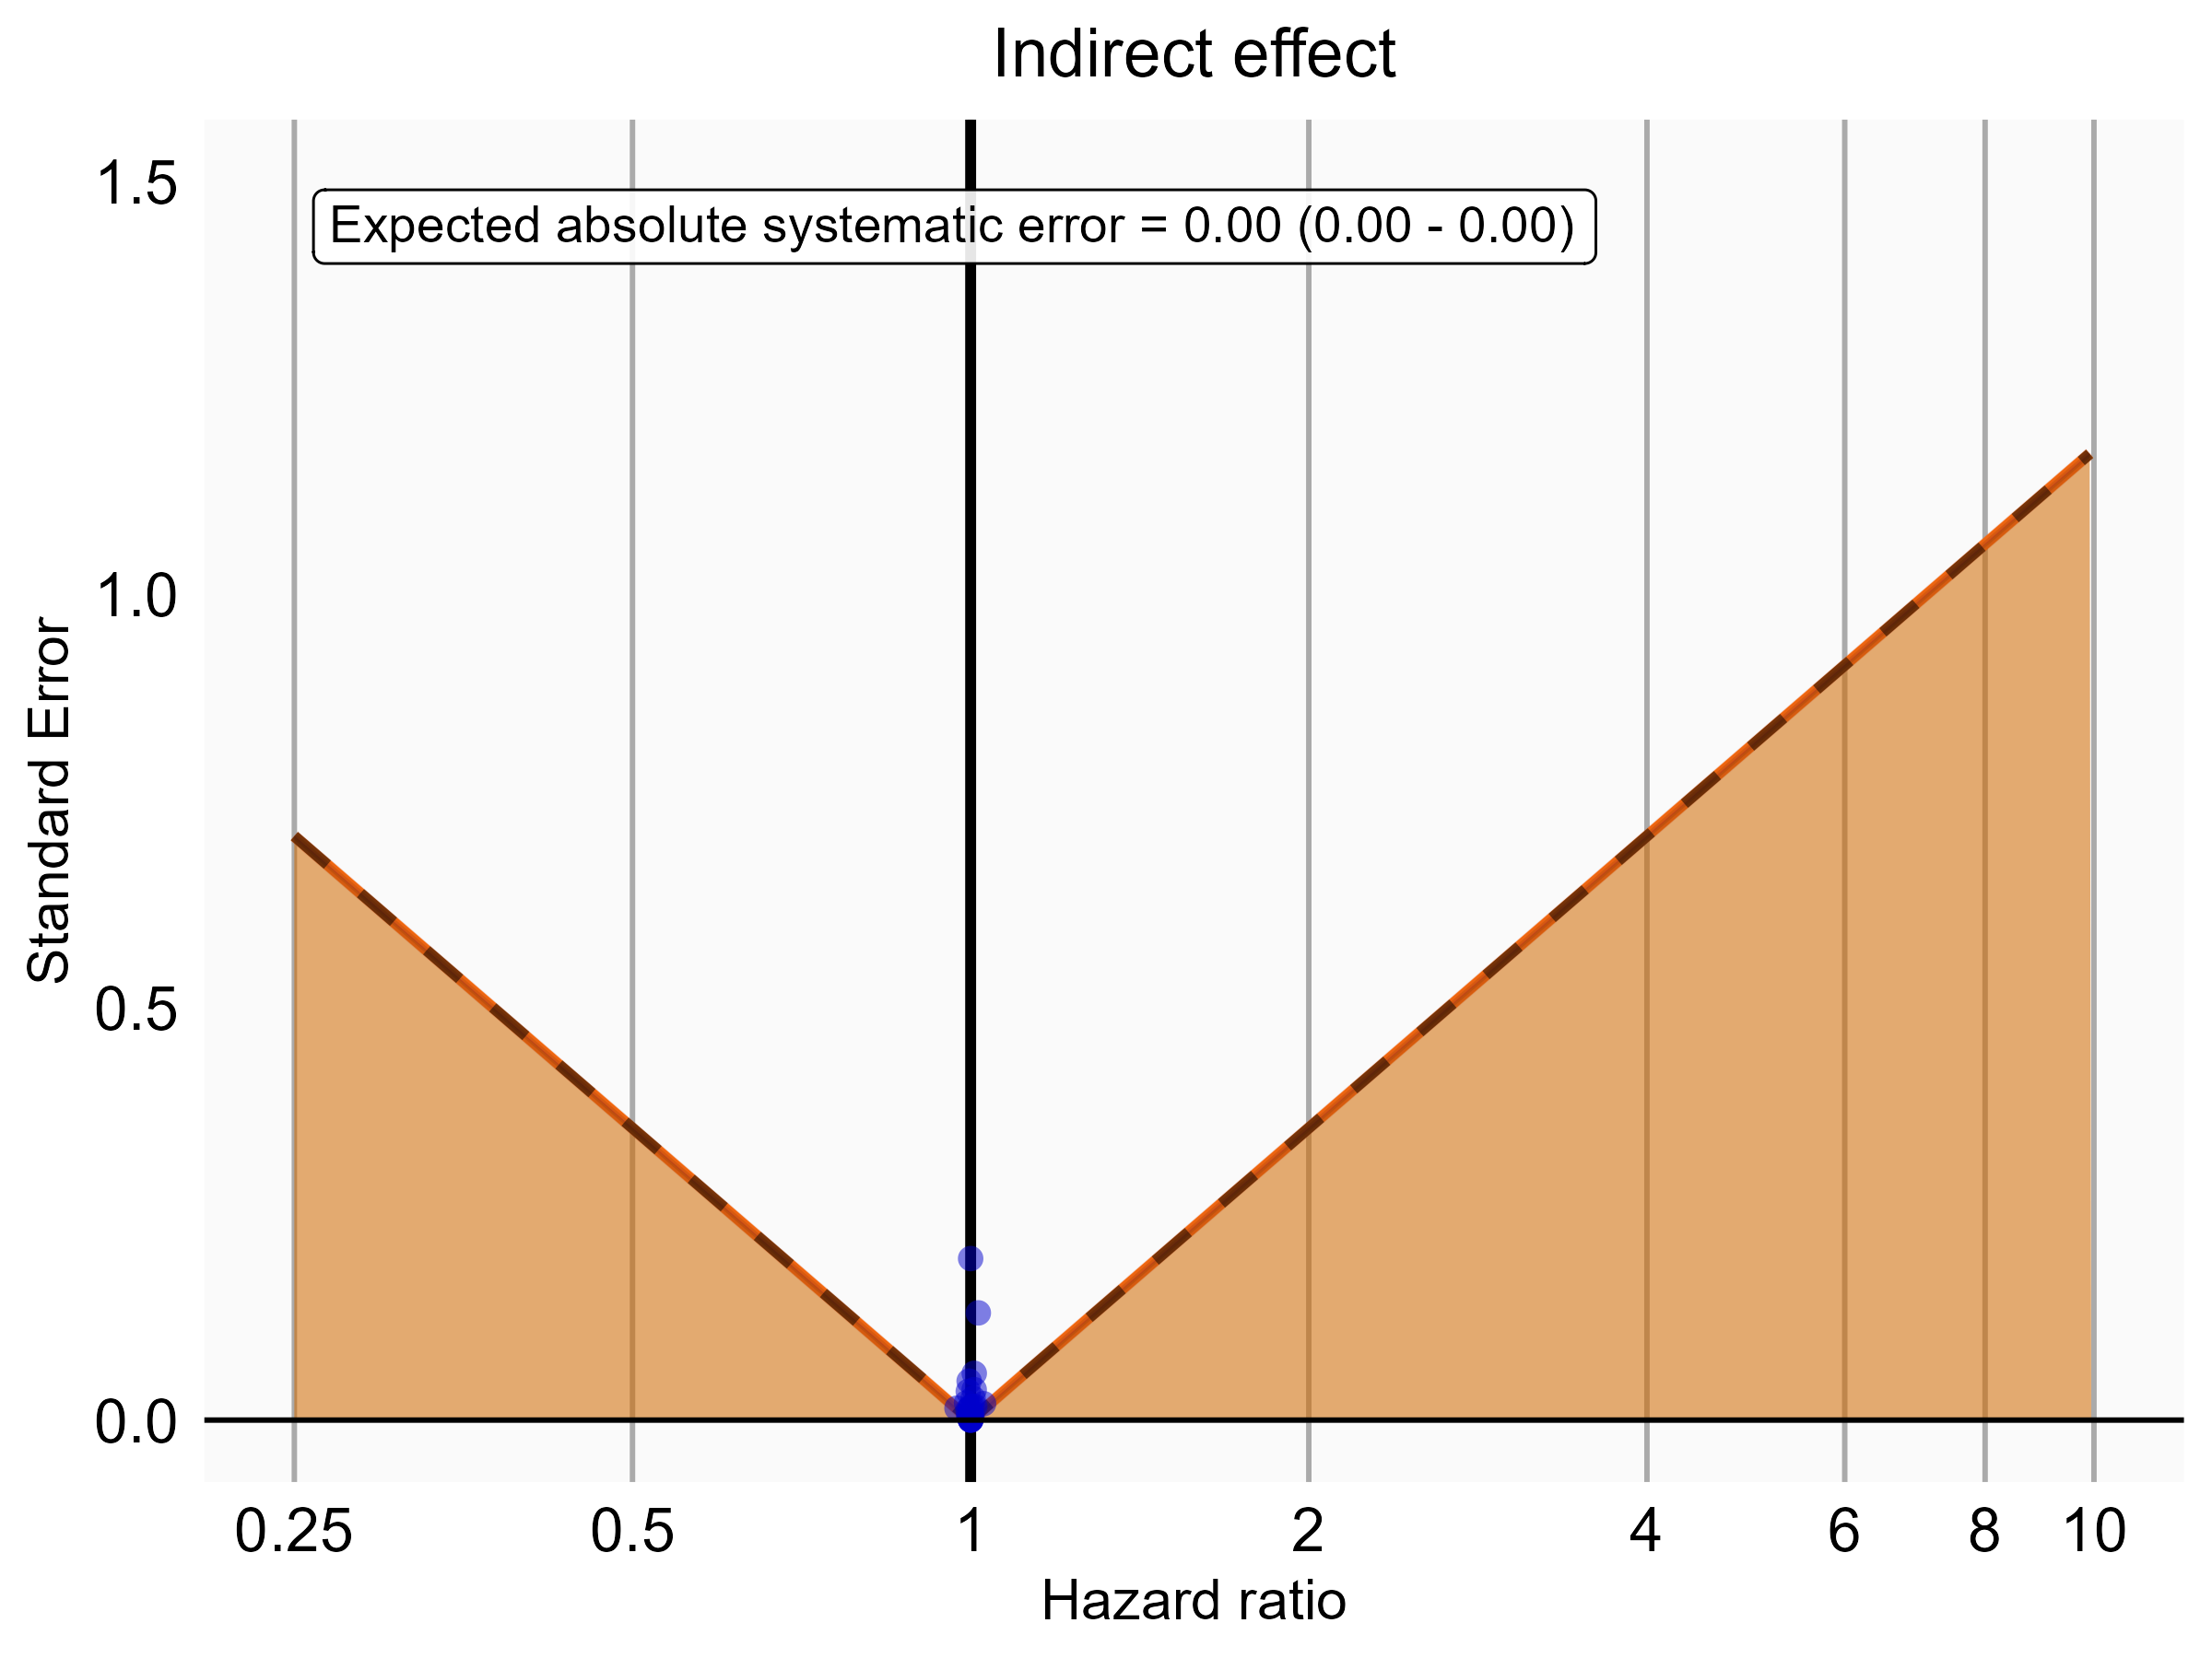

Negative control estimates of the indirect effect comparing DOACs to Warfarin using mediator Extracranial Major bleeding IP-ER in CCAE.

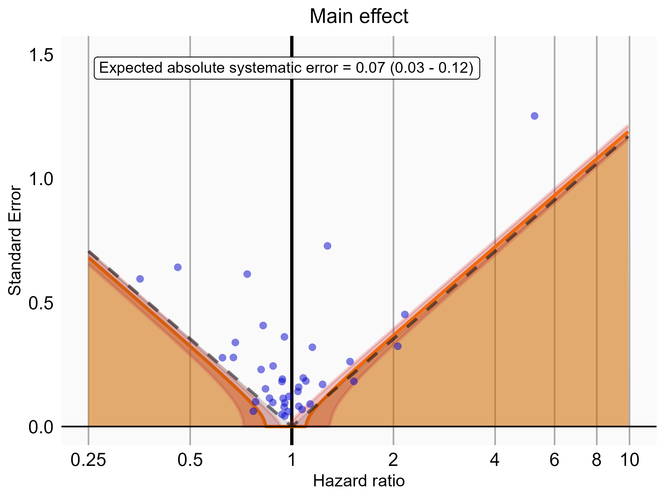

Negative control estimates of the main effect comparing DOACs to Warfarin using mediator Extracranial Major bleeding IP in CCAE.

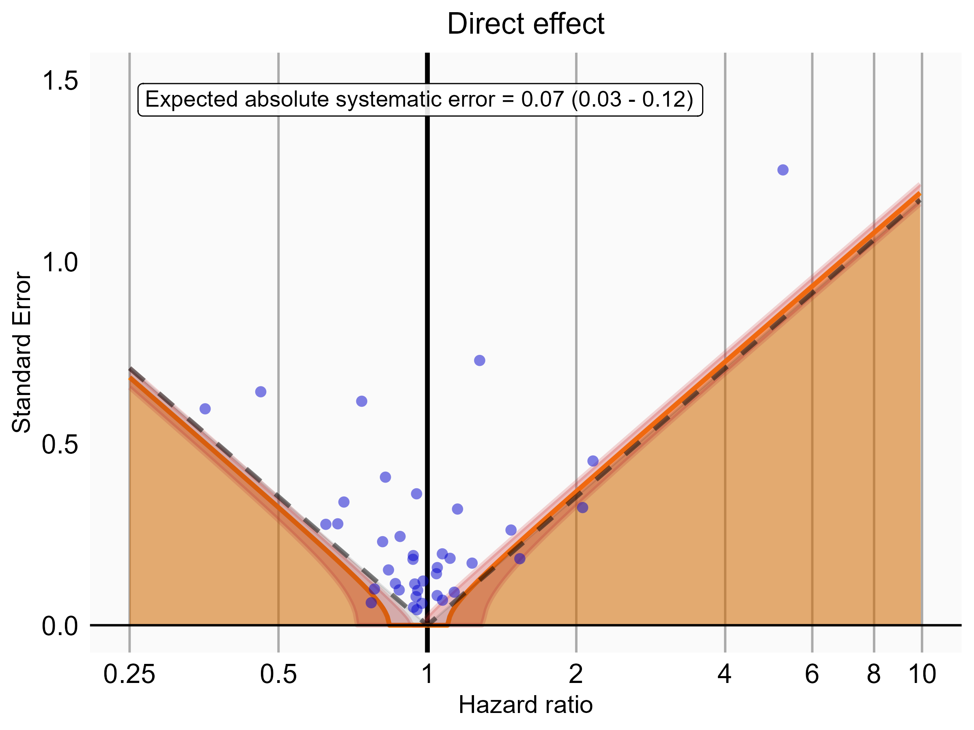

Negative control estimates of the direct effect comparing DOACs to Warfarin using mediator Extracranial Major bleeding IP in CCAE.

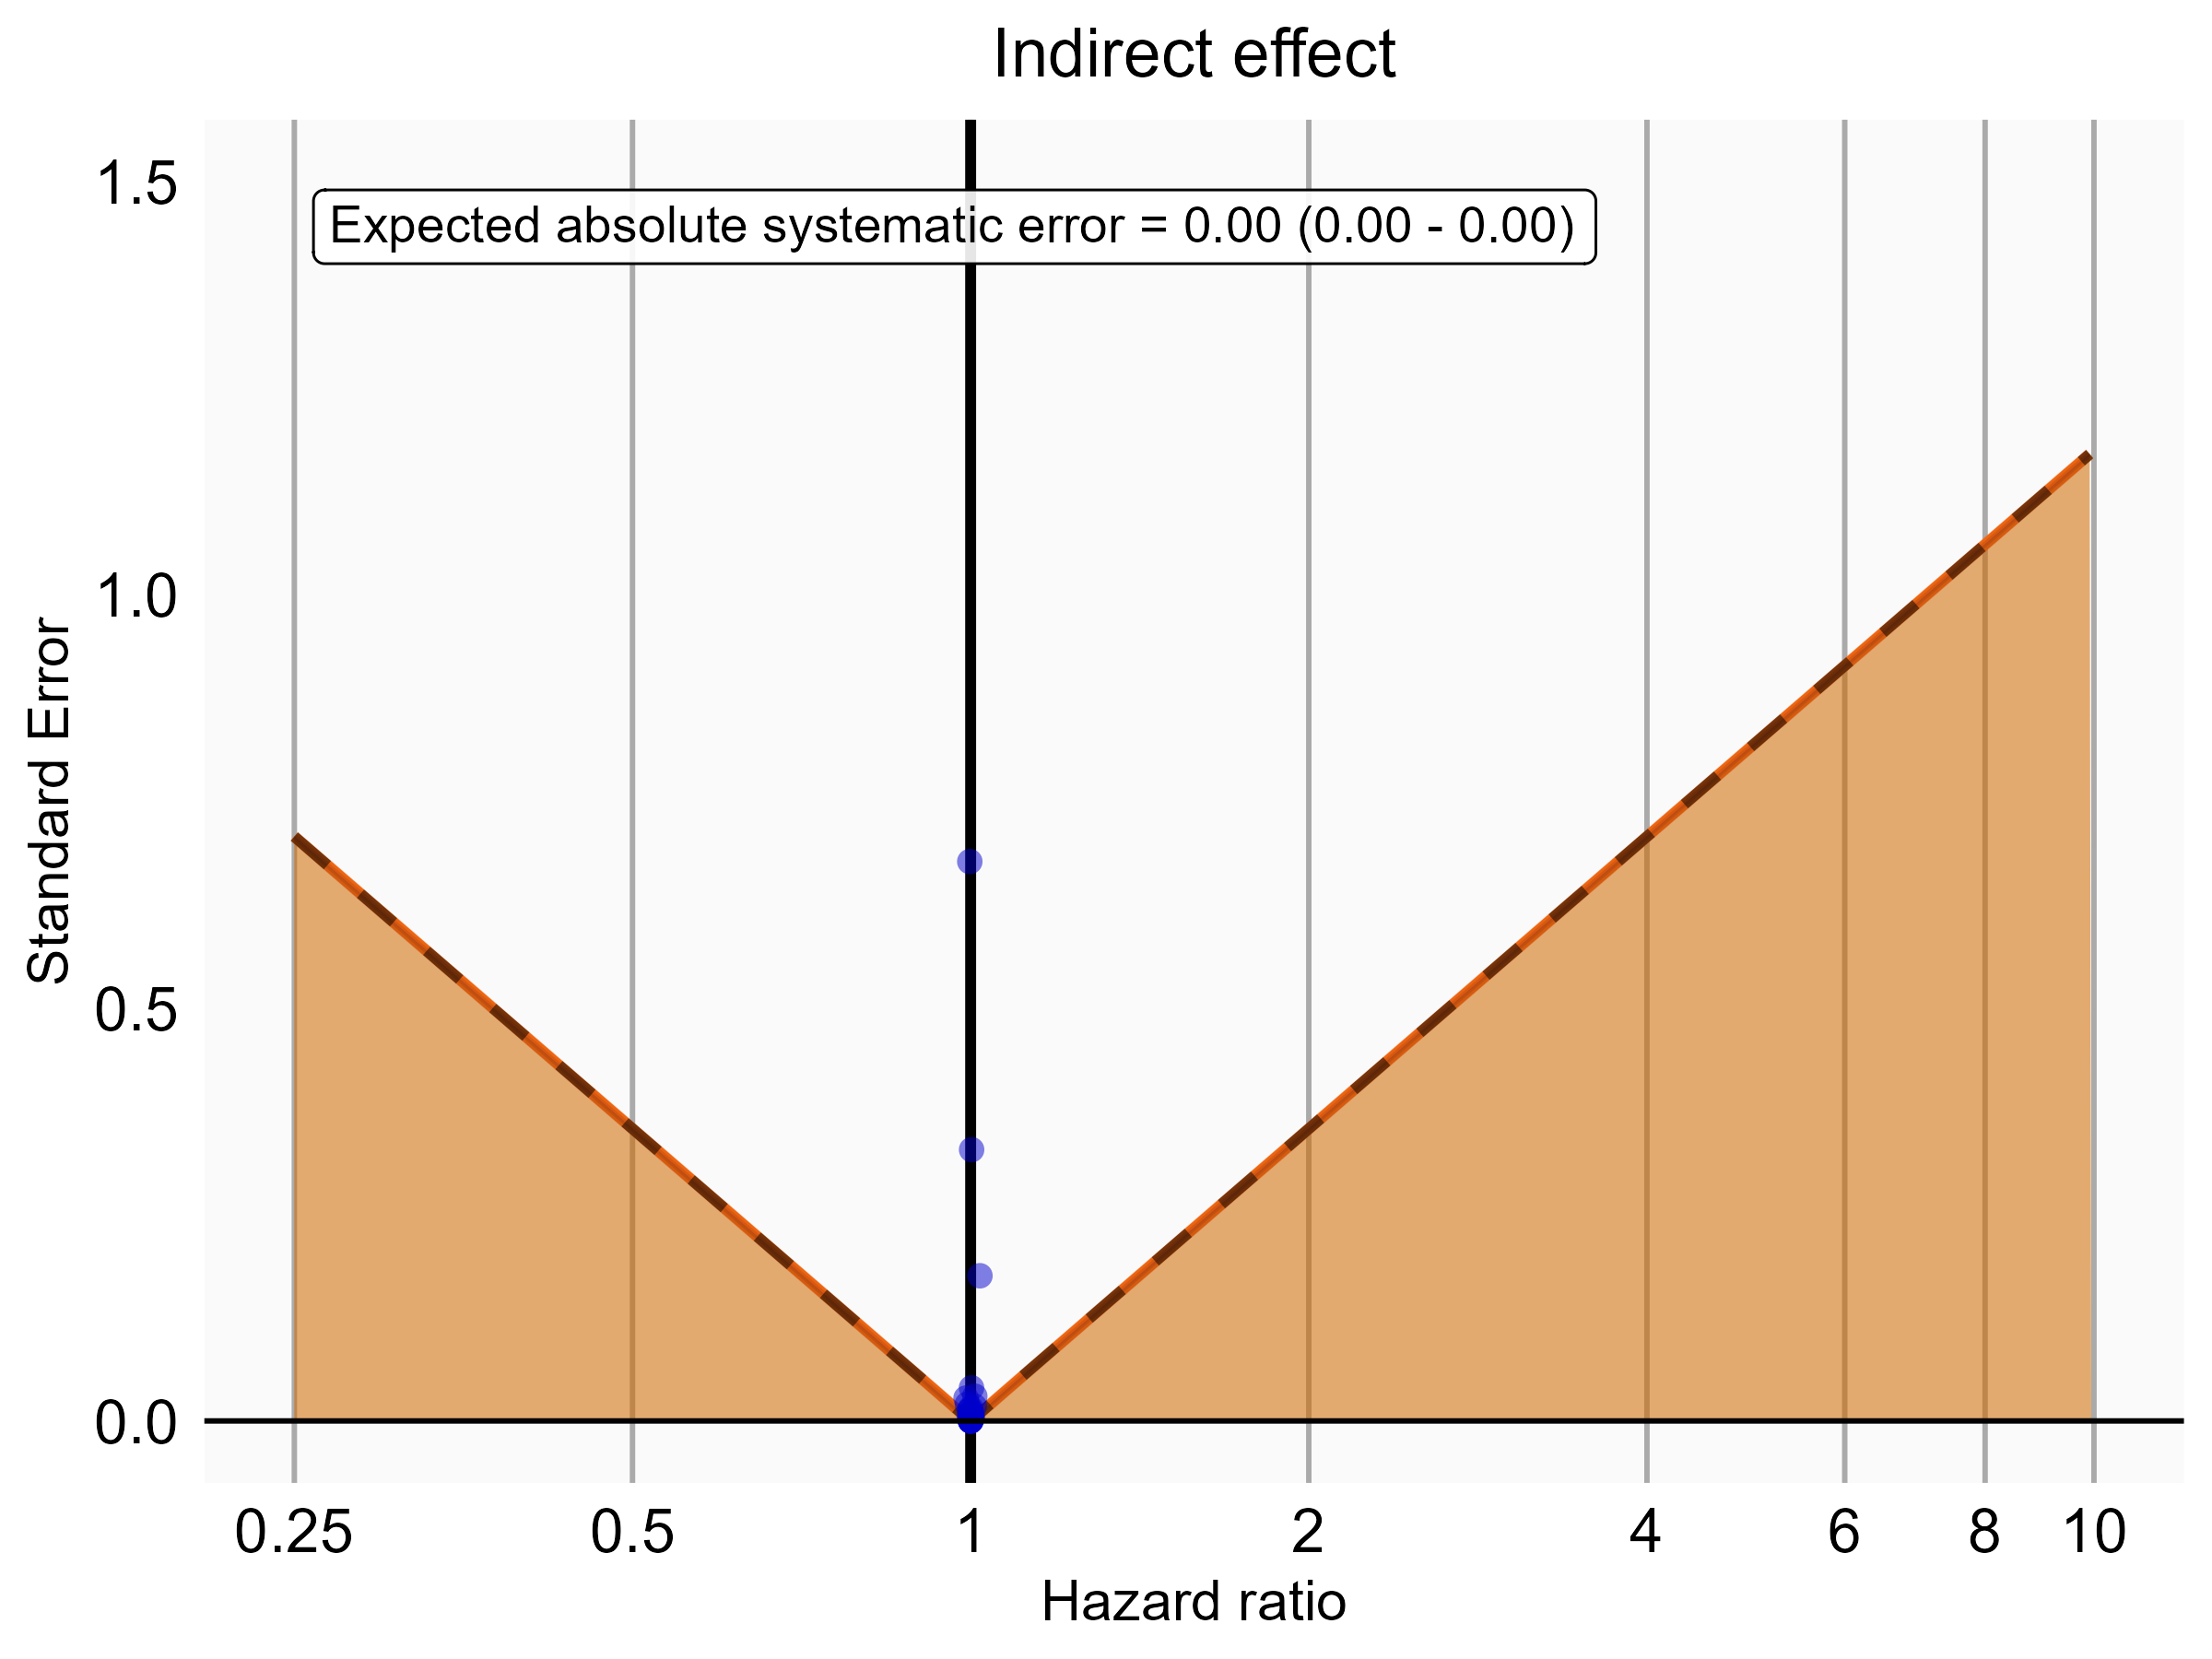

Negative control estimates of the indirect effect comparing DOACs to Warfarin using mediator Extracranial Major bleeding IP in CCAE.

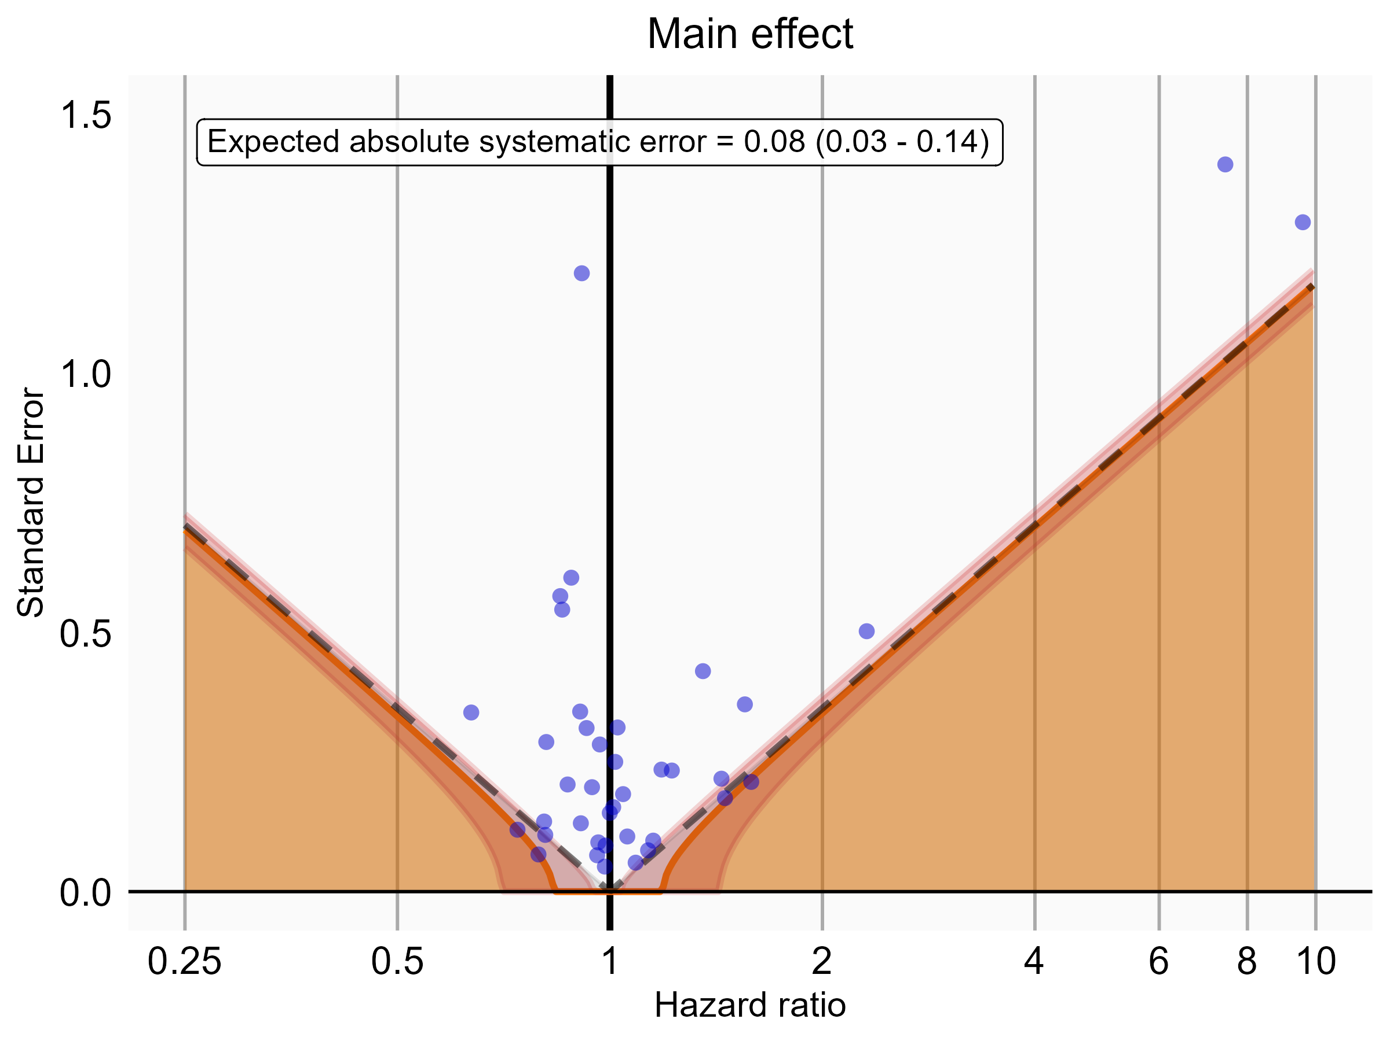

Negative control estimates of the main effect comparing Rivaroxaban to Warfarin using mediator Extracranial Major bleeding IP-ER in CCAE.

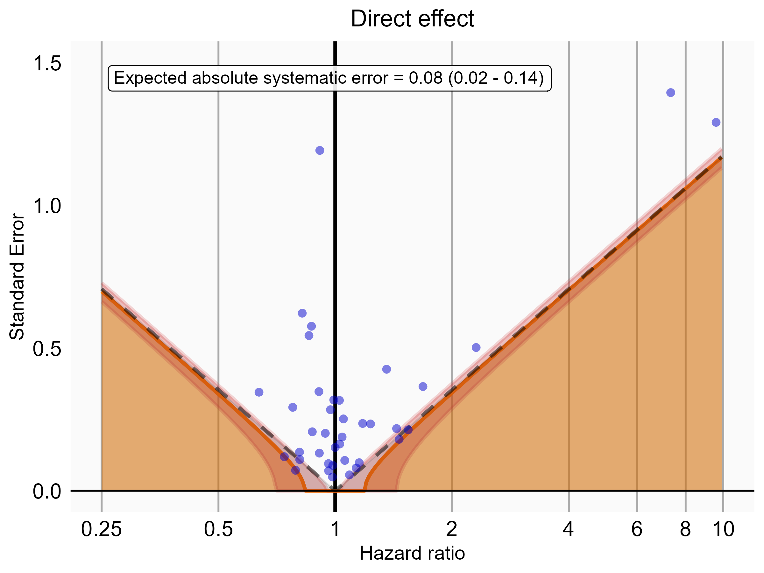

Negative control estimates of the direct effect comparing Rivaroxaban to Warfarin using mediator Extracranial Major bleeding IP-ER in CCAE.

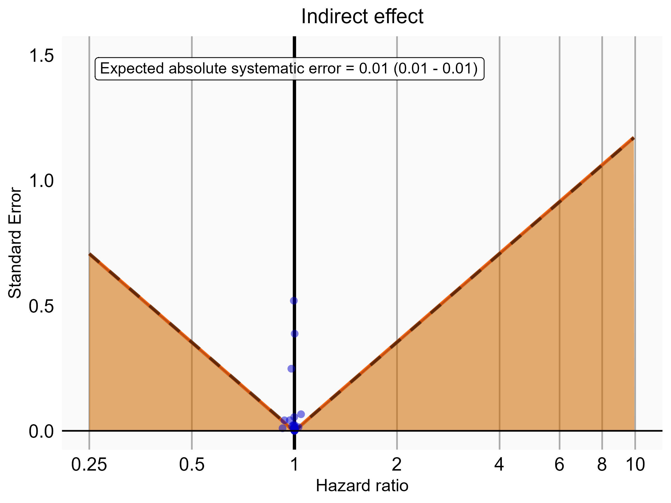

Negative control estimates of the indirect effect comparing Rivaroxaban to Warfarin using mediator Extracranial Major bleeding IP-ER in CCAE.

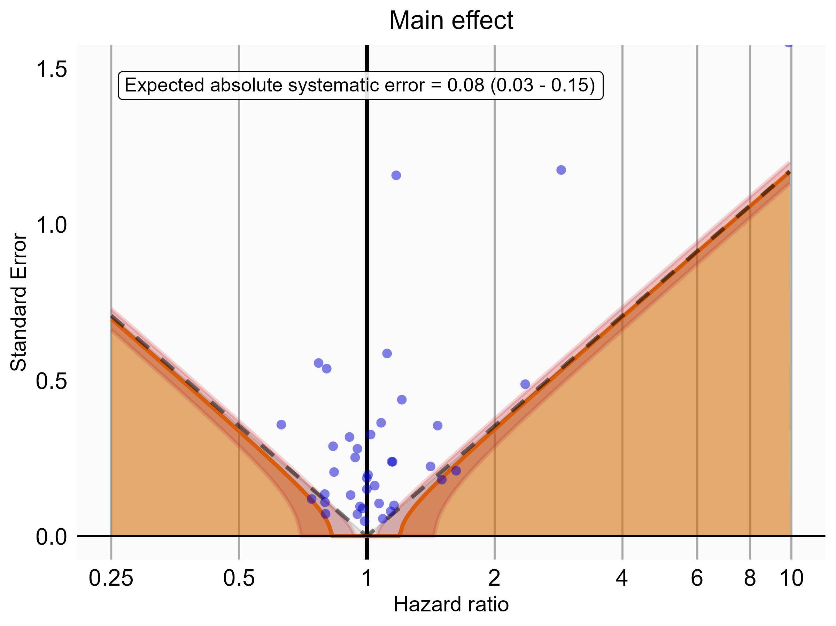

Negative control estimates of the main effect comparing Rivaroxaban to Warfarin using mediator Extracranial Major bleeding IP in CCAE.

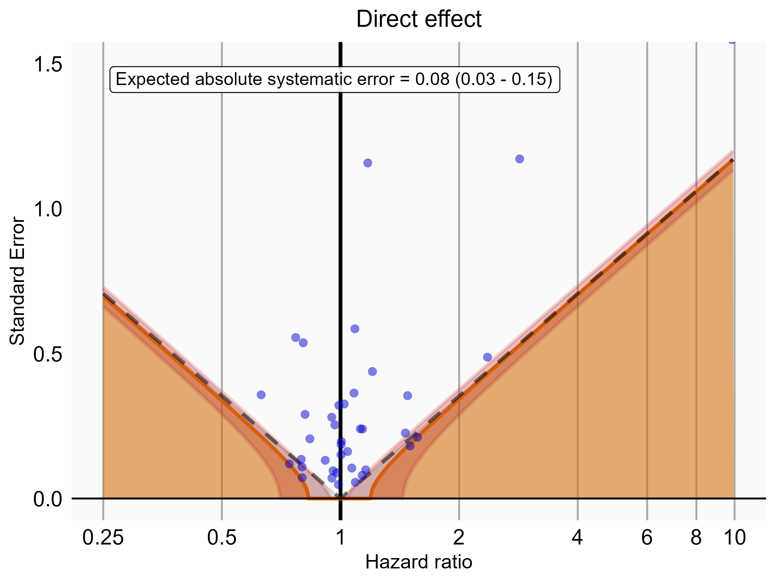

Negative control estimates of the direct effect comparing Rivaroxaban to Warfarin using mediator Extracranial Major bleeding IP in CCAE.

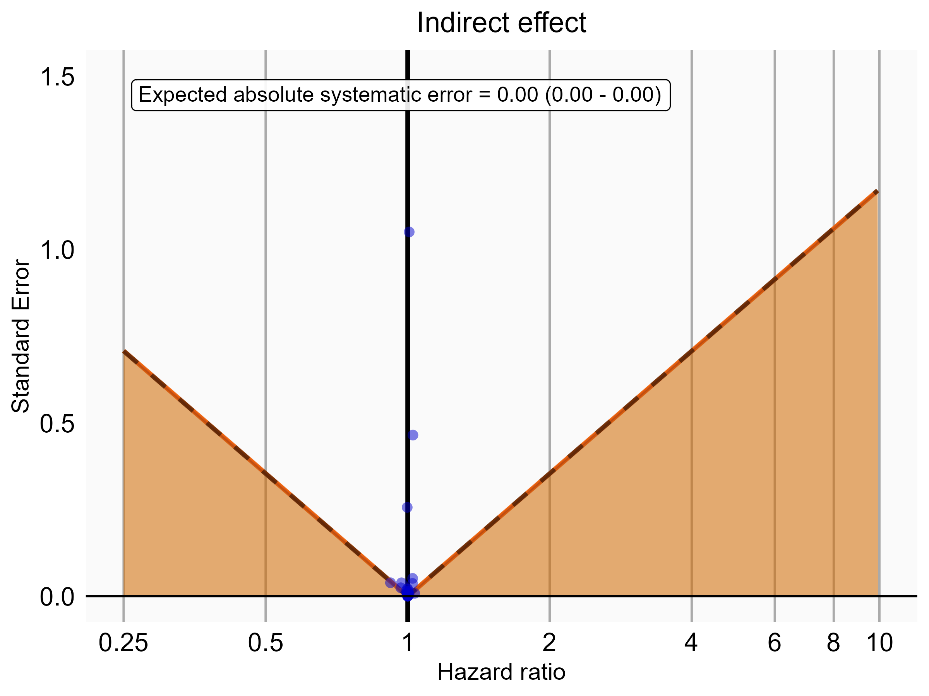

Negative control estimates of the indirect effect comparing Rivaroxaban to Warfarin using mediator Extracranial Major bleeding IP in CCAE.

### 5.0.2 OptumDod

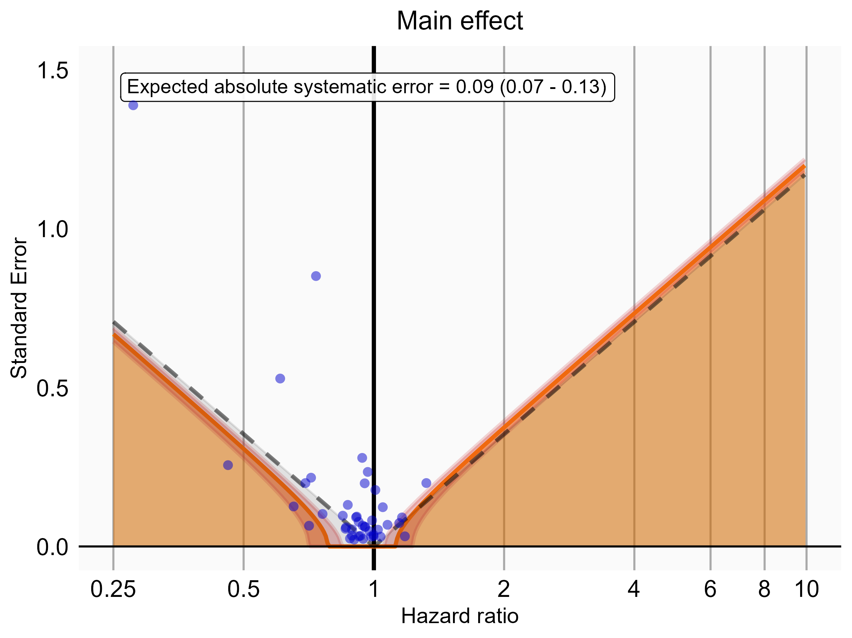

Negative control estimates of the main effect comparing DOACs to Warfarin using mediator Extracranial Major bleeding IP-ER in OptumDod.

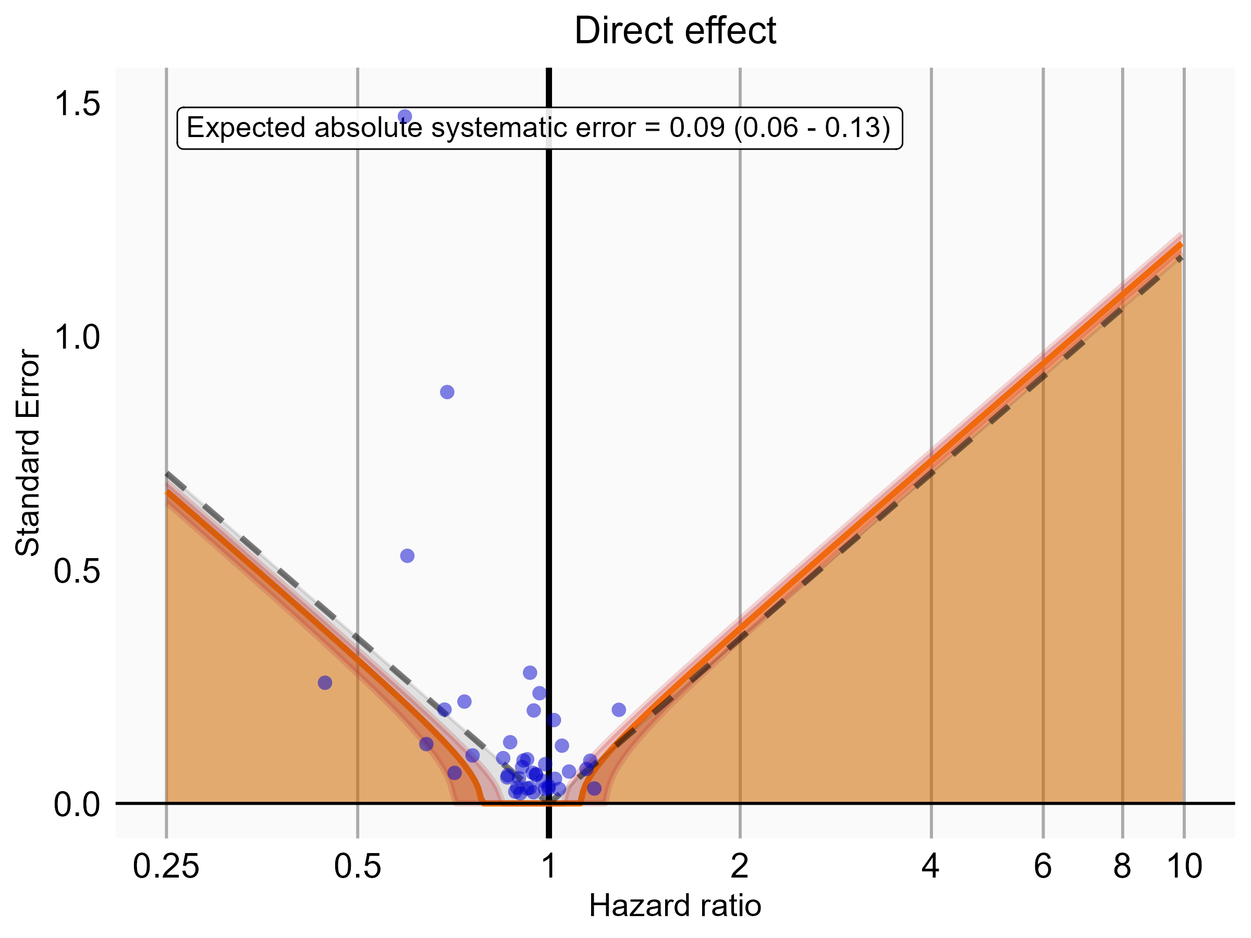

Negative control estimates of the direct effect comparing DOACs to Warfarin using mediator Extracranial Major bleeding IP-ER in OptumDod.

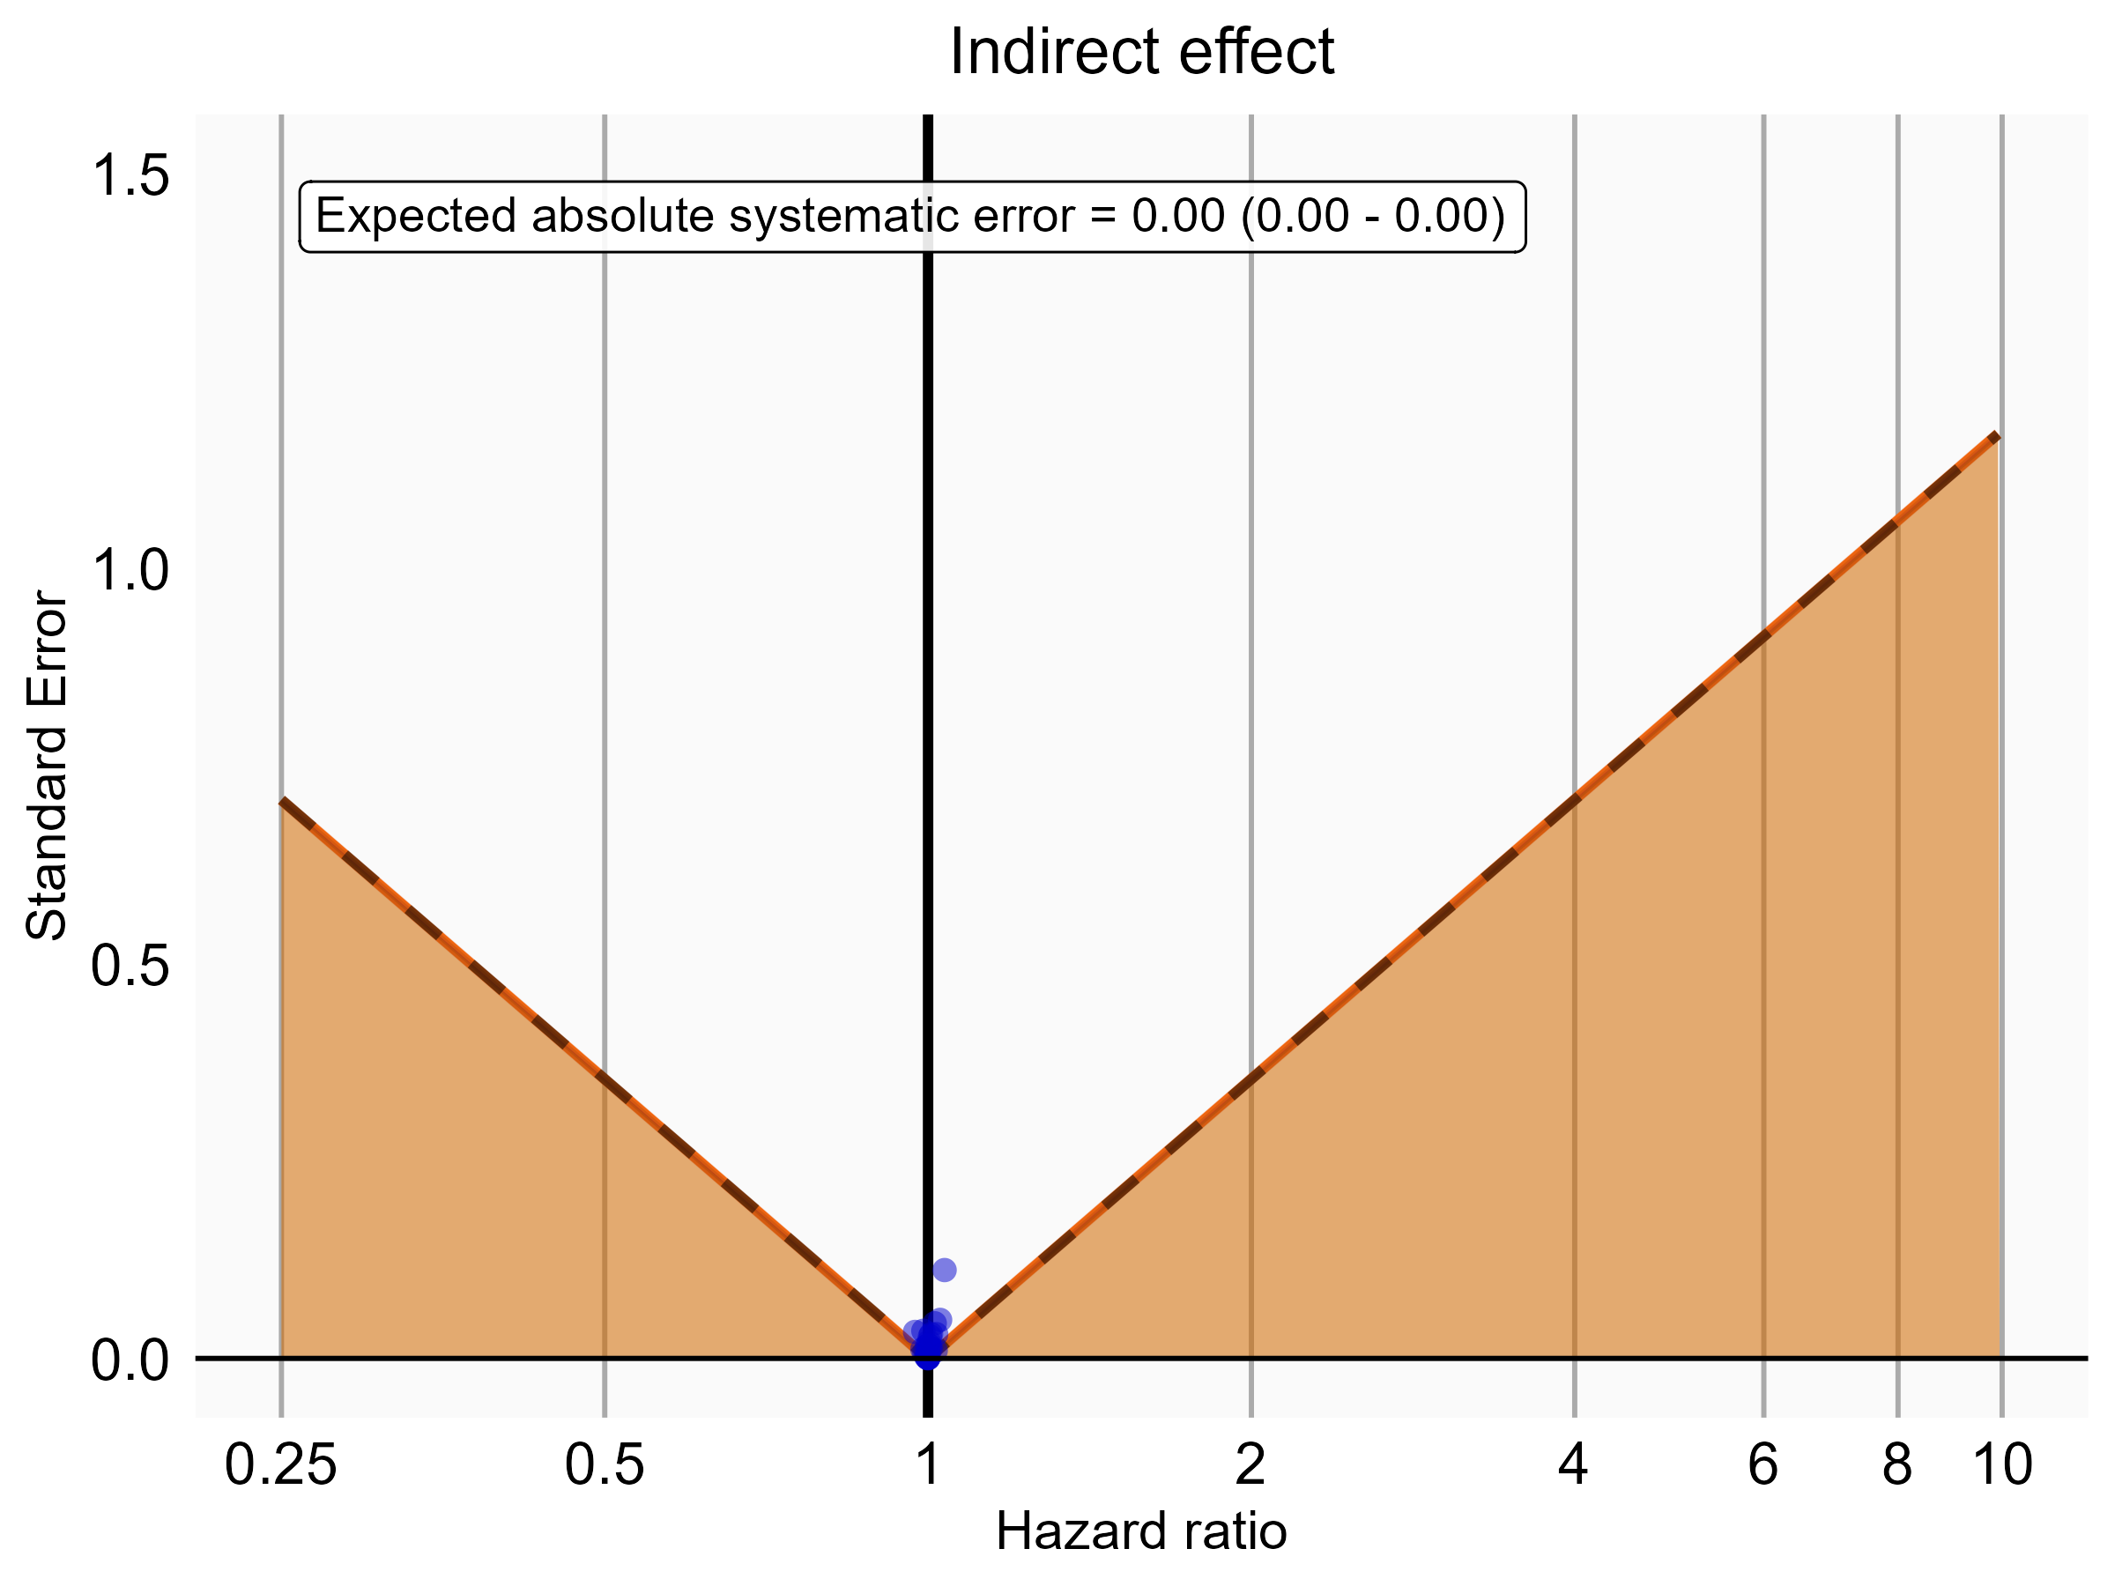

Negative control estimates of the indirect effect comparing DOACs to Warfarin using mediator Extracranial Major bleeding IP-ER in OptumDod.

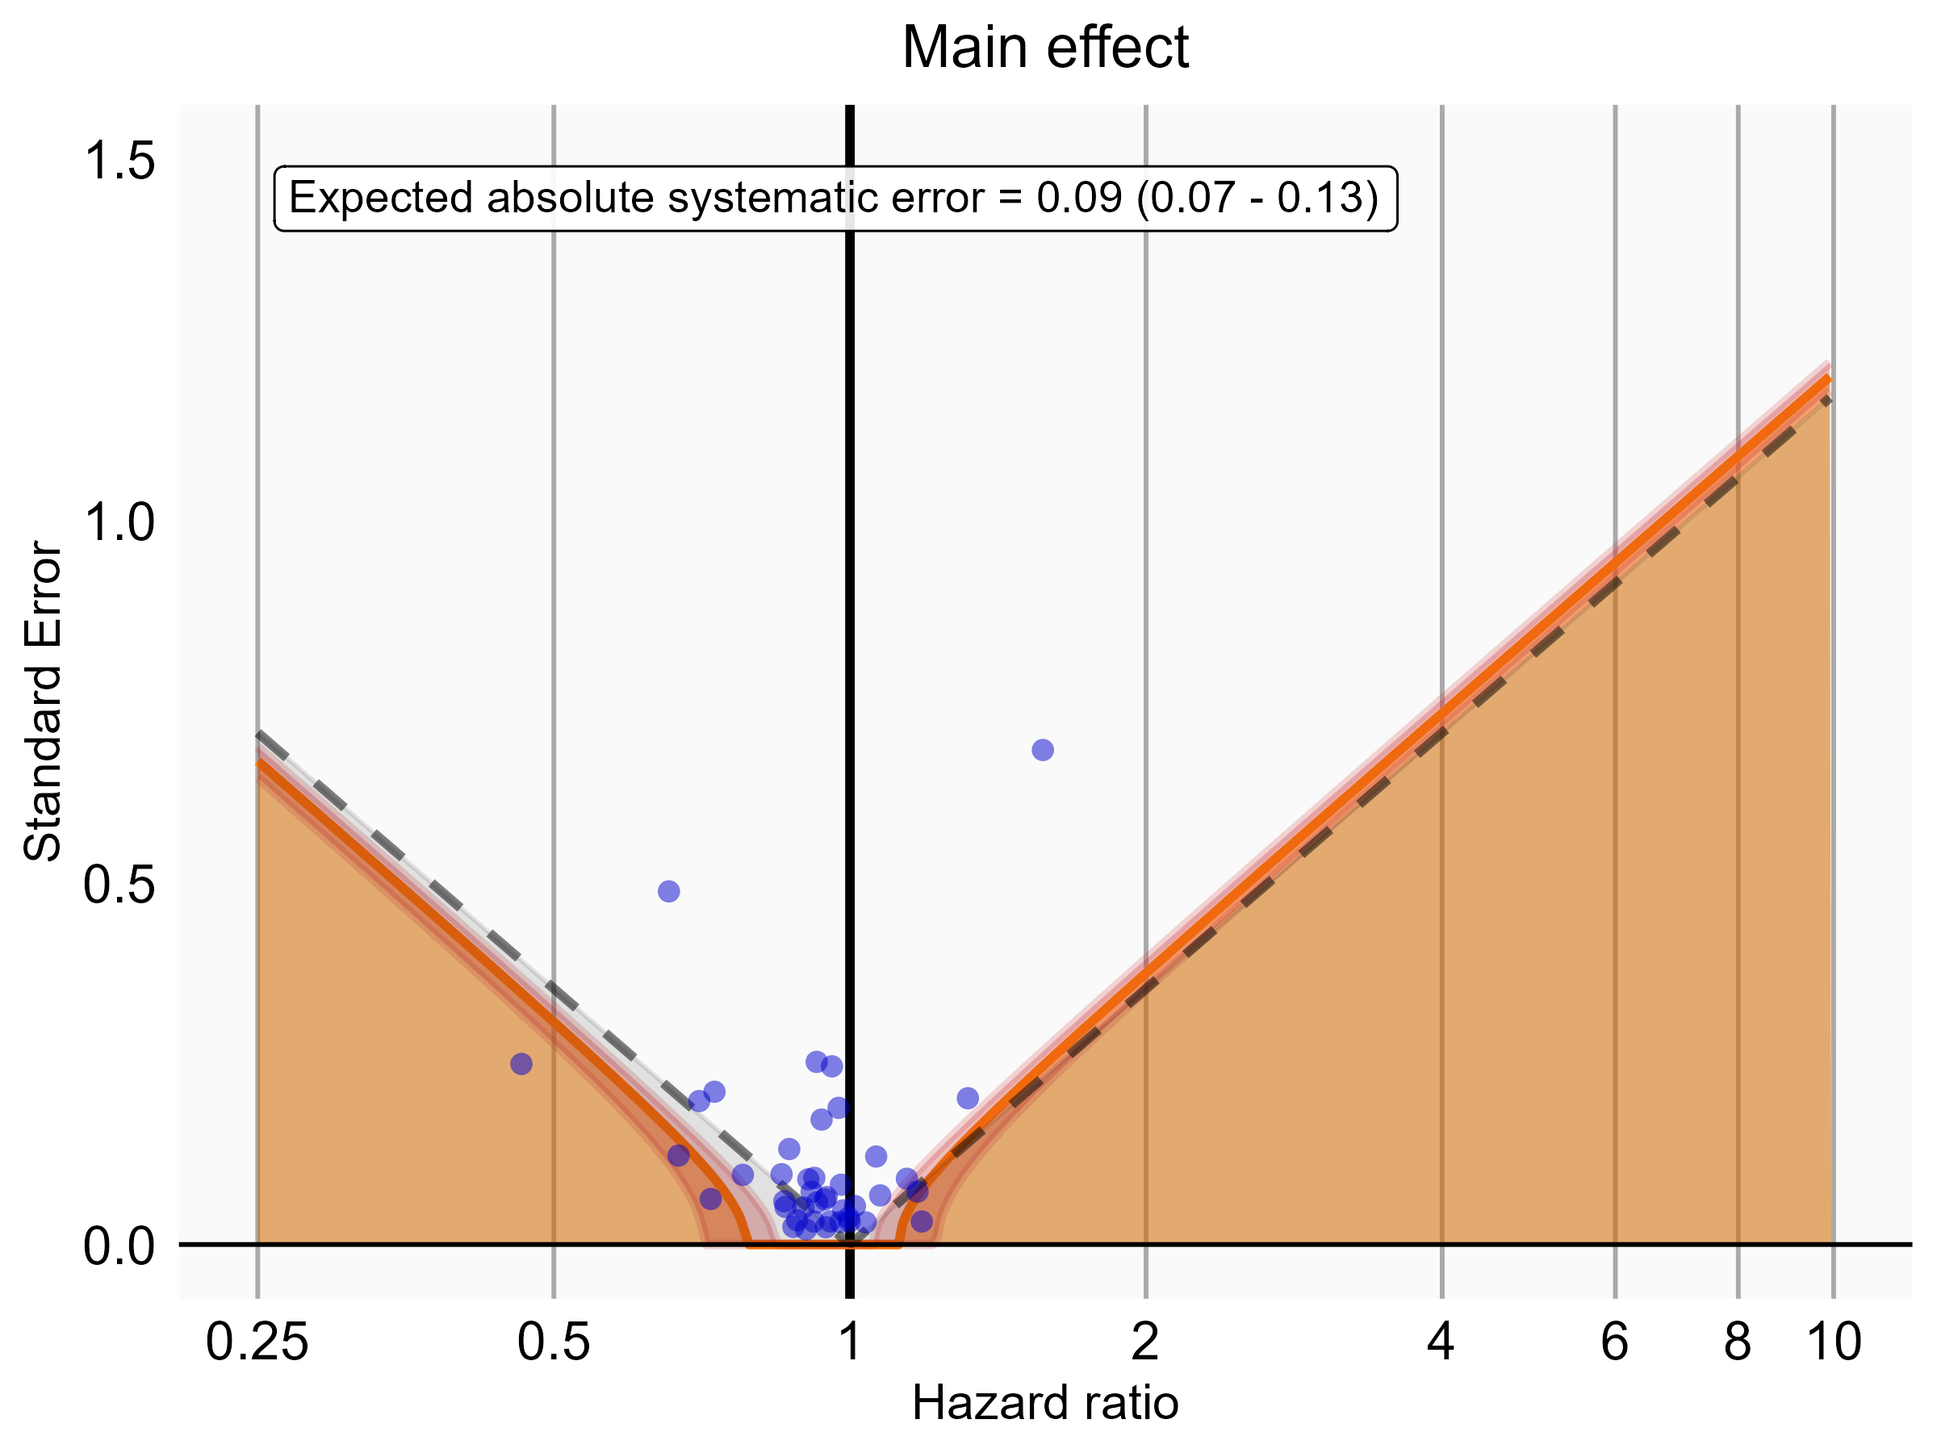

Negative control estimates of the main effect comparing DOACs to Warfarin using mediator Extracranial Major bleeding IP in OptumDod.

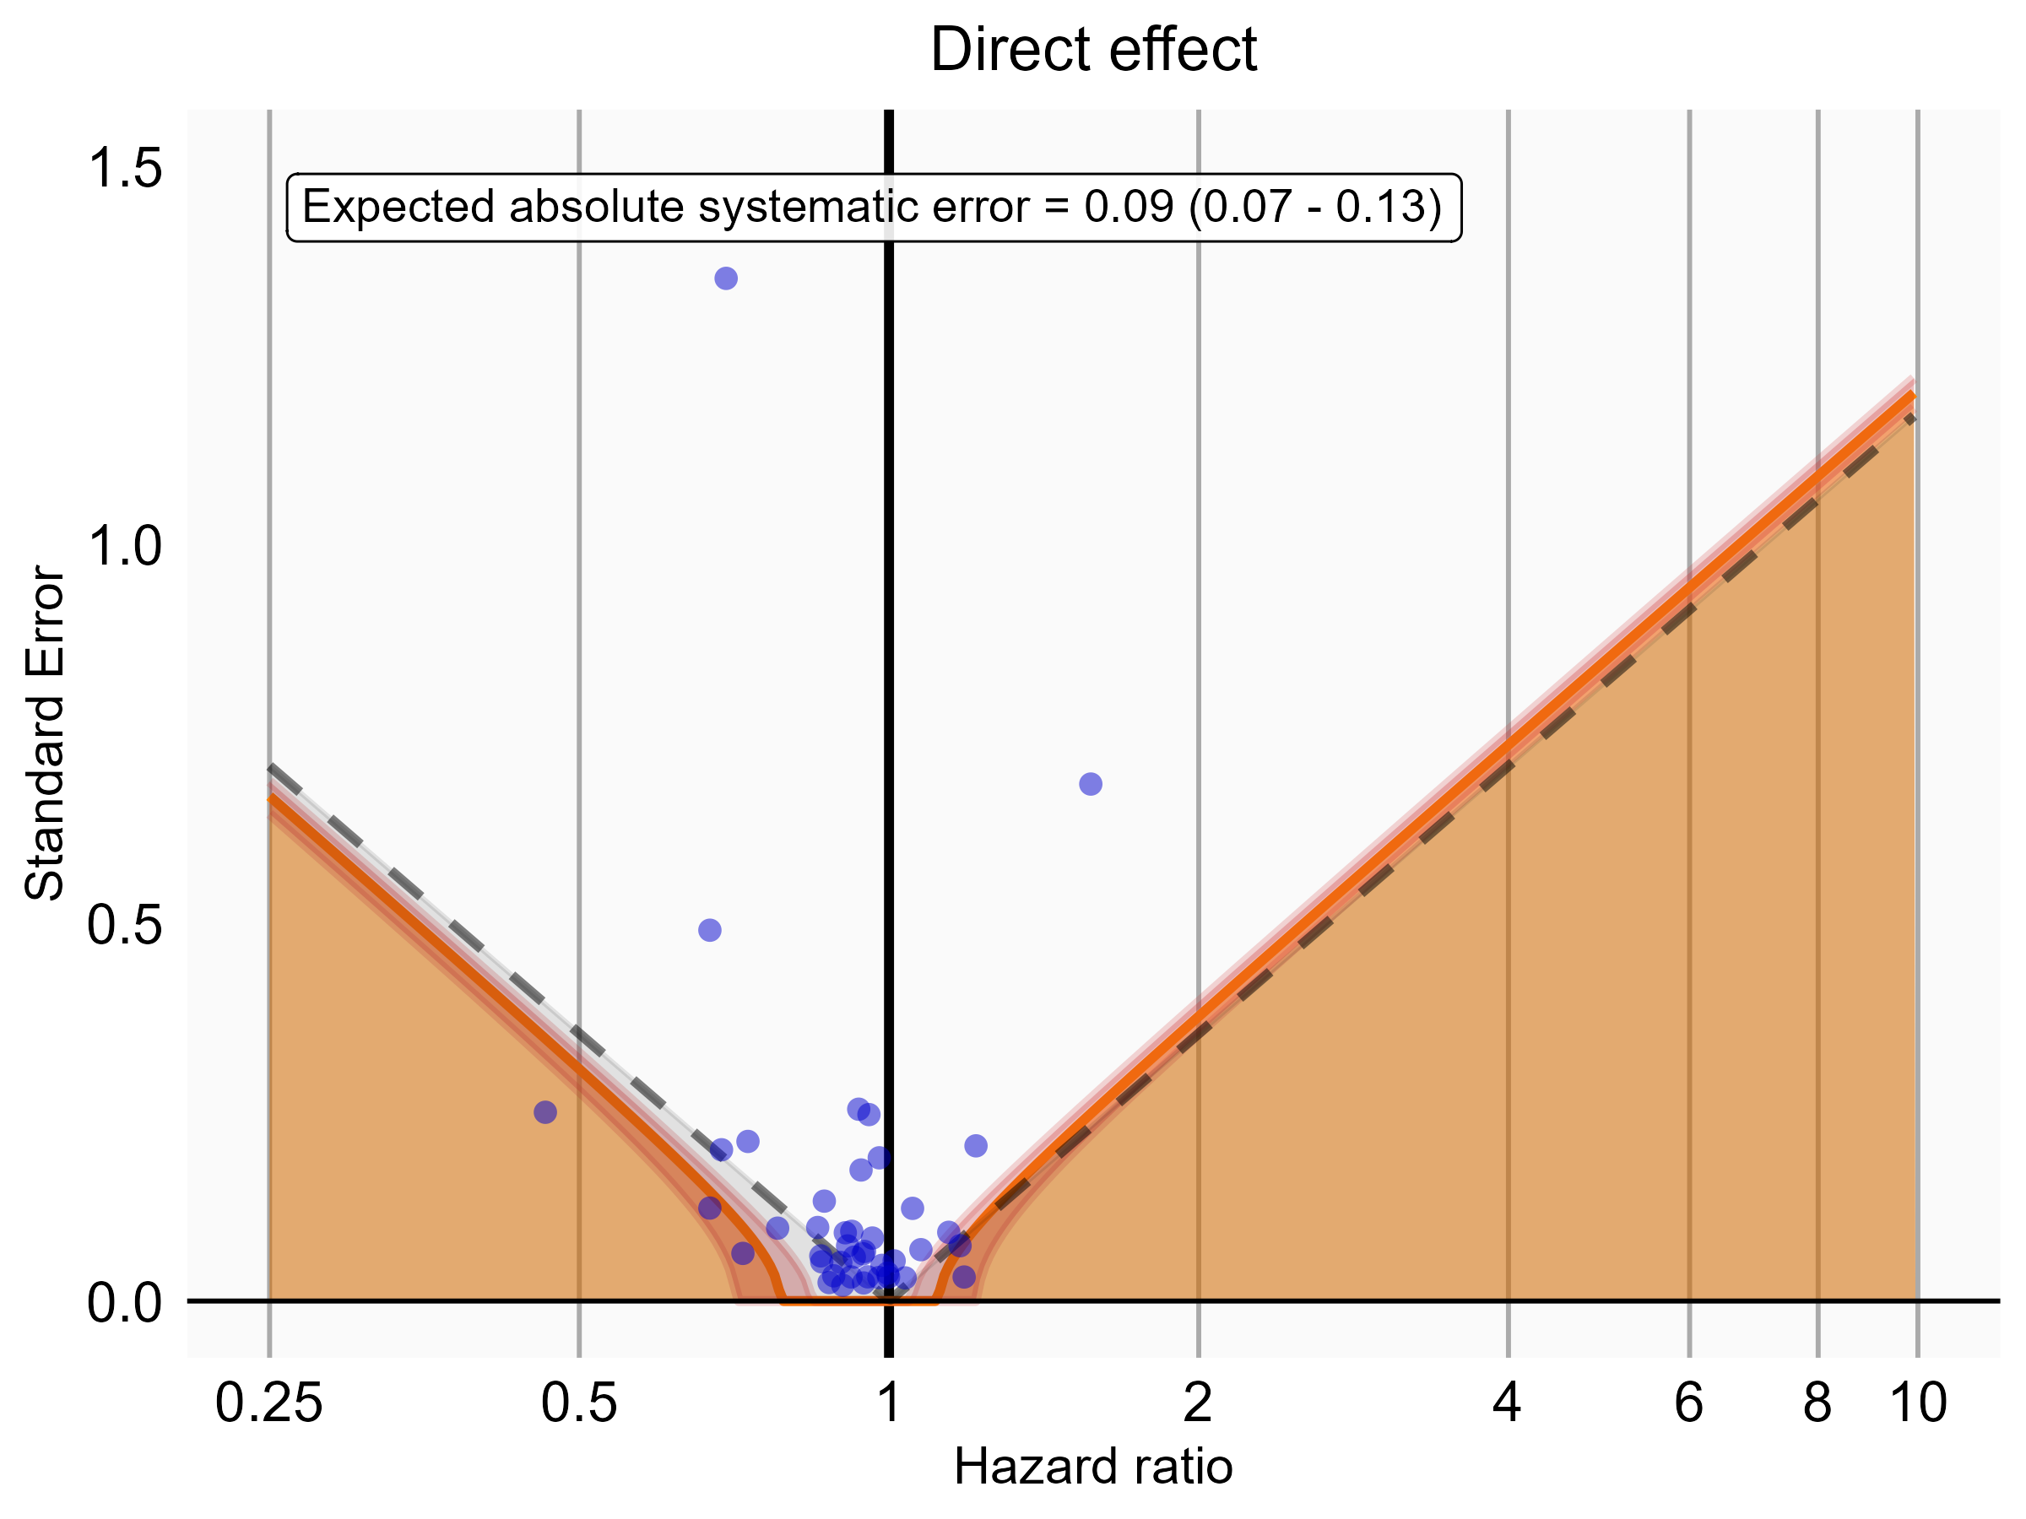

Negative control estimates of the direct effect comparing DOACs to Warfarin using mediator Extracranial Major bleeding IP in OptumDod.

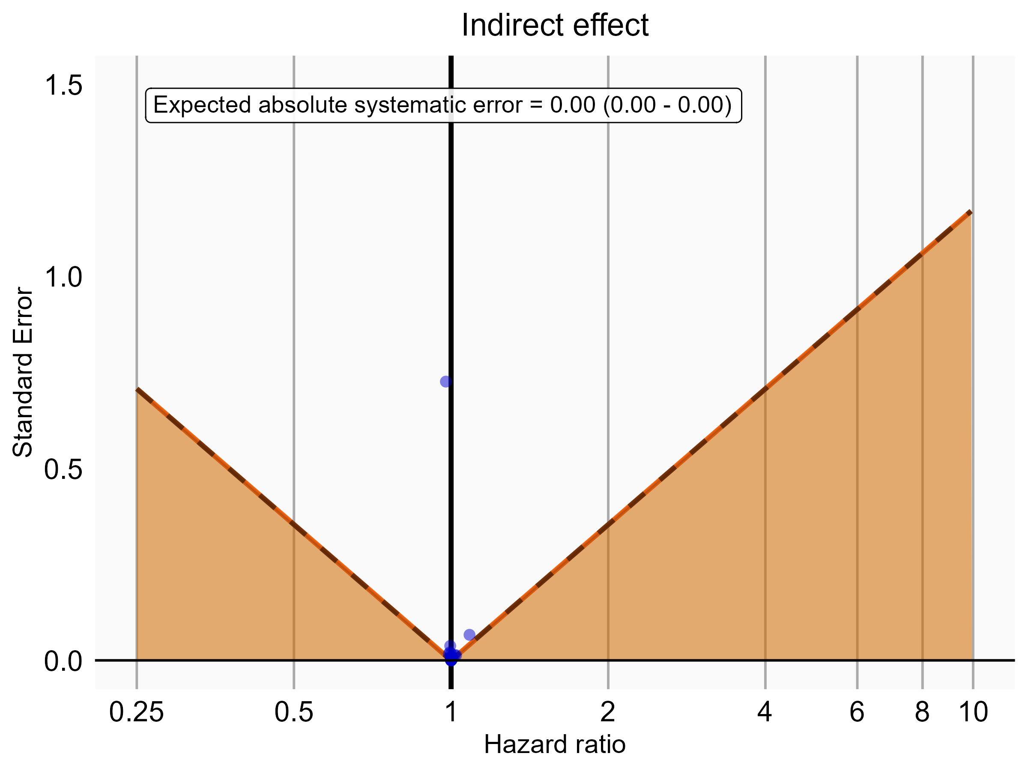

Negative control estimates of the indirect effect comparing DOACs to Warfarin using mediator Extracranial Major bleeding IP in OptumDod.

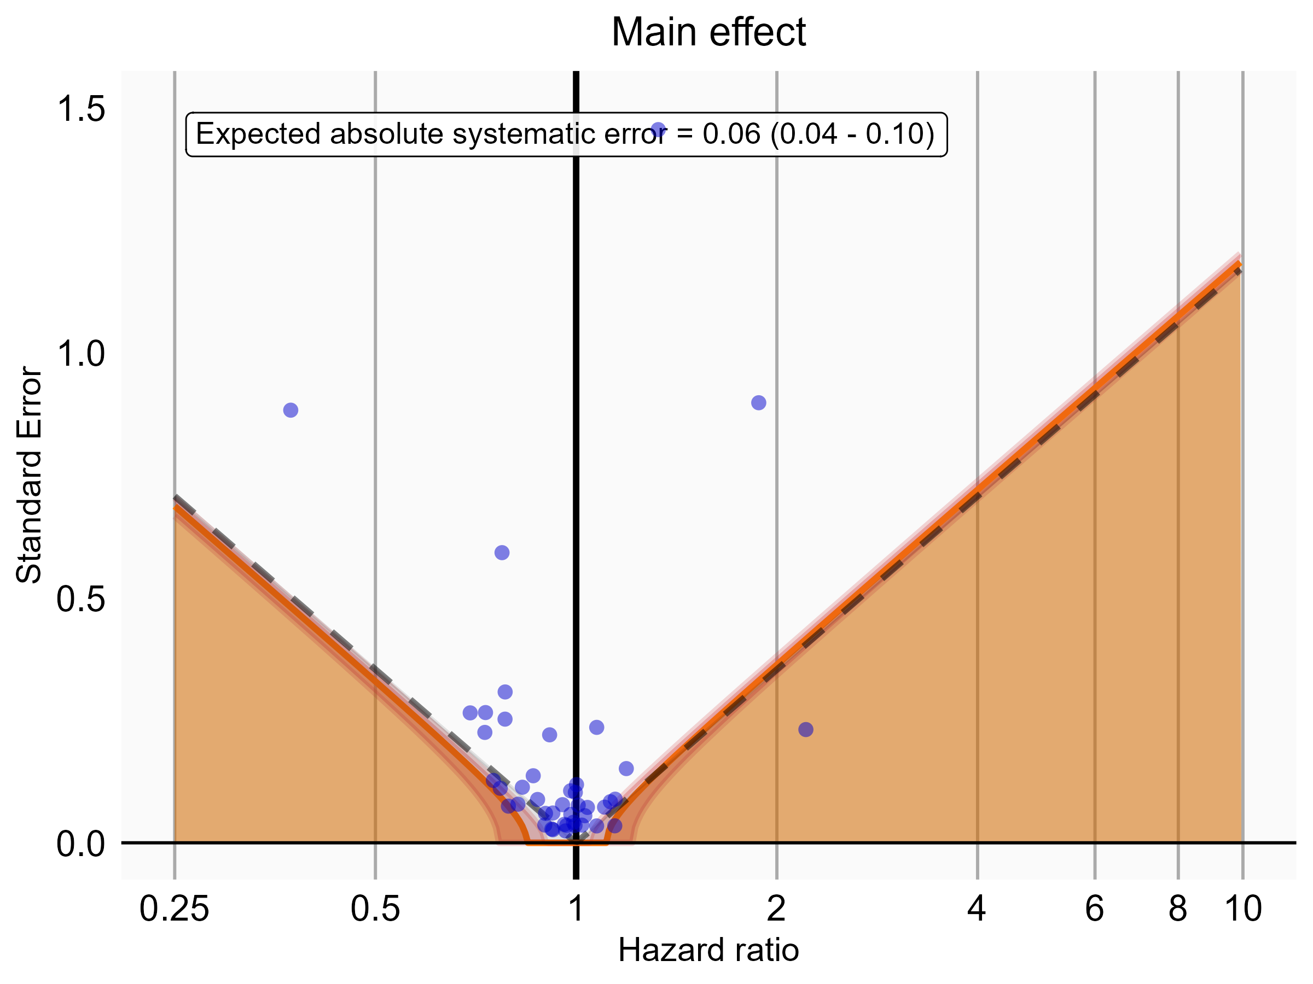

Negative control estimates of the main effect comparing Rivaroxaban to Warfarin using mediator Extracranial Major bleeding IP-ER in OptumDod.

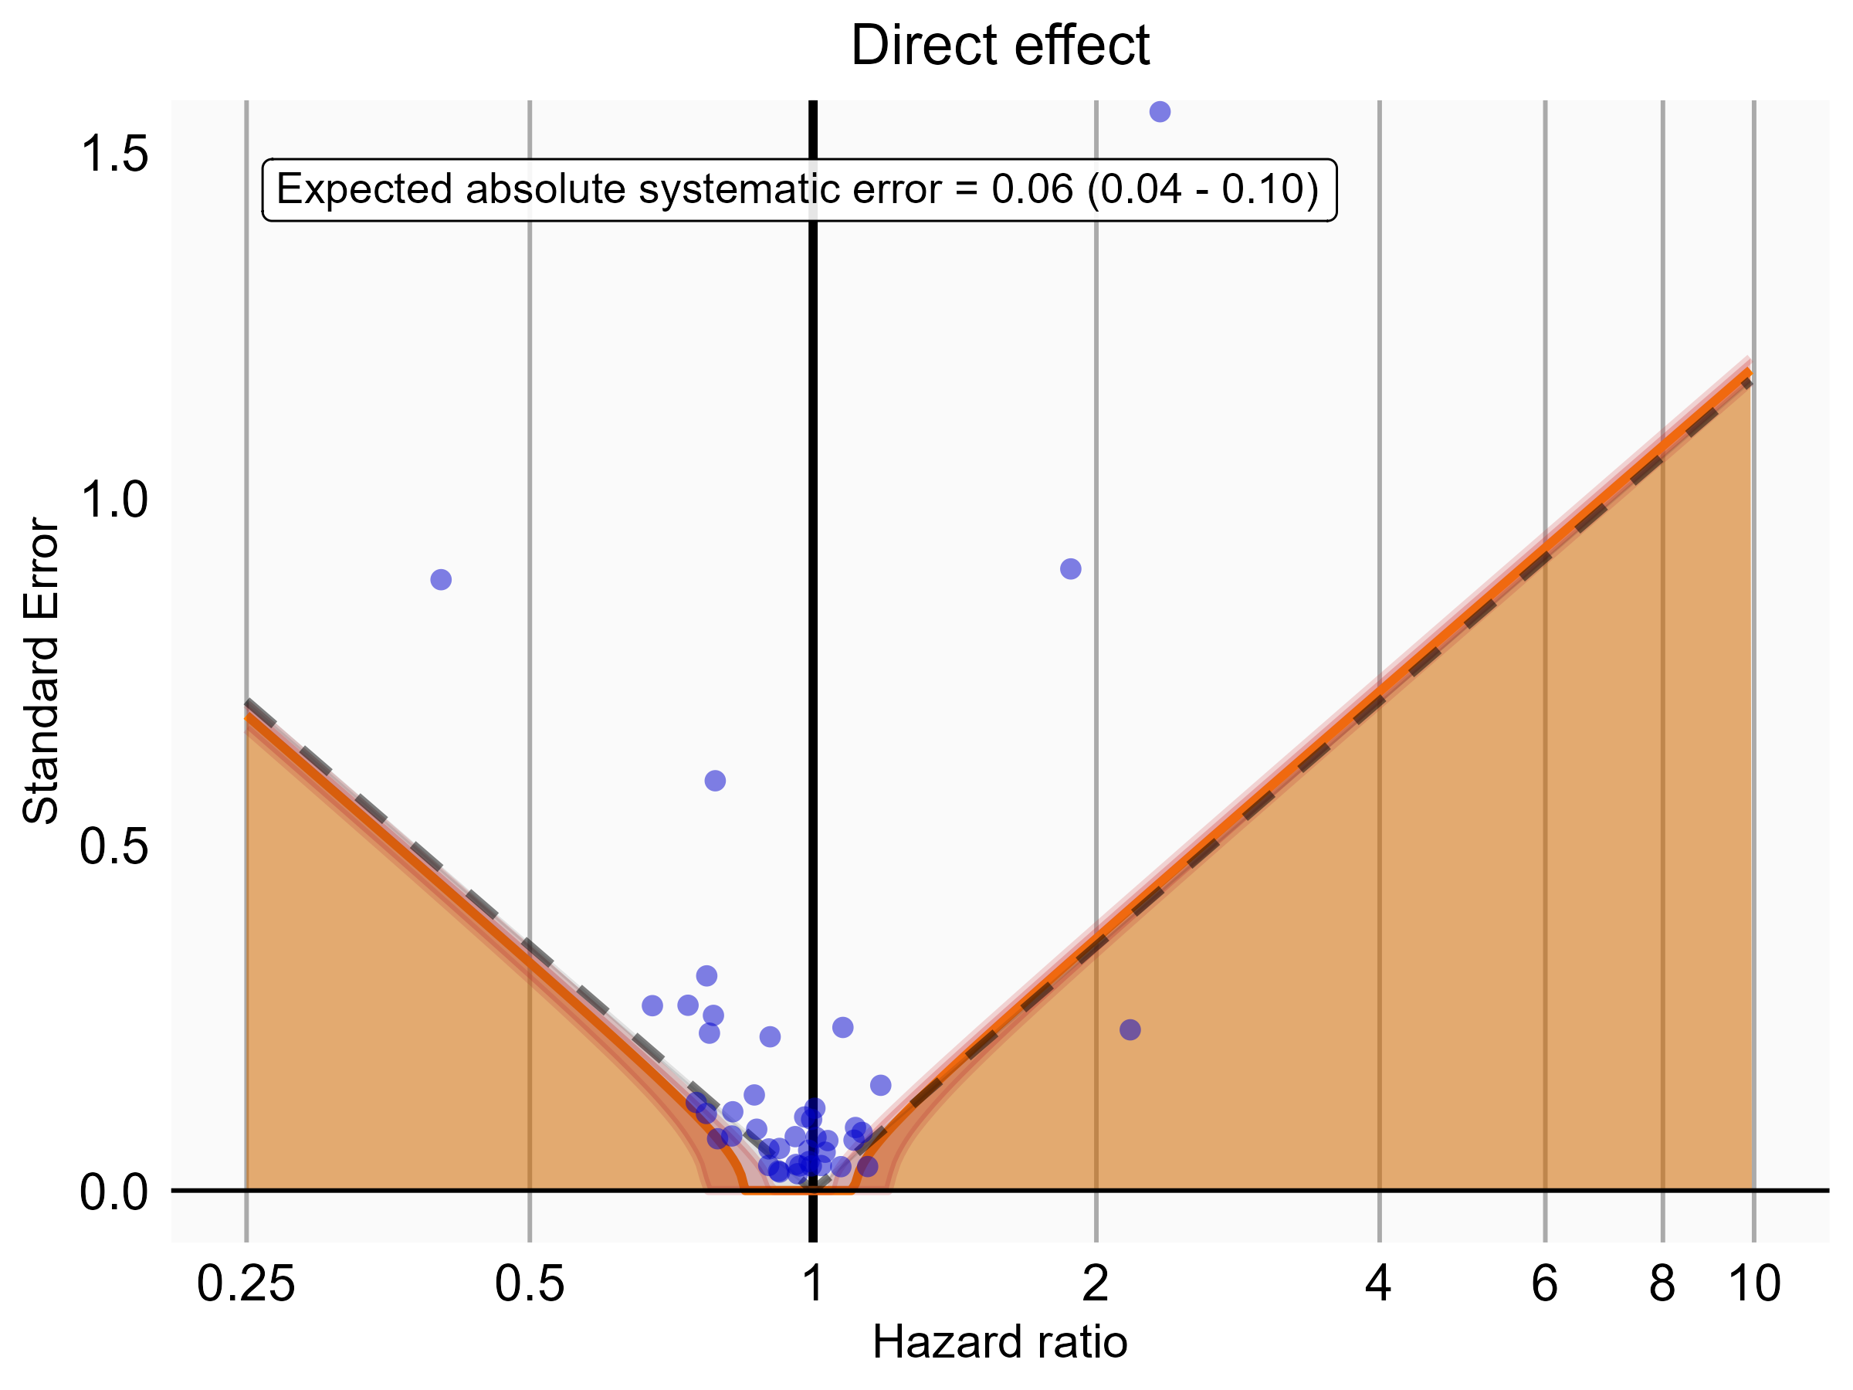

Negative control estimates of the direct effect comparing Rivaroxaban to Warfarin using mediator Extracranial Major bleeding IP-ER in OptumDod.

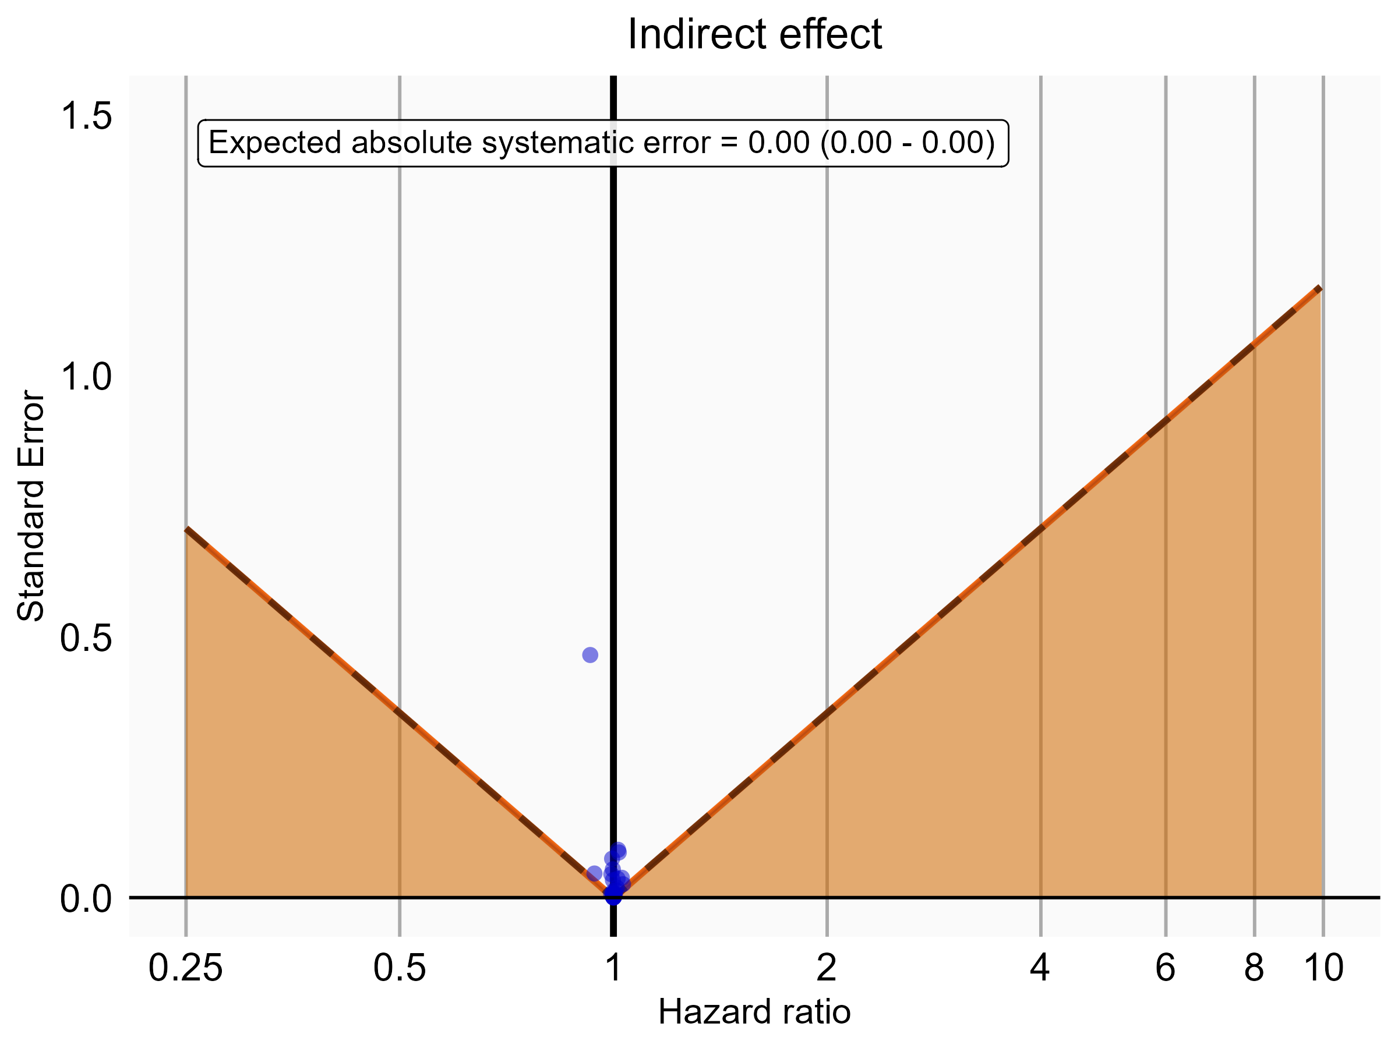

Negative control estimates of the indirect effect comparing Rivaroxaban to Warfarin using mediator Extracranial Major bleeding IP-ER in OptumDod.

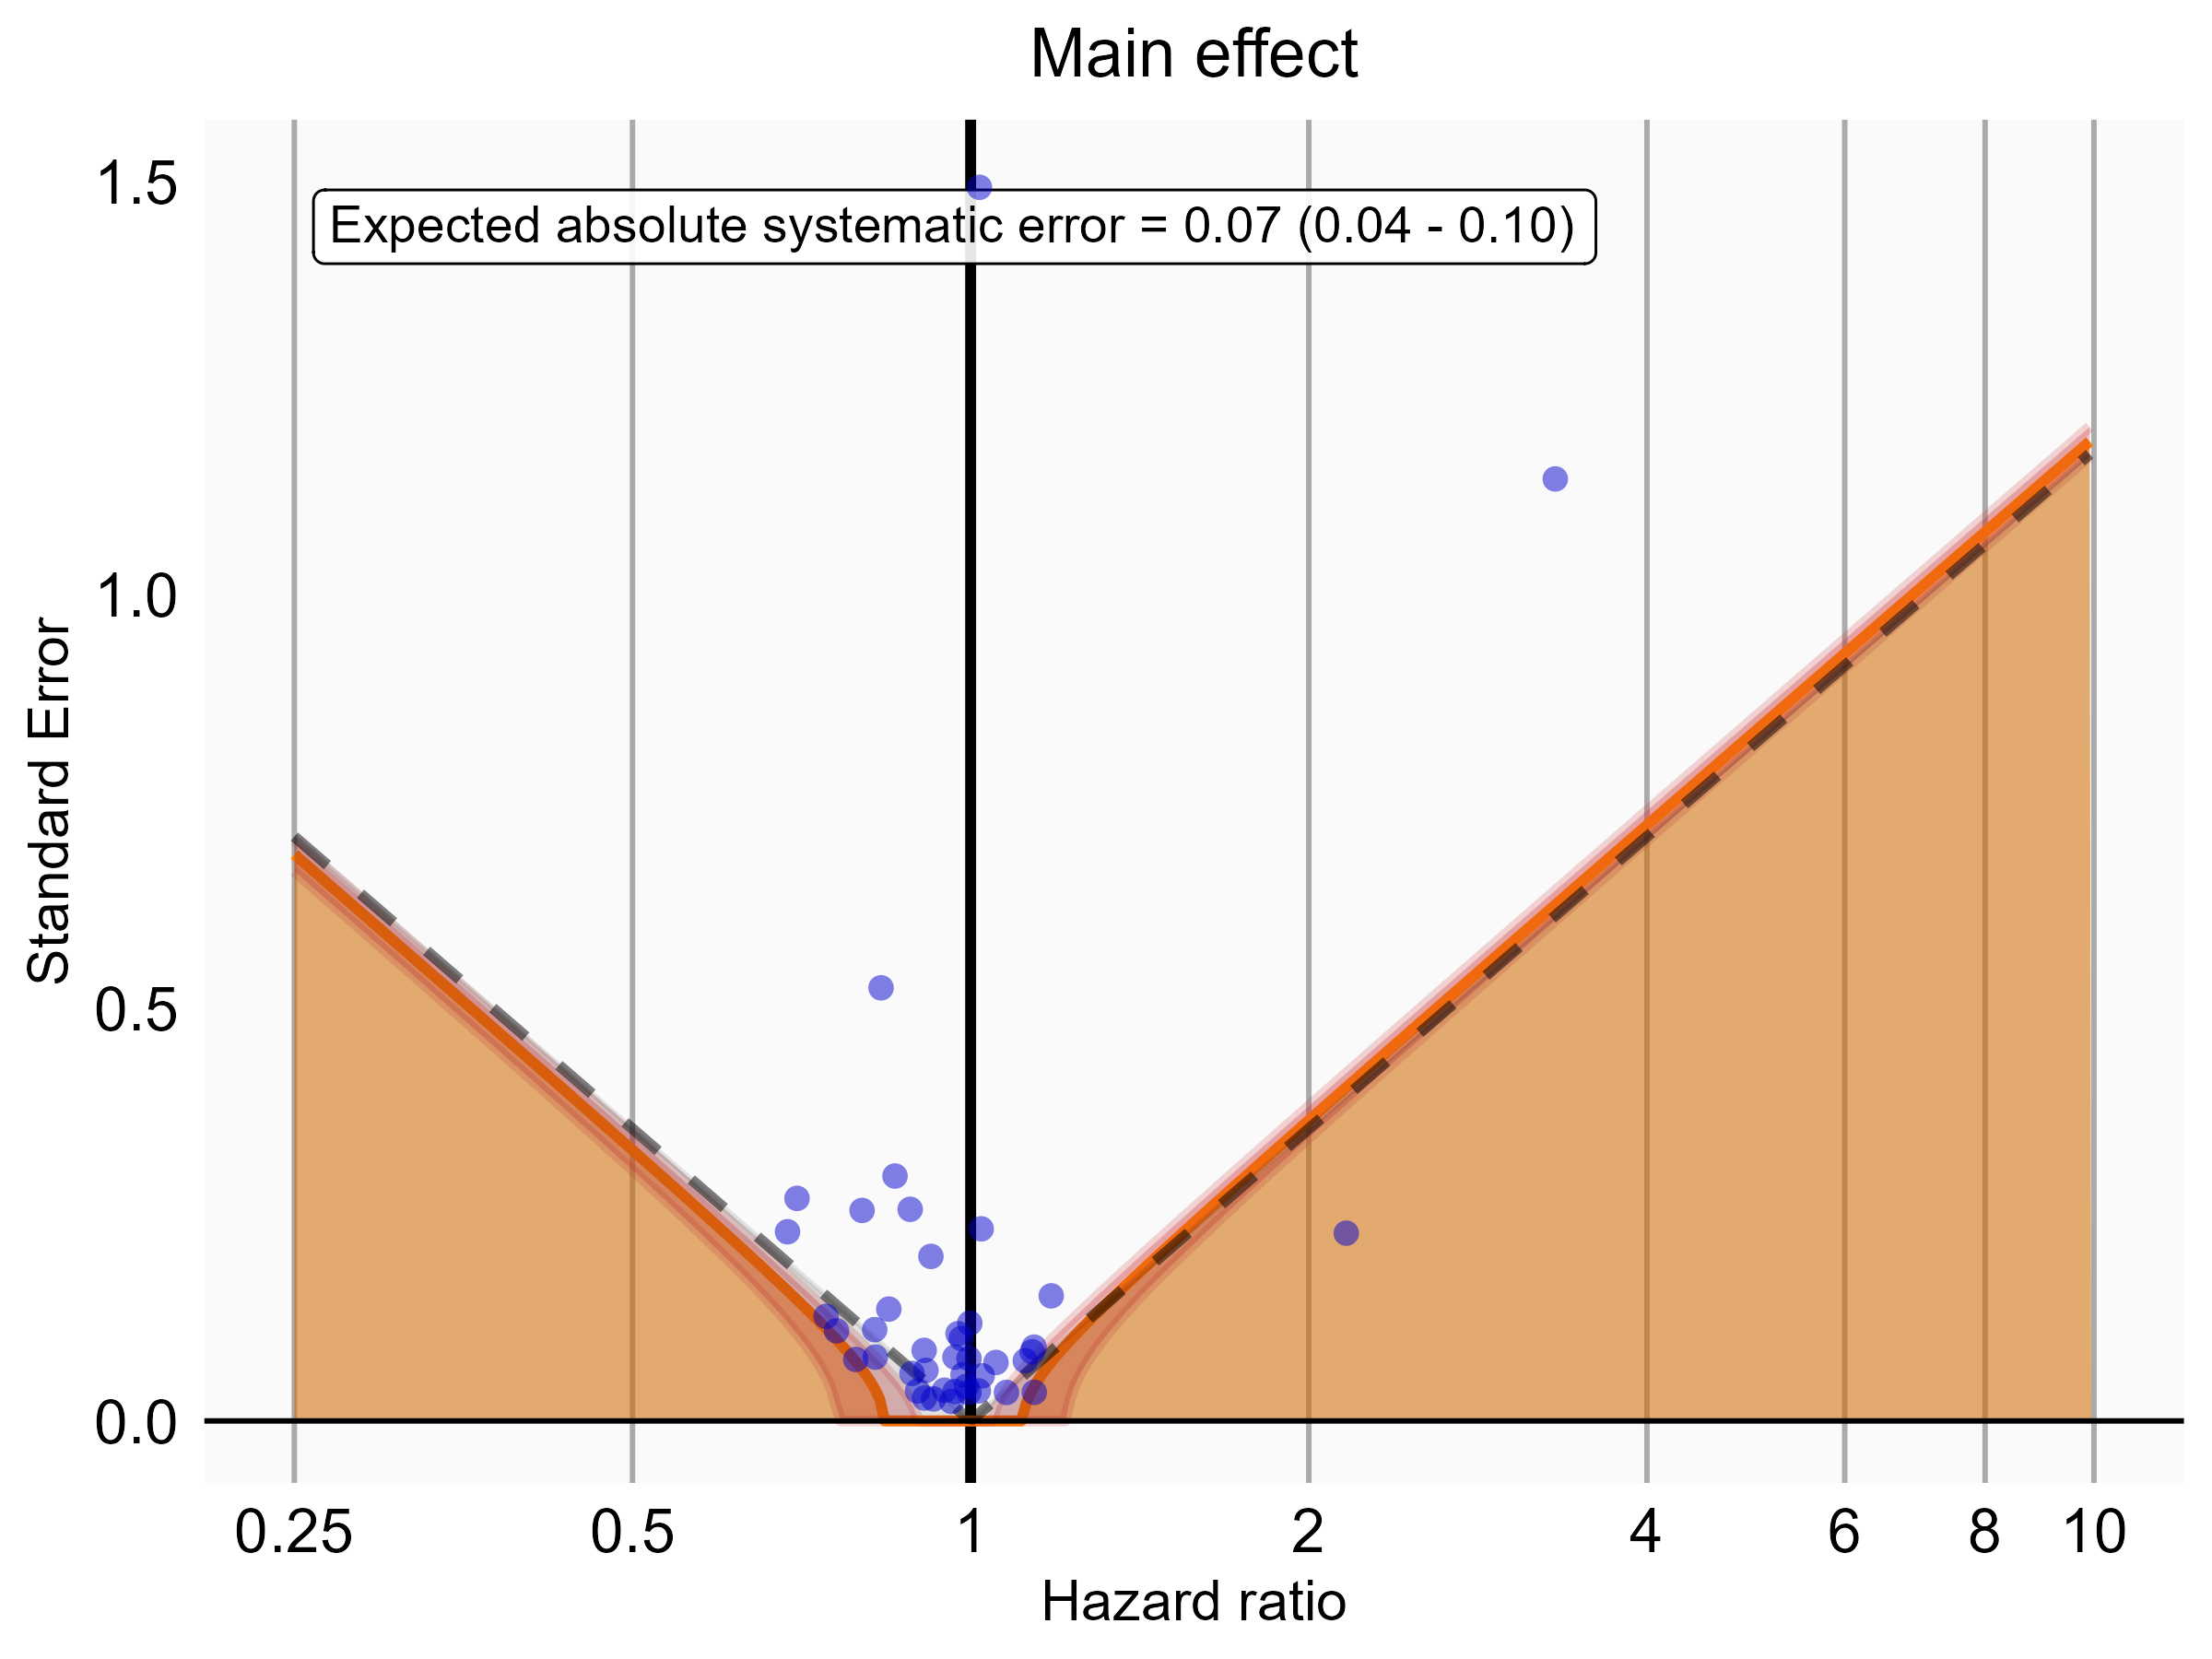

Negative control estimates of the main effect comparing Rivaroxaban to Warfarin using mediator Extracranial Major bleeding IP in OptumDod.

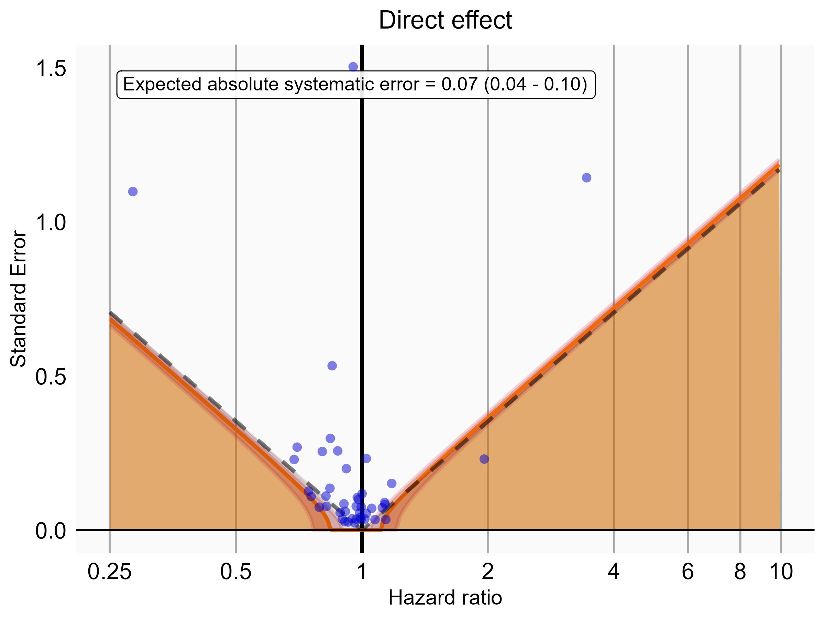

Negative control estimates of the direct effect comparing Rivaroxaban to Warfarin using mediator Extracranial Major bleeding IP in OptumDod.

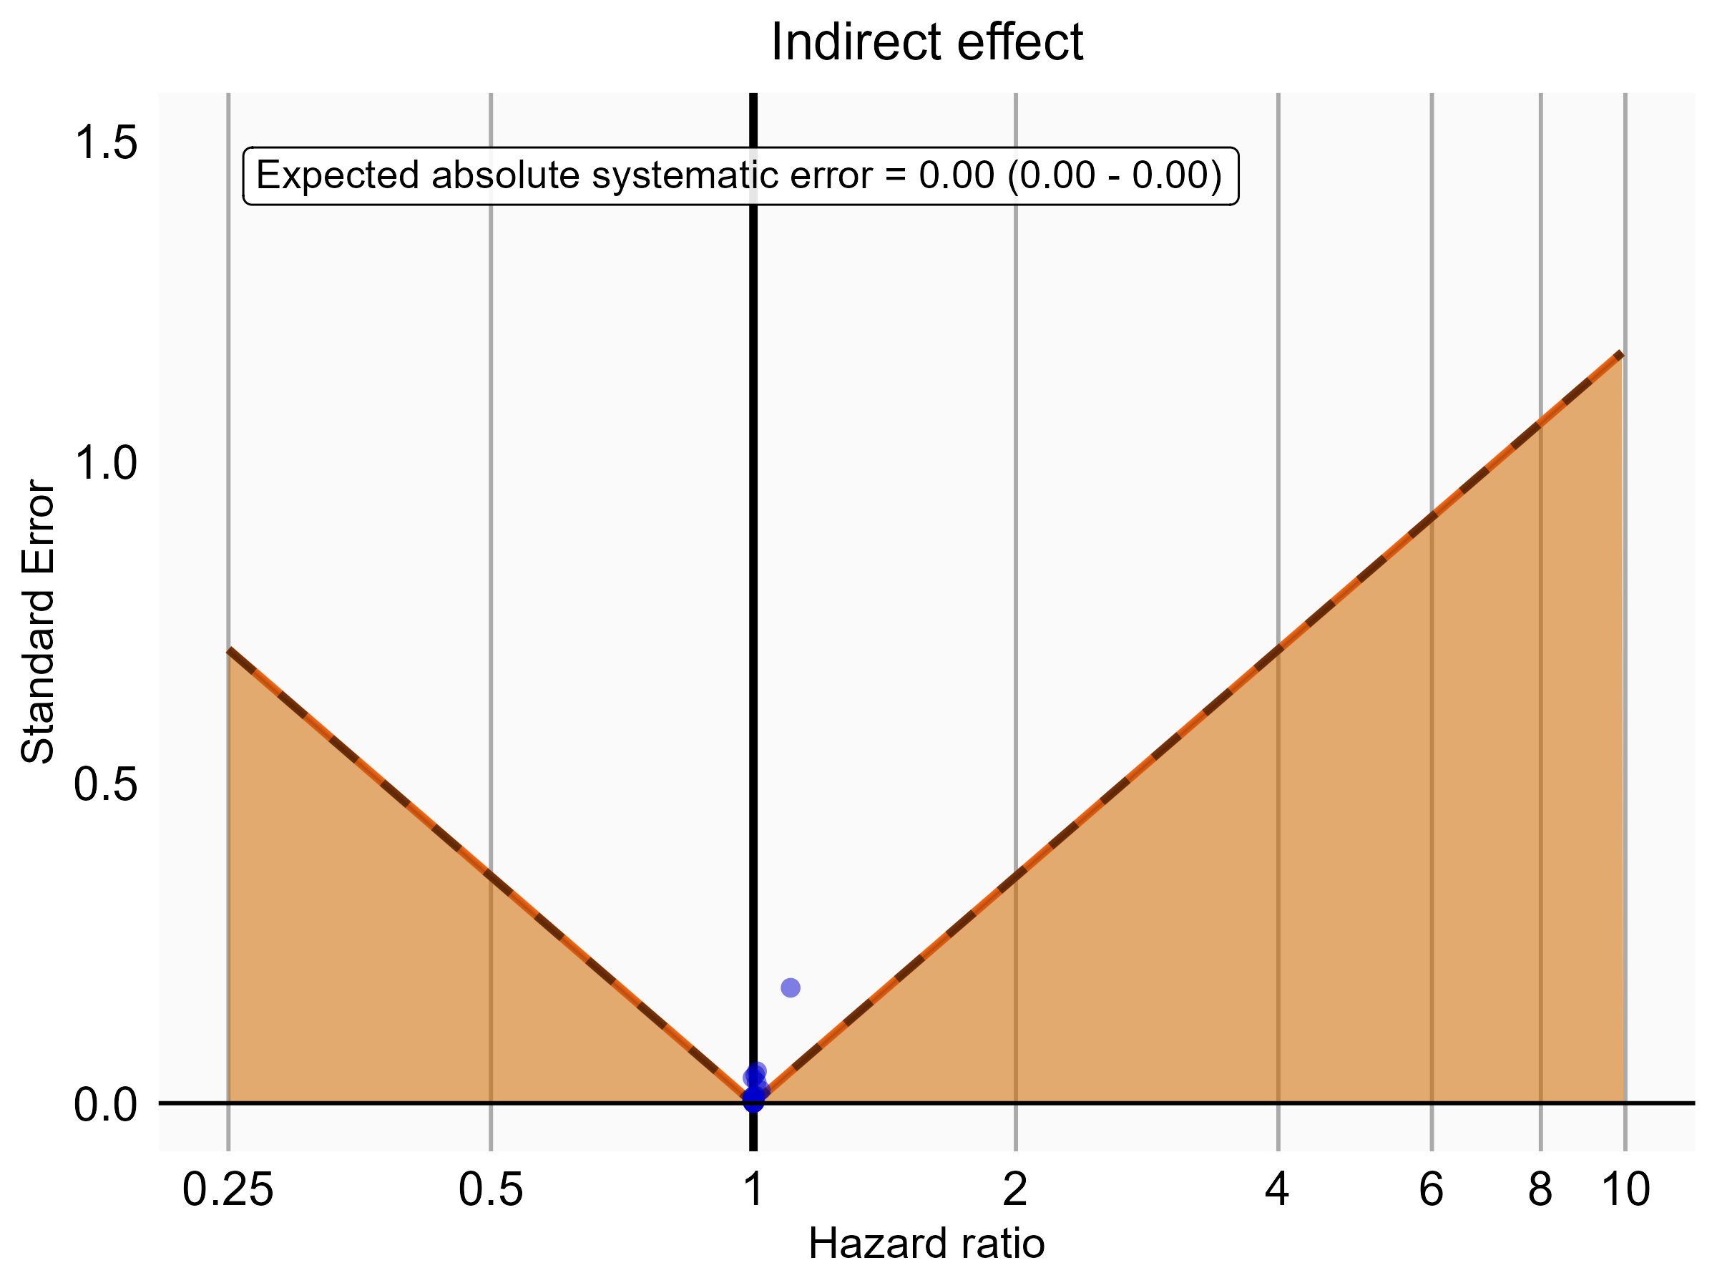

Negative control estimates of the indirect effect comparing Rivaroxaban to Warfarin using mediator Extracranial Major bleeding IP in OptumDod.

### 5.0.3 OptumEhr

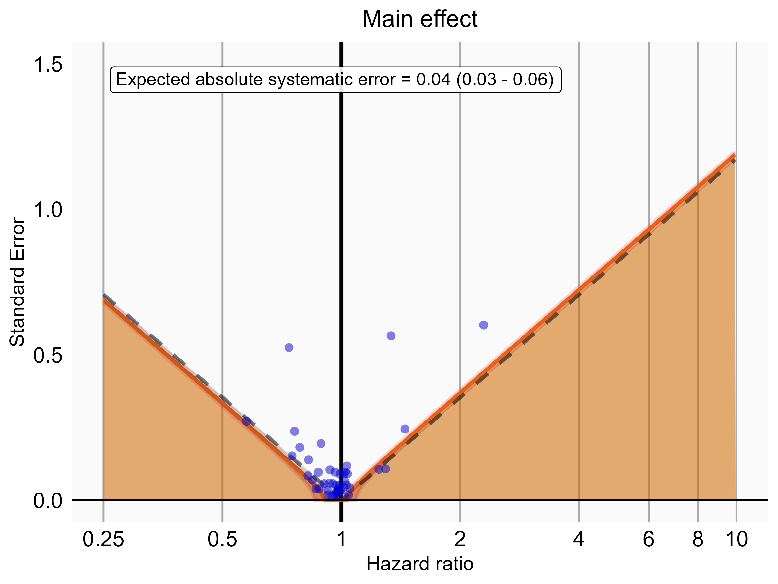

Negative control estimates of the main effect comparing DOACs to Warfarin using mediator Extracranial Major bleeding IP-ER in OptumEhr.

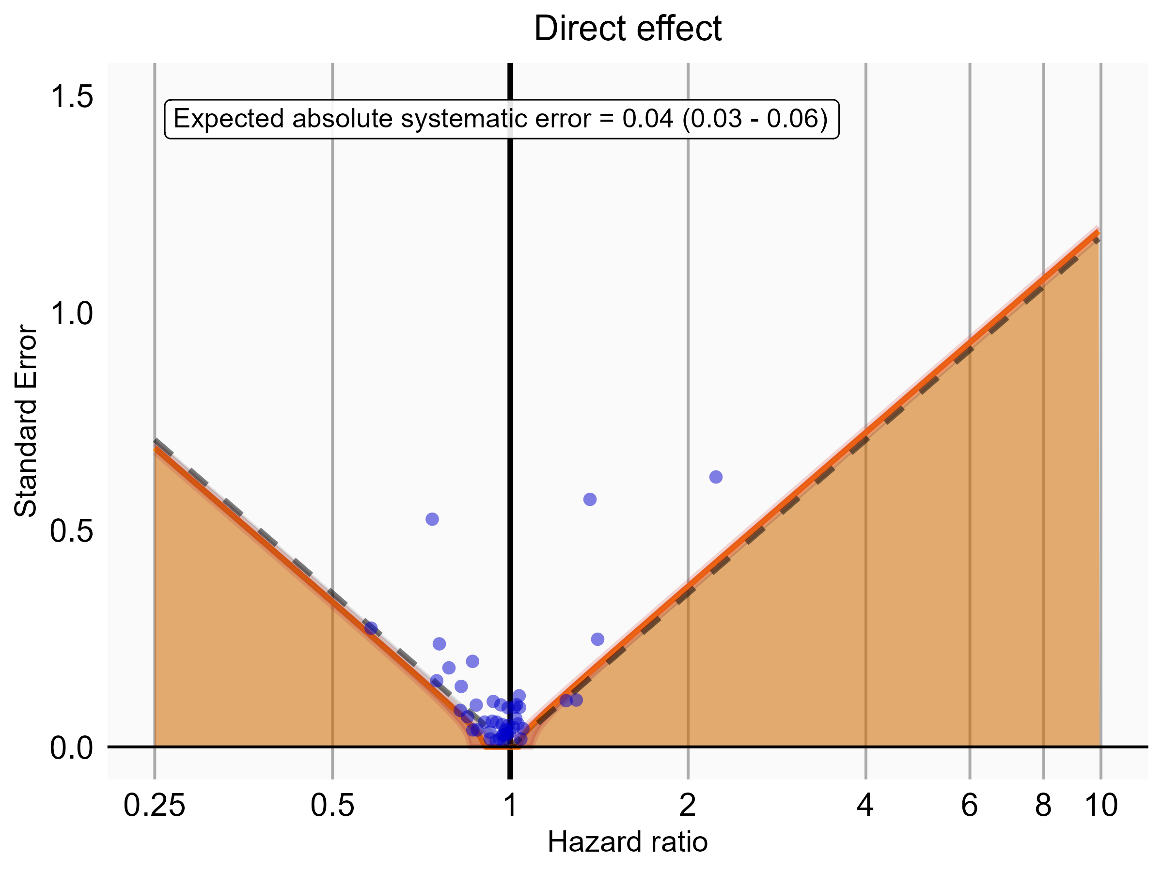

Negative control estimates of the direct effect comparing DOACs to Warfarin using mediator Extracranial Major bleeding IP-ER in OptumEhr.

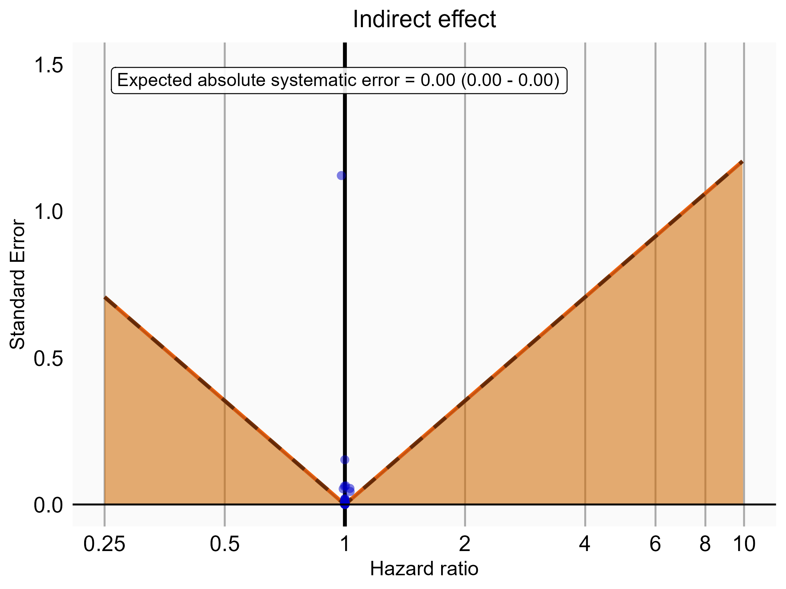

Negative control estimates of the indirect effect comparing DOACs to Warfarin using mediator Extracranial Major bleeding IP-ER in OptumEhr.

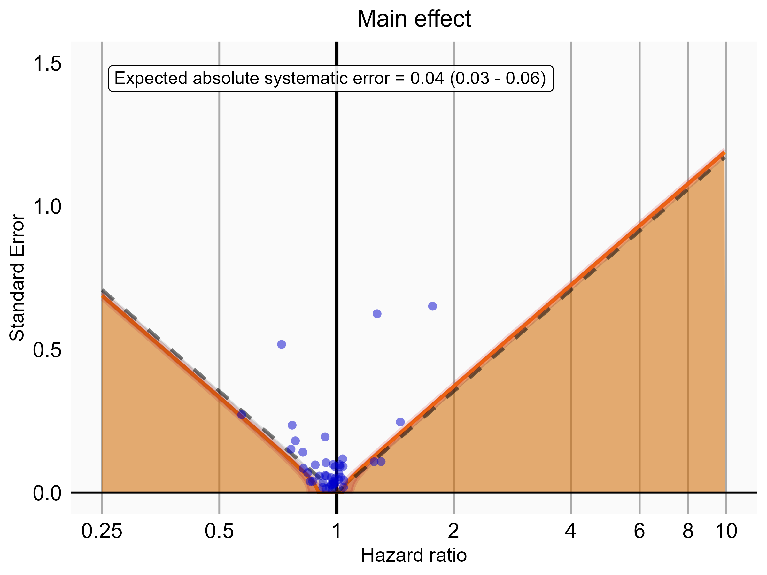

Negative control estimates of the main effect comparing DOACs to Warfarin using mediator Extracranial Major bleeding IP in OptumEhr.

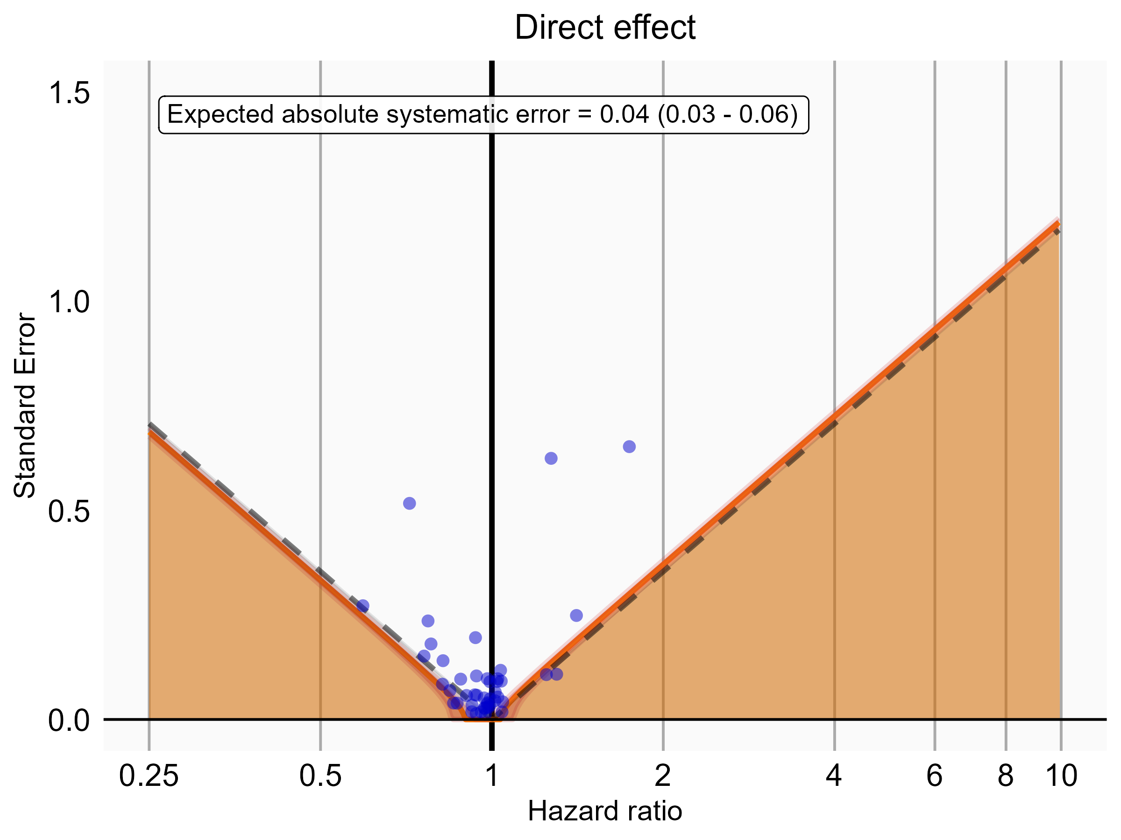

Negative control estimates of the direct effect comparing DOACs to Warfarin using mediator Extracranial Major bleeding IP in OptumEhr.

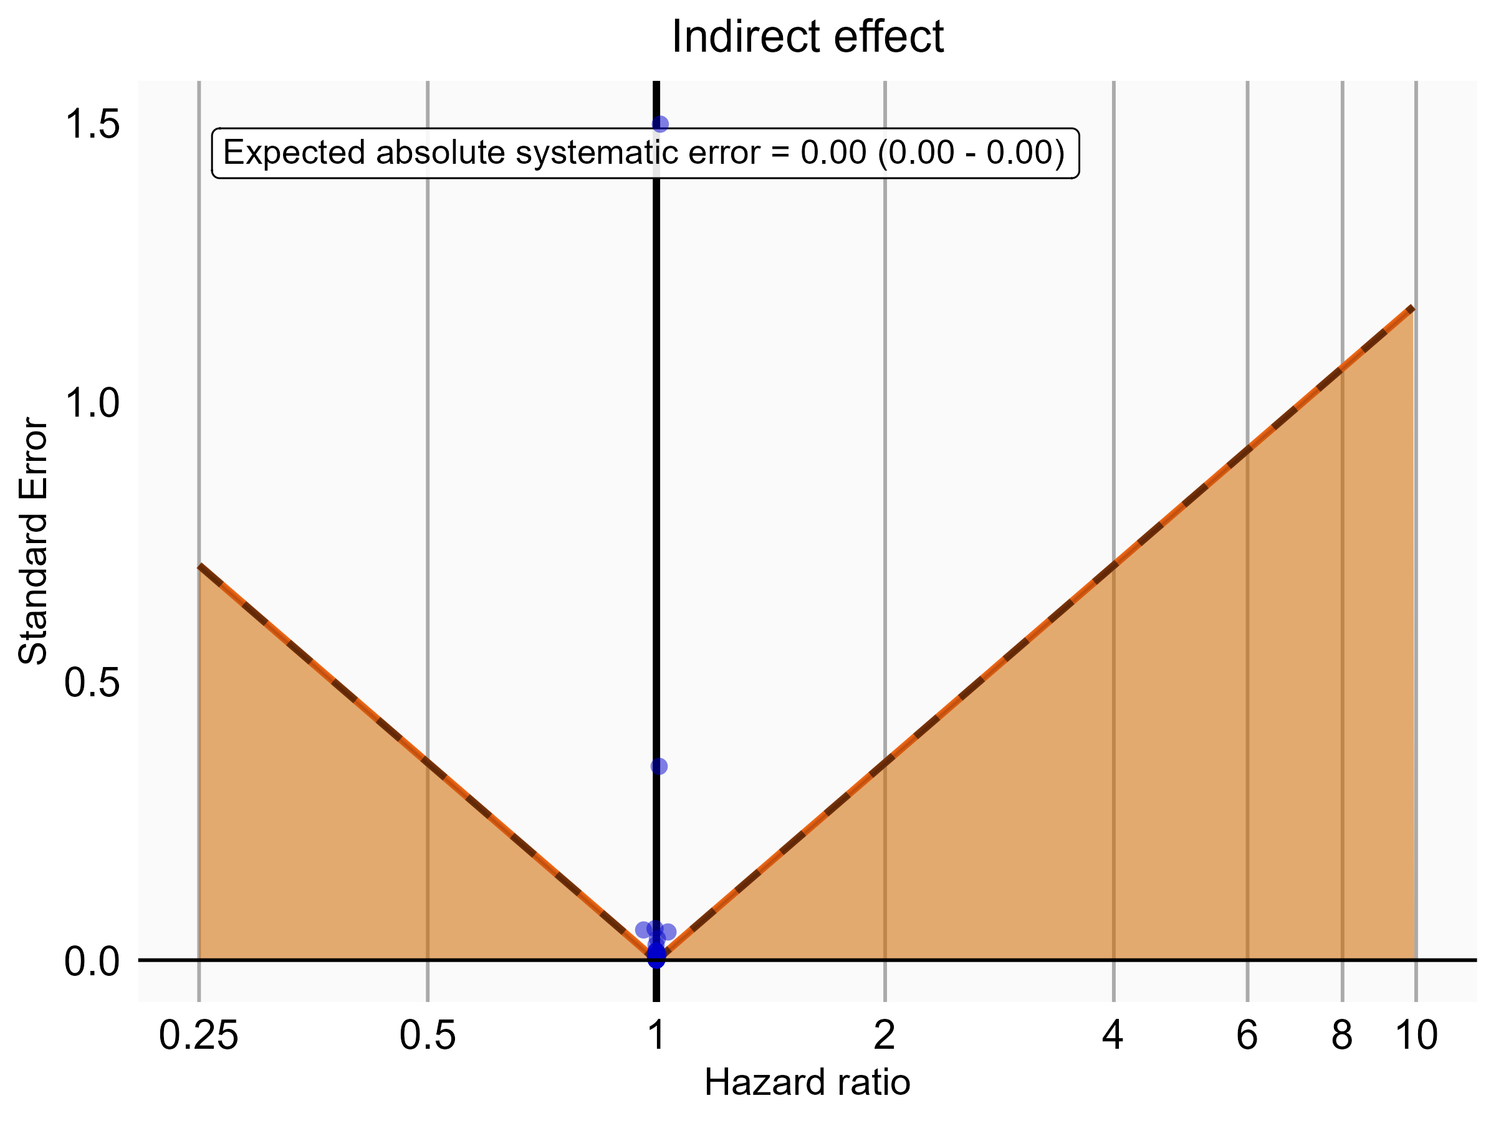

Negative control estimates of the indirect effect comparing DOACs to Warfarin using mediator Extracranial Major bleeding IP in OptumEhr.

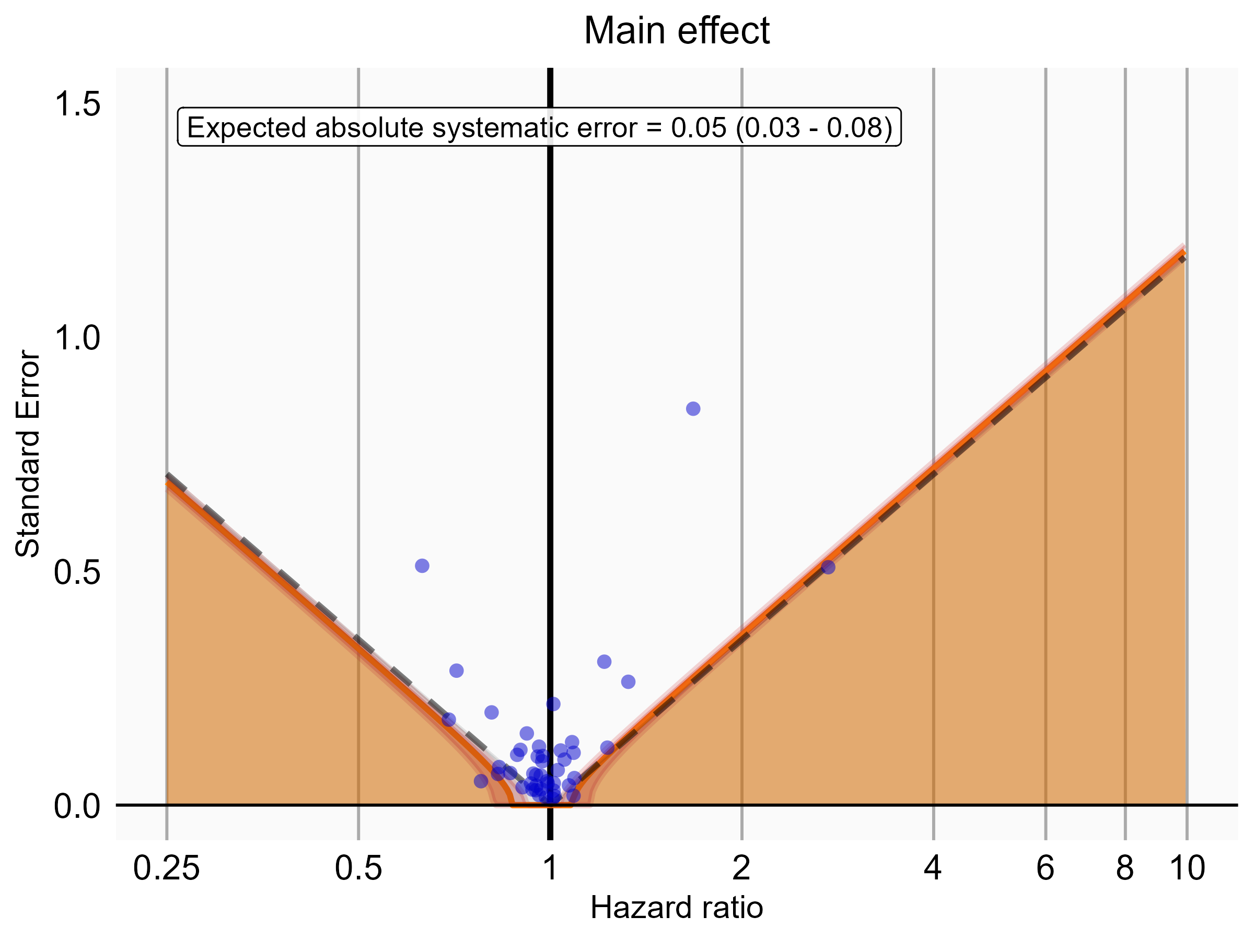

Negative control estimates of the main effect comparing Rivaroxaban to Warfarin using mediator Extracranial Major bleeding IP-ER in OptumEhr.

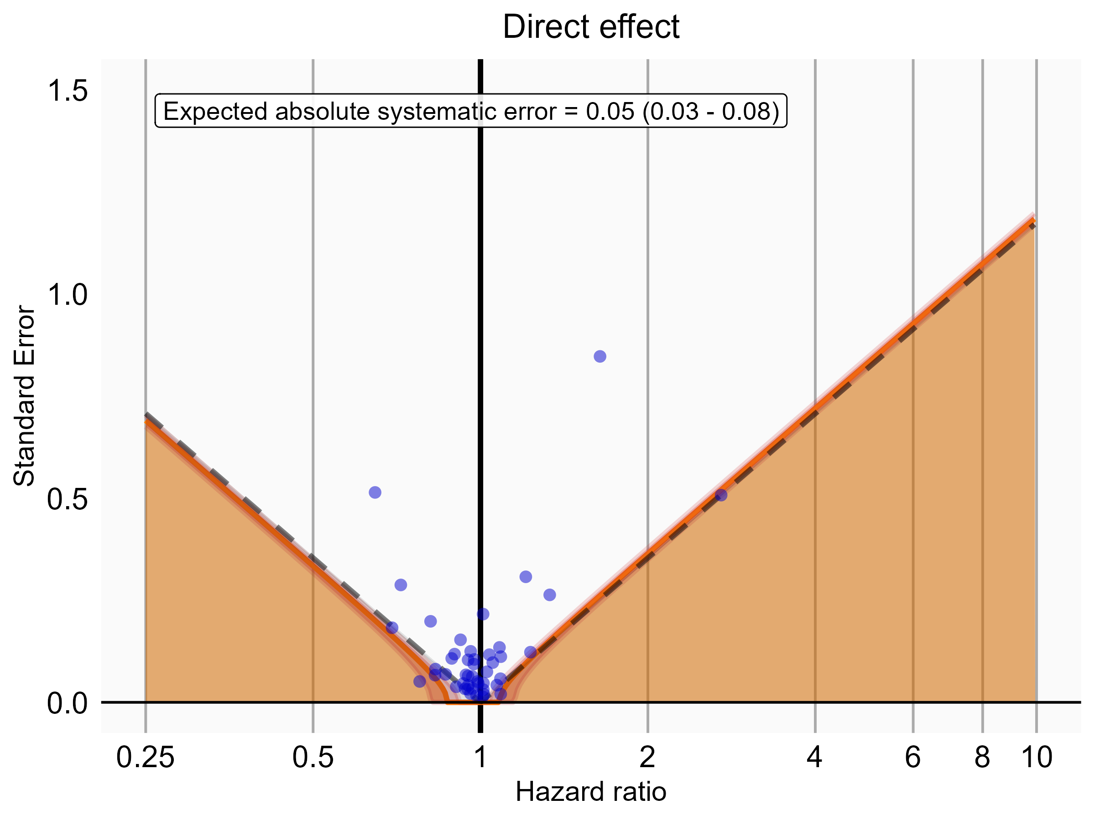

Negative control estimates of the direct effect comparing Rivaroxaban to Warfarin using mediator Extracranial Major bleeding IP-ER in OptumEhr.

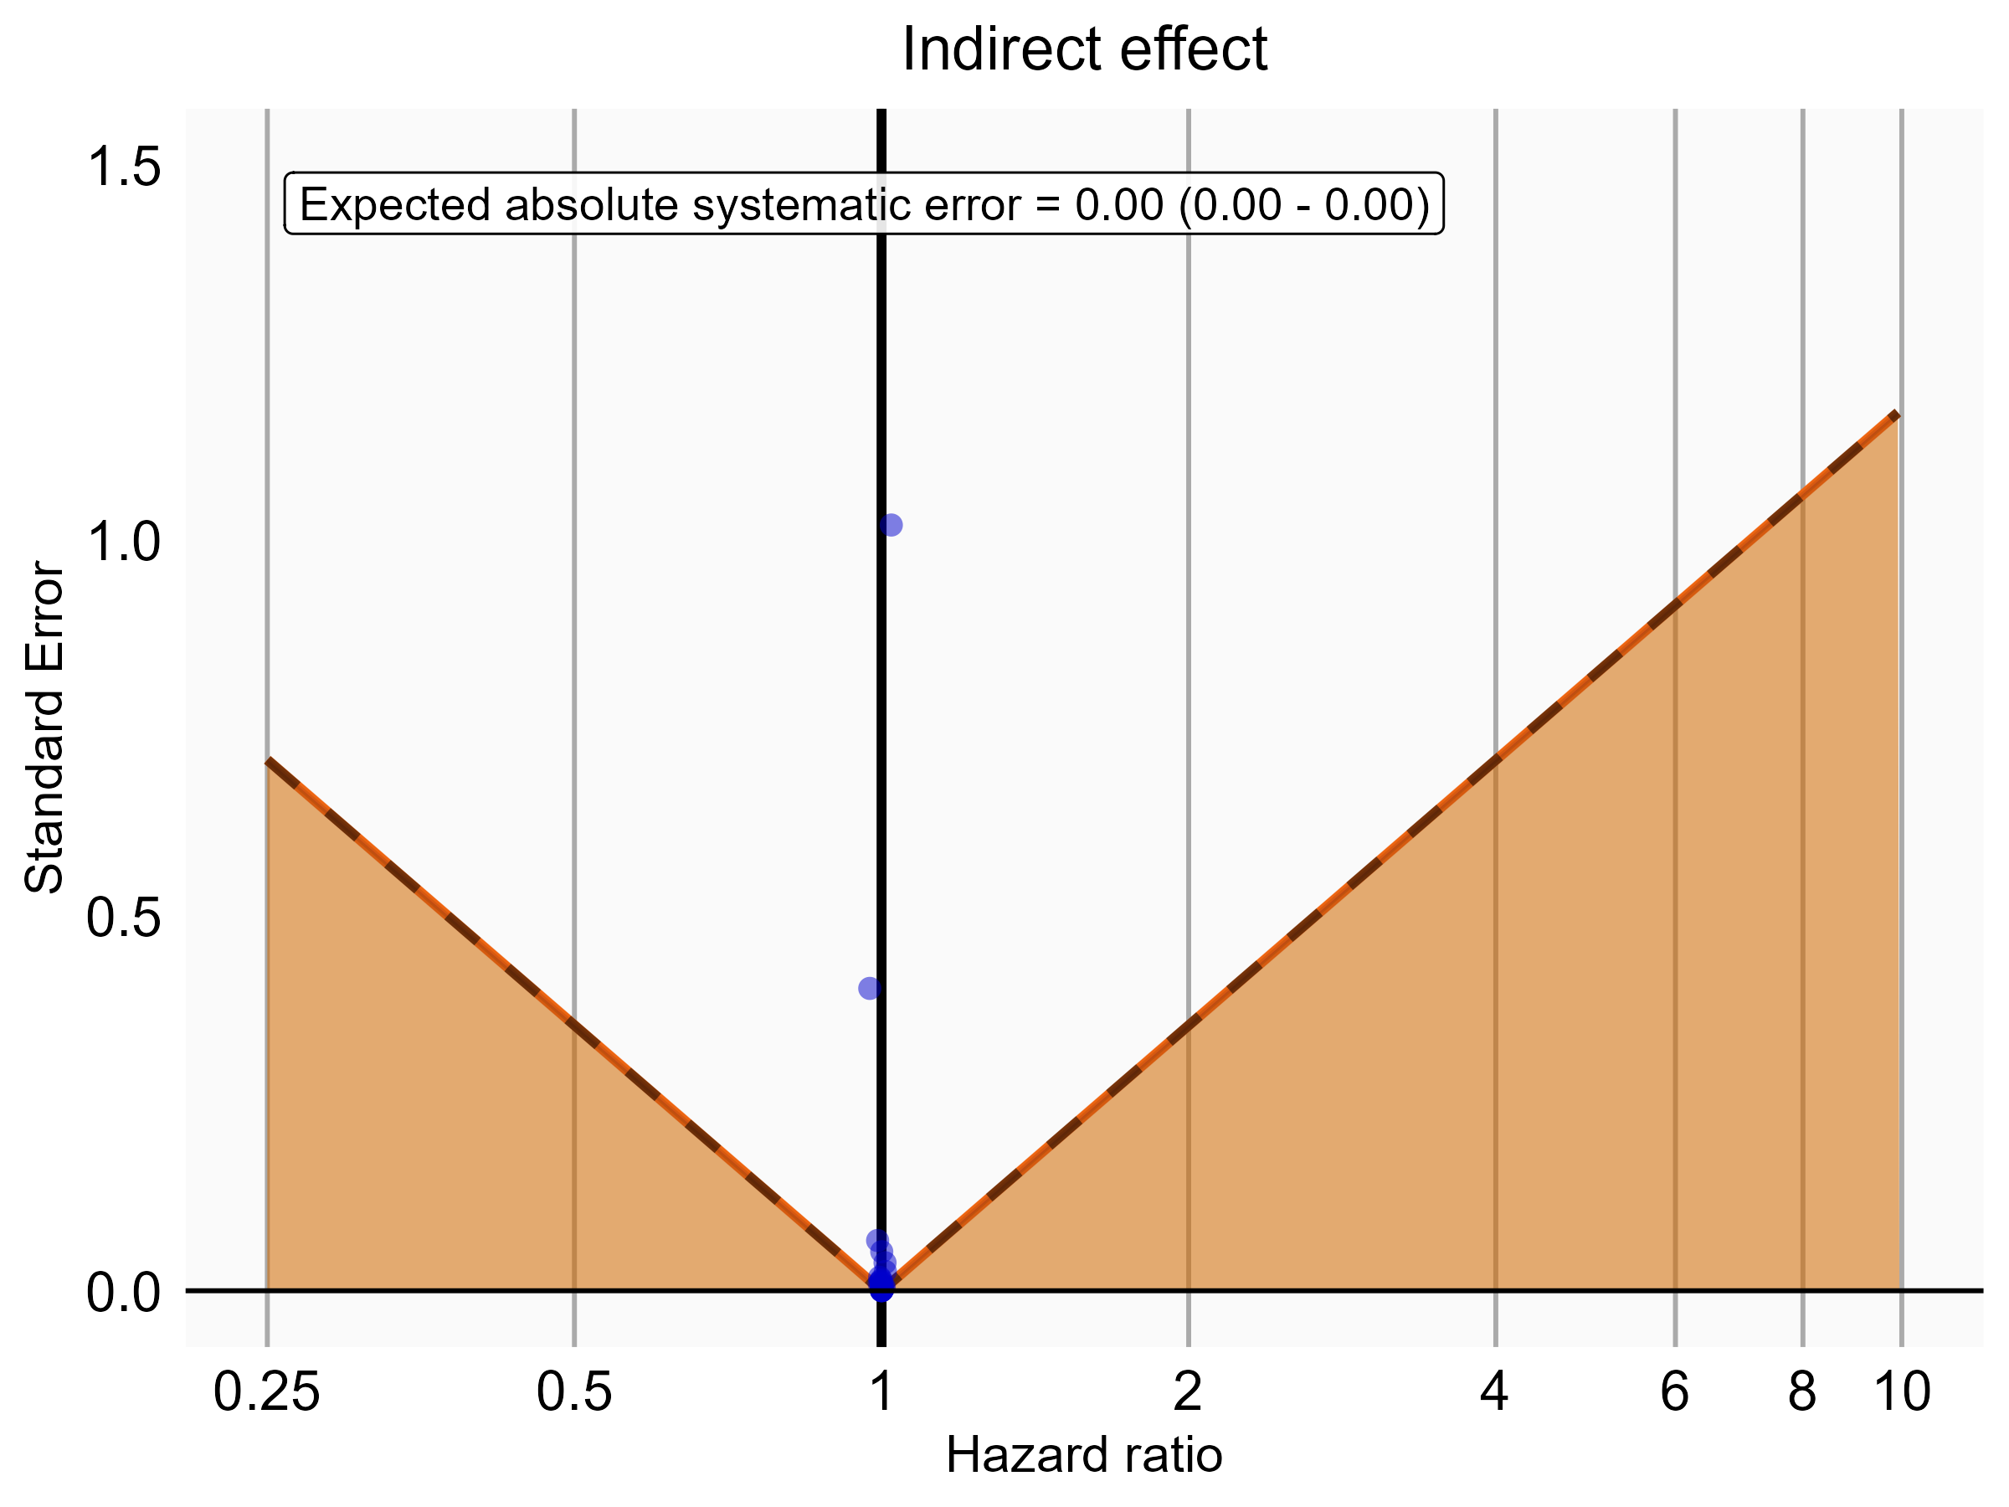

Negative control estimates of the indirect effect comparing Rivaroxaban to Warfarin using mediator Extracranial Major bleeding IP-ER in OptumEhr.

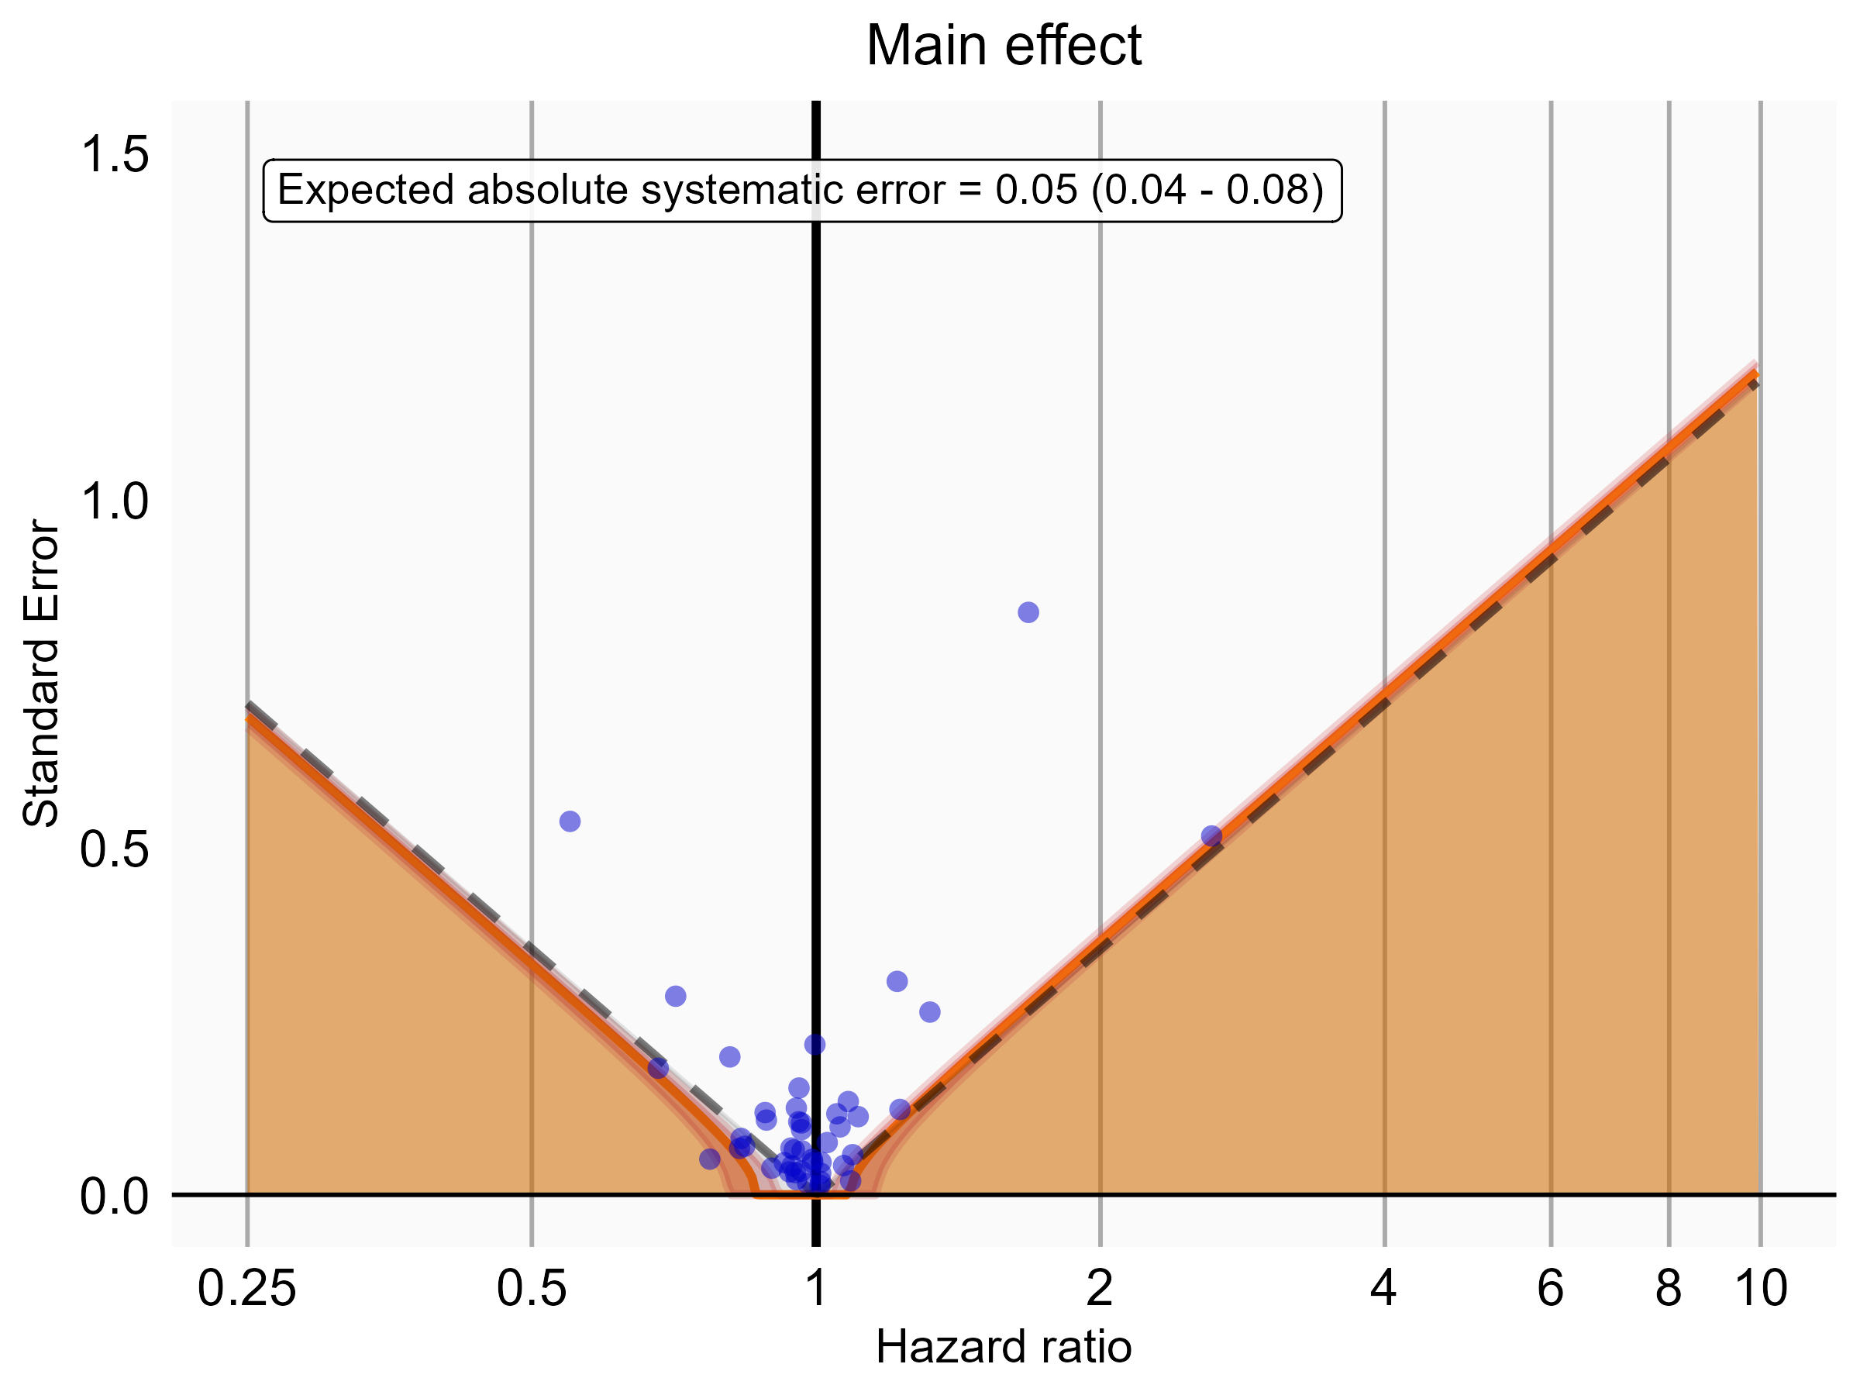

Negative control estimates of the main effect comparing Rivaroxaban to Warfarin using mediator Extracranial Major bleeding IP in OptumEhr.

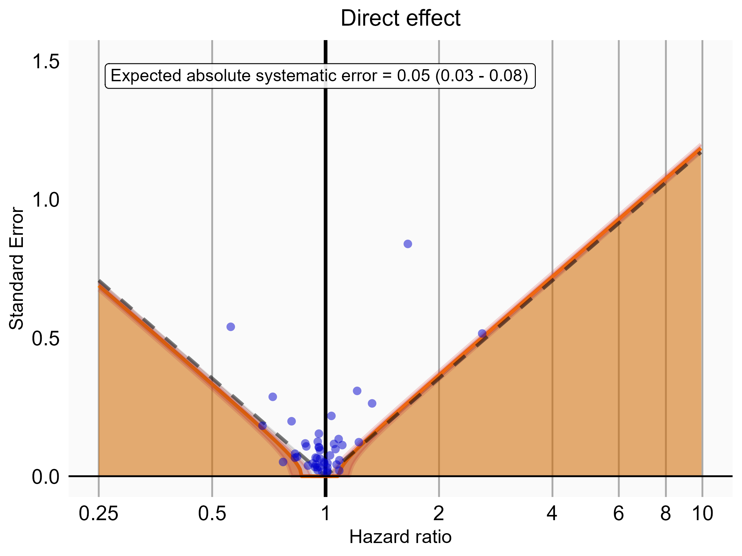

Negative control estimates of the direct effect comparing Rivaroxaban to Warfarin using mediator Extracranial Major bleeding IP in OptumEhr.

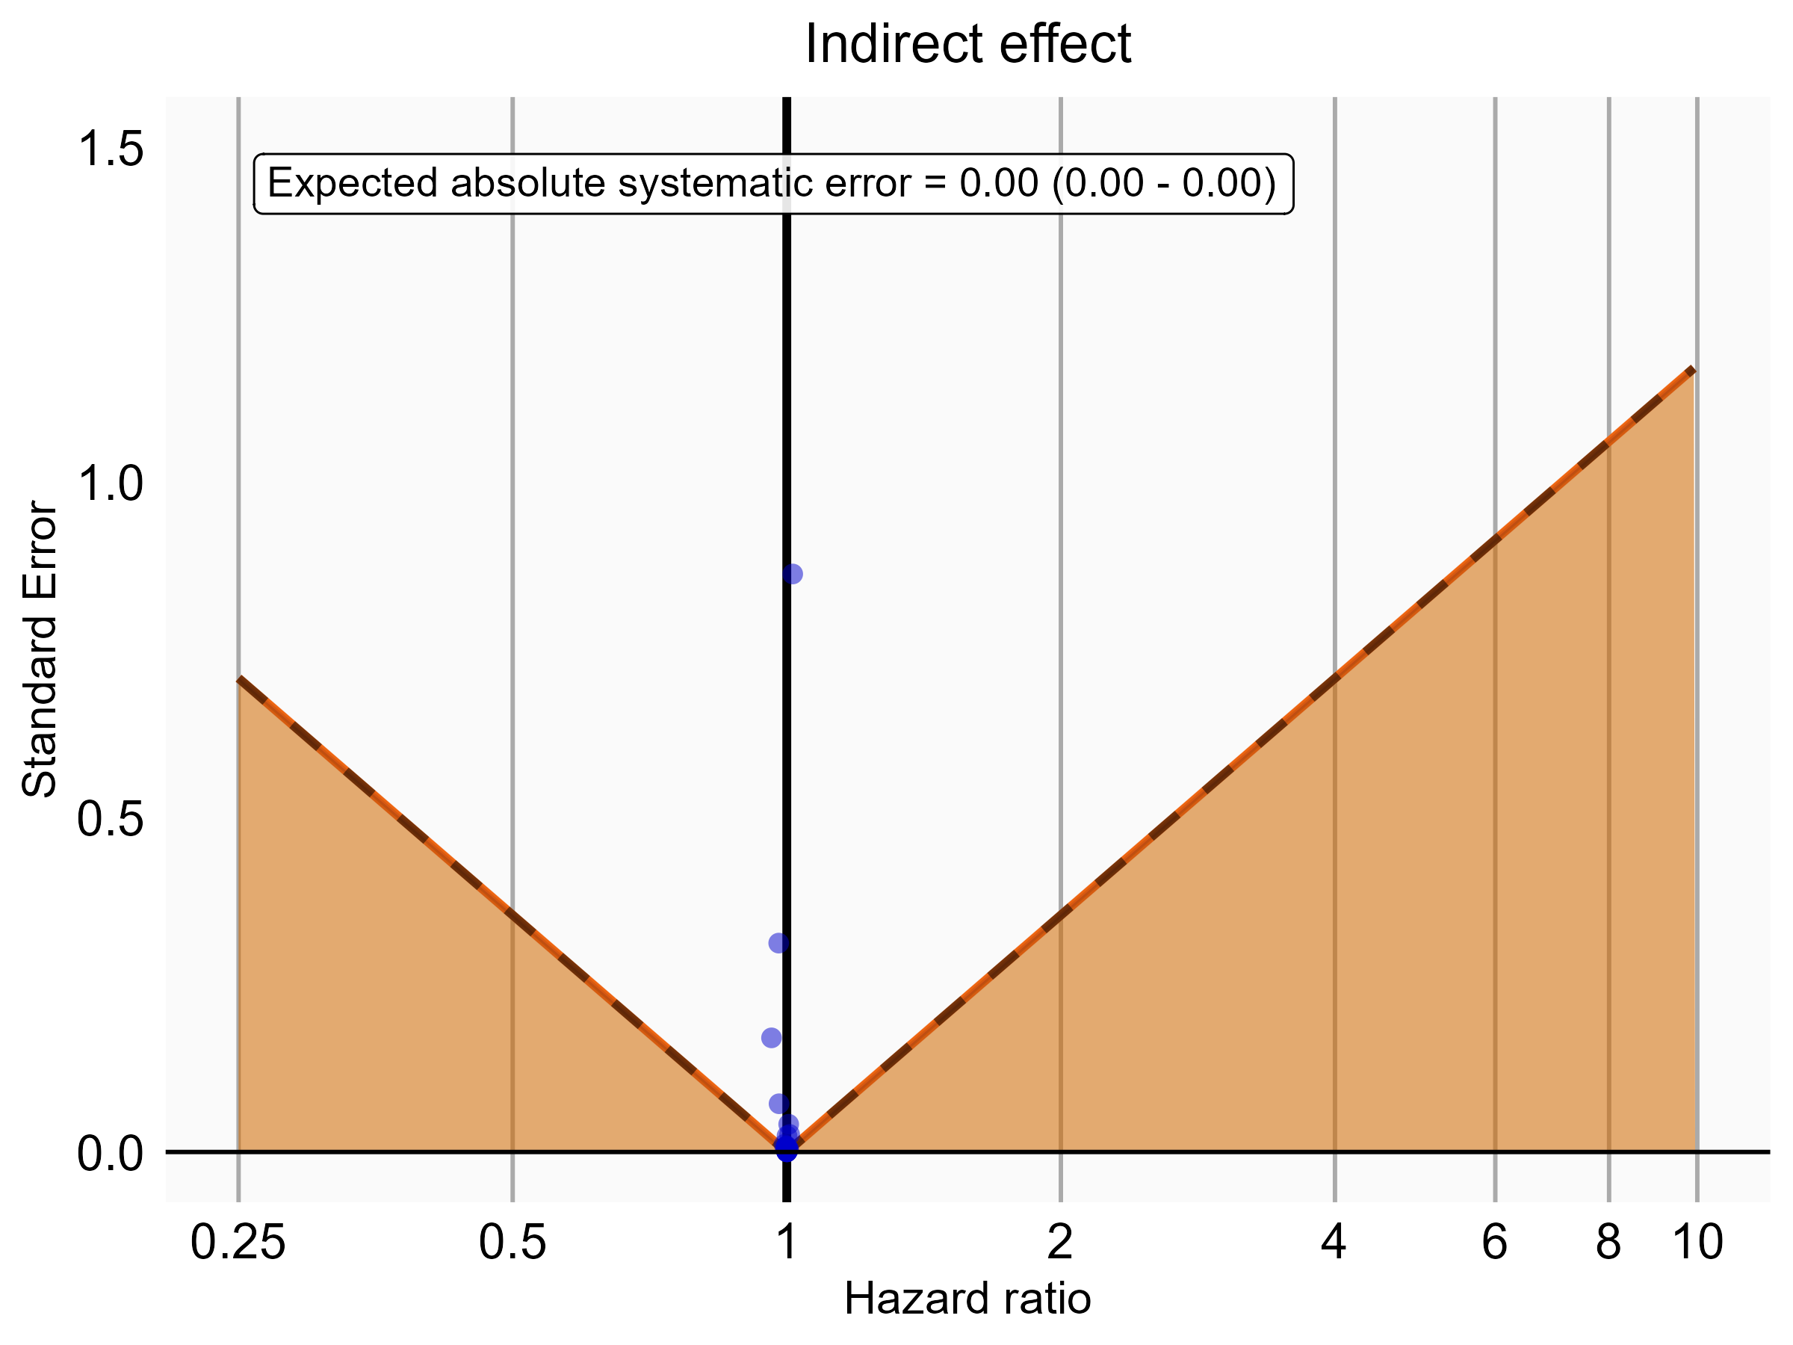

Negative control estimates of the indirect effect comparing Rivaroxaban to Warfarin using mediator Extracranial Major bleeding IP in OptumEhr.

### 5.0.4 PharMetrics

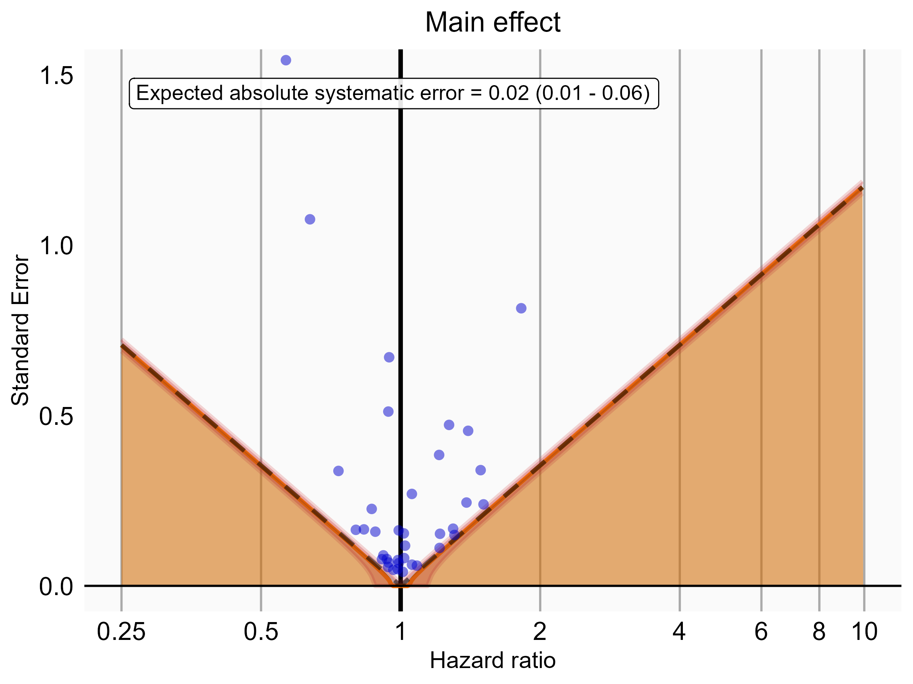

Negative control estimates of the main effect comparing DOACs to Warfarin using mediator Extracranial Major bleeding IP-ER in PharMetrics.

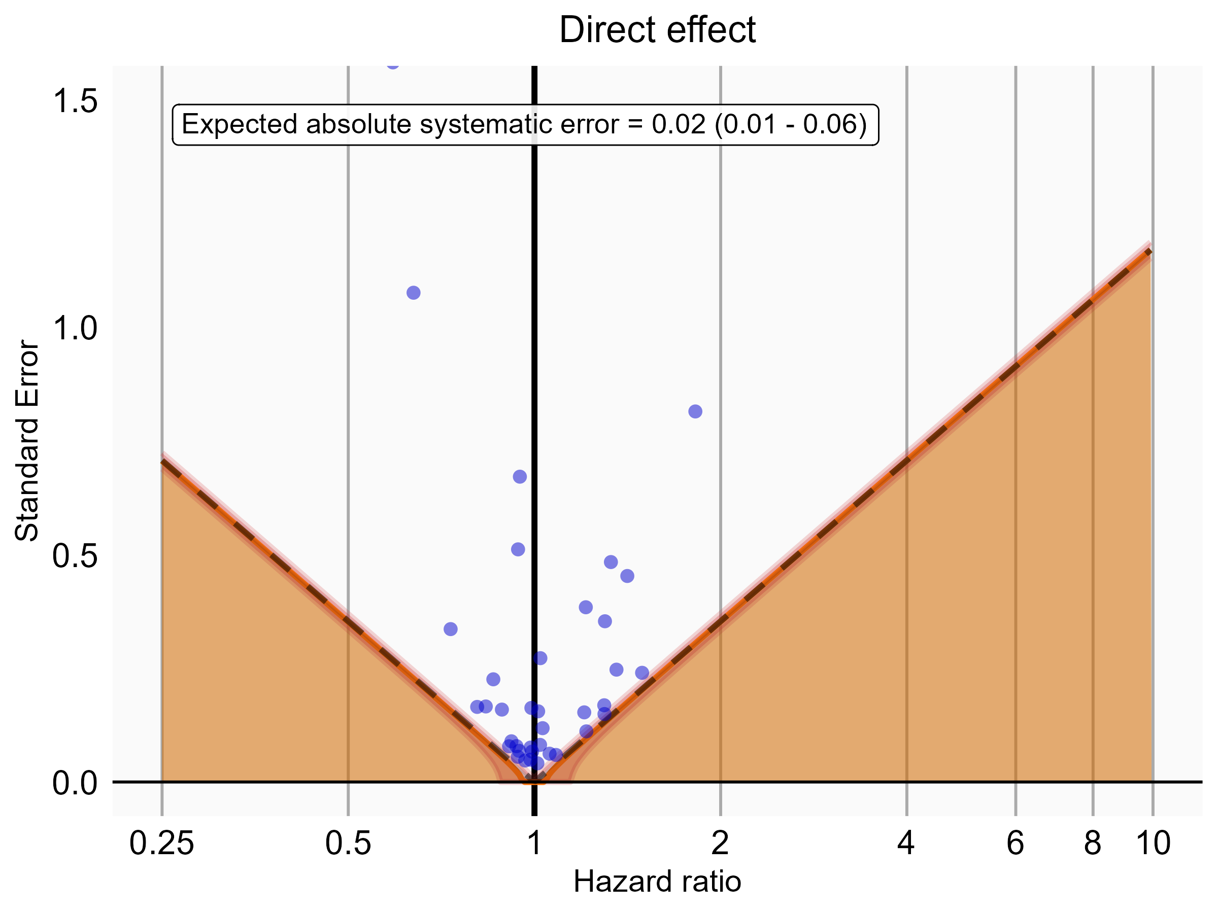

Negative control estimates of the direct effect comparing DOACs to Warfarin using mediator Extracranial Major bleeding IP-ER in PharMetrics.

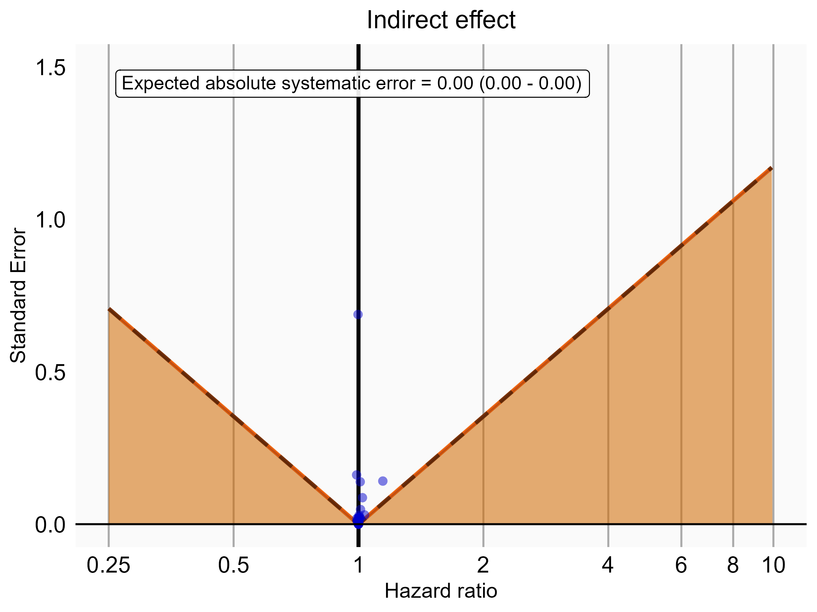

Negative control estimates of the indirect effect comparing DOACs to Warfarin using mediator Extracranial Major bleeding IP-ER in PharMetrics.

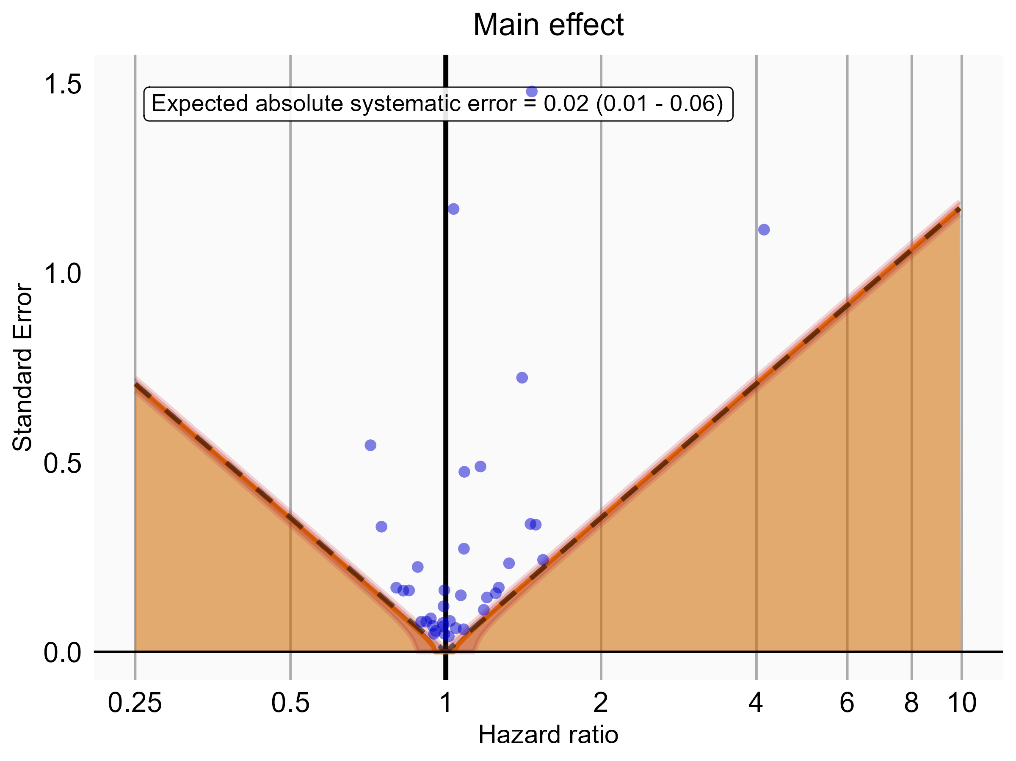

Negative control estimates of the main effect comparing DOACs to Warfarin using mediator Extracranial Major bleeding IP in PharMetrics.

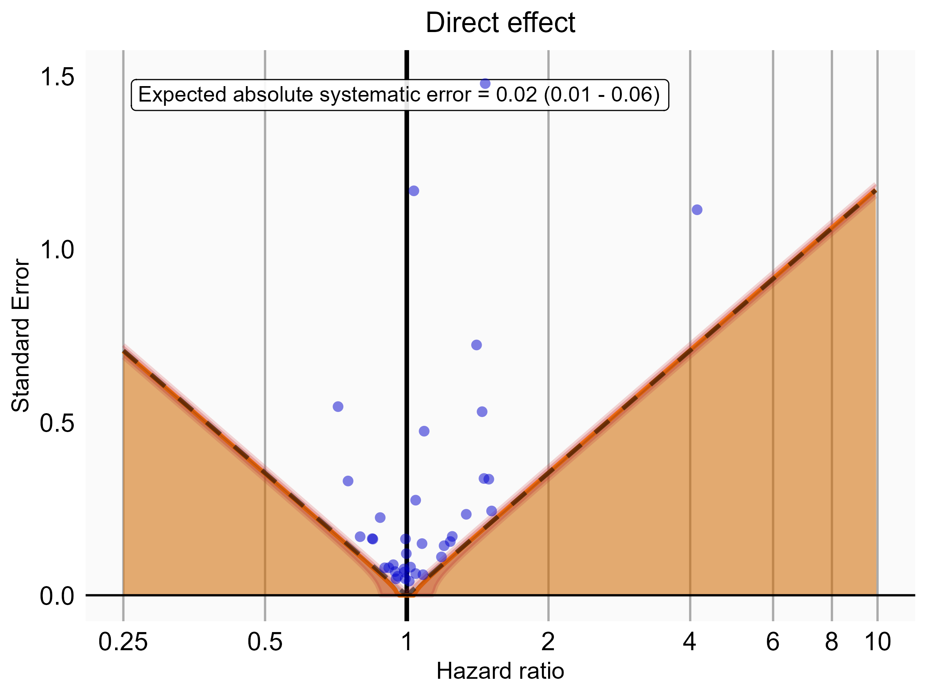

Negative control estimates of the direct effect comparing DOACs to Warfarin using mediator Extracranial Major bleeding IP in PharMetrics.

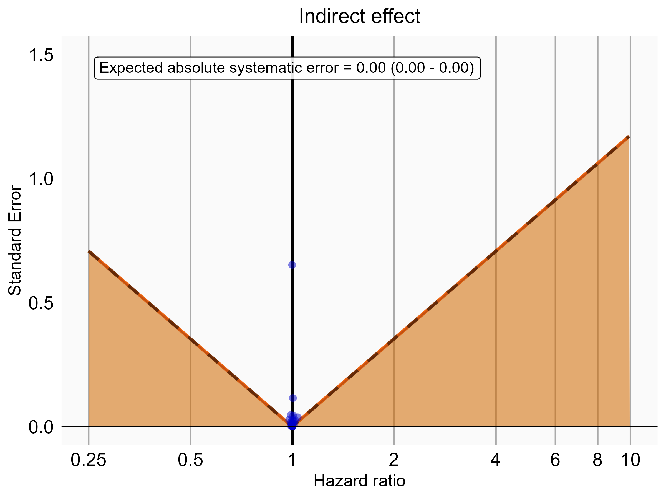

Negative control estimates of the indirect effect comparing DOACs to Warfarin using mediator Extracranial Major bleeding IP in PharMetrics.

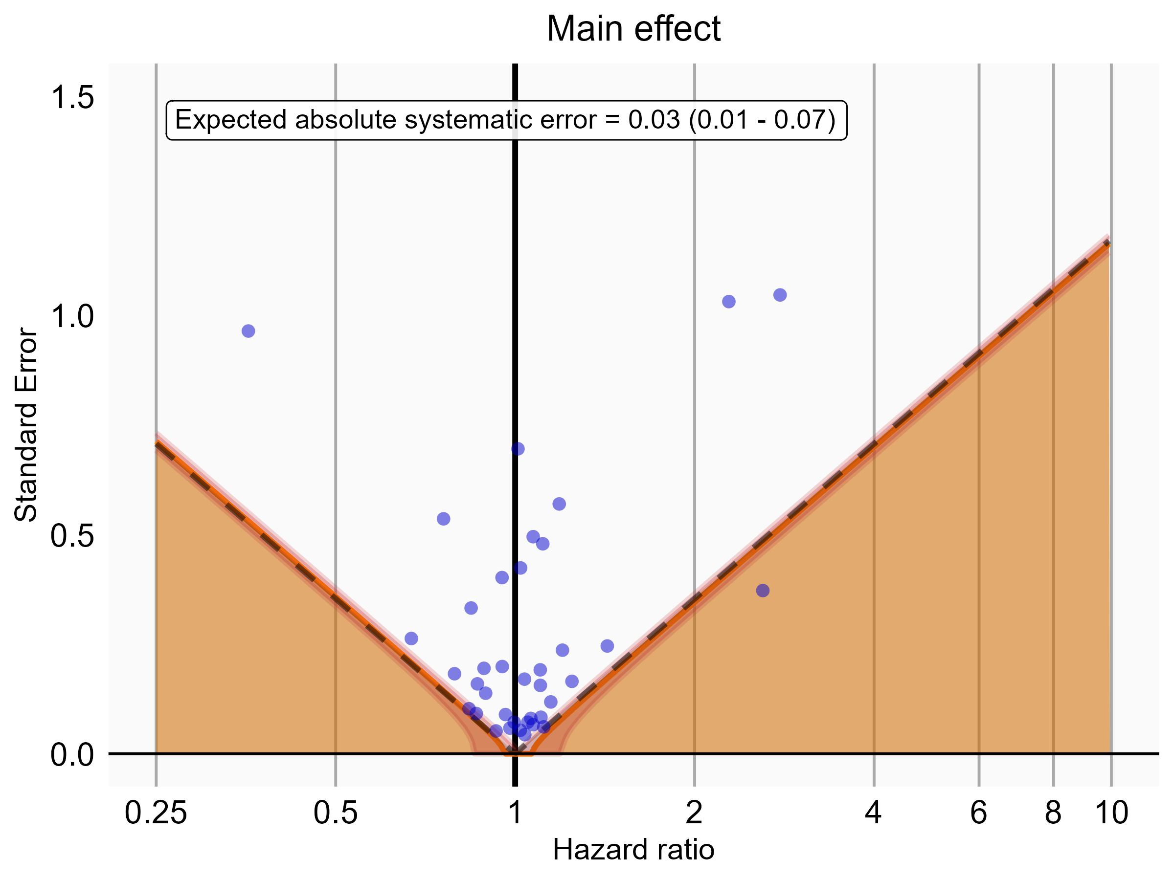

Negative control estimates of the main effect comparing Rivaroxaban to Warfarin using mediator Extracranial Major bleeding IP-ER in PharMetrics.

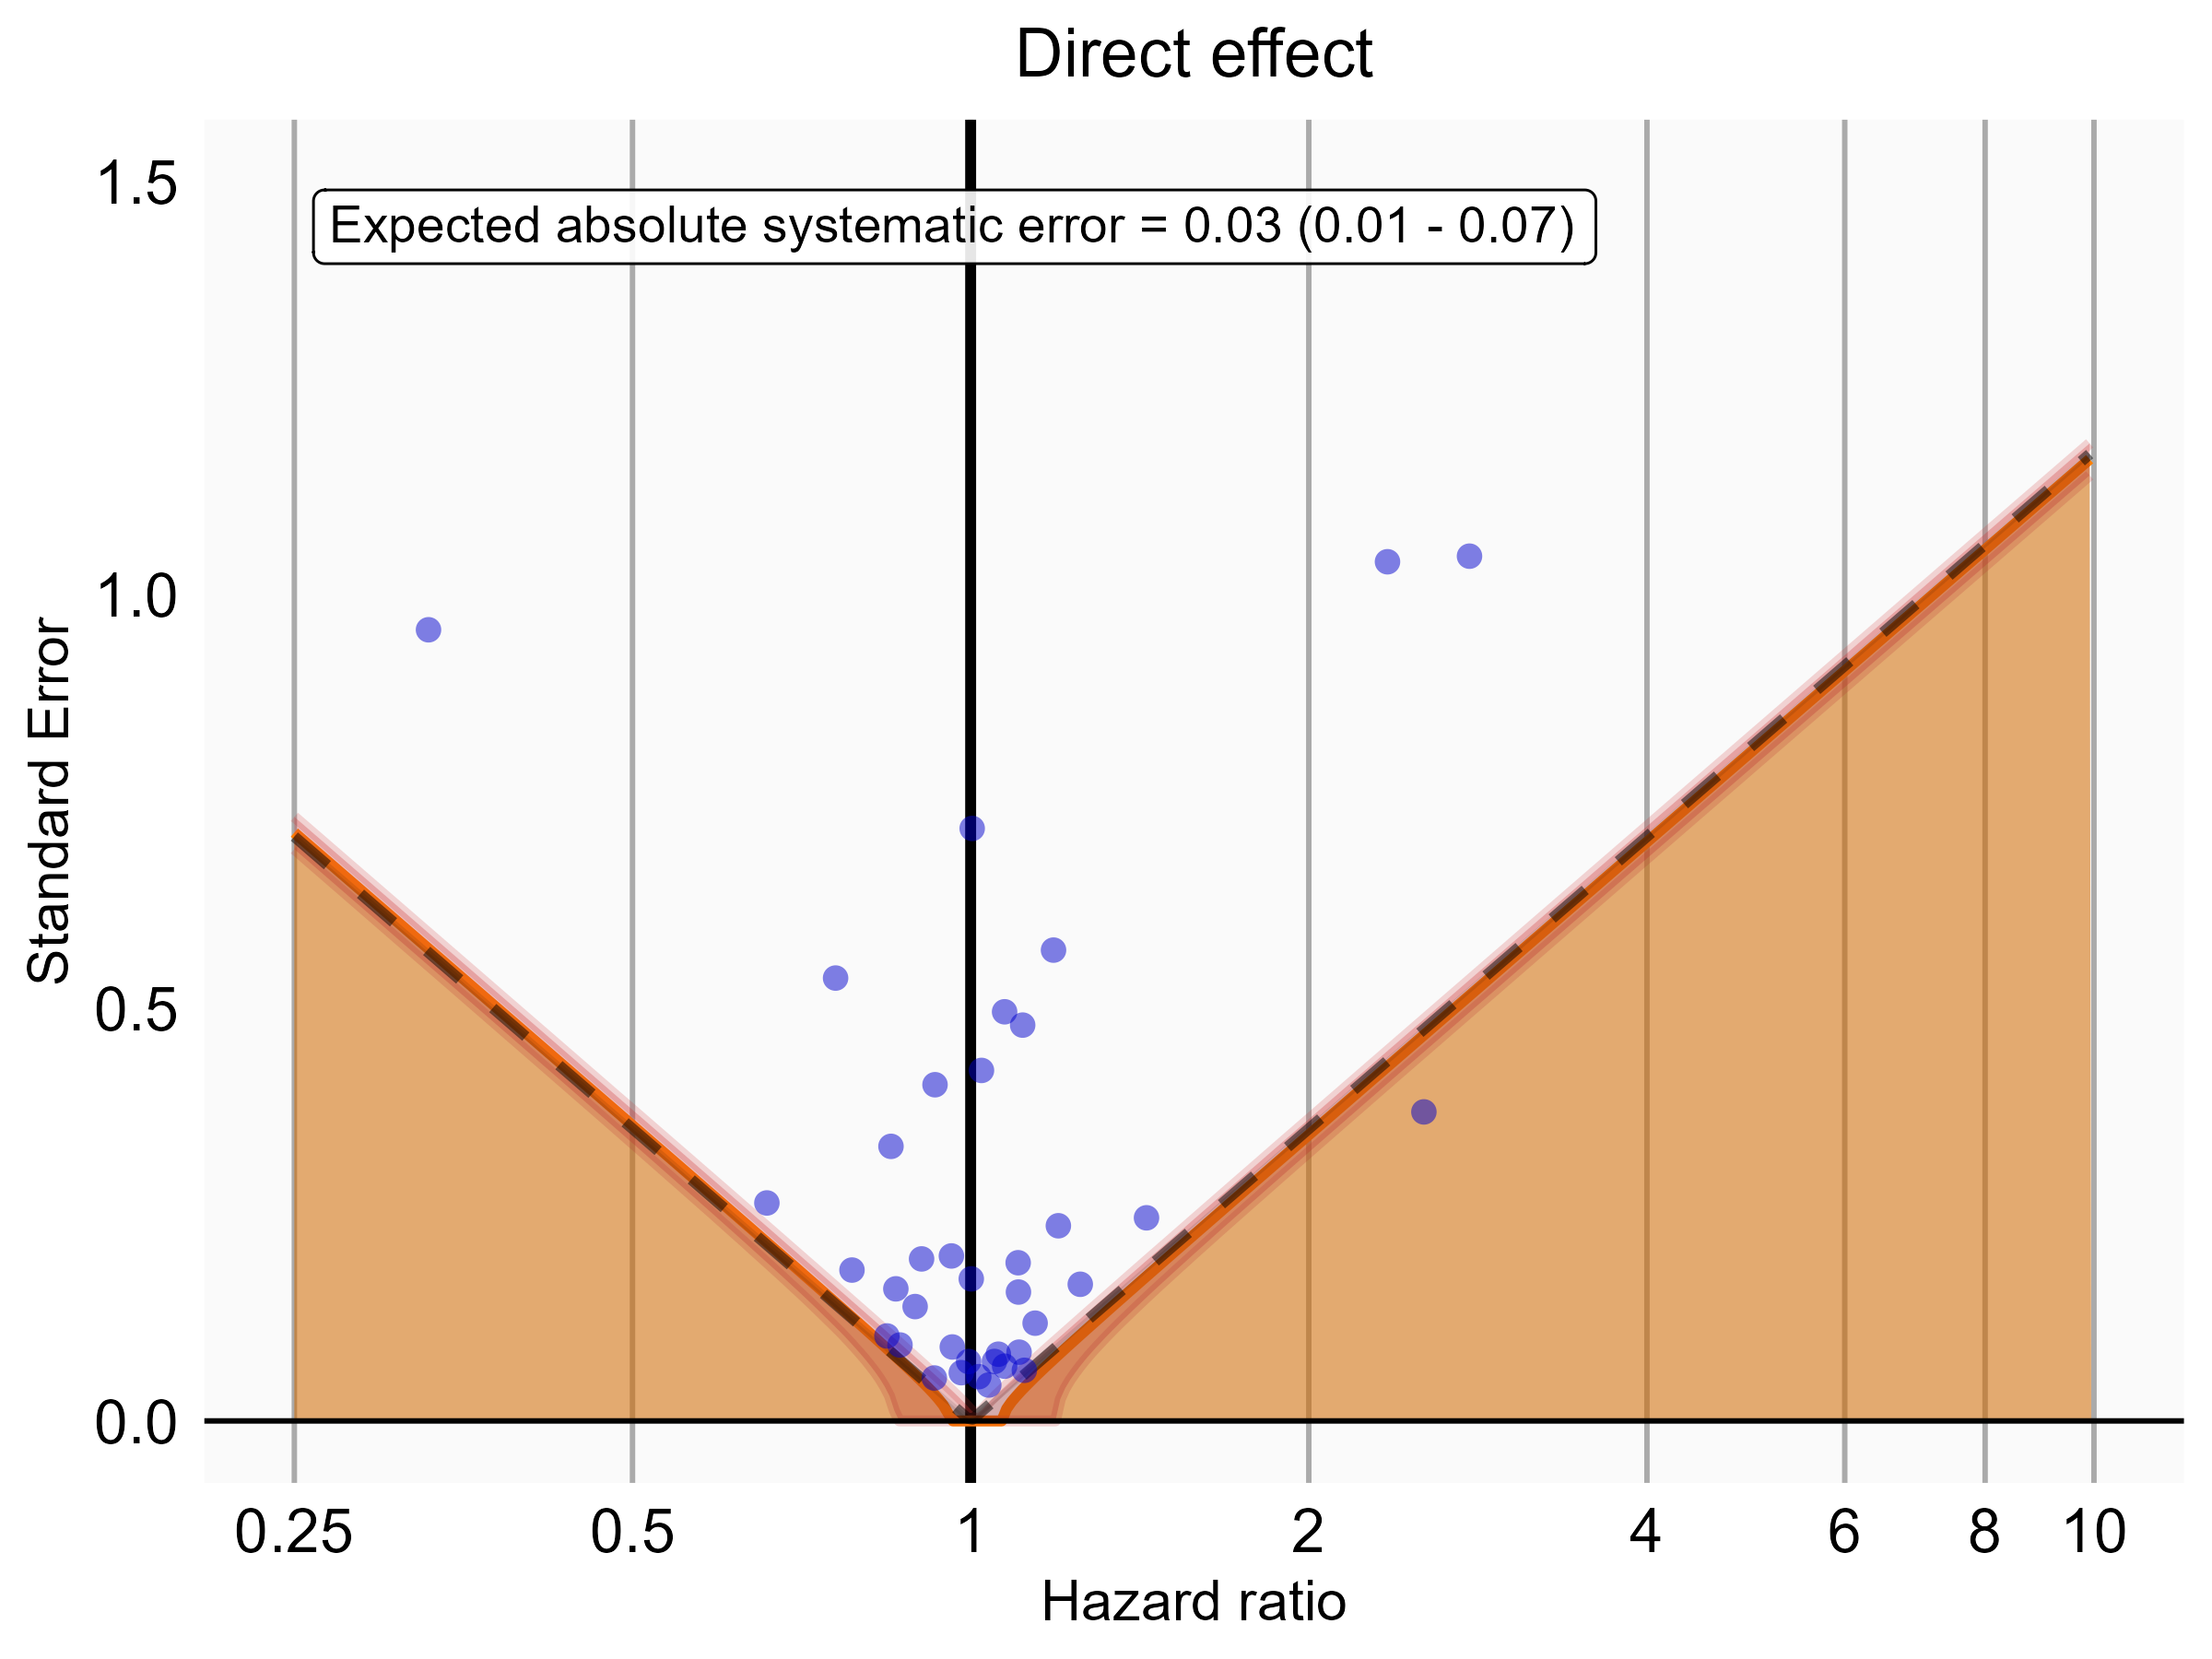

Negative control estimates of the direct effect comparing Rivaroxaban to Warfarin using mediator Extracranial Major bleeding IP-ER in PharMetrics.

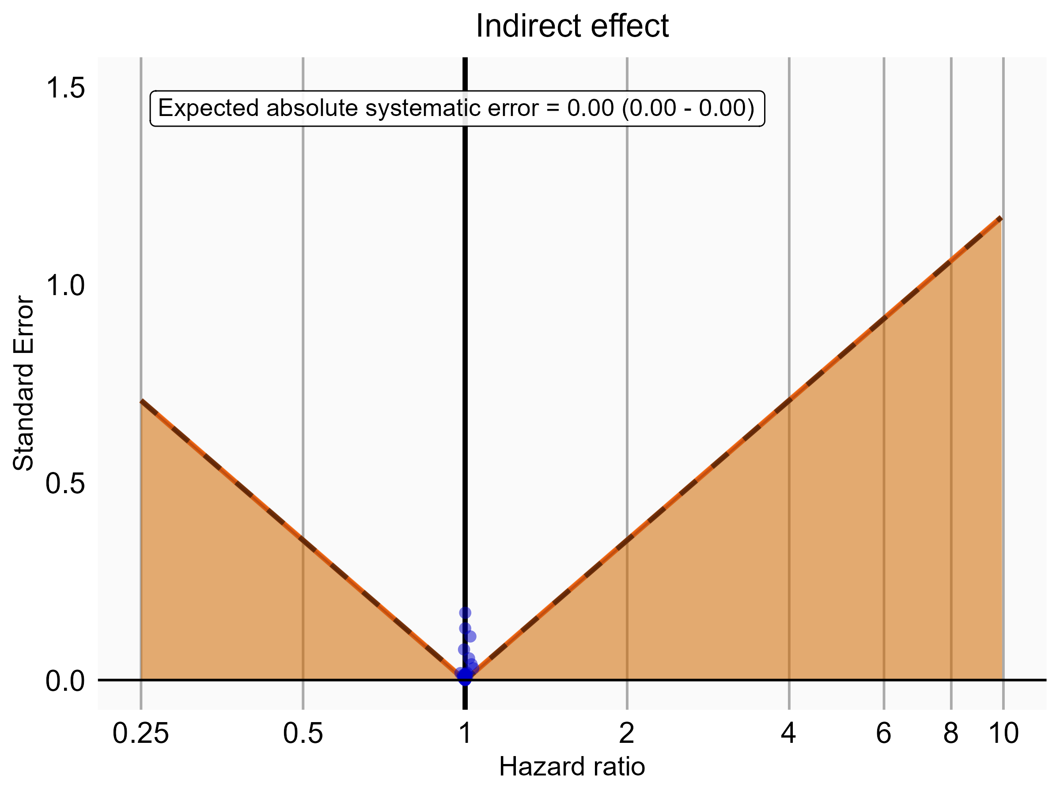

Negative control estimates of the indirect effect comparing Rivaroxaban to Warfarin using mediator Extracranial Major bleeding IP-ER in PharMetrics.

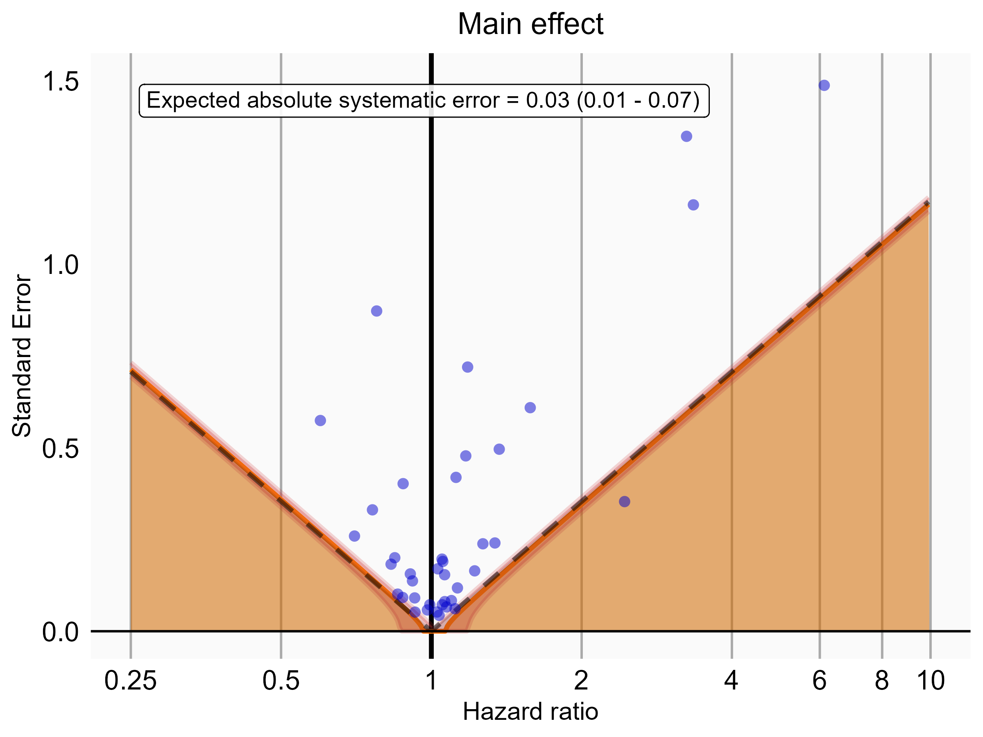

Negative control estimates of the main effect comparing Rivaroxaban to Warfarin using mediator Extracranial Major bleeding IP in PharMetrics.

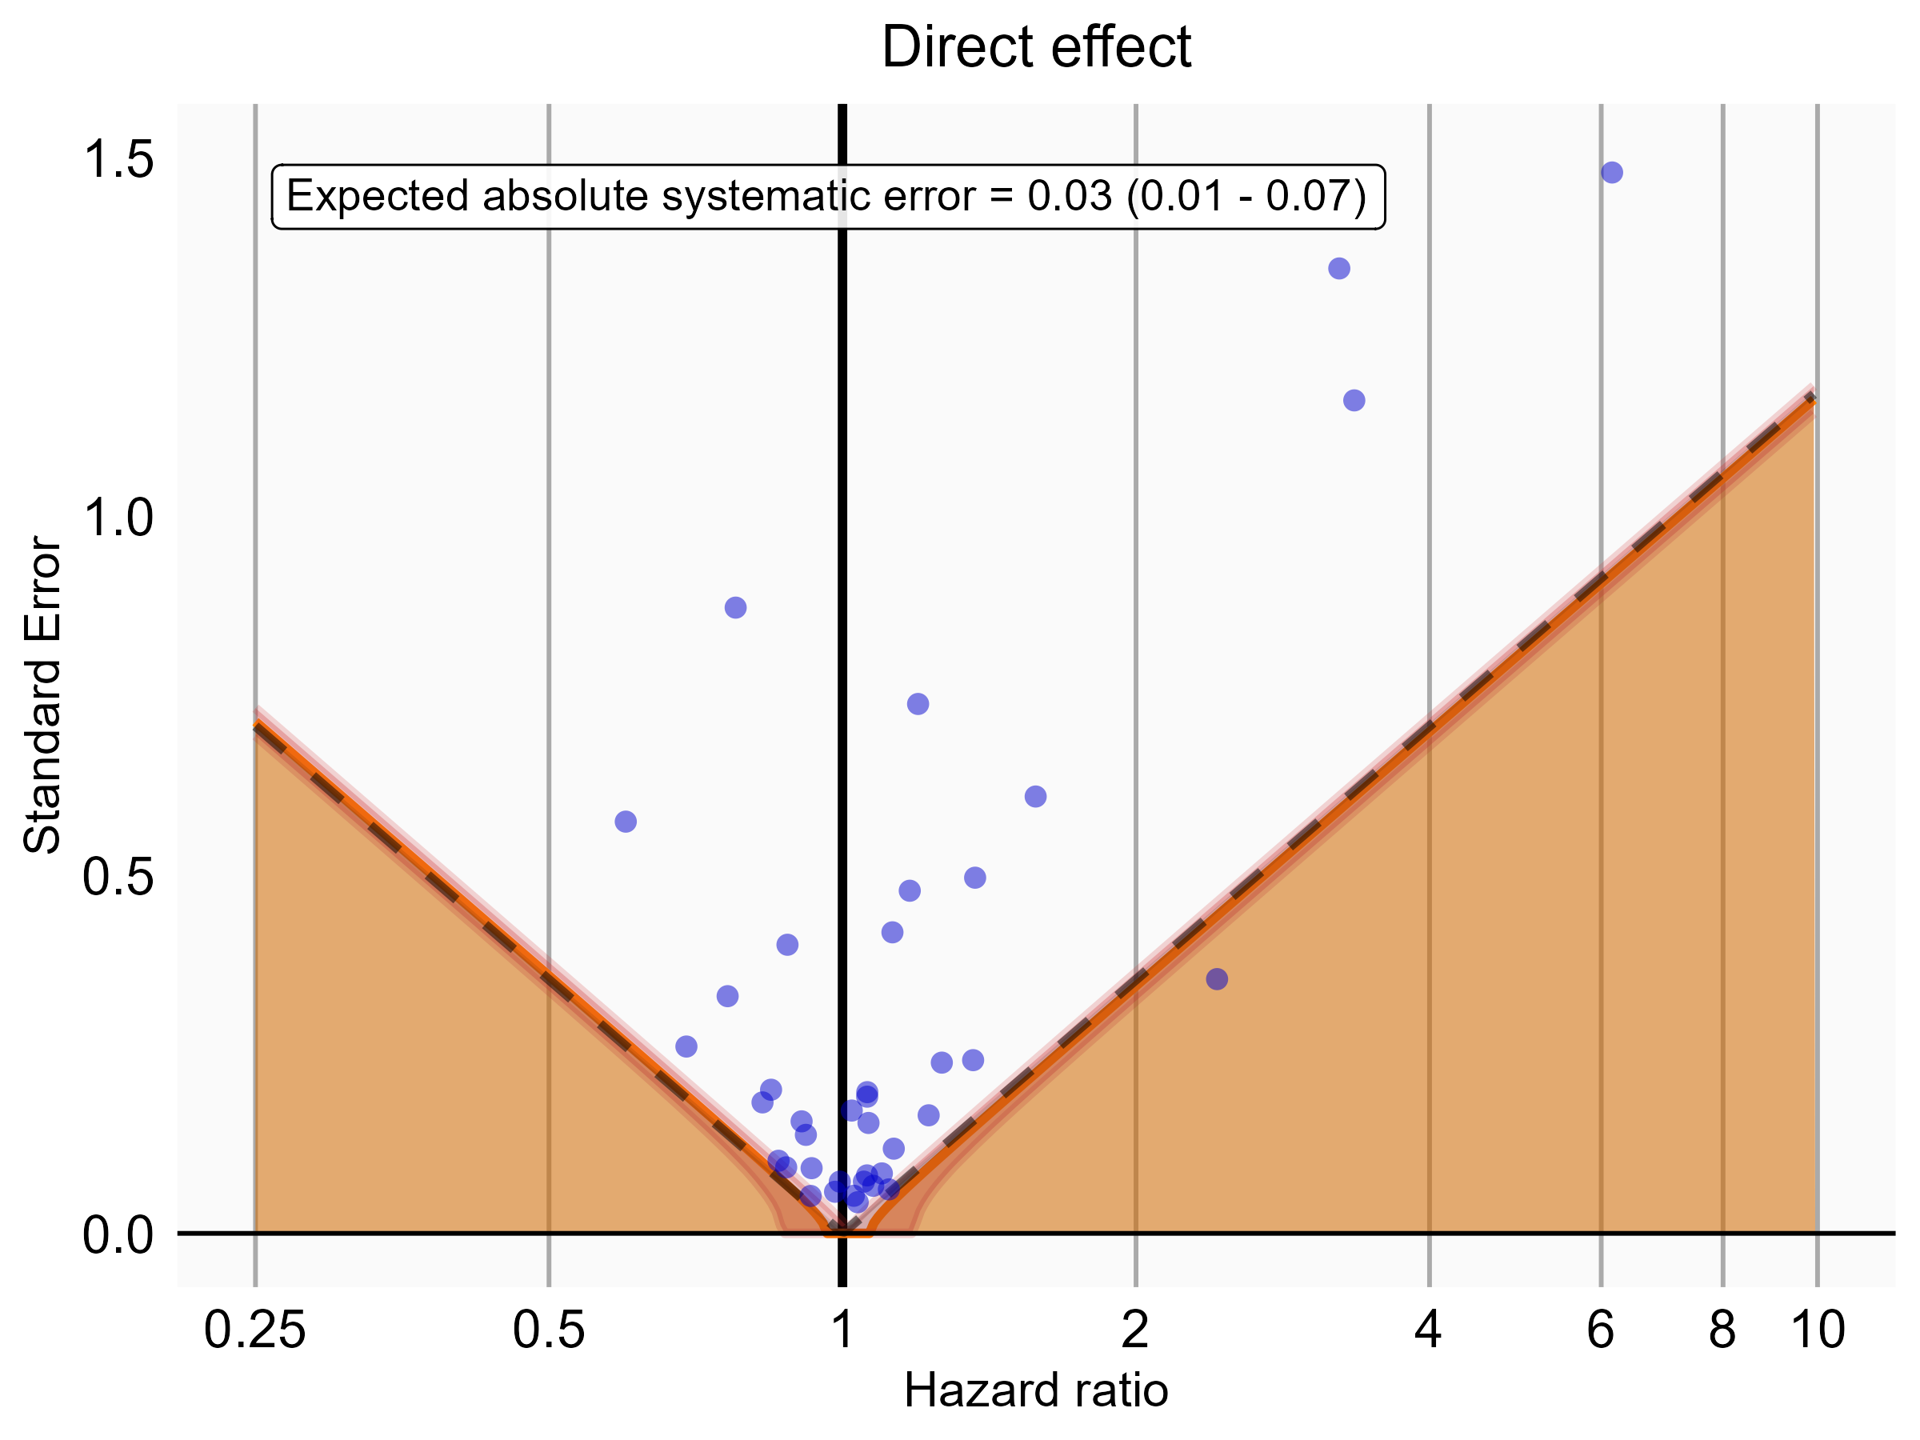

Negative control estimates of the direct effect comparing Rivaroxaban to Warfarin using mediator Extracranial Major bleeding IP in PharMetrics.

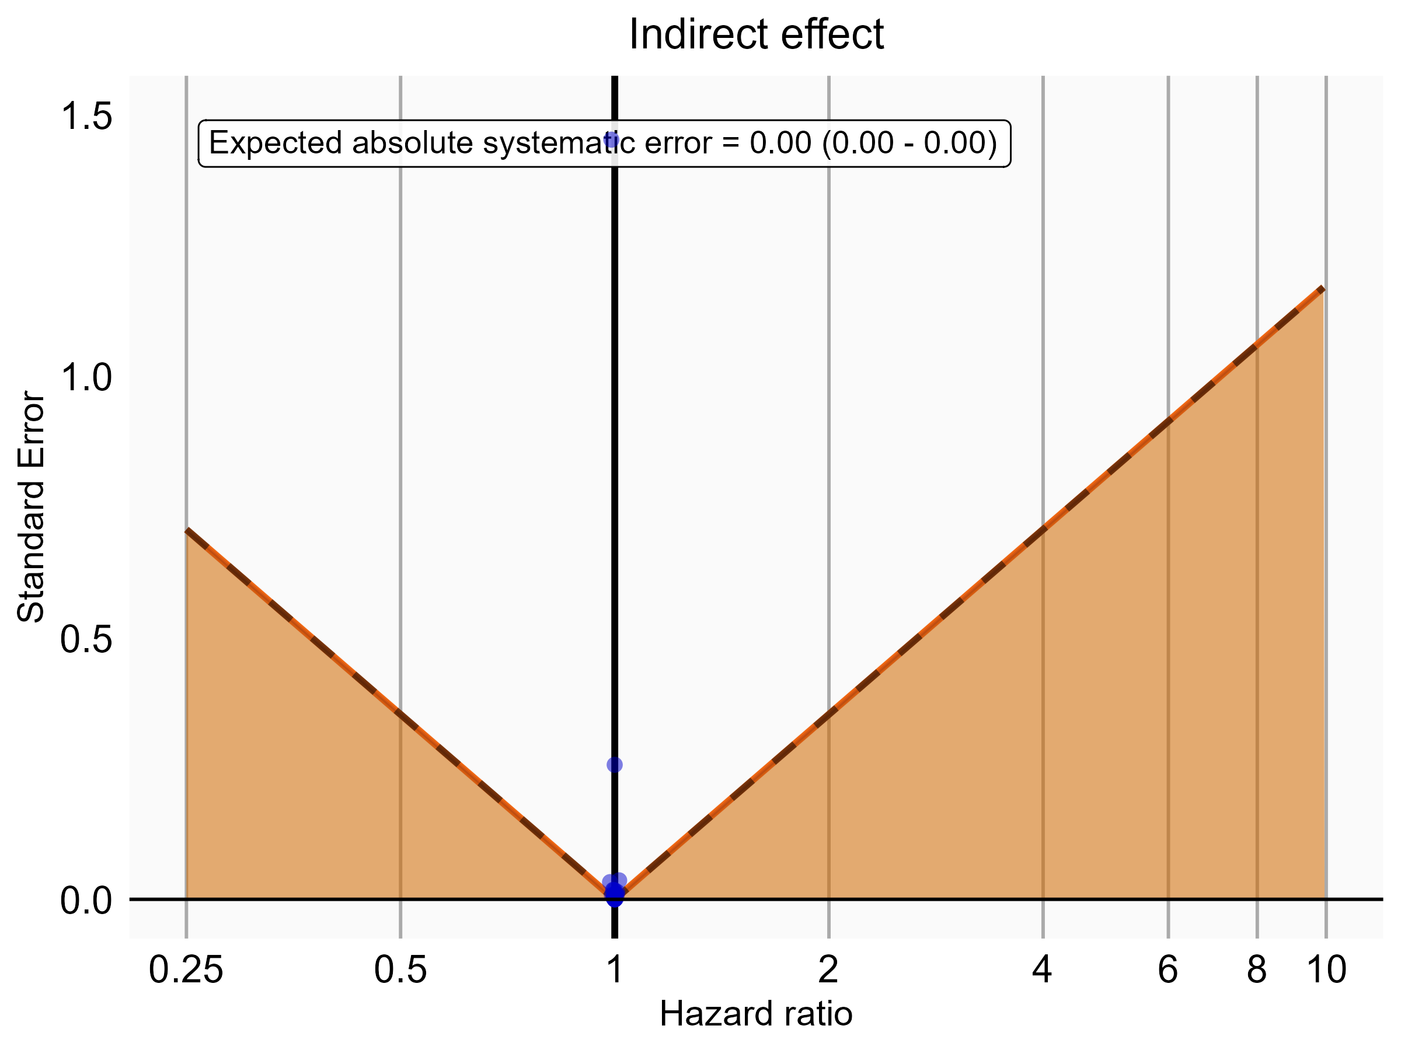

Negative control estimates of the indirect effect comparing Rivaroxaban to Warfarin using mediator Extracranial Major bleeding IP in PharMetrics.

### 5.0.5 MDCR

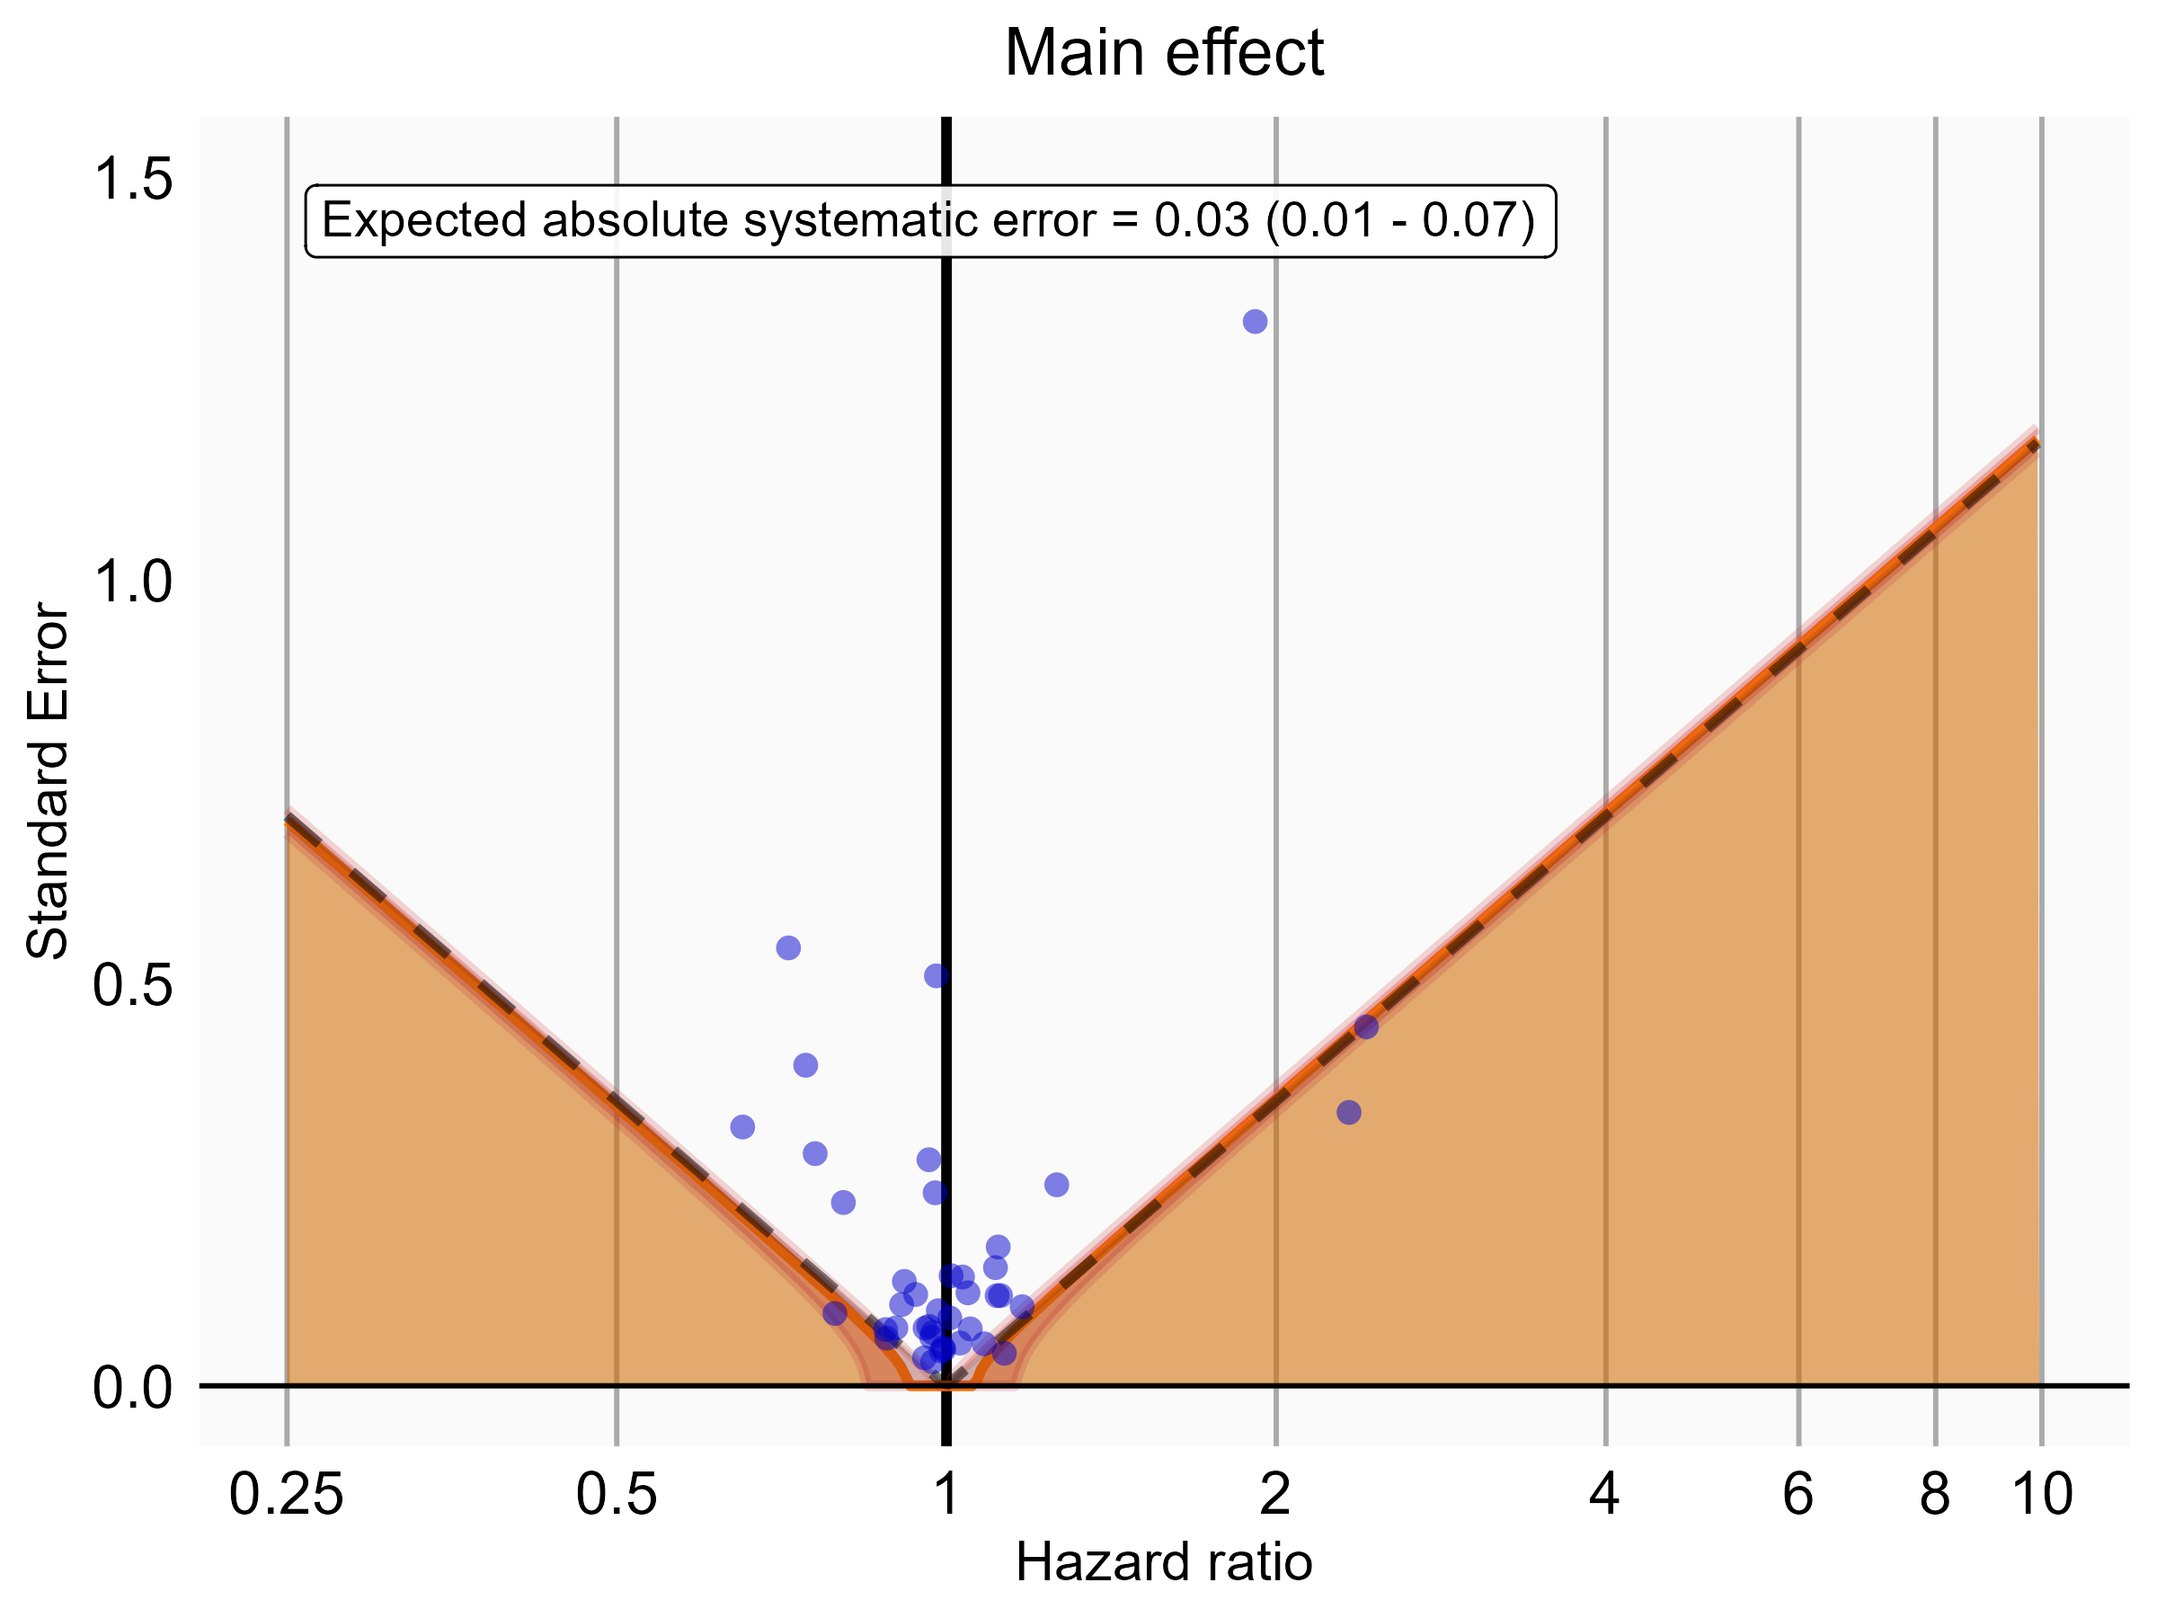

Negative control estimates of the main effect comparing DOACs to Warfarin using mediator Extracranial Major bleeding IP-ER in MDCR.

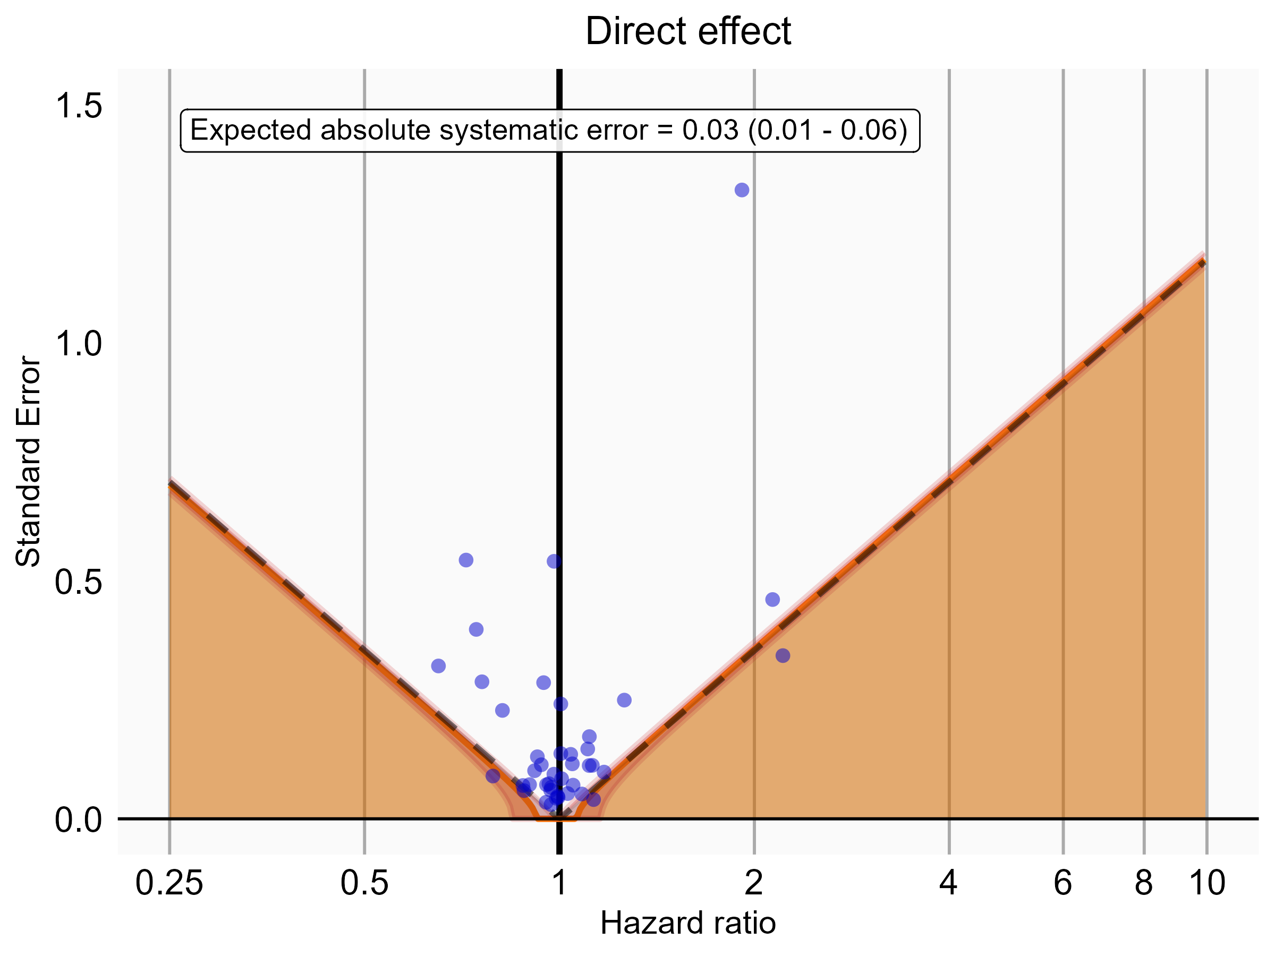

Negative control estimates of the direct effect comparing DOACs to Warfarin using mediator Extracranial Major bleeding IP-ER in MDCR.

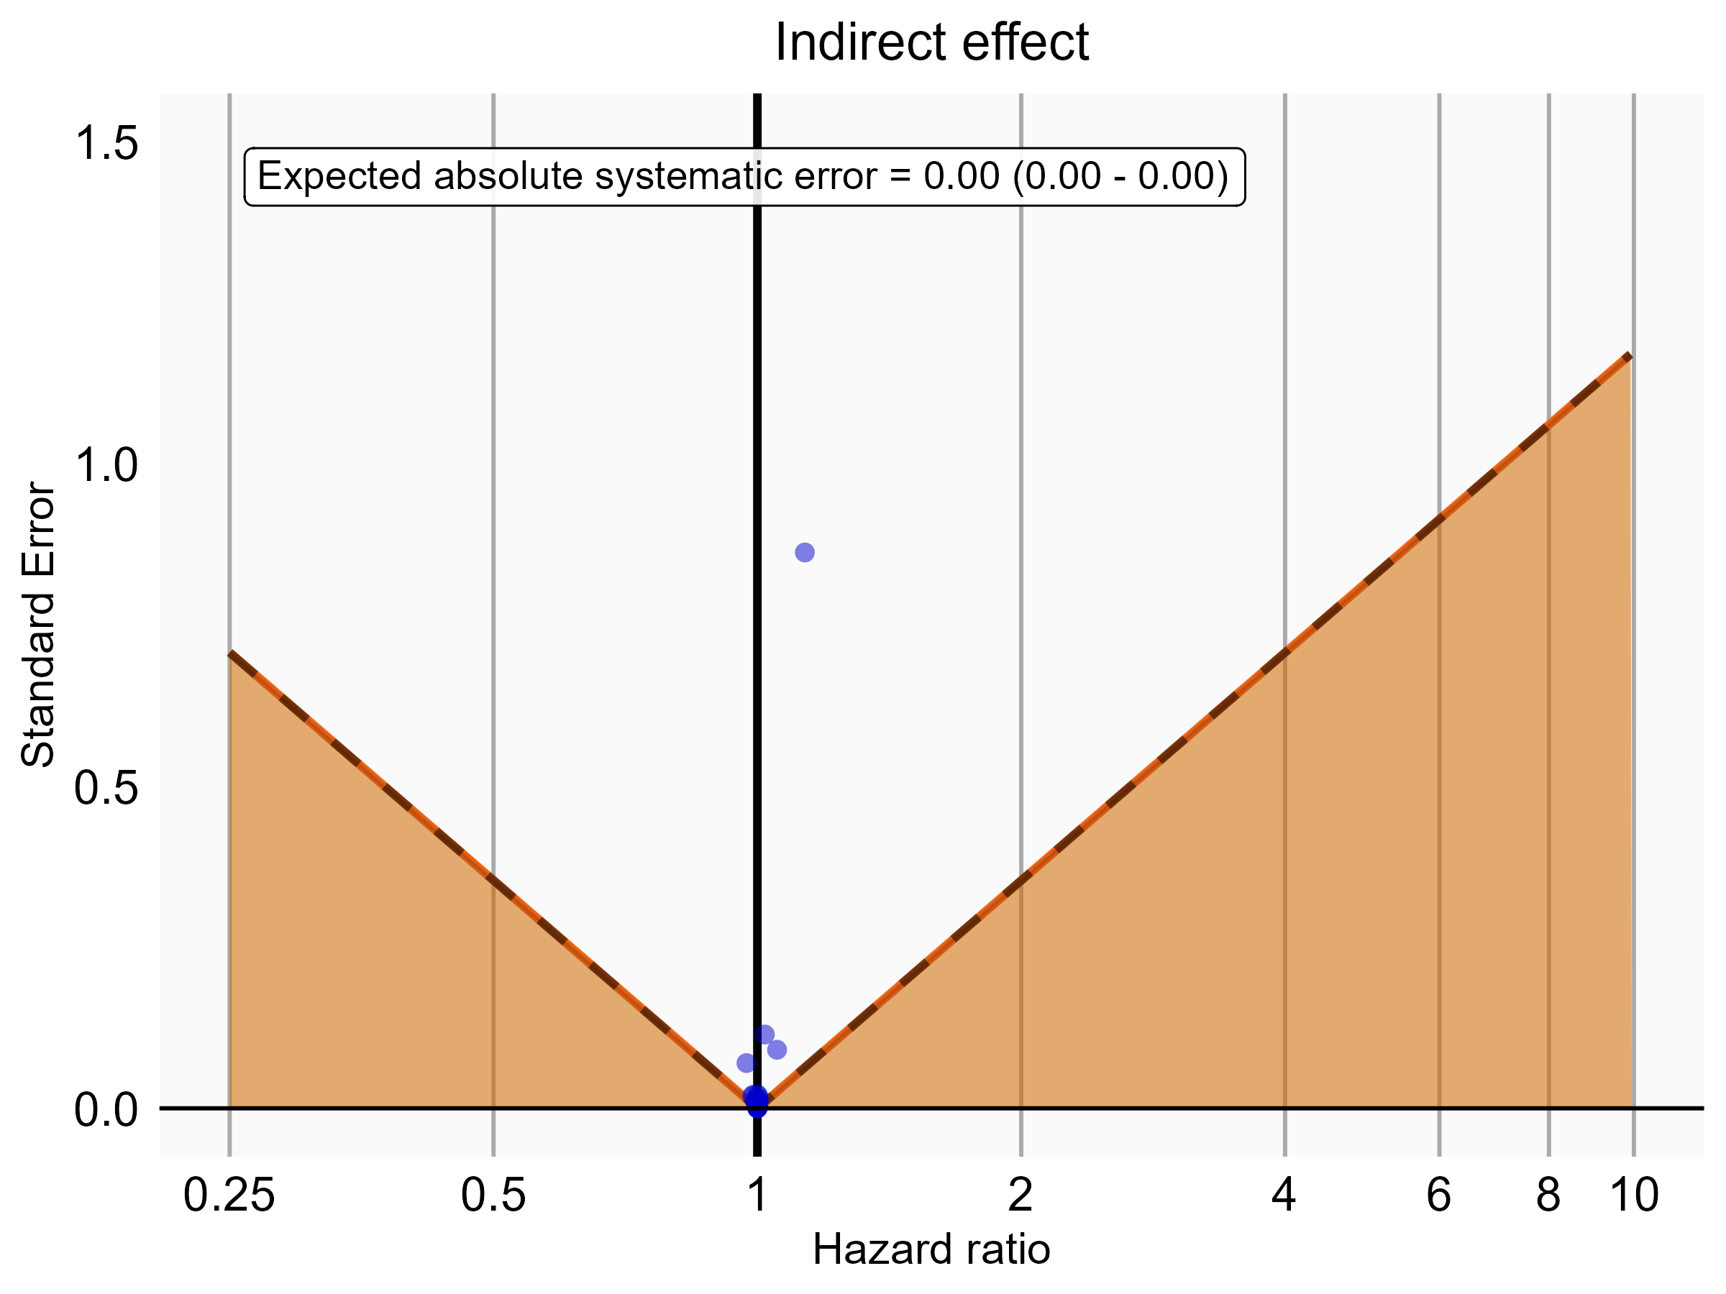

Negative control estimates of the indirect effect comparing DOACs to Warfarin using mediator Extracranial Major bleeding IP-ER in MDCR.

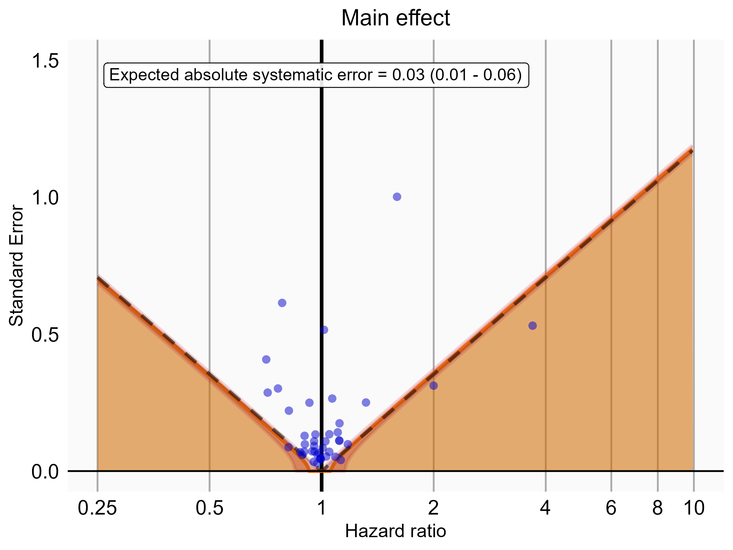

Negative control estimates of the main effect comparing DOACs to Warfarin using mediator Extracranial Major bleeding IP in MDCR.

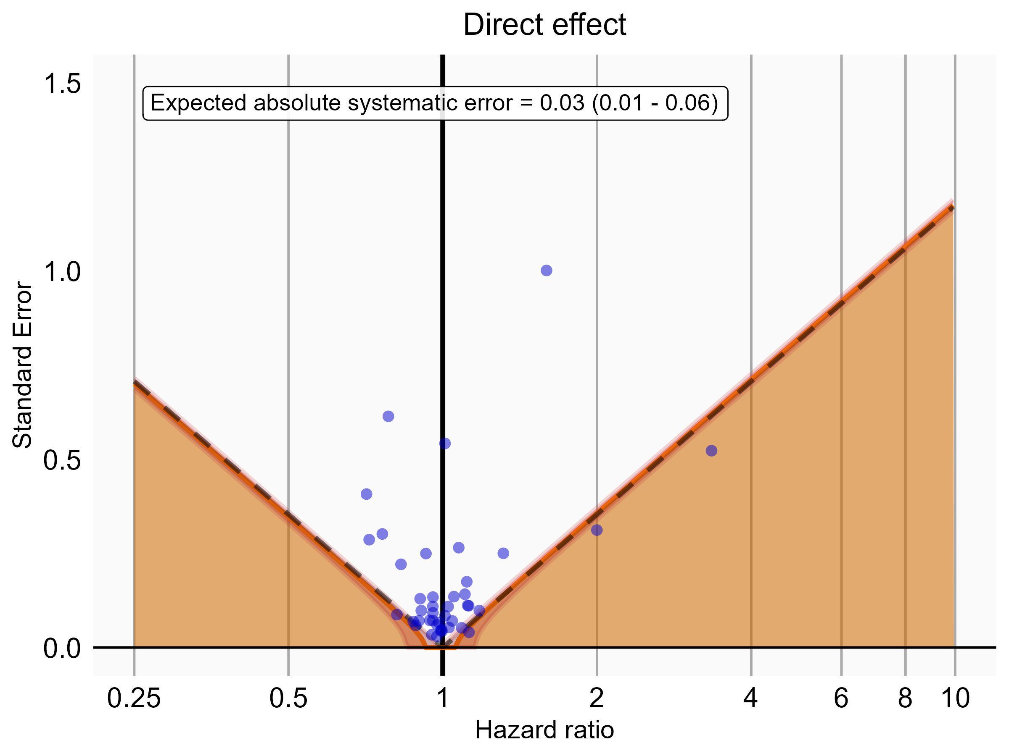

Negative control estimates of the direct effect comparing DOACs to Warfarin using mediator Extracranial Major bleeding IP in MDCR.

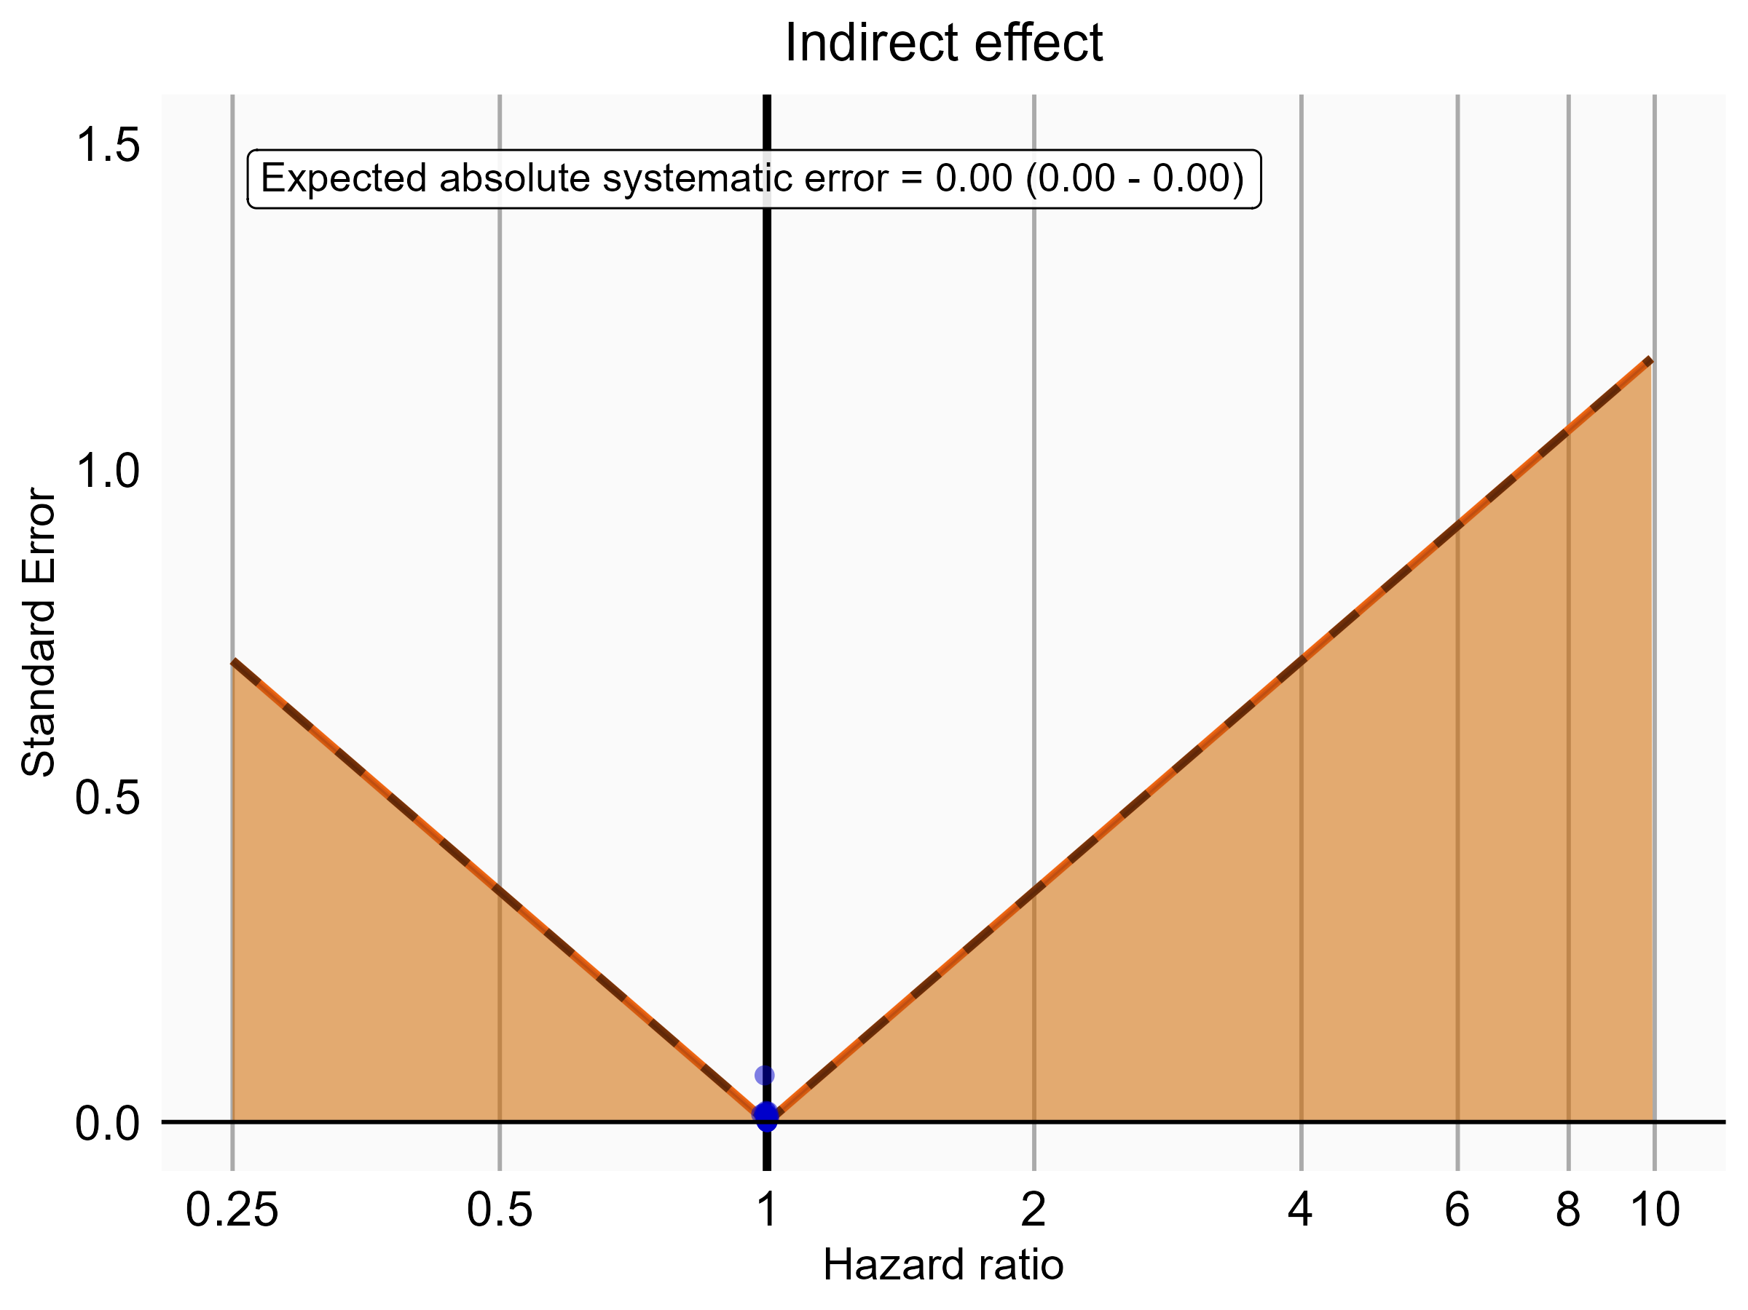

Negative control estimates of the indirect effect comparing DOACs to Warfarin using mediator Extracranial Major bleeding IP in MDCR.

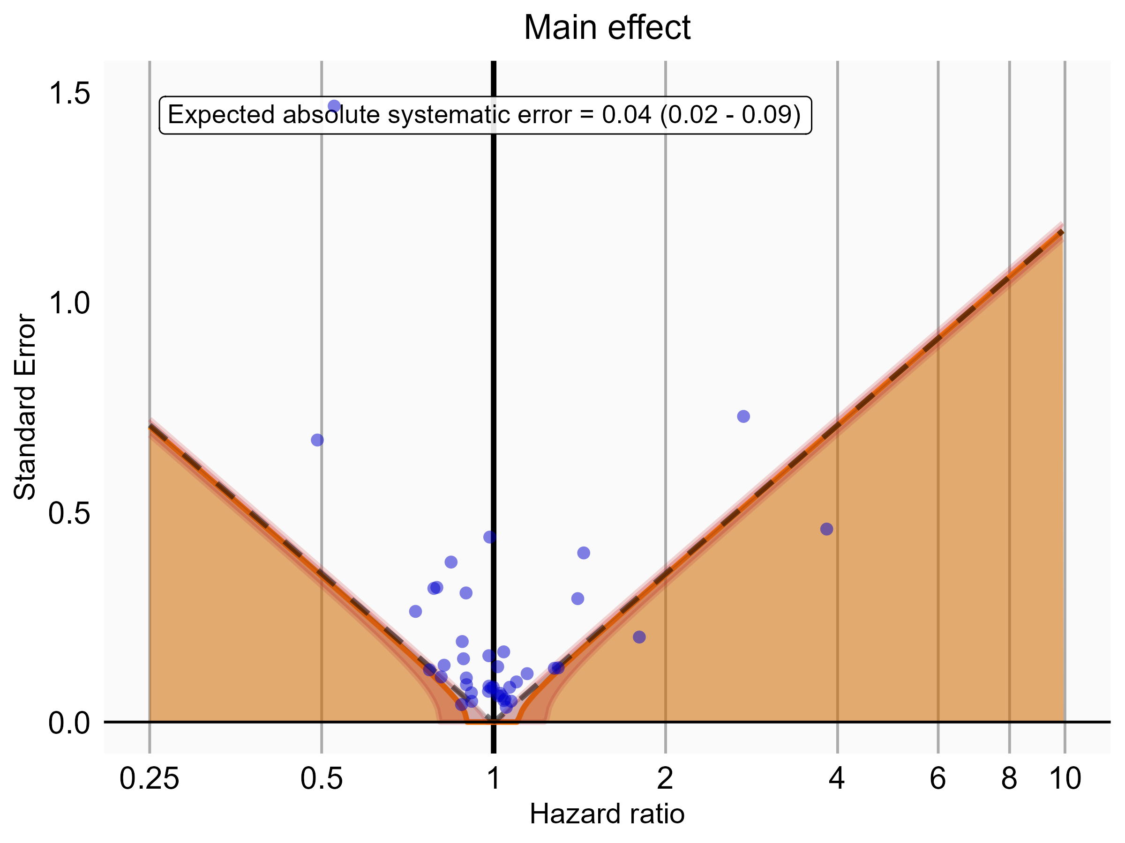

Negative control estimates of the main effect comparing Rivaroxaban to Warfarin using mediator Extracranial Major bleeding IP-ER in MDCR.

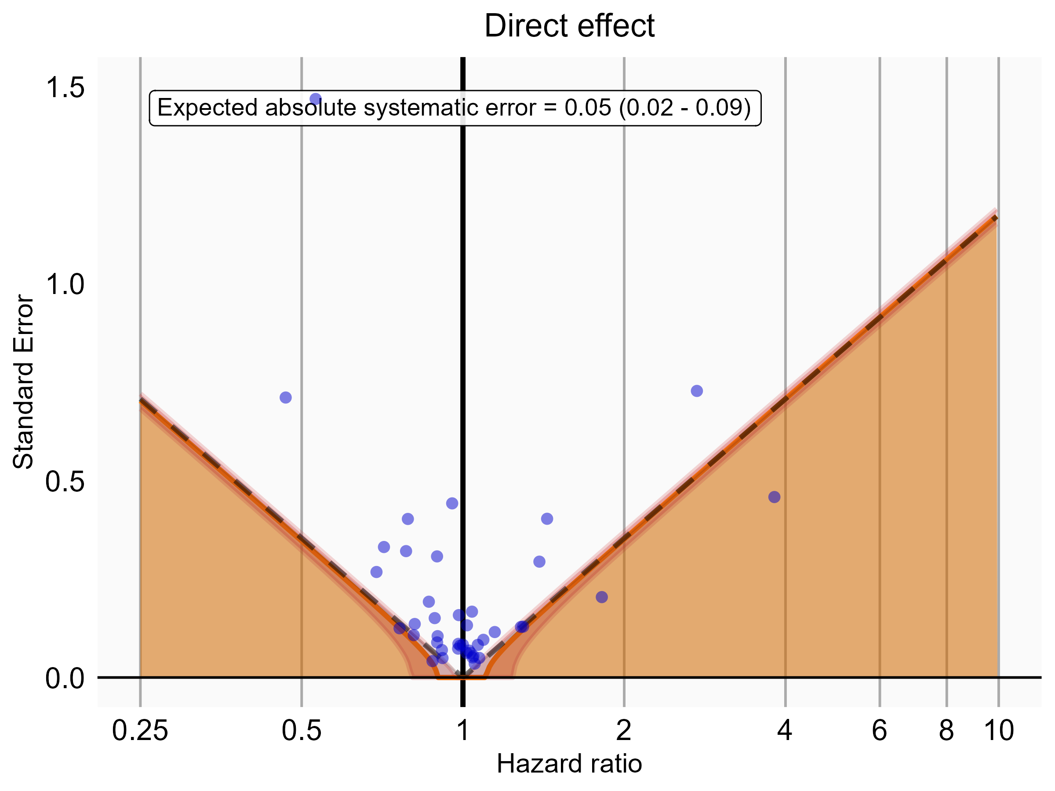

Negative control estimates of the direct effect comparing Rivaroxaban to Warfarin using mediator Extracranial Major bleeding IP-ER in MDCR.

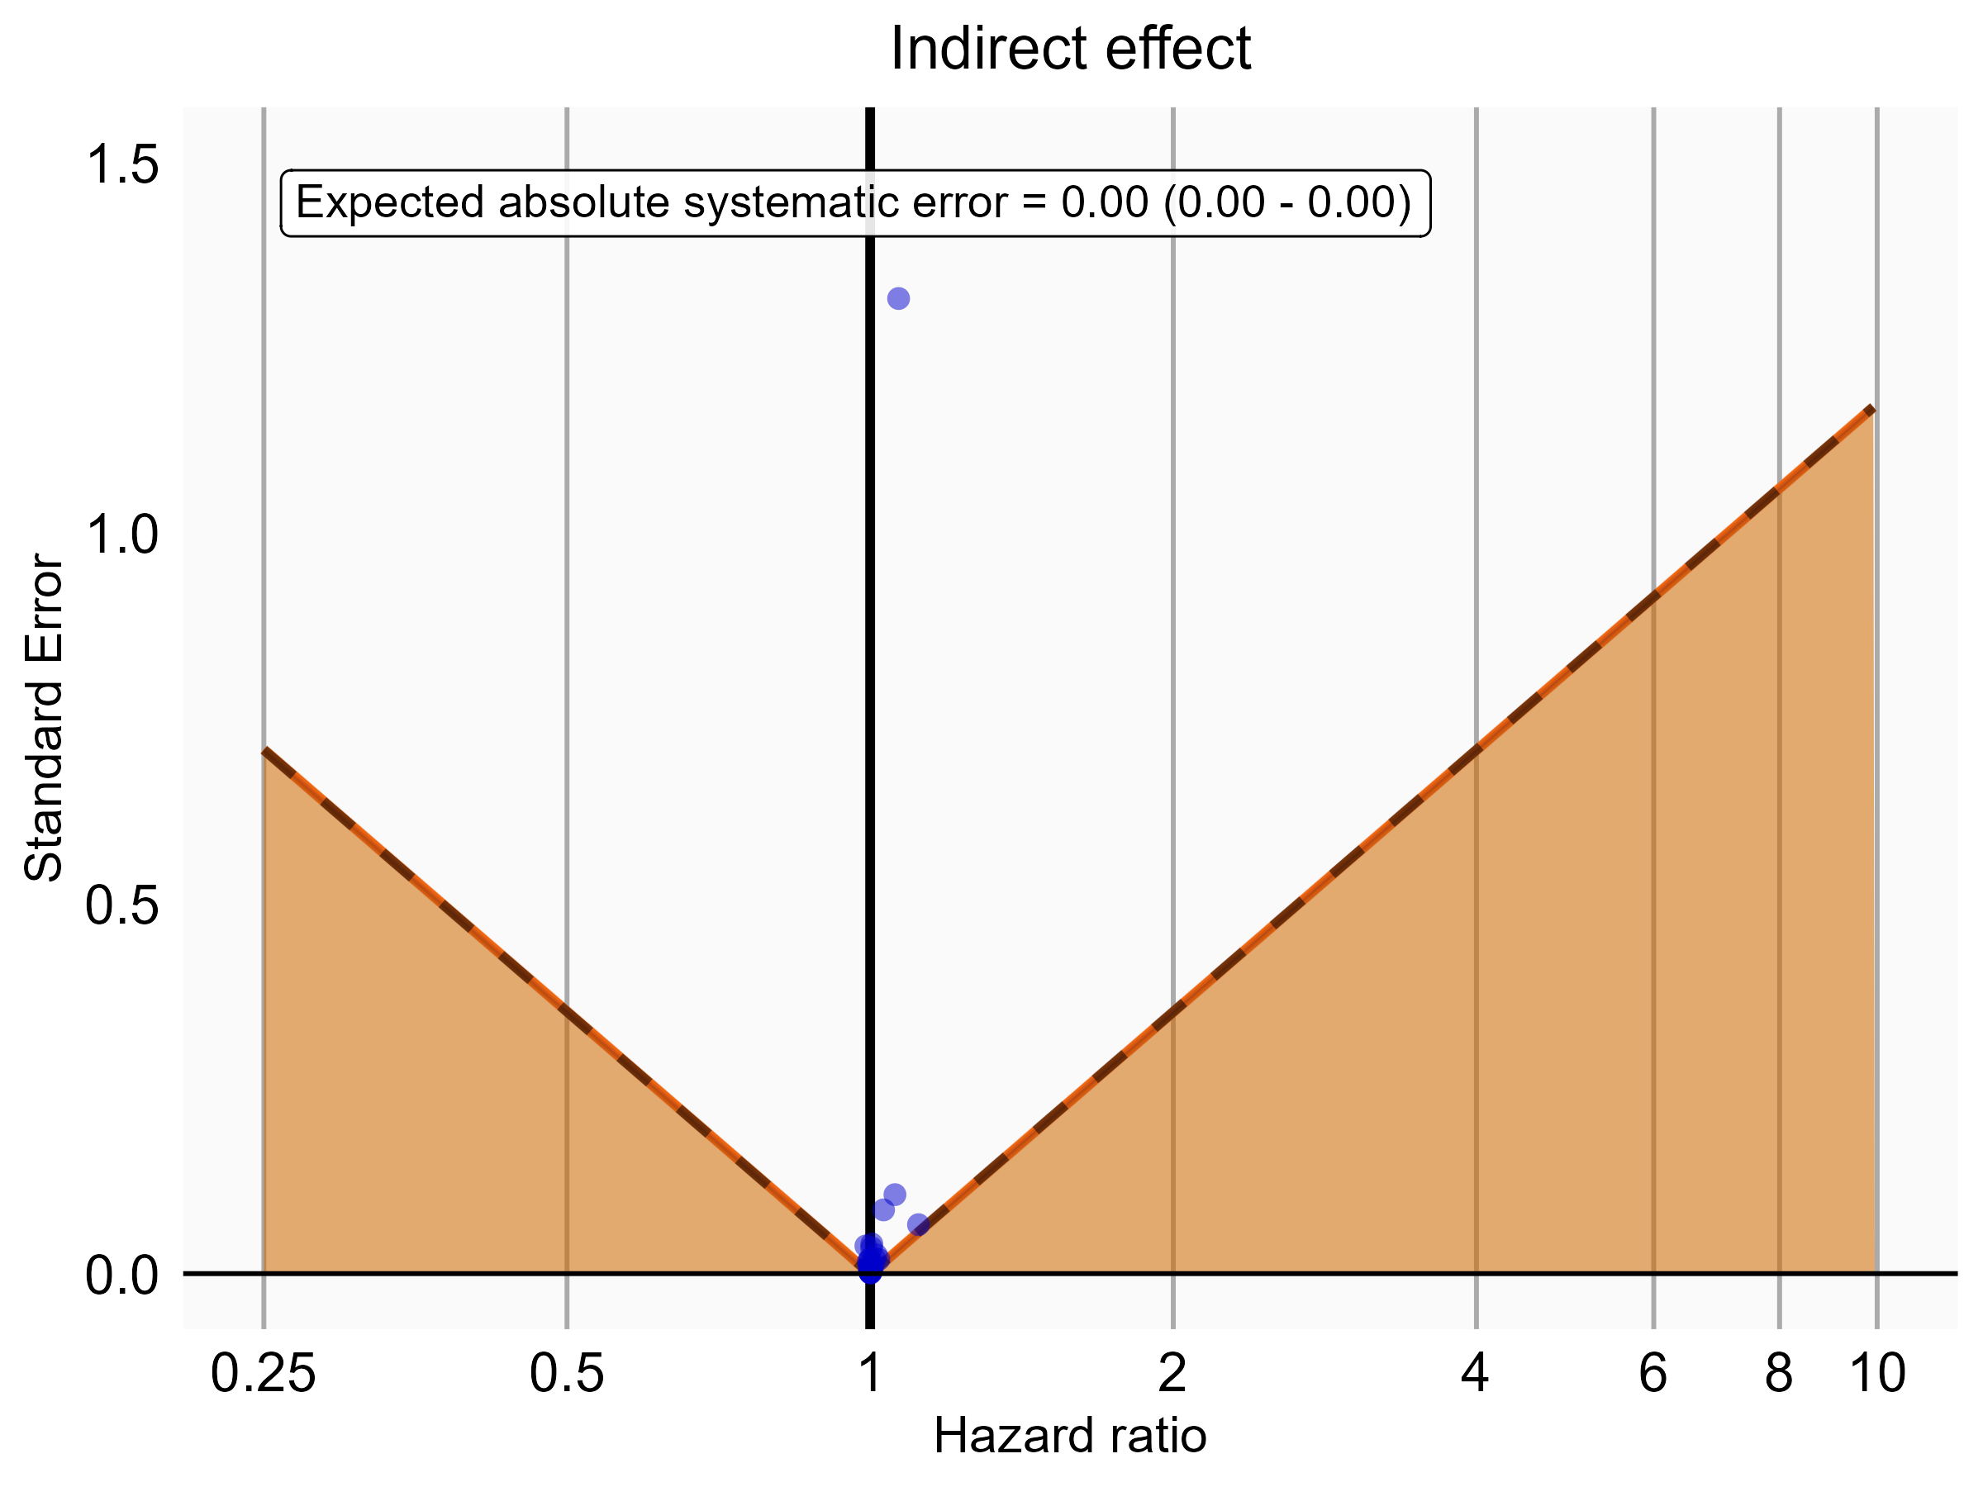

Negative control estimates of the indirect effect comparing Rivaroxaban to Warfarin using mediator Extracranial Major bleeding IP-ER in MDCR.

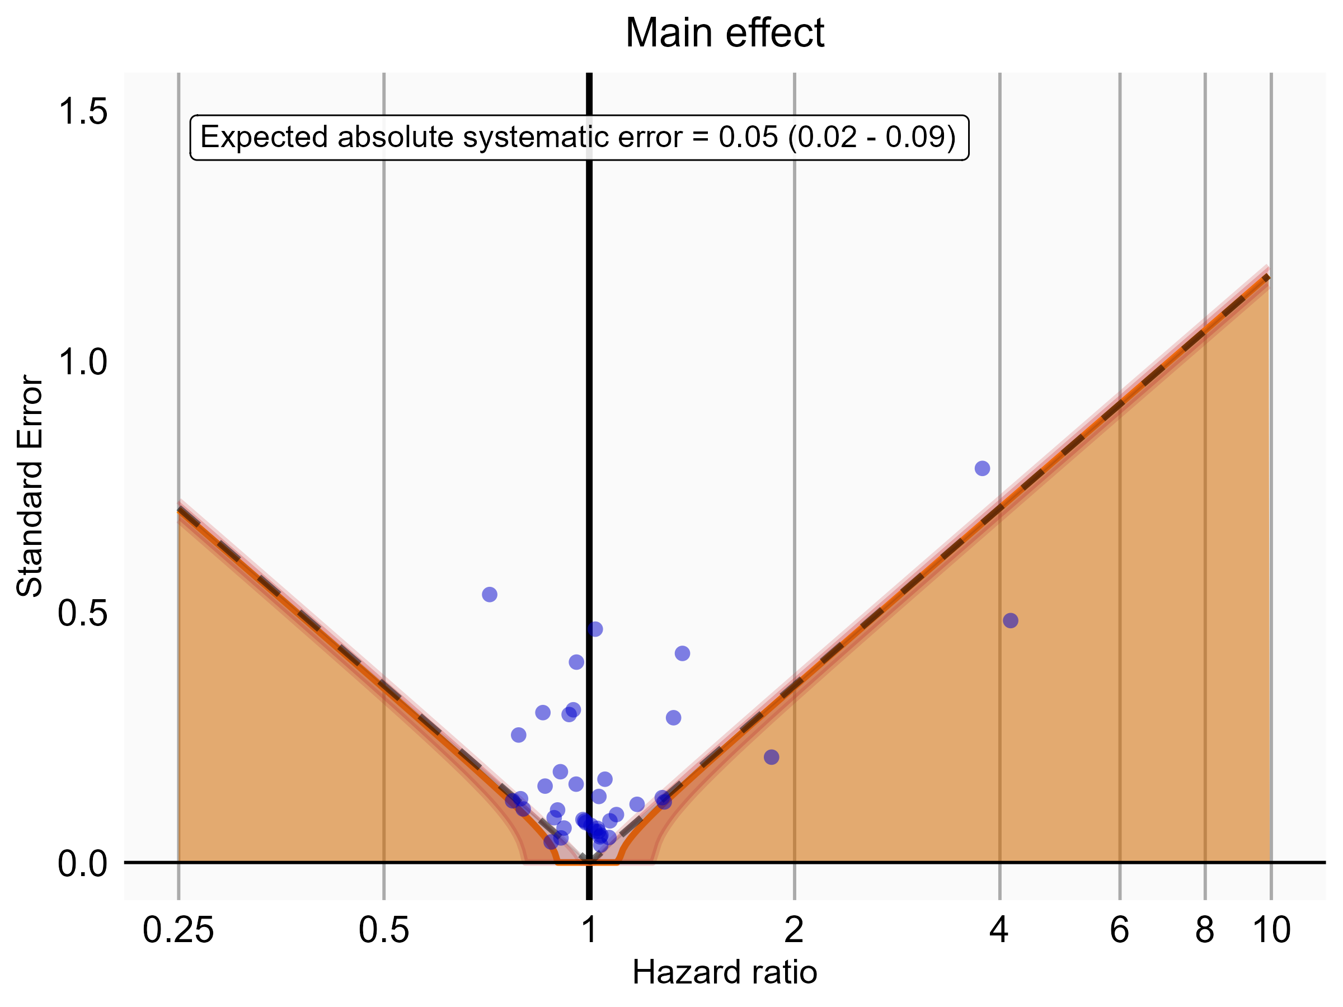

Negative control estimates of the main effect comparing Rivaroxaban to Warfarin using mediator Extracranial Major bleeding IP in MDCR.

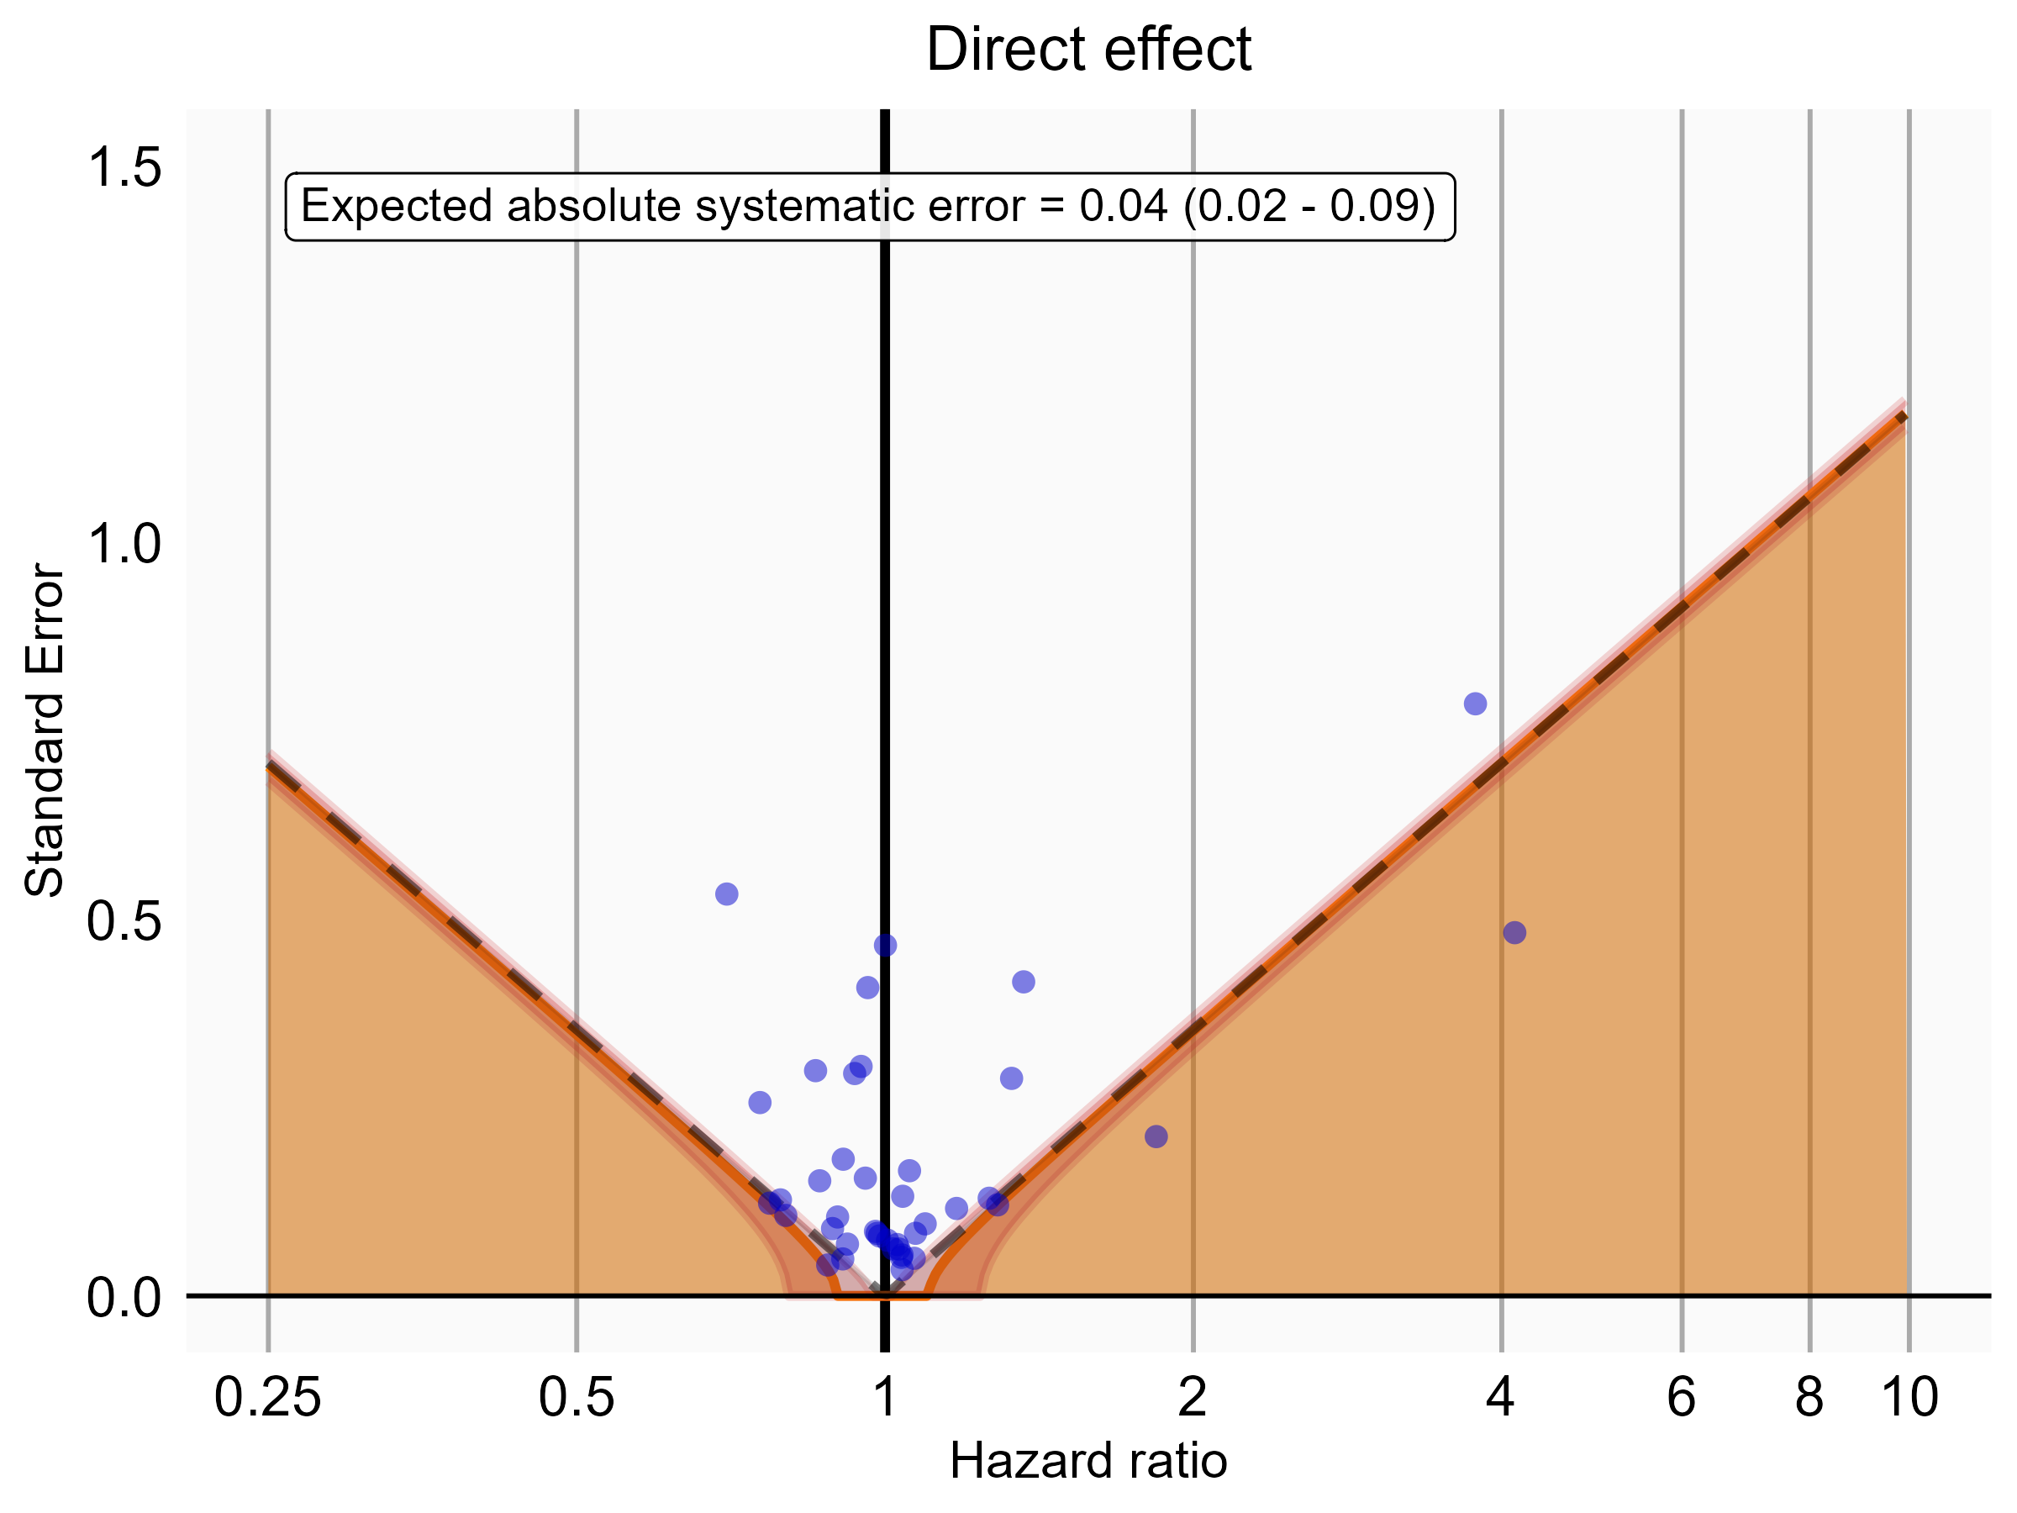

Negative control estimates of the direct effect comparing Rivaroxaban to Warfarin using mediator Extracranial Major bleeding IP in MDCR.

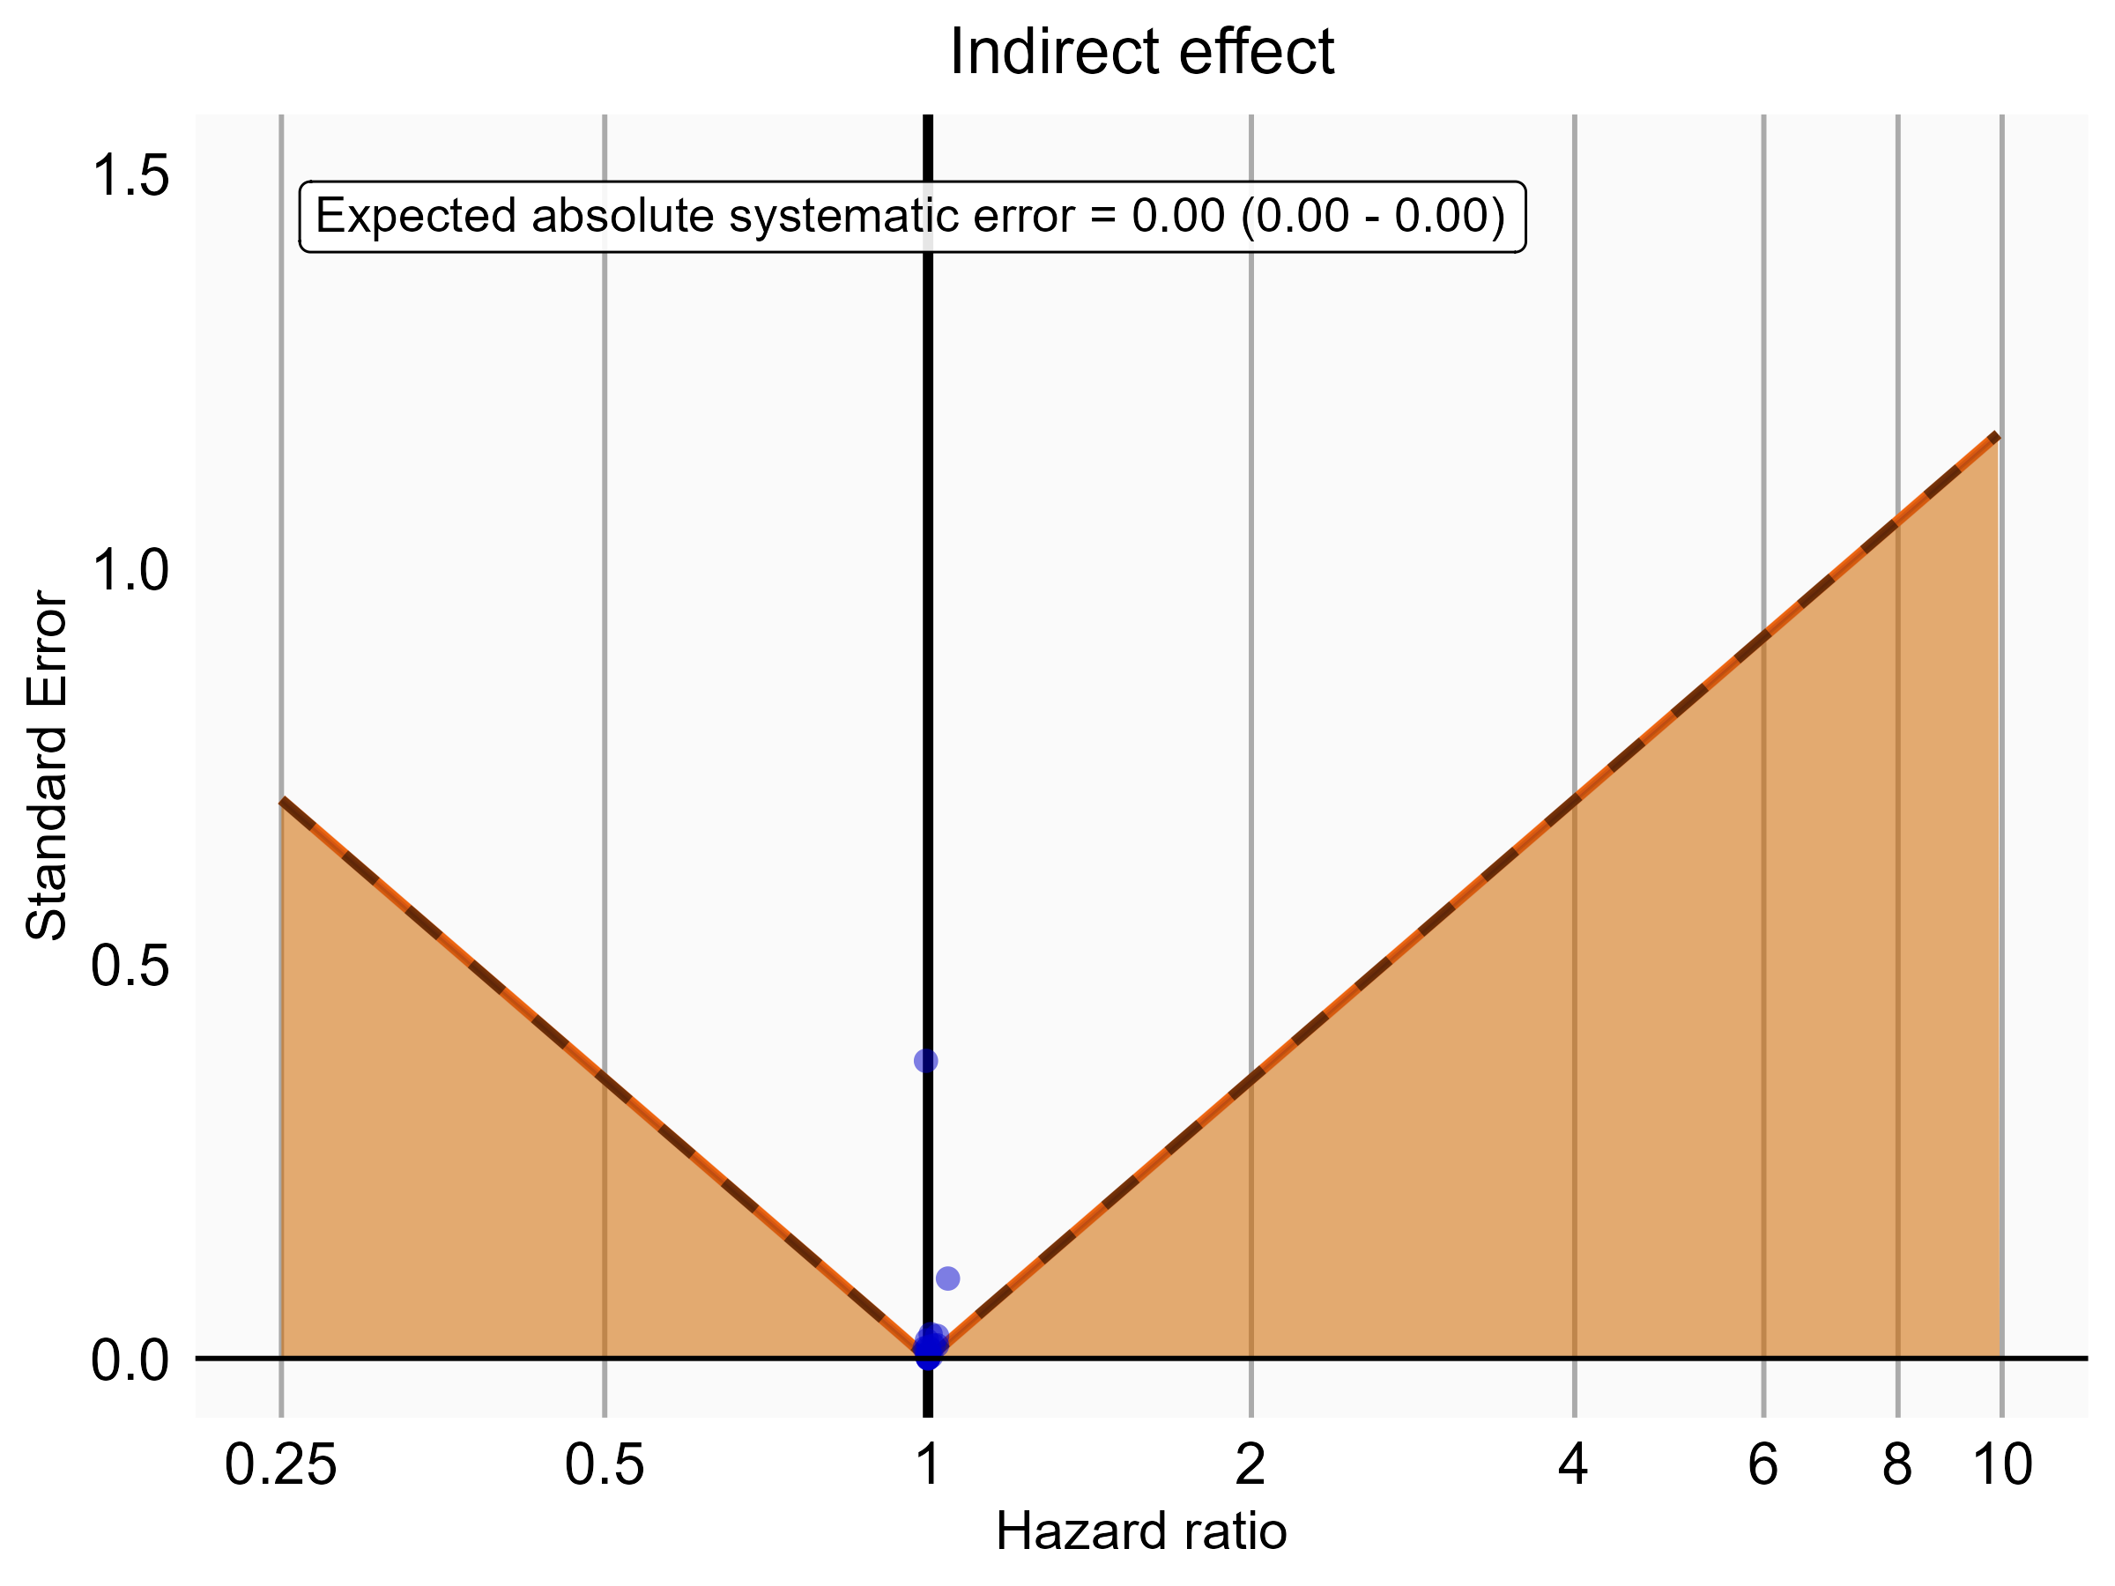

Negative control estimates of the indirect effect comparing Rivaroxaban to Warfarin using mediator Extracranial Major bleeding IP in MDCR.